1 Introduction 3
1.1 Menu Bar 5
1.1.1 File 5
1.1.1.1 Print Screen Snapshot 5
1.1.1.2 Change Site 5
1.1.1.3 Exit (Ctrl+E) 5
1.2 Edit 6
1.2.1 Copy (Ctrl+C) 6
1.2.2 Cut (Ctrl+X) 6
1.2.3 Paste (Ctrl+V) 6
1.2.4 Change Password (Ctrl+W) 6
1.2.5 Change Email (Ctrl+I) 6
1.2.6 Preferences (Ctrl+F) 7
1.3 View 8
1.3.1 Menu (Ctrl+M) 8
1.3.1.1 Menu Log (Ctrl+O) 8
1.3.1.2 Locks (Ctrl+L) 8
1.3.1.3 Toolbar 8
1.3.1.4 Color Scheme 8
1.4 Tools 9
1.4.1 System Administration 9
1.4.1.1 Backup (Ctrl+B) 9
1.4.1.2 Tape Verify 9
1.4.1.3 Tape Copy 9
1.4.1.4 View Users On System 9
1.4.1.5 View/Edit License 9
1.4.1.6 Users/Groups 10
1.4.1.4.1 Users Maintenance (Ctrl+U) 10
1.4.1.4.2 Groups Maintenance (Ctrl+G) 10
1.4.1.4.3 Menu/Form Report (Ctrl+G) 11
1.4.2 File Queue (Ctrl+Q) 11
1.4.3 Email Screen Snapshot (Ctrl+N) 11
1.4.4 Recorder 11
1.4.4.1. Record Session 11
1.4.4.2 Stop Recording 11
1.4.4.3 Play Media File 11
1.4.5 Windows 11
1.4.6 Help 12
1.4.6.1 Newzware Home 12
1.4.6.2 Turn On Debugging 12
1.4.6.3 News 12
1.4.6.4 Newzware Online 12
1.4.6.5 About 12
1.5 Toolbar 13
1.5.1 File Queue 13
1.5.1.1 Report List 15
1.5.2 Report Content 15
1.5.2.1 File Search Utility 16
1.5.2.2 Search For A File Name 16
1.5.2.3 Search For Text 16
1.5.2.4 Match Case 16
1.5.2.5 Search File Queue 16
1.5.2.6 Search Archive Files 16
1.6 Newzware Menu 17
1.7 Relational Database 18
1.8 Searching Data Records 19
1.9 Set Output Preferences 21
1.9.1 Report Action 21
1.9.2 Output Format 22
1.9.3 Other Options 22
1.9.4 Defaults 22
2 23

1 Introduction


Welcome to the Newzware Business Management System Application, Java version.

In the past, it was necessary to install a proprietary program to access the Newzware Newspaper Management system. This application has been created so Newzware can now be accessed on any modern desktop computer that can run Java.

The purpose of section is to provide the user with a quick introduction to each of the available menu and toolbar items. Most items will be skimmed with more detail given to those items that do not follow common Windows usage.

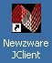

Start the Newzware application by double-clicking the Newzware icon, as seen at the left. As with any shortcut, the option to change the text and icon for the application is available to suit personal preferences. When launching Newzware for the first time, or after an update, there may be a short pause while the required update files are transmitted to the computer.

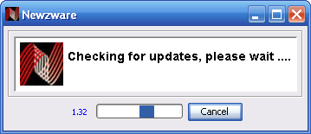

Occasionally, after receiving an update, it will also be necessary to restart Newzware. If this is the case, a message to this effect will appear. When OK is clicked, the window will close. If this happens, just double-click the Newzware icon again, and the application will start up once more.

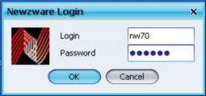

After any needed updates have completed, a login box will request a Login and Password. For the user’s convenience, the Login is remembered from the previous session.
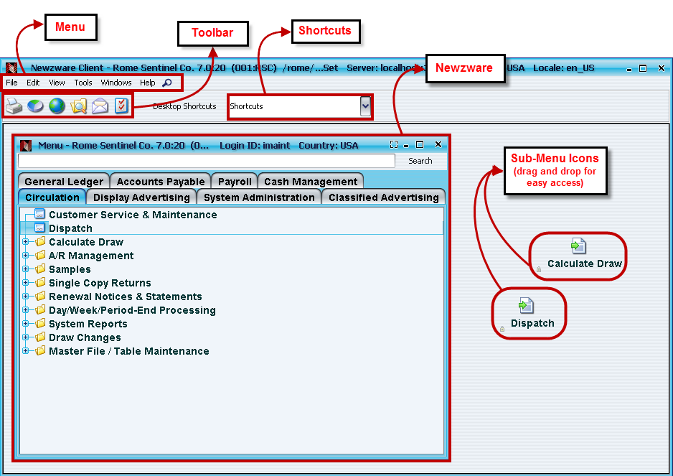
Figure 1-1 Newzware Java Application Window

The initial Newzware Java Application window is made up of 4 basic components

1) Menu Bar: Provided in nearly every windowed application, providing the standard options and sometimes a few additional items.

2) Toolbar: Allows quick access to often used applications.

3) Shortcuts: Provides quick access to often used menu items from within Newzware.

4) Newzware Menu: The gateway to the Newzware application.

5) Sub-Menu Icons: These are drag-and-drop items from the Newzware menu to the left. Icons can be placed onto the background of the program window for easy access depending on frequent use. The icons will appear in the Shortcuts drop-down menu.

Menu Bar
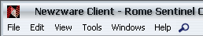

1.1.1 File

1.1.1.1 Print Screen Snapshot

This will open up the computer’s print dialog box, allowing the current Newzware screen to be sent to any printer desired.

1.1.1.2 Change Site

When multiple Newzware installations are available, the user might want to access the other location’s menus. Select Change Site and a box listing the sites available will appear.

Figure 1-2 Site Selection List
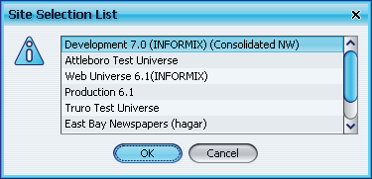

Choose one of the options. A notification announcing the changed database locations will come up:

Figure 1-3 Site Selection Change Confirmation
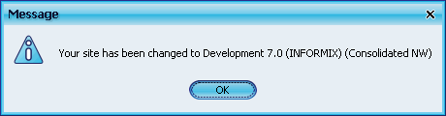

1.1.1.3 Exit (Ctrl+E)

This will close the application. If windows have been opened from the Newzware Menu, it will then ask for confirmation.

1.2 Edit

1.2.1 Copy (Ctrl+C)

This menu item (or key sequence) will Copy the selected text to the computer’s clipboard. The text can be in a screen field, or the File Queue report viewer.

1.2.2 Cut (Ctrl+X)

This clears the highlighted text from the current field.

1.2.3 Paste (Ctrl+V)

This will paste the content of the computer’s clipboard into the current field.

1.2.4 Change Password (Ctrl+W)

The menu item will open a window to allow the password used to access Newzware to be changed, provided the Current Password has been entered correctly.

Figure 1-4 Change Password Window
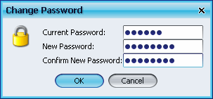

1.2.5 Change Email (Ctrl+I)

This will allow the email address receiving emailed reports sent from Newzware to be changed. This email dialog may also appear if the current user’s login id does not have an email address assigned.

Figure 1-5 Change Email Window
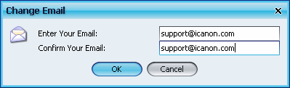

1.2.6 Preferences (Ctrl+F)
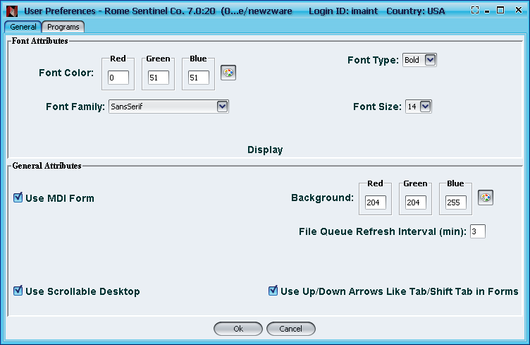

In the General tab gives the options to change the look and feel of the interface, by adjusting colors and fonts.

Figure 1-6 User Preferences – General Window

The Programs tab can be used to change the other programs launched by the Newzware application.

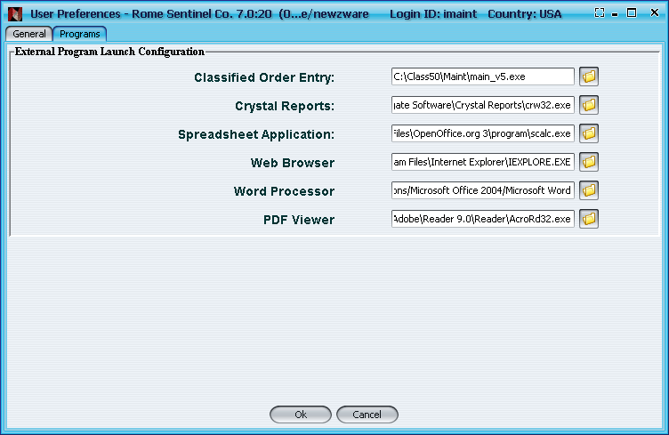
Figure 1-7 User Preferences – Programs Window

1.3 View
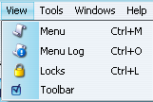

1.3.1 Menu (Ctrl+M)
This will launch the Newzware Menu, or, if the Menu is already running, it will bring the Menu to the front of the displayed items.

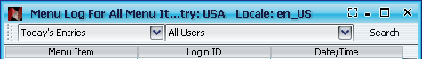

1.3.1.1 Menu Log (Ctrl+O)
This will open a window showing which menu items have been accessed by which users.

1.3.1.2 Locks (Ctrl+L)
This will show the locks currently in place, along with the users and processes that created them.

Locks are placeholders that let any processes or programs know which files are in use before it begins. Some processes will share the files. Some processes will need exclusive access to files. If both the current process and the process just starting are willing to share, then there is no problem - otherwise, the new process will not be able to start until the process already in progress has completed. Locks are a legacy resource for compatibility with prior Newzware releases. Newzware 7.0 does not utilize locks.

1.3.1.3 Toolbar
When checked, this will show the Toolbar with the Newzware window.
See 1.5 for an image and details of the Toolbar.

1.3.1.4 Color Scheme
By selecting the Newzware icon from the upper left area of the main window, users can change the color scheme of the application. The changes are immediate, so choose different options until satisfied with the most personally desired appearance.

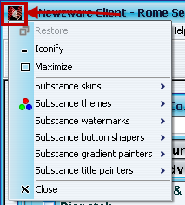

1.4 Tools

1.4.1 System Administration

Backup data (to disk and tape) and maintain User & Groups.

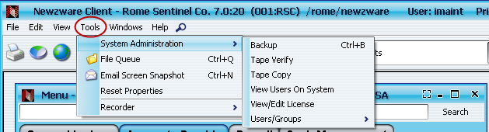

1.4.1.1 Backup (Ctrl+B)
Backup data files.

1.4.1.2 Tape Verify
Verify the integrity of a backup tape.

1.4.1.3 Tape Copy
Copy files to tape.

1.4.1.4 View Users On System
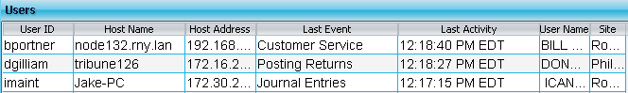
Lists currently logged in users in a new window, giving information such as User IDs, Host Names and Addresses.

1.4.1.5 View/Edit License
Displays current license settings, with available fields to alter and submit a request to regenerate a changed license.
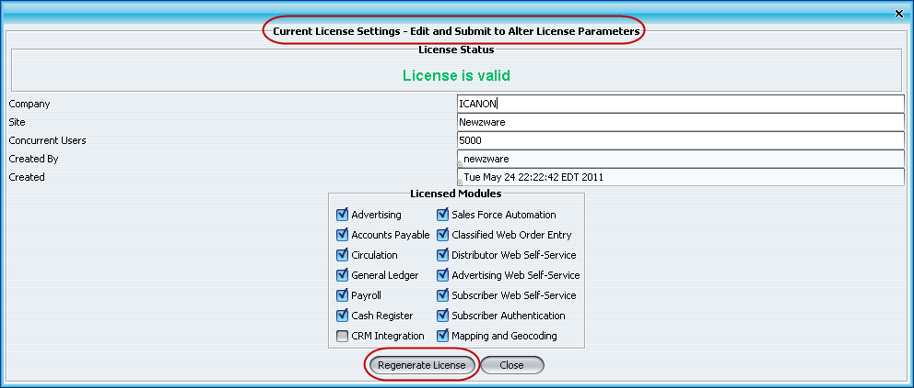

1.4.1.6 Users/Groups
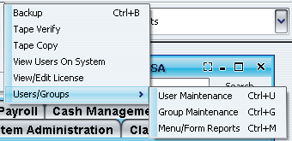
Administer User and Group definitions.

1.4.1.4.1 Users Maintenance (Ctrl+U)
Administer User ID's.
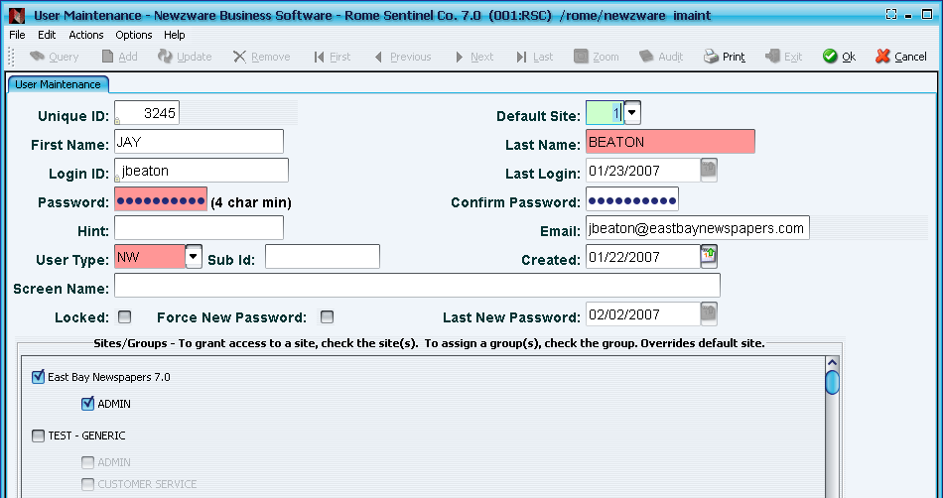

1.4.1.4.2 Groups Maintenance (Ctrl+G)
Administer user group definitions, which can be used in conjunction with access permissions to menu items.
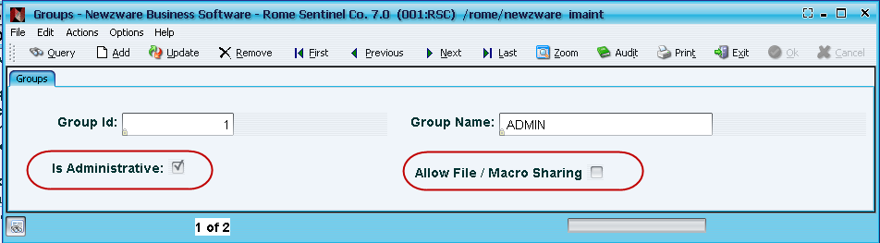
If the Group is checked as Administrative, as seen in the above window, then the members of that group will be able to see the Administrative menu on their screens. If Allow File/Macro Sharing is checked for the Group as well, then members of that group would be able to look at other users’ File Queue Entries and Report Macros. An Administrative group will also see the Viewing file queue for option in the File Queue that allows a drop-down bar listing users in the group.
See 1.5 for File Queue details and descriptions.
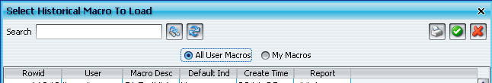
A user that is a member of the group currently allowed to view other macros will see two options for sharing and removing viewing history: All User Macros and My Macros. Other users that are not a member of the sharing group will not have those options available to them.

1.4.1.4.3 Menu/Form Report (Ctrl+G)
Administer menu/form definitions, which can be used in conjunction with access permissions to menu items.
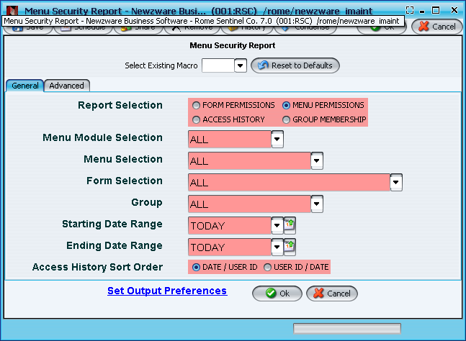

1.4.2 File Queue (Ctrl+Q)
Examine, search, print and share files and reports located on the Newzware server. When this option is chosen, the File Queue window will open.
See 1.5.1 for an image and detailed description of the File Queue window.

1.4.3 Email Screen Snapshot (Ctrl+N)
Send a copy of the current screen to an email address. This uses the mail sending abilities of the Newzware server. When selected, a window below will appear, requesting to choose which open window to email from the pull down menu.

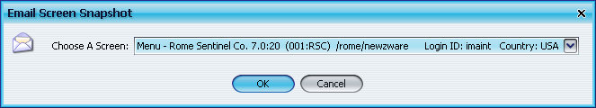

1.4.4 Recorder

1.4.4.1. Record Session
After requesting a name for the new movie, this function will capture a video of everything happening on the computer screen in a QuickTime video file.

1.4.4.2 Stop Recording
Stops the recording session, started previously.

1.4.4.3 Play Media File
Play back a previously recorded file.

1.4.5 Windows
Select this to see a list of Newzware windows open for the current session. Making a selection from the list will bring that Newzware window to the front of the pack.

1.4.6 Help

1.4.6.1 Newzware Home
Displays the current user and home location of the installed Newzware software.

1.4.6.2 Turn On Debugging
Turns on a background program to assist in trouble shooting. Should only be used when asked by a Newzware engineer.

1.4.6.3 News
Latest news as provided by Icanon & Associates. A window will appear on the screen.

1.4.6.4 Newzware Online
Redirects user to the Customer Resources area of the Newzware website.

1.4.6.5 About
This will show the name and current version number of the application running.

1.5 Toolbar
The toolbar provides quick access to a number of often used programs. The Toolbar can be toggle off and on, via the File Menu (View, Toolbar).
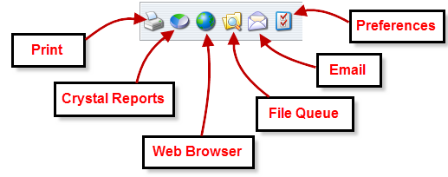
Print: Send a copy of the screen to a printer.
Crystal Reports: Launch Crystal Reports.
Web Browser: Launch the selected web browser.
File Queue: Open the Newzware server’s file queue to access printed reports.
Email: Send an email.
Preferences: Set the user preferences for this application. There are two available tabs, General and Programs. General can be used to set font types, sizes and colors. Programs is used to indicate the locations for external applications launched from Newzware.

1.5.1 File Queue
Through this set of windows, the reports generated within the Newzware system can be listed, searched, viewed, mailed, copy and pasted.

The File Queue window consists of a toolbar and 3 smaller windows, which will display the list of available reports (Status: green for not opened, blank for opened), a search window, and searched results.

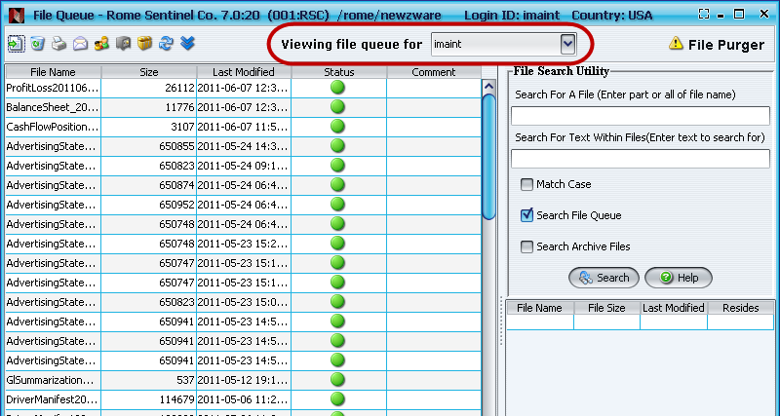

The Viewing file queue for drop-down option listing users in the group indicated above will only be available to Administrative users. To switch a user to Administrative, the settings can be changed in Group Maintenance.
See 1.4.1.4.2 for details and descriptions on Group Maintenance alterations and settings.
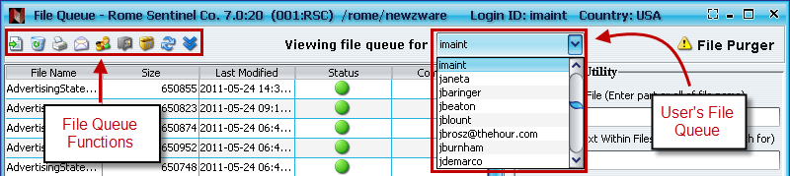

View current file

Delete current file

Print the current file

Email the current file

Share file with another user. A secondary window will appear, prompting to choose the user in which to share the file.

Archive current file

Switch between file queue and file archive

Refresh the current list

Download selected file

Viewing file queue for: Use the pull down menu to switch between viewing different users' file queues.

Clicking the File Purger button on the toolbar will result in the following message window to appear:

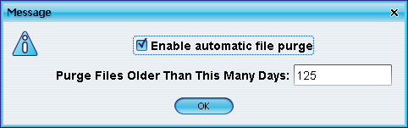

Check the Enable automatic file purge box to allow the alteration of the Purge Files Older Than This Many Days field, and click OK to save those changes. This action allows the removal of old and possibly unnecessary files in the File Queue without having to do so manually. As a default, automatic file purging is not enabled. File purging does NOT affect the archive file queue – those files remain permanently stored.

1.5.1.1 Report List
The list of available reports can be sorted by clicking any of the column headers (File Name, File Size or Last Modified). To reverse the order of the sort, hold Shift while clicking on the column header.
.
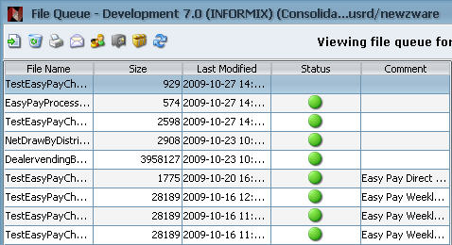
Figure 1-12 Report List
Green circles are used to indicate reports that have not been viewed.

1.5.2 Report Content
Multiple reports can be displayed. Each new report opened will open over the prior report displayed

Figure 1-13 Report Content

1.5.2.1 File Search Utility
Use this to search through the reports for specific data. Files can be searched using a single or multiple options.

The available search options are:
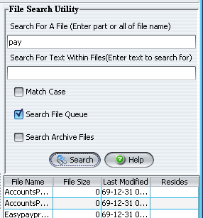

1.5.2.2 Search For A File Name
Enter any part of a file name into this field to find it.

1.5.2.3 Search For Text
Enter text into this field in order to find it.

Options - Select 1 or more of these options to indicate what should be searched.

1.5.2.4 Match Case
Check this box to make the search case specific. This box applies only to the “Search For Text” field.

1.5.2.5 Search File Queue
Search through the files within the File Queue

1.5.2.6 Search Archive Files
Search through the files within the File Archives.

Launch Buttons -

Launch the search, using the indicated options.
Open the File Search Utility help window.
Search Results - the result of the search will be displayed in this section. File Name, File Size, Last Modified & Resides.
Clicking the column header can sort the results by File Name, File Size, Last Modified, or Resides. By <Shift>-clicking, the order of the sort can be reversed.

If no files are found matching the search criterion entered, the following message box will appear:

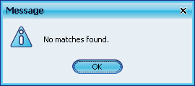

Figure 1-15 Search Results Message

1.6 Newzware Menu
The Newzware menu consists of Sub-System Menus, Menus and Executable items. One can switch between the Newzware Sub-Systems by selecting the appropriate tab. Expand or collapse menus by double-clicking folders (or the plus/minus symbol). When the desired menu item is displayed, launch it by double-clicking.

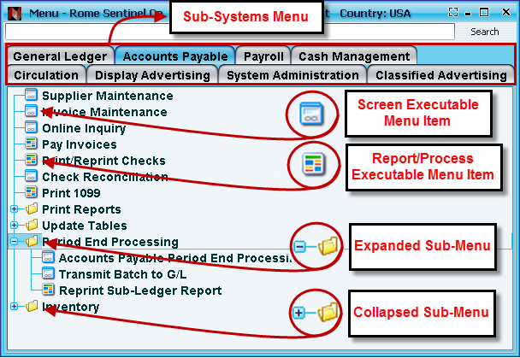
Figure 1-16 Newzware Menus

If the location of a menu item is forgotten, use the “Search” box to help locate it. Enter any portion of the menu text* that might help find the item, click the "Search" button, and the results will be displayed in message window. Double-click the item from the search results to launch that program.

To access an item's Security settings, Menu Log, and Properties, right-click on that menu item.

*This search is case sensitive.

1.7 Relational Database

The Newzware system utilizes a relational database system consisting of several different tables. Each table contains a variety of fields that store particular information about the user’s newspaper. For example, the occupant table may contain a subscriber’s first and last names, along with their title and a few other fields. The columns for the name and title’s information are named occ_fname, occ_lname and occ_title. The address information for a subscriber would be stored in another table, called addr. For reasons of storage efficiency, we have separated the occupant and the address information so that we can have multiple people residing at the same address and but store the entire address only once throughout the system. The occupant table has another column called occ_addr_id that serves as the sequence identifier or key to the addr table. The value of a particular occ_addr_id column is an index (or key) to the addr table. From this relationship, we can say that the occupant table relates to the addr table using the occ_addr_id column on the occupant table and the db_rowid column on the addr table.

Or, to share the relationship in computer (SQL) lingo:
- occupant.occ_addr_id = addr. db_rowid

This is shorthand for stating the occupant and addr table relationship. The subscriptions for a subscriber are stored in an altogether different table called subscrip. The following relationship exists between the occupant and subscrip tables:
- occupant.occ_subscr_id = subscrip.sp_num

The column occ_subscr_id holds the subscriber number. The subscrip table has a special relationship with the occupant table because there can be more than one subscrip record per subscriber/occupant. We will learn more about why this is the case later, but it is important to note that major effort has been taken to conserve computer storage space and processor overhead. Storing the subscriber name and address for every subscription would create vast amounts of duplicated data. We divide information into separate tables and then tie them together using key columns to avoid this waste.

The Newzware software manages these relationships, so users are not required to have a detailed knowledge of how the tables relate. Knowing that there are multiple tables that tie together is still useful for working with Newzware effectively, especially if when planning to create Crystal Reports in the future.

1.8 Searching Data Records

One of the strengths of the Newzware system is the searching ability. If the “Query” selection is available, we can search records by entering any known information into the available fields to narrow down the search or, to simplify the process, leave all of the fields blank to find all of the records.

To find all of the distributors in the database, from the Distributor/Route/Truck
Maintenance screen, simply choose “Query” and click the “OK” button (or press <Alt>-O, if preferred). The system will collect all of the distributors and display the first distributor, along with the message “1 of X”, where X represents the total number of records found. In this case, that number would be our total number of distributor records in the database.

Using what we know, we can find specific records or information that we do not know. For instance, we can choose “Query” and enter a “Distributor ID” to pull up that distributor’s name, address and other information.

We can use any combination of the available fields to query information. One can populate anywhere from none, to some, to many, to all of the fields, with the data specifying what to find. The more fields populated with data, the more fine-tuned the results.

One way to use multiple fields in a search would be to find all of the active distributors living within the city limits, enter the name of the city into the city field, and then check the “Active?” box. After we execute our search, the first record found, will be displayed and a message “1 of X” will be at the bottom of the screen, telling us just how many active distributors operate within the city limits.

We’ve used examples where we enter data to find records, but we can also exclude records in the same way, with a subtle difference. The difference is that we precede our input with the numeric symbol used to indicate “not equal” (“!=” or “<>”).

Using our previous example, we decide that we want to find all of the active distributors that do not operate within the city limits, again, we check the “Active?” box, but this time, when we enter our city name after we type “!=” before our city name (I.E. “!=SPRINGFIELD”). With the fields populated, hit “OK”, and you’ll see the distributors that are outside of the city of SPRINGFIELD.

There are also times, when we have an idea of what we want, but we are unsure about the specifics. This is where we can take advantage of metacharacters, or as they are sometimes referred, wild cards. Much like a wild card can fill an inside straight in a hand of poker, we can use a wild card to fill the gaps of our input while searching.

Listed below are some examples of the available wild cards, the types of fields where they can be used and how they are used.
Table 1-4 Wild Cards / Metacharacters
Character | Type/Field | Description | Example | Results
* | Character | Used to match any number of characters. | SM* | SMITH, SMOTHERS
= | Character | Used alone, it will match a field with no data. Use “=” in a first name field to find records that have no first name stored. | =
| | Character | Can be used to search for any number of different values | BLACK|WHITE| GREEN | BLACK, WHITE
> | Numeric or Date | Finds a value greater than that entered. | >1  >02/02/1998 | 2,47,100  02/03/1998, 01/01/2000
< | Numeric or Date | Finds a value less than the number or date entered. | <100  <12/31/1998 | 0,33,89  05/08/1998, 11/18/1998
>= | Numeric or Date | Will find values greater than or equal to the value entered. | >=1  >=07/03/1998 | 1,30,73  07/03/1998, 01/01/2000
<= | Numeric or Date | Will find values less than or equal to the value entered. | >=1  <=07/03/1998 | 1,30,73  07/02/1998, 07/03/1998
: | Numeric or Date | Specify a range of values to find, setting the low and high values. | 3:10  010198:120198 | 3,4,7,9,10  01/01/1998, 06/03/1998

Not a wild card, but just as valuable, when the cursor is in a field, “<Ctrl>-A, <Ctrl>-X” can be used to clear all data from that field.

1.9 Set Output Preferences
Whenever the user runs a report, it will give the opportunity to set (or review) where the report will be sent, and in what format. Among the “where” choices include to a printer, to an application (like Excel), to the screen and email address. Among the formatting choices include standard text, HTML (web browser) and PDF, which is a format that ensures the report will look the same regardless of the type of computer it is viewed with.

The Set Output Preferences opens the Output Options form, which can be seen below, along with an explanation of its choices.

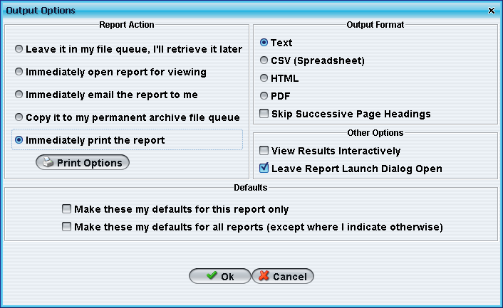

1.9.1 Report Action
This area is used to indicate what should happen with the output once it has finished generating.
Leave it in my file queue. I’ll retrieve it later - use this option to generate the report but not actually send it anywhere. This is best used in a situation that requires a report that will take time to generate, but the user running it needs to sign off of the computer for a while. The user in question could leave the computer and have the report completed and waiting the next morning.
Immediately open the report for viewing –use this option when the report needs to be viewed right after being generated. The report will open a window or application on the computer (based on the output format selected) and display the contents of the report.
Immediately email the report to me - this option will send the report to the given email as an attachment. The email address in use can be set or changed on the Newzware Client’s toolbar at “Edit” > “Email” or by typing <Ctrl>I.
Immediately email the report to me - will send the report to the email that was entered in the user’s profile maintenance set up.
Immediately print the report - will send the report to the desired printer. When this is selected, the “Print Options” becomes available, thus enabling the user to indicate which printer should be used to print the report.

1.9.2 Output Format
Selecting the report’s format will affect how the output looks and/or what programs are used when displaying the contents of the report.

Text will save the output in standard text. This type of file can be view in the standard Newzware viewer, or any kind of text editor or word processor. There are no special or hidden characters saved in the output.

CSV (Spreadsheet) will save the report in a text file, but data will be enclosed in quotes and separated by commas. This type of file will be opened in a spreadsheet application (set at the Newzware Client’s toolbar at “Edit”, “Preferences”, or by typing <Ctrl>F, and selecting the “Programs” tab).
- CSV is short for “Comma Separated Values.”

HTML will format the output using HTML (Hyper Text Markup Language) which, even if the user personally does not know what that means, is still a common enough acronym easily recognized from URLs used whenever browsing the internet. This file will be opened in the default web browser on the currently used computer.
- Changing the default web browser for this program can be done on the Newzware Client’s toolbar by clicking “Edit” and selecting “Preferences” from the drop-down menu, or by typing <Ctrl>F and selecting the “Programs” tab.

PDF, which stands for “Print Document Format”, is used to format the output in a specific manner, so the output will look exactly the same wherever the file is viewed. A special program is required to open this type of file. There are several available, but the original creator and program used most often is Adobe’s Acrobat Reader.

1.9.3 Other Options
This area will enable the user to view the output in an interactive table viewer (like a spread-sheet). The presented data can then be sorted, exported, or otherwise manipulated in this view.

As a convenience, the report launch window can be kept open after the report is launched. This can be useful when testing a report with various options.

1.9.4 Defaults

This area can be used to reset any or all default values.

Make these my defaults for this report only will set the choices indicated to be the default values whenever the current report runs in the future.

Make these my defaults for all reports (except where I indicate otherwise) will set these choices to be the default answers for all of the reports printed in the future. The option of changing the Output Options for an individual report or setting new Defaults will always be available at any point in time.

When happy with the selections made, select “OK”, or if to revert to the form’s original settings, and close the form, select “Cancel.”

