SSM and Authentication Manual – 7.0

Table of Contents

Chapter 1 - Authentication

Page 2 Login and Password
Page 2 What is the Authentication Module?
Page 3 Authentication Form
Page 4 Authentication Parameters
Page 5 Authentication Response
Page 6 Authentication DOM Response

Chapter 2 – Self Service Module (SSM) New Start Forms

Page 7 Retail Rates
Page 8 New Start by Zip Code
Page 9 Zip Ranges
Page 12 Confirmation Page
Page 13 New Start by Address
Page 15 Payment Options
Page 18 New Start Processed

Chapter 3 – Self Service Module (SSM)

Page 20 Account Maintenance
Page 20 Subscriptions
Page 21 Vacations and Moves
Page 22 Payment Center
Page 24 Missed Deliveries and Complaints
Page 25 Automatic Login

Chapter 4 – Self Service Module (SSM) Administrator

Page 29 Fonts, Colors and More
Page 31 Custom Maintenance/Payment Email
Page 32 Publishing
Page 33 Advanced SSM Administration
Page 36 CSS/Preferences
Page 37 Verification of Changes

Chapter 1 - Authentication

Login and Passwords

The Newzware Authentication Module and Self Service Module use logins and passwords to allow users to access account information or to send back information to another program after validation has been done. All subscribers are eligible to create an online account (SSM Installation Required), which includes the creation of a login and password. The login is unique in the Newzware system and is directly associated with a subscriber account. Logins can be viewed by going into the User Maintenance screen (Administrators only). You can find the User Maintenance screen inside the Newzware client software by clicking Tools System Administration Users/Groups User Maintenance or CTRL – U. All SSM or Web Accounts that are authenticated or used to gain access to manage accounts online contain an “S” as the User Type. The Sub. Id field is the subscriber account. Login Ids cannot be updated. If a subscriber cannot log into his/her account because they do not know their password or their login id, simply click the Query button in the User Maintenance form and enter the account number in the Sub. Id. Field. If an online account exists, a record will be returned containing the information for that online account. Since passwords cannot be seen, a new password must be issued. To enter a new password, click the Update button. Navigate to the Password field and enter a new password. Tab over to the Confirm Password field and re-enter the same password. Click the Ok button. The online account will now be updated with the new password.

What is the Authentication Module?

The Newzware Authentication Module is a server side Java Server Page (JSP) that is placed on the Newzware server and works in conjunction with the Newzware application. The JSP accepts parameters from an HTTPS request from an external source and returns an XML response back to the calling source containing information about the validity of the parameters passed. If the request is authenticated, then account information is returned. Let’s take a look at a sample form.

<HTML>
<HEAD>
</HEAD>
<BODY>
<FORM name='authentication' id='authentication' METHOD='POST' ACTION='https://aspc1.newzware.com/authentication/auth70_xml.jsp'>
<INPUT TYPE='HIDDEN' NAME='token' VALUE='TOKEN'>
<INPUT TYPE='HIDDEN' NAME='site' VALUE='philan02'>
<INPUT TYPE='HIDDEN' NAME='edition' VALUE='PT'>
<INPUT TYPE='HIDDEN' NAME='active_only' VALUE='Y'>

<INPUT TYPE='HIDDEN' NAME='custom' VALUE='N'>
<TABLE>
<TR>
<TD>Login ID:</TD>
<TD><INPUT TYPE='TEXT' NAME='login_id' VALUE=''></TD>
</TR>
<TR>
<TD>Password:</TD>
<TD><INPUT TYPE='PASSWORD' NAME='password' VALUE=''></TD>
</TR>
<TR>
<TD colspan='2'><INPUT TYPE='SUBMIT' NAME='sub' VALUE='Submit'></TD>
</TR>
</TABLE>
</FORM>
</BODY>
</HTML>

The resulting page looks like the following:

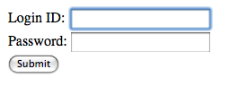
This is a basic form. The important piece of this form is the actual parameters that will be passed with the form data. There are only three required parameters that need to be passed to the authentication module. These are:

login_id - The user’s login id
password - The user’s password
site - The site (Provided by ICANON)
edition (optional) - The edition code (In Newzware)
active_only(optional) - Query only active subscriptions
token(optional) - Unique request identifier
dom(optional) - Show response in DOM format as opposed to traditional

These are case sensitive parameters. The action in the form will vary from site to site and will be given at the time of installation.

When the auth70_xml.jsp page receives the request, it queries the Newzware database for the login id and password values. The site parameter identifies which Newzware database to query. The combination of these three parameters validate whether or not the request can be authenticated.

The first step checks to see if the login and password exist and are valid. The next step is to determine whether or not there are any active or future subscriptions for the account associated with the login and password. Checking for future subscriptions is an option and can be excluded by passing the active_only parameter as seen in the form. The edition parameter can also be used to only check for active subscriptions to a particular edition. What if a subscriber is on vacation? There is a parameter in the system that can identify which vacations can be authenticated and which vacations should not be authenticated. Please contact an ICANON Associate for more information on authenticating subscriptions that are on vacations. The default behavior is to allow access for subscribers on vacation (Depending on the active_only parameter and edition parameter).

The result of a request is an XML response. The following is a response that denied access for a login and password.

Note: The example response is taken from the form on the previous page and the parameters passed as they are.

<newzware>
<authenticated>No</authenticated>
<token>TOKEN</token>
<login>subscr</login>
−
<message>
Denied access for subscr. Login and password combination incorrect.
</message>
</newzware>

The <authenticated> tag contains the value that states whether or not a subscriber has been authenticated. A value of No indicates the parameters passed were denied access. The following is an authenticated response.

<newzware>
<authenticated>Yes</authenticated>
<token>TOKEN</token>
<login>subscr</login>
−
<subscrip>
<unique>29142</unique>
<account>1884</account>
<fname>ACCOUNT</fname>
<lname>TEST</lname>
<email>jshoman@icanon.com</email>
<edition>PT</edition>
<paytype>P</paytype>
<issue>3D</issue>
<abc>10</abc>
<vacation>0</vacation>
<begin>07/31/2009</begin>
<end>03/28/2010</end>
</subscrip>
</newzware>

As seen above, the <authenticated> tag contains a value of Yes, indicating that the request was authenticated. The following information is also sent back in the response inside the <subscrip> tag: Account number, subscription unique number, first name, last name, email address, edition code, payment type for the subscription, issue code, abc zone, vacation id (0 indicates the subscriber is not on vacation), the begin and end date for the subscription. Multiple subscriptions can be in the request.

The token parameter can be used to send a unique value in the request. This value is automatically returned inside the authenticated response. This value can be used for multiple objectives, but it is not a required parameter.

The dom parameter changes the response XML and is used more for AJAX type requests. Instead of containing values inside independent tags, attributes are given to a main tag. A dom parameter value of “Y” sent in the request will result in the following response for an authenticated user.

<newzware>
<authenticated value="Yes" token="TOKEN" login="subscr"/>
<subscrip unique="29142" account="1884" fname="ACCOUNT" lname="TEST" email="jshoman@icanon.com" edition="PT" paytype="P" issue="3D" abc="10" vacation="0" begin="07/31/2009" end="03/28/2010"/>
</newzware>

Chapter 2 – Self Service Module(SSM)

The Newzware Self Service Module(SSM) is an online account management system for subscribers. This utility grants access to a subscriber’s account information, along with the ability to perform subscriber transactions online. These transactions include making a payment, performing a vacation or move, making a complaint, changing passwords, email addresses, phone numbers and security login information, adding a missed delivery, performing new starts and previewing subscription history. This document will go through each part of the SSM in detail and describe each of the transactions that can be done within the Newzware SSM. The SSM works directly and in real time with the Newzware database. All changes or transactions performed within the SSM can be viewed immediately through the Newzware Customer Service screen.

SSM New Start Form/Retail Rates

Retail rates are added and edited through the retail rates screen in the Newzware client application. The retail rates screen can be found under the Circulation Tab. Navigate to Master File / Table Maintenance Table Maintenance Rate and Tax Tables Retail Rates. The field that indicates whether or not a rate will appear on the SSM is determined by the SSM Allow checkbox on the Retail Rate screen. If this checkbox is checked, this rate is eligible for selection in the new start forms. The description entered for the rate is what is seen by the user. This description appears in the selection box for the subscription rates being offered by the SSM. All changes performed on this screen are in real time. This means that any change to a description or change of the SSM Allow checkbox immediately falls through to the SSM.

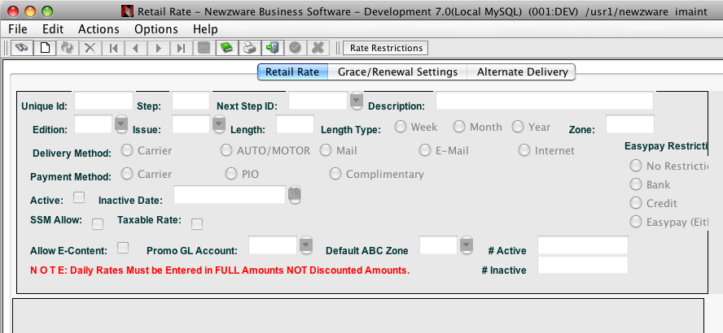

There are many factors that determine whether or not a rate will appear in the selection box for a new or existing subscriber. Let’s examine the first of two forms that are used in the new start process.

New Start By Zip Code

The new start by zip code form is utilized by sites that would like to offer subscription rates based on a subscriber’s zip code. This form first prompts for a zip code and then queries the Newzware database to determine which rates are available. The table used in this form is a table linked off of the Retail Rates screen. Query a rate and then click the Rate Restrictions button. The following screen is shown:

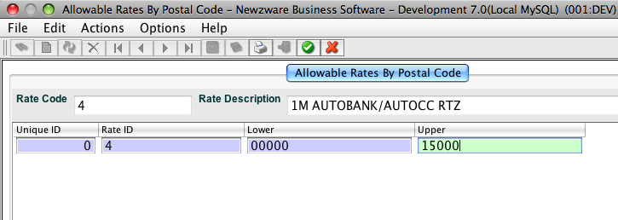

This is where rates can be linked to zip code ranges. An upper and lower range can be assigned to a rate id. The screen will launch with the current retail rate being viewed in the Retail Rate screen. To add Rate Restrictions, click add and enter the rate code into the rate id field and enter a lower and upper zip code limit into the columns marked lower and upper. The picture indicates a lower value of 00000 and an upper value of 15000. If a user enters a zip code of 10000 into the new start by zip form, rate id 4 would be shown in the selection box of available rates. NOTE: This rate is only available if the SSM Allow checkbox is checked for the rate id entered into the Rate Restrictions. Let’s take a look at the new start by zip form.

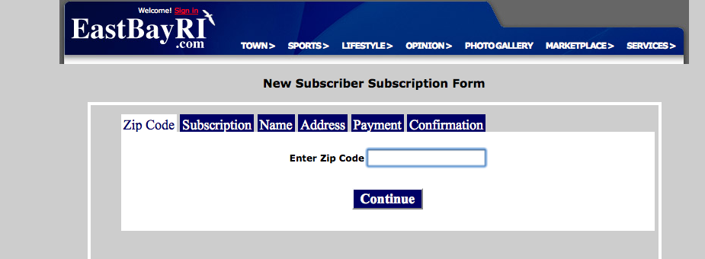

When the zip code is entered and the Continue button is clicked, rates are selected from the query and the following screen is shown:

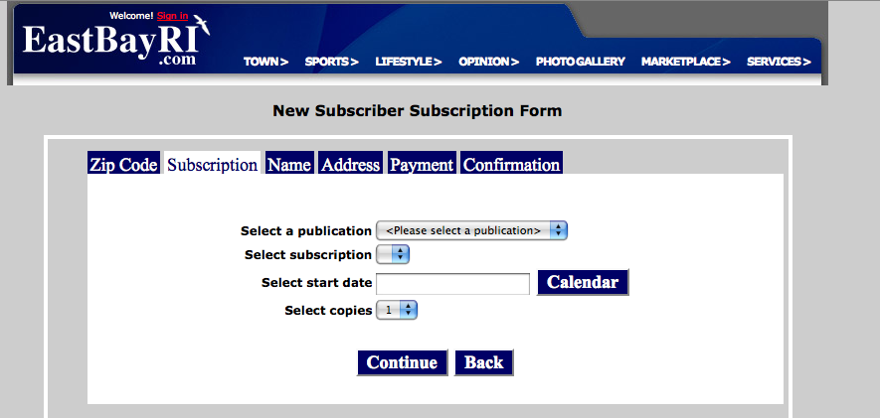

The user then selects the publication, which then filters the rate selections and presents a selection box containing all the valid rates for that zip code/edition combination. The start date is then selected and the number of copies. The next step is the entering of the user address and personal information. Once that is completed, the payment screen is shown.

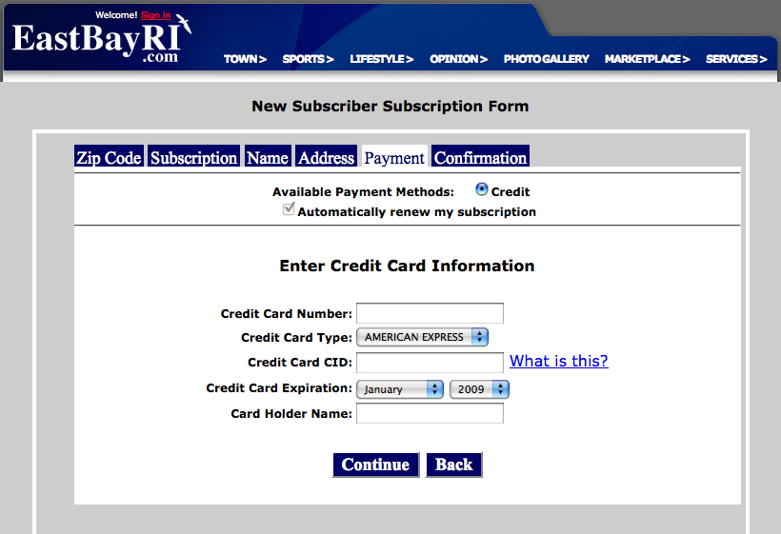

Available options for payment are shown according to the configuration of the SSM and the rates. Bank, Credit and Bill me options are available and can be configured further by a properties file that can be edited within the SSM Administrator (More on this later). Once the payment information is entered, a confirmation screen is shown.

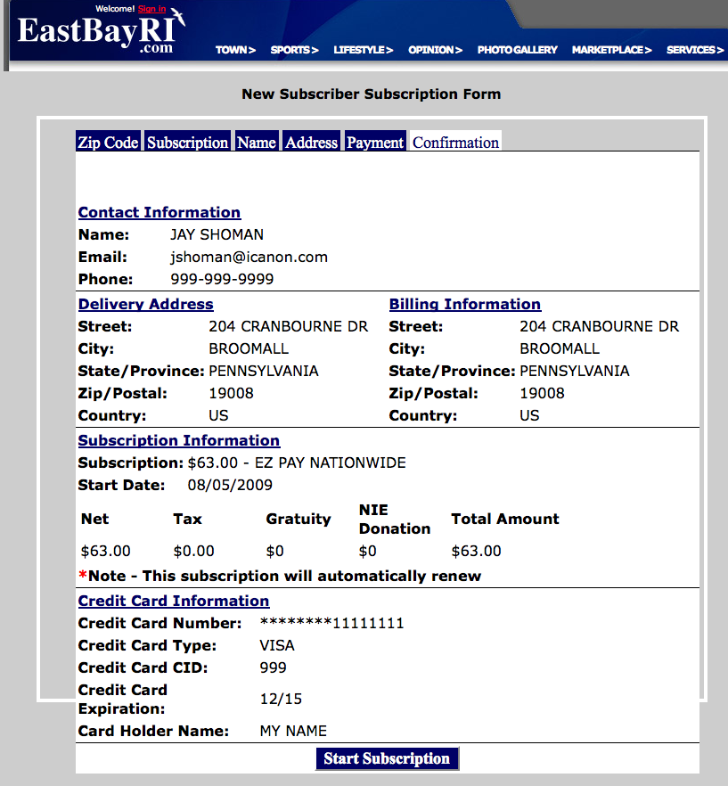

The user will then click the Start Subscription button and the new start will be entered into the Newzware database.

New Start By Address

The new start by address form takes the user’s address and checks to see if the address can be routed by checking the Newzware routing wheel. The Newzware routing wheel can be found under the Circulation Tab. Navigate to Master File / Table Maintenance Table Maintenance Carrier Routing Information Routing Wheel Table. This screen links street segments with a route. For more information on how to use this screen, please refer to the Circulation Manual or contact an ICANON engineer.

After an address is entered and the Continue button is clicked, the address is cleaned by an address cleaning program (If installed) and the address segments are checked against the entries in the routing wheel table. If a route cannot be found in the routing wheel table for the address entered, the program considers this user to be a mail subscriber. Based on the route check, the appropriate rates are queried. If the address is routed, carrier delivered rates are shown in the rate selection list. If the address cannot be routed, mail rates are shown in the rate selection list. The difference between the zip code form and the address form is the direct linking of zip codes to rates. In the new start by address form, there is no direct link to a rate. The SSM Allow checkbox, the rate delivery type and the routing wheel determine what rates are shown in the rate selection box. The other difference is the first screen that the user is shown. In the case of the new start by address form, the following screen is shown first. The rest of the process is the same as the zip code form. The next screen shown is the subscription selection which includes the edition selection and associated rates, along with a date and number of copies.

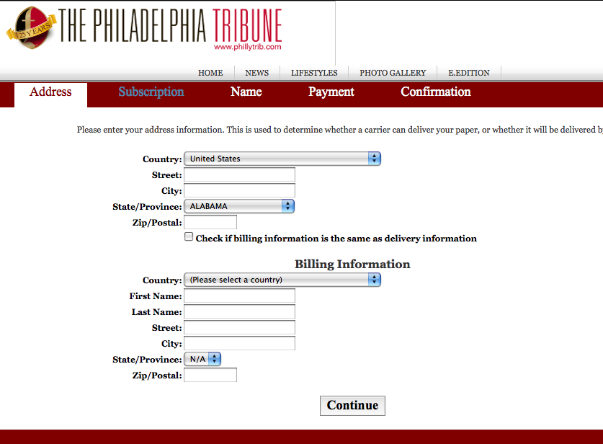

Subscription Details

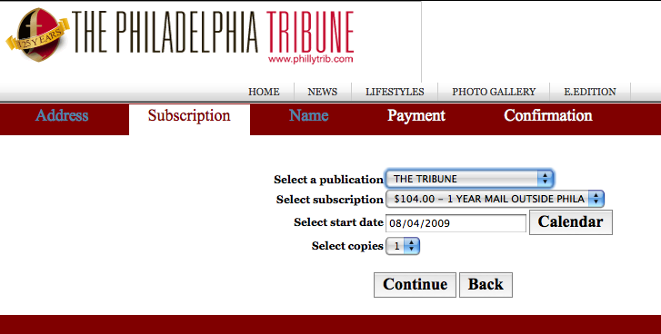

After a user enters their personal information, the payment screen is shown. The type of payment options available are based on configurations in the SSM. If an EZ Pay Credit Card Rate is selected, only the credit card option is available. Based on the rate selected, different payment options can be available.

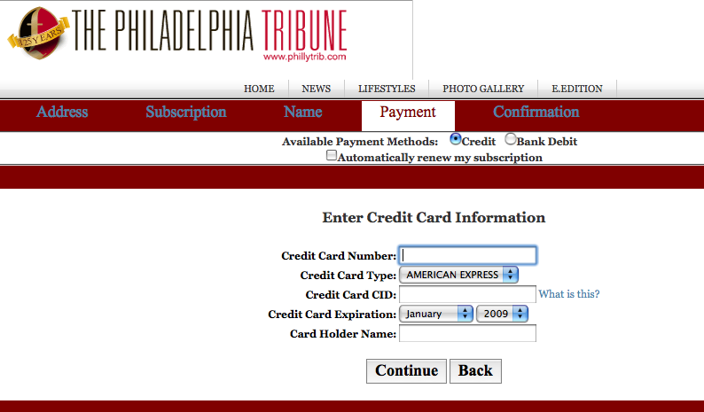

Payment Options

The payment options are controlled by the retail rate definitions available in the retail rate screen. Let’s look at the retail rate screen (Found at Master File / Table Maintenance Table Maintenance Rate and Tax Tables Retail Rates.

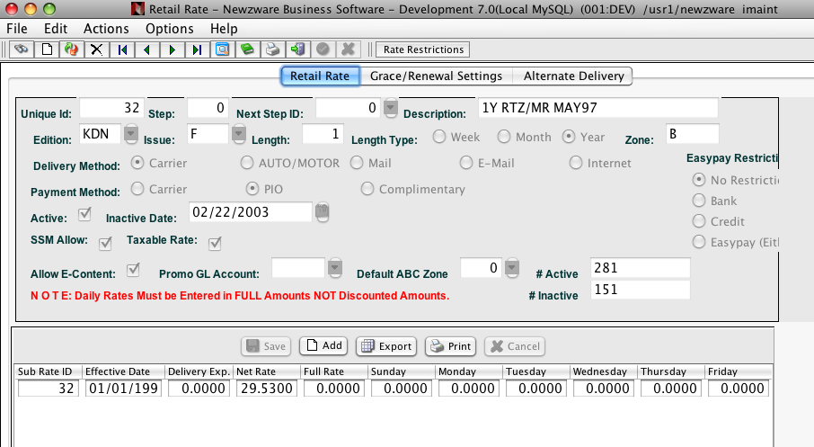

The retail rate fields that the SSM queries, are the edition field, delivery method field and the SSM Allow checkbox, along with the Easy Pay Restrictions options. These four fields determine which rates are queried and available for possible selection and what payment type options are displayed. The type of payment is shown based on the Easy Pay Restrictions field. An easy pay restriction value of Bank will show only the bank debit option. The easy pay restriction value of Credit will only show the credit card option. The easy pay restriction value of Easy Pay will show both the credit card and bank debit option. If the easy pay restriction option is Bank, Credit or Easy pay, the automatic renew check box is automatically checked and disabled. The easy pay restriction value No Restriction allows for a definition to be declared in the SSM property file. For example, you can define No Restriction as Credit. This would show the payment type of credit and the automatic renew checkbox would be enabled to allow the user to opt in or out of the automatic renew process. This type of Easy Pay Restriction is desired if the site does not want to restrict the automatic renewal of the subscription.

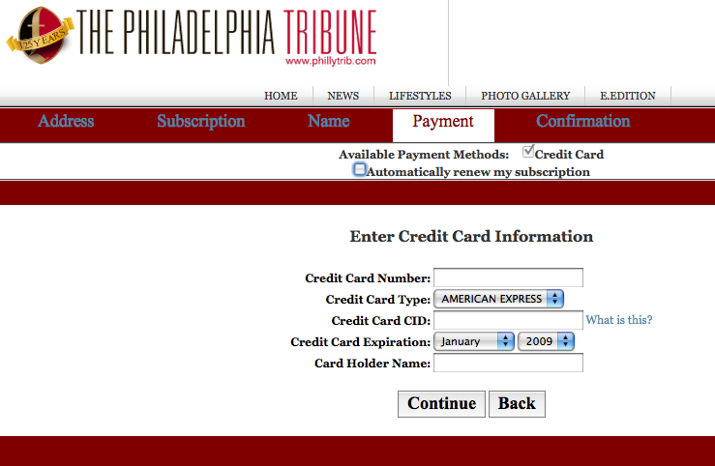

The above shows a No Restriction rate defined as credit card in the property file. The file property looks like the following:

## The no_restriction property is used to determine which easy pay value to use for rates that have
## no restriction, type "N"
no_restriction=C

If the rate selected in the Subscription tab had an Easy Pay Restriction of C,B, or E, the Automatically renew my subscription checkbox would have been automatically checked and disabled.

After the payment information is entered the confirmation page is shown and the subscription is then started.

New Start Processed

After a new start is processed an optional email can be sent with an activation link. If this option is turned on, the activation link must be clicked if the subscription is to be processed. This validates the email that the user has entered and confirms that a valid attempt at a subscription start was made. This option can be turned off. When the option is on, a transaction is entered and can be viewed under the Transaction tab in Customer Service for the new subscriber account that has a Status of Pending. This Pending status will be updated to Not Processed once the user clicks on the activation link. Once the status is Not Processed, calculate draw will activate the Not Processed start transaction on the transaction date specified. If the option is turned off, the status will be Not Processed and will be activated once the calculate draw is run for the transaction date specified.

Chapter 3 – Self Service Module (SSM)

This chapter will describe the functionality inside the Self Service Module. Let’s begin with the login screen.

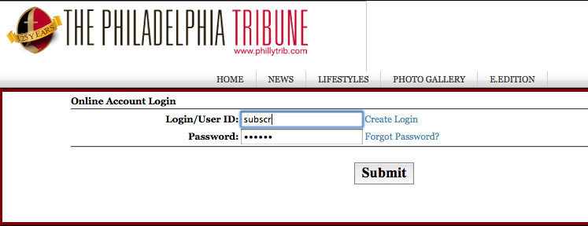

As seen above, the login screen contains links to create a new login for existing subscribers, a Forgot Password link that will attempt to obtain a password from either a security question or account number and a Submit button that will log the user into the SSM. Existing subscribers should use the Create Login link to create their online account. If a new person wants to start a new subscription (has never been a subscriber), the new start form should be where this person is directed. The new start forms are solely for individuals who wish to start an account with your newspapers. It is not intended for existing subscribers. Existing subscribers can start another subscription to another edition by creating an online account and using the new subscription link inside the SSM to start a new subscription. Every page can be customized using the SSM Administrator tool, which will be discussed later. Let’s look inside the SSM. The first page that is shown is the Account maintenance area.

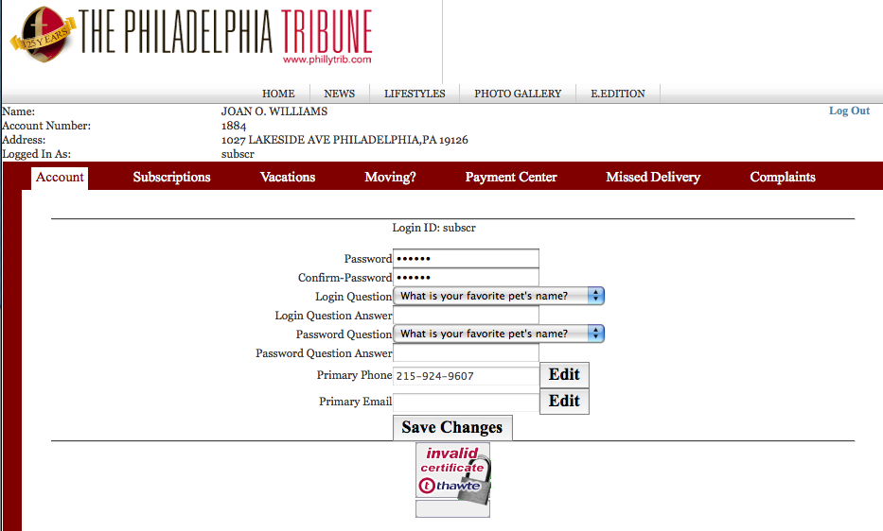

The account maintenance area contains buttons to edit email addresses, phone numbers and change passwords and security questions and answers. The next tab is the Subscriptions tab. All changes made are in real time and can be viewed in Customer Service immediately.

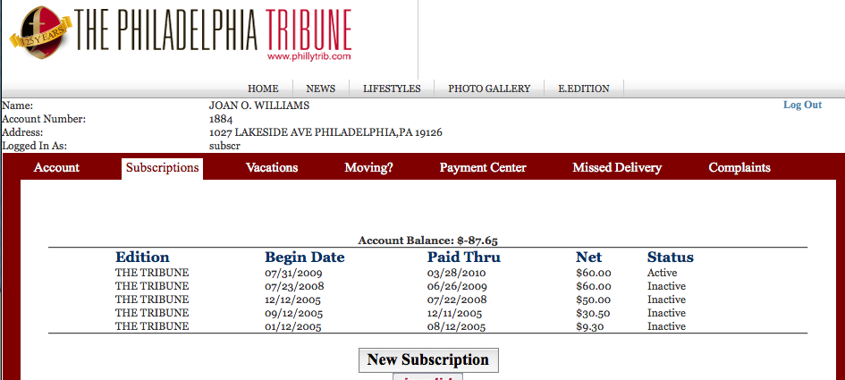

The Subscriptions tab displays the subscription history and permits a subscriber subscribe to a new publication. If a subscriber clicks the New Subscription button, the new start form is loaded. If the subscriber is already subscribed to all publications, a message is displayed indicating all possible publications are already subscribed to. Only publications not already subscribed to will be available. The address is not re-entered because the account is passed to the new start form and all the relative information is already in the database. This shortens the new start process for existing subscribers.

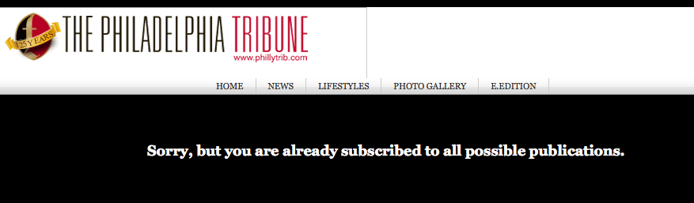

The next tab is the Vacation tab. The vacation screen lets a user view and add vacations for subscriptions. Like the account maintenance area, all changes are viewable in the Customer Service screen under the Vacations tab. Let’s look at the screen.

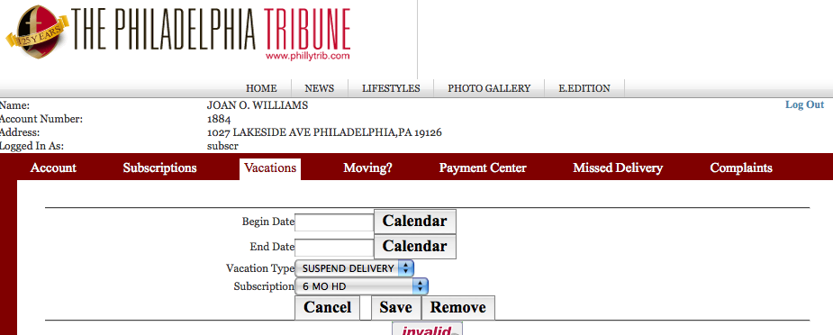

The next tab is the move screen. Very similar to the vacation screen and does the same processing as a move from Customer Service. Here is a look at the move screen.

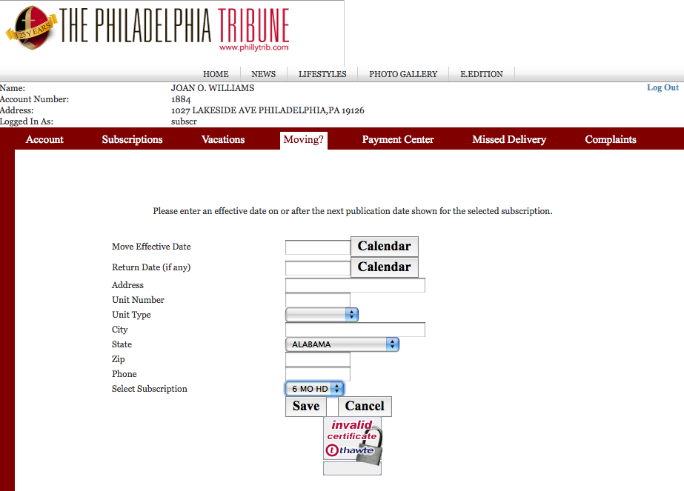

The next tab is the Payment Center tab. This screen has the same functionality as Customer Service’s Easy Pay screen. Subscribers can make a one time payment and/or opt into the Easy Pay automatic renewal process. For one time payments, the payment amount is calculated based on the current retail rate of the subscription selected. A confirmation screen is presented to the user after either choice is made and the continue button is clicked. The screen snapshots are below.

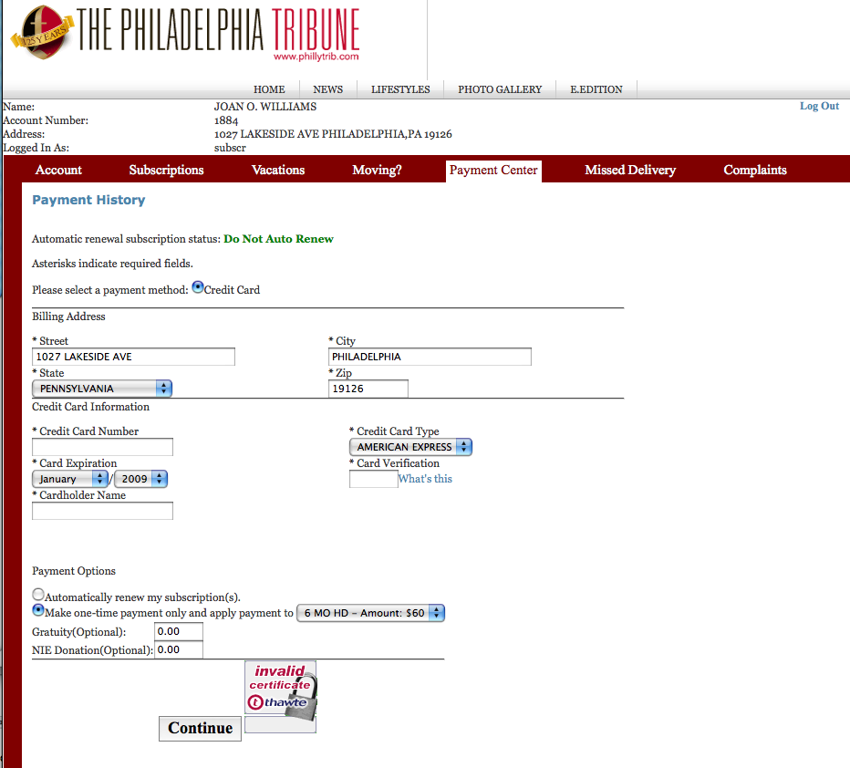

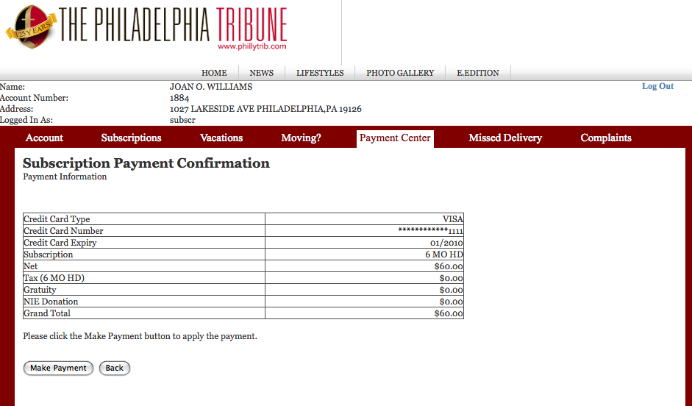

Once the Make Payment button is clicked, the payment is applied. If a real time credit card processing is configured with the Newzware application, a real time sale is done. The payment is applied in Newzware when the credit card batch is settled at the end of the day. If a real time credit card processor is not present, a one time payment is entered into the system and when the easy pay process is run, the payment is picked up and bundled into the credit card file for downstream processing through third party vendor software.

The remaining tabs are for Missed Deliveries and Complaints. Both are entered into the Newzware database in real time. Complaints are entered using the transaction date of the next publication date for the subscription selected. Alternate remarks can be made within both screens.

Automatic Login Processing

The SSM contains logic to automatically log a user into the SSM when passed the login id and password as parameters in the request. The following are examples on how to automatically log a user into the SSM and direct them to a specific tab inside the SSM.

*************************************************************

As straight links

*************************************************************

To go into billing. Make a payment

https://<NEWZWARE WEB SERVER>/ss70/common/login.jsp?site=SITE&login_id=LOGIN&password=PASSWORD&task=billing&action=billing_view&module=sub

To go into the account maintenance.

https://<NEWZWARE WEB SERVER>/ss70/common/login.jsp?site=SITE&login_id=LOGIN&password=PASSWORD&task=account&action=account_view&module=sub

To go into the vacation maintenance.

https://<NEWZWARE WEB SERVER>/ss70/common/login.jsp?site=SITE&login_id=LOGIN&password=PASSWORD&task=vacation&action=vation_view&module=sub

To go into the move maintenance.

https://<NEWZWARE WEB SERVER>/ss70/common/login.jsp?site=SITE&login_id=LOGIN&password=PASSWORD&task=move&action=move_view&module=sub

To go into the missed deliveries.

https://<NEWZWARE WEB SERVER>/ss70/common/login.jsp?site=SITE&login_id=LOGIN&password=PASSWORD&task=missed&action=missed_view&module=sub

To go into the complaint page.

https://<NEWZWARE WEB SERVER>/ss70/common/login.jsp?site=SITE&login_id=LOGIN&password=PASSWORD&task=complaint&action=complaint_view&module=sub

****************************************************************

Embedded as a form

****************************************************************

To go into the account maintenance.

<form name='frm' method='post' action='https://<NEWZWARE WEB SERVER>/ss70/common/login.jsp'>
<input type='hidden' name='site' value='SITE'>
<input type='hidden' name='login_id' value='LOGIN'>
<input type='hidden' name='password' value='PASSWORD'>
<input type='hidden' name='task' value='account'>
<input type='hidden' name='action' value='account_view'>
</form>

To go into the billing maintenance.

<form name='frm' method='post' action='https://<NEWZWARE WEB SERVER>/ss70/common/login.jsp'>
<input type='hidden' name='site' value='SITE'>
<input type='hidden' name='login_id' value='LOGIN'>
<input type='hidden' name='password' value='PASSWORD'>
<input type='hidden' name='task' value='billing'>
<input type='hidden' name='action' value='billing_view'>
</form>

To go into the vacation screen

<form name='frm' method='post' action='https://<NEWZWARE WEB SERVER>/ss70/common/login.jsp'>
<input type='hidden' name='site' value='SITE'>
<input type='hidden' name='login_id' value='LOGIN'>
<input type='hidden' name='password' value='PASSWORD'>
<input type='hidden' name='task' value='vacation'>
<input type='hidden' name='action' value='vacation_view'>
</form>

To go into the move screen

<form name='frm' method='post' action='https://<NEWZWARE WEB SERVER>/ss70/common/login.jsp'>
<input type='hidden' name='site' value='SITE'>
<input type='hidden' name='login_id' value='LOGIN'>
<input type='hidden' name='password' value='PASSWORD'>
<input type='hidden' name='task' value='move'>
<input type='hidden' name='action' value='move_view'>
</form>

To go into the missed delivery screen

<form name='frm' method='post' action='https://<NEWZWARE WEB SERVER>/ss70/common/login.jsp'>
<input type='hidden' name='site' value='SITE'>
<input type='hidden' name='login_id' value='LOGIN'>
<input type='hidden' name='password' value='PASSWORD'>
<input type='hidden' name='task' value='missed'>
<input type='hidden' name='action' value='missed_view'>
</form>

To go into the complaints screen

<form name='frm' method='post' action='https://<NEWZWARE WEB SERVER>/ss70/common/login.jsp'>
<input type='hidden' name='site' value='SITE'>
<input type='hidden' name='login_id' value='LOGIN'>
<input type='hidden' name='password' value='PASSWORD'>
<input type='hidden' name='task' value='complaint'>
<input type='hidden' name='action' value='complaint_view'>
</form>

Chapter 4 – Self Service Module (SSM) Administrator

The Self Service Administrator is an SSM customization tool. Inside the SSM Administrator, many pages can be edited and customized. The general tab layout of the SSM cannot be altered. This is the template. But all pages inside the SSM as well as the new start pages are their own html files. A web developer can view all these files through the SSM Administrator. This chapter will go through the Administrator and explain in detail each of the features and the general practice to updating or changing your production SSM site.

Like the SSM, there is a login. The login and password is provided by an ICANON Associate, or a system administrator can create the user through the User Maintenance screen described above. When creating a user through the User Maintenance screen, the user type of “A” must be entered in the User Type field. This denotes an administrator.

The SSM Administrator is equipped with many hover over hints and descriptions of fields. Please hover over the field labels to get an understanding of what each label represents.

NOTE

When making changes in the SSM Administrator, the changes are made to a test version of the site. Nothing in the production version is changed. A process called Publishing must be done to see the changes in the production site.

Once the administrator is logged in, the following screen is displayed.
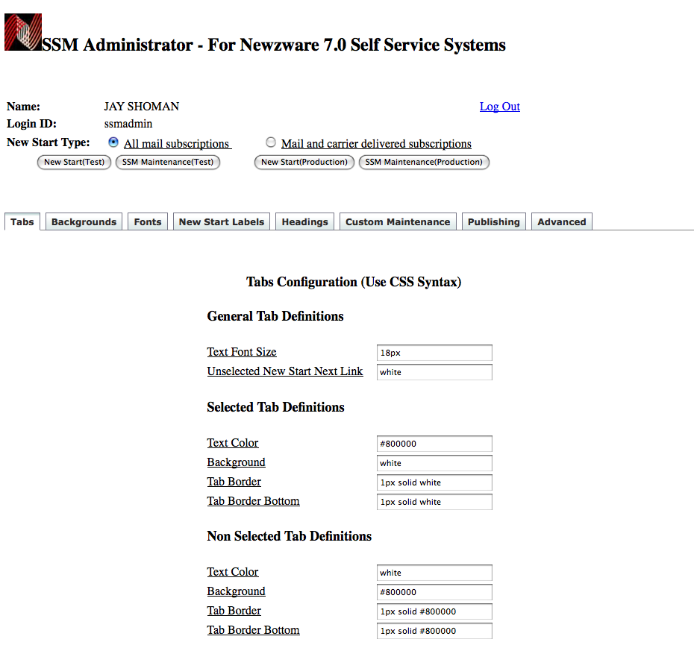

The Tabs tab describe the tab definitions for the tabs in the SSM and the New Start page. Font color and background color can be adjusted here. The next tab is the Backgrounds tab. As indicated by the name, the Backgrounds tab contains fields to change the backgrounds for the SSM and the New Start forms.

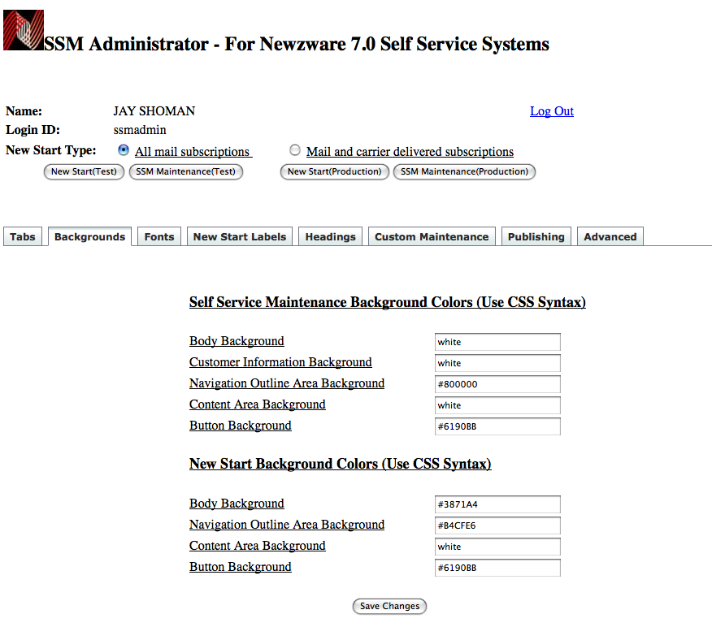
The next tab is the Fonts tab. And yes, it deals directly with fonts. This is the screen where all fonts can be changed. The next tab is the New Start Labels. The New Start Labels is the property file for the New Start form described earlier. This file contains all the wording for the labels used in the New Start Form, along with configuration settings for the SSM application. Please contact an ICANON engineer if the file is being edited for any reason other than changing the labels.

The next tab is the headings tab. The headings tab contains the heading for all the files in the SSM and New Start Form. The text area boxes can contain HTML markup or an include statement. An include statement looks like the following:

|nw_include page = “../custom/mypage.html”|

All files that are uploaded go into the custom directory and the ../custom reference is the relative path to the file. This include reference can be placed inside the heading text area box. This makes editing of the heading much simpler since only file needs to be edited to change the heading on every page.

The next tab is the Custom Maintenance. This is where the administrator can edit, delete and upload new files. In the custom area, there are a couple of files that should catch your attention. Notice the payment files in the select box.

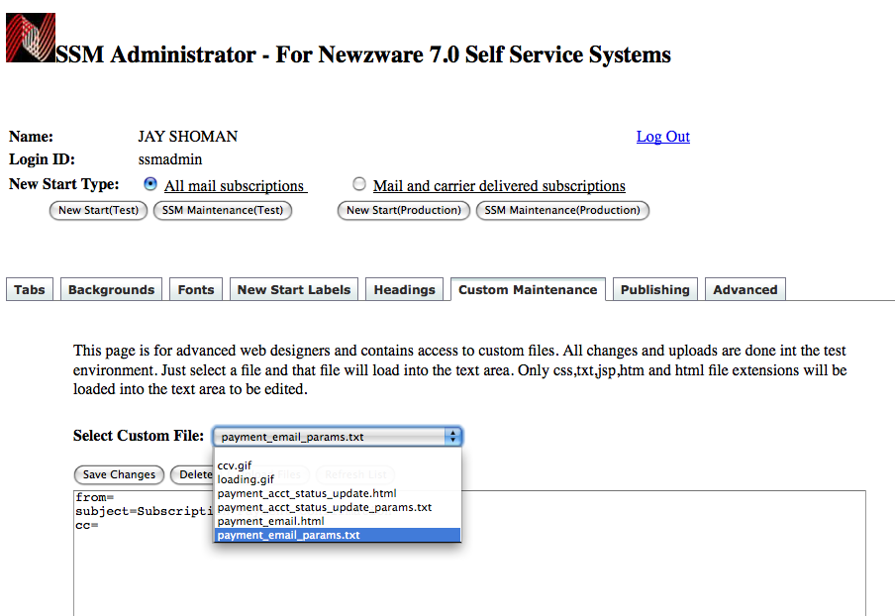

The payment files require a from email address. These files are used when a payment is made inside the SSM.

payment_acct_status_update.html – Sent when the auto renew status or payment information has been updated in the SSM.

Payment_acct_status_update_params.txt – The email parameters used for emailing the status update HTML document.

Payment_email.html - This is sent when a payment is done through the SSM.

Payment_email_params.txt – These are the email parameters that are used for emailing the payment_email.html document.

Publishing

Once all changes are made and the test site looks ok, the administrator can publish the changes to the production site through the Publish tab. Simply click the Publish button to publish all the changes. Every time a publish of the site is done, a backup of the production site is done before the changes are put into place. This allows the administrator to perform a restore of the old version is there is a problem with the new changes. Just click the Restore button to perform the restore.

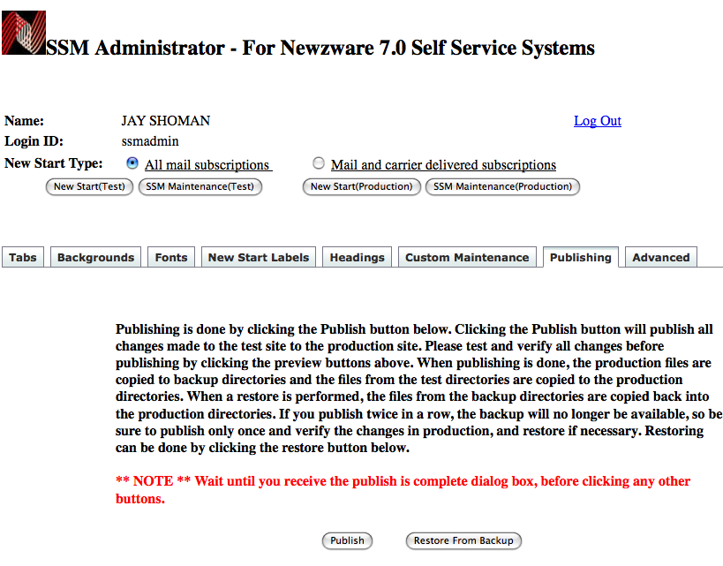

Advanced SSM Administration

The Advanced tab unlocks the philosophy behind all the other tabs and magic. For web developers, this is probably where most changes will be made. The select box contains all the available pages to edit. Once a page is selected, it is loaded in the text area box where it can be edited. Each page has a description that describes the page and what it is adjacent to the select box.

New Start Forms

The new start pages are regular HTML pages that contain many javascript functions. The other pages that are seen during the new start process are described when selected from select box. The following pages are associated with the new start forms.

Subscription Activation Email
No publications available HTML page
New Start By Zip CSS Styles
New Start By Address CSS Styles
Subscription Processed HTML
Subscription Activated HTML
New Start Properties

Other Independent Pages

Login HTML Page
All Forgot Password and Create Account Pages

SSM

The SSM works completely different than the new start forms. Each page in the SSM contains a corresponding properties file that contains the definition of the page. It helps dynamically create table based forms that can have columns added to it by adjusting the properties file. The administrator should not be concerned with how the property file works, but the messages and labels that reside in the property files. Let’s examine the account maintenance view page. This examination will provide a explanation for all the pages that reside in the SSM because all the pages in the SSM operate in the same fashion. Open up the administrator and select the Advanced tab and select the Account View HTML page.

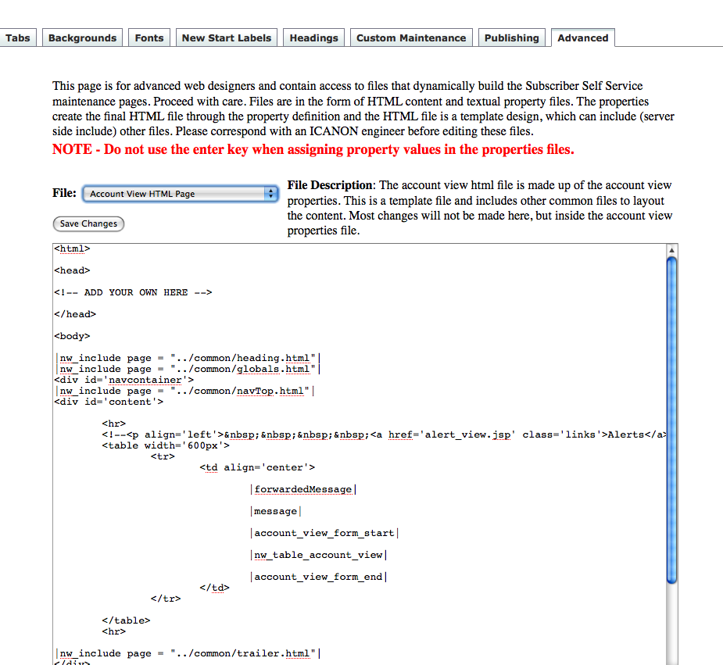

This page is a template. The nw_include tags include external content into the page. Every page in the SSM is an independent page that may or may not include other content. All tags start and end with the “PIPE” symbol ( | ). The SSM reads this file and then reads the associated properties file, Account View Properties in the Select Box (Seen Below)

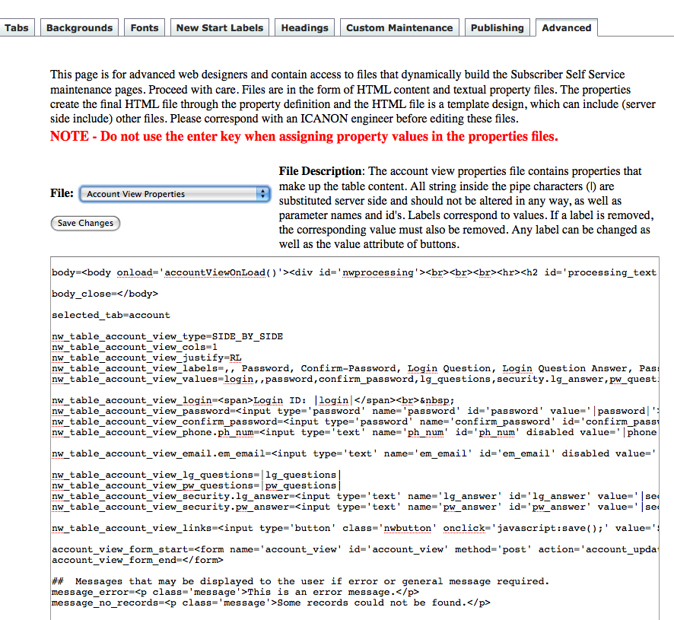

and substitutes the tags with the properties definition. In the above example, the nw_table_acccount_view is the generated table that you see in the document. The nw_table_account_view_labels contain the actual wording of the labels on the page. Notice how the labels directly correspond to a database column identified by the nw_table_account_view_values. Those values are actually the webprofile.web_login column names. The table is then outputted using the nw_table_account_view_type. The SIDE_BY_SIDE definition places the labels and values side by side in a two column output. Again, administrators will most likely not change the look of the table, but the labels for the columns can easily be updated. Just change the Login Question label to Your Security Question. Now the new label Your Security Question will appear in the Account Maintenance area. The message at the bottom are messages that will appear in case of an error or processing circumstance that requires the user to do something different. These messages are completely under your control and can be altered. The property files are not changed when updates are performed to the site. The prior demonstration is how the entire SSM works and each of the pages in the select box under the advanced tag can have independent images and markup. HTML files are not altered during the update process.

CSS

The SSM layout is controlled with style sheets. The main style sheets are parent.css and new_start_address.css and new_start.css. The parent.css controls the SSM pages and the new_start_address.css controls the new start by address form. The new_start.css controls the new start by zip code form. The rest of the style sheets are specific to the page and can be found under the sites installation directory in the css directory.

Preferences

The preferences under the drop down menu for the advanced tab contains the ability to update an administrator’s password and the account the administrator is using to gain access to the SSM. This can also be done in the User Maintenance screen discussed at the beginning of this manual.

Verifying Changes

When changes are made to the SSM test site, they can be viewed by selecting the New Start Type and clicking the button that you want to preview the changes for. For example, if changes were made to the New Start Form then the New Start (Test) button should be clicked to view the changes to the New Start Form in the test site. Likewise, if the changes were made to the SSM, then the SSM Maintenance (Test) button should be clicked to view the changes in the SSM test site. To view the production site, the adjacent buttons that contain the word (Production) should be clicked. The account number specified in the Preferences screen is used to load the correct information and to verify the user. Without an account, the administrator will be denied access to the SSM in both the test and production sites.

