**ECE/CS 5565 PROJECT3**

**Fall 2024**

**Daksh Dave**

**PID: ddave**

Q 1.1

|  |  |  |  |
| --- | --- | --- | --- |
| Router | Interface | Link-Local Address | Global Unicast Address |
| Router1 | eth0 | fe80::a8bb:ccff:fe00:1/64 | 2001:db8:a:1::1/64 |
| Router2 | eth0 | fe80::a8bb:ccff:fe00:2/64 | 2001:db8:a:2::1/64 |
| Router3 | eth0 | fe80::a8bb:ccff:fe00:3/64 | 2001:db8:a:3::1/64 |
| Router4 | eth0 | fe80::a8bb:ccff:fe00:4/64 | 2001:db8:a:4::1/64 |
| Router5 | eth0 | fe80::a8bb:ccff:fe00:150/64 | 2001:db8:a:1::5/64 |
| eth1 | fe80::a8bb:ccff:fe00:250/64 | 2001:db8:a:2::5/64 |
| eth2 | fe80::a8bb:ccff:fe00:35/64 | 2001:db8:a:3::5/64 |
| eth3 | fe80::a8bb:ccff:fe00:450/64 | 2001:db8:a:4::5/64 |

Q 1.2

We analyzed the Global Unicast Addresses (GUAs) for Router1 (eth0), Router2 (eth0), and Router5 (eth0 and eth1). Router1 (eth0) and Router5 (eth0) share the IPv6 prefix 2001:db8:a:1::/64 and the IPv4 subnet 192.168.1.x. Meanwhile, Router2 (eth0) and Router5 (eth1) share the IPv6 prefix 2001:db8:a:2::/64 and the IPv4 subnet 192.168.2.x. This means the connections between Router1 and Router5 are in a separate network from those between Router2 and Router5, with distinct subnets isolating traffic and ensuring efficient routing.

Q 1.3

Interval t = 0 to 1 s:

During this initial period, host1, host2, host3 and host4 send Neighbor Solicitation packets to their respective neigboring routers. The network is in the setup phase, and hosts begin to initialize their interfaces. The "NS" messages (Neighbor Solicitation messages) are part of the IPv6 Neighbor Discovery Protocol. Router1, Router2, Router3 and Router4 are the neigboring routers under the ICMPV6 protocol.

Purpose of NS Messages: These messages are used by hosts to determine the link-layer address of other nodes (e.g., routers) on the same local link or to verify that a neighbor is still reachable. This is crucial for establishing initial communication and populating the neighbor cache.

Q 1.4

Interval t = 2 to 5 s:

Host1, Host2, Host3 and Host4 send NS packets to the respective routers-Router1 to Router5 under ICMPV6 protocol. In this phase, the network transitions to establishing communication between hosts and routers. The "RS" (Router Solicitation) and "RA" (Router Advertisement) messages are exchanged.

Purpose of RS Messages: Sent by hosts to request configuration information from routers. Hosts use RS messages to prompt nearby routers to send RA messages.

Purpose of RA Messages: Sent by routers to provide network configuration information to hosts, such as prefixes, default routes, and other parameters necessary for IPv6 autoconfiguration.

Q 1.5

Interval t = 5 to 6 s:

During this time, routers begin to establish OSPFv3 neighbor relationships by exchanging "Hello" messages.

Purpose of OSPF Hello Messages: These messages are used to discover and maintain neighbor relationships. They help routers identify neighbors on the same network segment and establish the parameters for OSPF communication, such as hello intervals and dead intervals. If routers agree on the parameters, they can become OSPF neighbors and exchange routing information.

Q 1.6

Interval t = 15 to 16 s:

During this phase, routers exchange critical OSPF link-state information to maintain an accurate network topology. The process begins with routers sending OSPF Hello messages, followed by Database Description (DD) packets exchanged between Router1, Router2, Router3, Router4, and Router5 to synchronize their Link-State Databases (LSDBs).

After initial DD exchanges, Router5 compares its LSDB with those of the other routers. If discrepancies are detected, Router5 sends Link State Request (LSR) packets to request the missing or updated information. The neighboring routers respond with Link State Update (LSU) packets, containing the necessary updates. Once Router5 receives these updates, it sends Link State Acknowledgment (LSAck) packets to confirm receipt.

This sequence of DD, LSR, LSU, and LSAck messages ensures all routers maintain a consistent and up-to-date view of the network topology, which is crucial for efficient routing operations.

Q 1.7

The routers are updating each other by sending new OSPF Hello messages approximately every 10 seconds. This was determined by observing the simulation logs, where Hello messages were consistently sent at timestamps such as 5 s, 15 s and so on. The consistent 10-second interval between these messages indicates the configured OSPF Hello interval.

Q1.8

T=25s we could see the TCP connection established and we could see TCPseg packets exchanged between host 1 and host2 through the route given below.

HOST1 <-> ROUTER1 <-> ROUTER5 <-> ROUTER2 <-> HOST2

This is further validated by examining the IPv6 routing table entries for Router1 and Router5 at the end of the simulation.

**Router1**: Destination 2001:db8:a:2::/64 with Next Hop fe80::a8bb:ccff:fe00:150 at 10.10.10.5/101

**Router5**: Destination 2001:db8:a:2::/64 with Next Hop fe80::a8bb:ccff:fe00:200 at 10.10.10.2/102

These destinations align with Router2's Global Unicast Address (GUA), and the Next Hops indicate the connections to Router5 (fe80::a8bb:ccff:fe00:150/10.10.10.5/101) and Router2 (fe80::a8bb:ccff:fe00:200/10.10.10.2/102), respectively.

Q1.9

Q2.1

Q2.2

|  |  |  |  |
| --- | --- | --- | --- |
| Router | Interface | Link-Local Address | Global Unicast Address |
| Router1 | eth0 | fe80::a8bb:ccff:fe00:100/64 | 2001:db8:a:1::1/64 |
| Router2 | eth0 | fe80::a8bb:ccff:fe00:200/64 | 2001:db8:a:1::2/64 |
| Router3 | eth0 | fe80::a8bb:ccff:fe00:300/64 | 2001:db8:a:1::3/64 |
| Router4 | eth0 | fe80::a8bb:ccff:fe00:400/64 | 2001:db8:a:1::4/64 |

Q2.3

<**Router** id=*"Router1"*>

<**Routing6**>

<**OSPFv3**>

<**Process** id=*"100"*>

<**RouterID**>10.10.10.1</**RouterID**>

</**Process**>

</**OSPFv3**>

</**Routing6**>

<**Interfaces**>

<**Interface** name=*"eth0"*>

<**Process** id=*"100"*>

<**Instance** AF=*"IPv6"*>

<**InterfaceType**>Broadcast</**InterfaceType**>

<**Area**>0.0.0.0</**Area**>

</**Instance**>

</**Process**>

<**IPv6Address**>fe80::a8bb:ccff:fe00:100/64</**IPv6Address**>

<**IPv6Address**>2001:db8:a:1::1/64</**IPv6Address**>

</**Interface**>

<**Interface** name=*"eth1"*>

<**Process** id=*"100"*>

<**Instance** AF=*"IPv6"*>

<**InterfaceType**>Broadcast</**InterfaceType**>

<**Area**>0.0.0.0</**Area**>

</**Instance**>

</**Process**>

<**IPv6Address**>fe80::a8bb:ccff:fe00:110/64</**IPv6Address**>

<**IPv6Address**>2001:db8:1::1/64</**IPv6Address**>

</**Interface**>

</**Interfaces**>

</**Router**>

Q2.4

HOST1 <-> ROUTER1 <-> ETHERNETSWITCH <-> ROUTER2 <-> HOST2

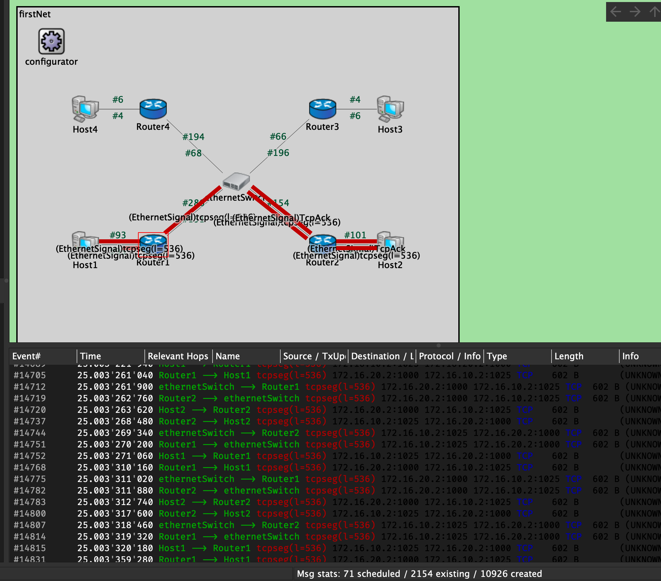

T=25s we could see the TCP connection established and we could see TCPseg packets exchanged between host 1 and host2 through the route given below.

Q2.5

Q3.1

a)Message Type: Hello Packet (1)

b)(multicast/broadcast)

c)192.168.121.4

d)255.255.255.0

e)10s

f)2 active neighbours- Active Neighbor: 192.168.255.11, Active Neighbor: 192.168.255.15

Q3.2

a)Message Type: LS Update (4)

b)(unicast)

c)Advertising Router: 192.168.255.11

**4. Summary**:

No problems were encountered during the execution of this project