Lists and Iteration

OVERALL TASK: Create a program that takes several names and grades, stores them in lists and then allows users to add, remove or search the lists. Aim to allow the user to repeat the program and edit the lists as many times as they would like. Can you make it give the maximum value, average and range?

If you are feeling confident, don’t feel you must keep reading. Use the rest of this sheet as help if you get stuck!

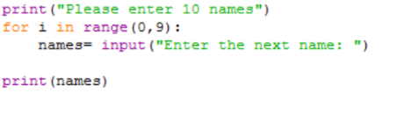Often in programming you need to allow a user to input multiple values. Try the following code and see what happens…

What is printed after the program runs? __ _________

We need a way of storing all of the names that the user has typed in one variable name otherwise we would have to just write 10 lines of inputs with 10 different variable names!

For this reason, python has LISTS (In fact, all programming languages have LISTS but most of them call them ARRAYS).

Variables can only store one value at a time.

Lists can store multiple items and can be edited. Each item in a list has its own address called an INDEX. For the program above, we will use a list called names and it will store all of the names and each name will have an address:

Name 1

Name 2

Name 3

Name 4

Name 5

Name 6

Name 7

Name 8

…

0

1

3

4

5

2

6

7

What do you notice about the address in comparison to the names?

_____

**Task 1**

Edit your code to look like the following.

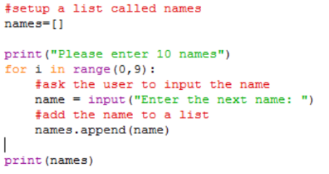

What has changed with this program?

____ _________

How many names did you enter? ___________

Find the mistake and change it to allow the user to input 10 names?

**Task 2**

Add three lines of code to your program. Use comments to help you figure out where to place them.

1. Create a new list called ‘grades’
2. Ask the user to input a grade
3. Add (append) the grade to your list

Test the program works by adding a PRINT function to display the entered grades.

**Task 3**

Earlier, you created a program that used IF…ELIF…ELSE.

After the for loop, ask the user if they would like to add a student and a grade, remove a student and a grade or exit the program. Use the following pseudocode to structure your program. NOTE: the **correct** syntax for removing items has been included.

INPUT user_answer

IF user_answer == “add” THEN

INPUT new_name

INPUT new_grade

LIST append new_name

LIST append new_grade

ELIF user_answer == “remove” THEN

INPUT name_remove

names.remove(name_remove) #this will remove the name given

ELSE

OUTPUT “Thanks for using my program”

**Task 4**

What happens to the grade list when you remove a name? ________________________________

To keep both lists working together, we will need to make sure we delete the grade with the same address (INDEX) as the name that was deleted. Can you fit the following two pieces of code into the program to get the index of the name and then delete the grade at that address?

1. **address = names.index(name)** this will get the address of a name and store it in ‘address’
2. **del grades[address]** this will use the index stored in address to delete the correct grade from the grades list

If you get really stuck, go on to task 5.

**Task 5**

Using the example while loop below can you get the code to do two different loops?

1. Loop one, ask to repeat the program.
2. If the user adds or removes and item, ask them if they want to add or remove anything else.

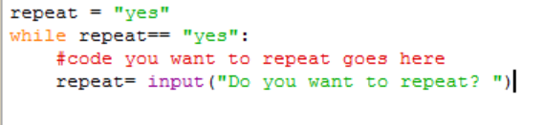

**Task 6**

Play around with the code to make it better. Here are some ideas:

1. Where the user is asked if they want to add or remove an item, can you add a search function in to find a student’s grade?

HINT: IF name in names THEN

1. What happens if the user types a name that isn’t in the list? Can you use a while loop in to ask them to try again?

HINT: while name not in names:

1. Can you create a formula to find the average of the grades?

HINT: loop through list, total += grade

**Extension:**

Can you make the program find the maximum grade?