Installation

For this application, we will be using XAMPP v.3.2.2. The installer can be downloaded from this link. <https://www.apachefriends.org/index.html>. Run through the application.  
  
Next, copy the quiz folder into the htdocs folder. On windows, the default installation path of xampp is C:/xampp/htdocs/. Paste the whole quiz folder inside the htdocs folder.

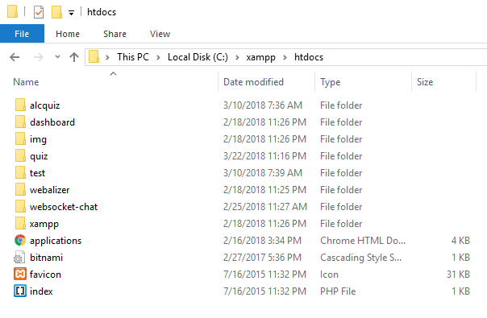

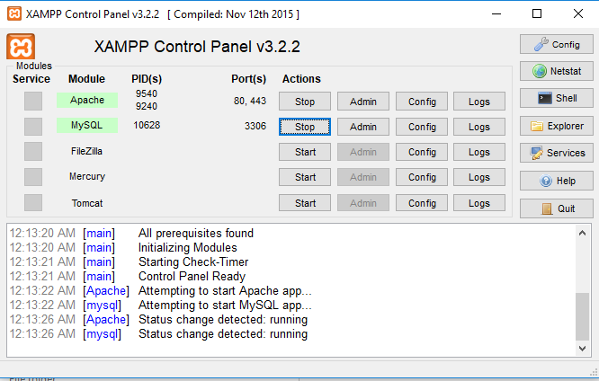After copying the quiz files, run the XAMPP application and start the Apache and MySQL servies.

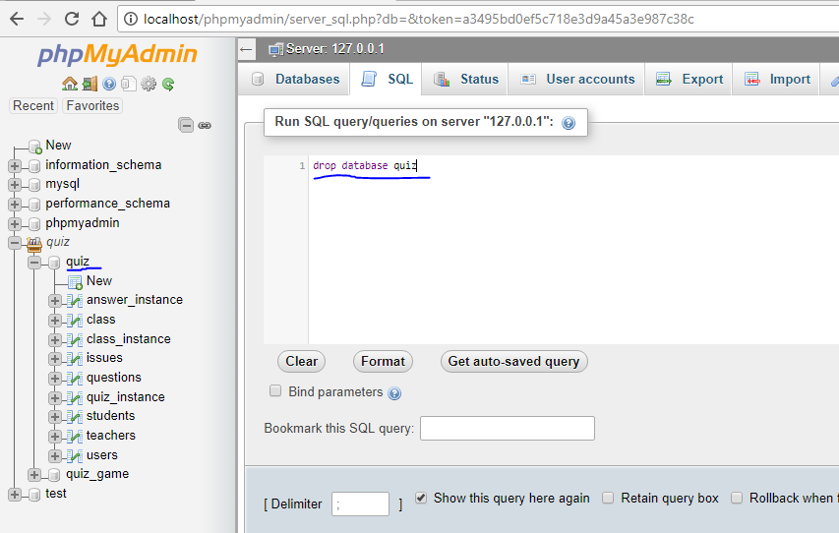We need to make sure that the setup runs smoothly, so we will delete any database instance named quiz. Open up a browser and access localhost/phpmyadmin. Then, execute the SQL command “DELETE DATABASE quiz”;

After deleting the quiz database, open another browser. This time, access localhost/quiz. If the deletion is successful, you should be welcomed with an initial setup for the admin account and the system.

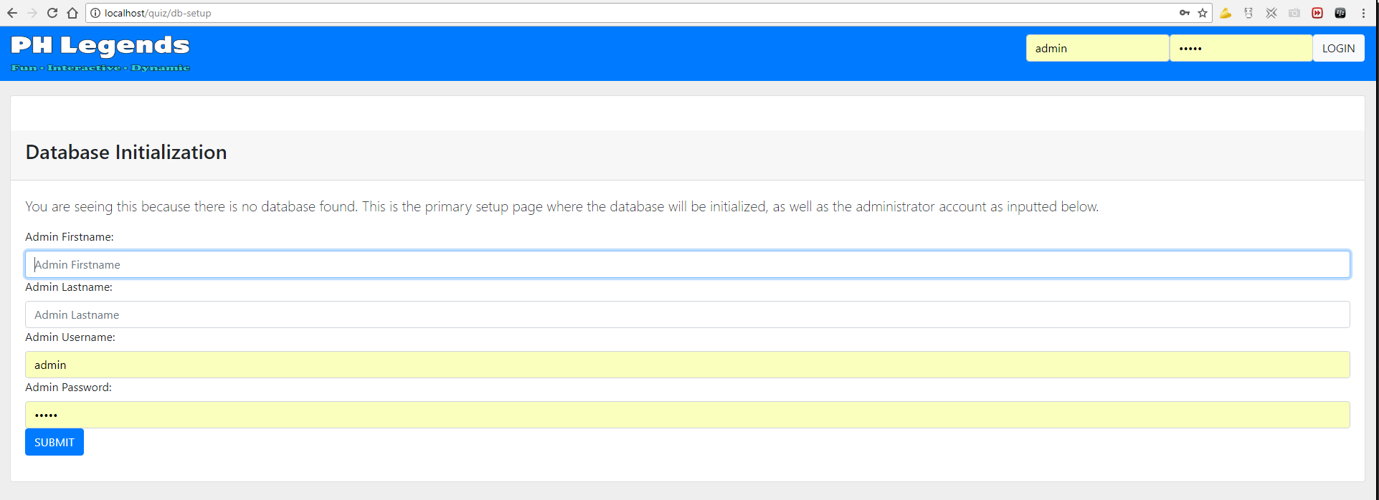Enter the required fields and press submit. This will take you to the index page of the system. Initially, only the admin account is available, and it will be used in creating a teacher account.