Socioeconomic Factors Associated with ACT Scores

Abstract
This project investigates how socioeconomic factors are associated with average student ACT scores. We analyzed 7,857 school observations through exploratory data analysis (EDA), simple linear regression and multiple linear regression models to investigate relationship between five socio-economic factors and ACT scores. The resulting analysis showed that percentage of student participation in free or reduced-price lunch had the strongest negative relationship with average school ACT scores. While unemployment rate and college attainment were also statistically significant, other predictors like median household income and percentage of students from married household were not statistically significant in predicting average school ACT score. The multiple linear regression model explained approximately 61.8% of observed variation in ACT scores.
Overall, the analysis shows that socioeconomic factors are strongly associated with school average ACT scores/academic performance of students.

Introduction
The American College Testing (ACT) exam is a standardized test used by U.S. colleges and universities to assess college readiness. The exam historically evaluated English, Mathematics, Reading, and Science, with scores ranging from 1 to 36 (Harland, 2026). Socioeconomic conditions, including household income, educational attainment, employment, and family structure, may be associated with differences in academic achievement. Understanding these relationships can help identify potential educational disparities.
This study investigates the association between five socioeconomic factors and school-level average ACT scores: free/reduced-price lunch participation, unemployment rate, adult college attainment, median household income, and the percentage of children living in married-couple families.
Data were obtained from EdGap, which provides school-level ACT scores and socioeconomic predictors, and the National Center for Education Statistics (NCES), which provides school characteristics, including charter status, school type, and location. The datasets were merged using school identifiers, invalid values were addressed, missing predictor values were imputed, and schools without ACT scores were excluded. The final dataset contains 7,857 records for schools offering grade 12.
For the linear regression analysis, this study focused on the following key questions:
- How is free or reduced-price lunch participation (lunch participation) associated with average ACT scores?
- Which socioeconomic factors remain statistically significant with ACT scores when all five numerical predictors are considered?
- Is lunch participation (reduced price lunch participation) the strongest predictor of average ACT scores among the five socioeconomic variables?
- Does charter school status remain associated with average ACT scores after adjusting for socioeconomic factors?
Exploratory data analysis, simple linear and multiple linear regression were used to help us answer our research questions.

Theoretical Background
Existing research suggests that socioeconomic conditions are associated with differences in educational achievement. According to the American Psychological Association (2017), socioeconomic status is related to academic performance and educational progress. Socio economic characteristics like household income, employment status, family dynamics as well as students’ participation in free or reduced-price lunch can serve as important indicators or socio-economic inequalities among students.
Linear regression will be used as core statistical framework by which we examine relationships between various predictors and our dependent variable. Simple linear regression model will be used to analyze relationship between one predictor and average ACT scores. Multiple linear regression models will be used to investigate relationship between average ACT scores and multiple predictors. Multiple regression allows us to identify if there are relationships between multiple socioeconomic predictors.

Methodology

About Data
The primary datasets were obtained through Canvas LMS as part of the DATA 5100 course. The EdGap dataset contains school average ACT scores as well as socioeconomic variables. School information dataset contains various categorical information about the schools referenced in the EdGap dataset.

Data Preparation
The data preparation process involved importing, investigating, cleaning, and merging the EdGap and school information datasets. Relevant variables were selected and renamed using consistent naming conventions. The datasets were merged using the school id, and missing values and potentially invalid numerical observations were investigated.
Observations with missing ACT scores were removed, while missing numerical predictor values were imputed using “IterativeImputer”, with predefined minimum and maximum bounds to maintain data validity. The resulting dataset contains 7,857 schools and 14 numerical and categorical variables, with no missing values in the selected analytical variables. The prepared data were exported as “education_final.csv” for exploration data analysis and regression modeling.

Exploratory Data Analysis
Exploratory data analysis was conducted using descriptive statistics and data visualizations to investigate distributions and potential relationship among various variables. Primarily histograms and boxplots were used to investigate distributions, central tendency, skewedness and outliers. Additionally, pair plots were used to access relationship between numerical variables. Finally, correlation analysis was conducted to investigate linear relationship among numerical predictors and average ACT scores.

Regression Analysis
Simple linear regression was conducted to investigate the relationship between lunch participation and average ACT scores. Multiple linear regression was used to analyze all numerical socio-economic predictors. Additionally, a categorical variable, charter status of school was used to analyze relationship to average ACT scores. Finally, we compared our regressions models using R-squared, Mean Absolute Error (MAE) and Root Mean Squared Error (RMSE).

Computational Results
Free/reduced-price lunch participation demonstrated the strongest negative association among the five socioeconomic predictors. The simple regression model explained approximately 60.5% of the observed variation in ACT scores, while the multiple regression model explained 61.8%. Unemployment rate, adult college attainment, and lunch participation were statistically significant predictors, whereas median household income and family structure were not significant after adjusting for other socioeconomic factors.
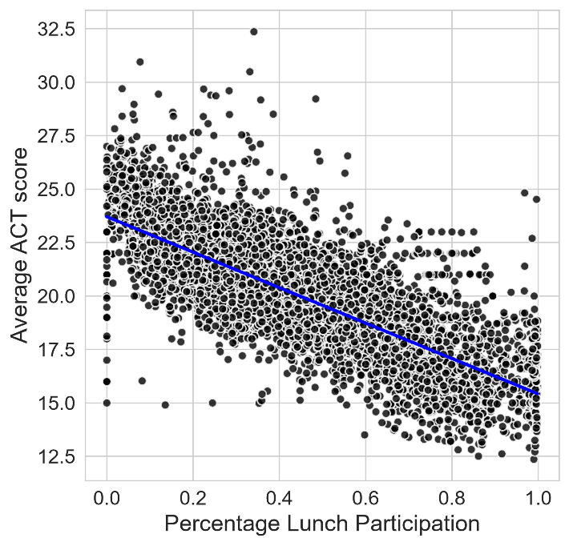
Figure: The figure above shows the relationship between lunch participation and school average ACT score. Blue line represents fitted regression.
Charter-school status was statistically significant in the unadjusted model but was no longer significant after accounting for socioeconomic predictors. Among the four models compared, the reduced three-predictor model (M3), consisting of unemployment rate, adult college attainment, and lunch participation, provided a reasonable balance between simplicity and explanatory performance, with results nearly identical to the full five-predictor model. Overall, the findings highlight strong associations between socioeconomic conditions and academic achievement, particularly lunch participation, although these observational relationships do not establish causation.
Four regression models were evaluated using the same 7,641 schools. The following table summarizes their performance.
Model | R_squared | Adjusted_R2 | MAE | RMSE
M1: Lunch Only | 0.6049 | 0.6048 | 1.1968 | 1.5924
M2: Five Predictors | 0.6177 | 0.6175 | 1.1743 | 1.5663
M3: Three Predictors | 0.6177 | 0.6175 | 1.1746 | 1.5664
M4: Three + Charter | 0.6178 | 0.6176 | 1.1749 | 1.5661
Table: Comparison of performance of regression models.

Discussion
The results show that socio-economic factors have a strong association with average ACT score of students. Free or reduced priced lunch participation showed the strongest negative relationship among the 5 predictors evaluated. In simple linear regression, a 10 percentage-point increase in lunch participation was associated with approximately 0.83 points decrease in predicted average ACT scores. This relationship between average ACT score and lunch participation remained statistically significant during multiple regression analysis using all numerical predictors. Additionally, removing lunch participation from the multiple regression model reduced model performance with R-squared value dropping from .618 to .295. Unemployment rate and college attainment rate were also statistically significant. However, median household income and percent married were not statistically significant. Charter status of school showed statistical significance when evaluated using simple linear regression. However, the relationship was no longer significant after adjusting to other socioeconomic variables with p-value of 0.100. With an R squared value of .618, the three-predictor model which included unemployment rates, percent lunch participation, and adult college attainment explained about 61.8% of variation in ACT scores. Residual quantile-quantile (QQ) plots showed deviation in both tails from normal distribution. This indicates some larger prediction errors.

Conclusion
This study analyzed how socio-economic factors are associated with academic performance of students measured through average school ACT scores. The exploratory data analysis and regression analysis found that percentage of students participating in free or reduced lunch program was the strongest predictor among five socioeconomic factors examined in this report. The relationship was negative in that as the percentage of lunch participation increases, school average ACT score decreases.
The findings show the importance of socio-economic conditions in assessing disparities in student performance. These findings may help educators, lawmakers and other stakeholders identify schools and communities experiencing socioeconomic disadvantages. Such insights could guide decisions about where additional educational support and resources may be needed.

References
American Psychological Association. (2017). Education and Socioeconomic Status. https://www.apa.org/pi/ses/resources/publications/education
Harland, A. (2026). What is the act? format, scoring, and cost in 2026. Crimson Education. https://www.crimsoneducation.org/us/blog/what-is-the-act

