Precipitation patterns in Seattle, WA and Charlotte, NC
This project compares historical weather data from Seattle and Charlotte with a focus on precipitation. The analysis compared precipitation frequency, seasonal variations, as well as overall precipitation to answer the following questions:
- Does Seattle receive more precipitation than Charlotte?
- Does Seattle experience more days with precipitation than Charlotte?
- When there is precipitation, how does the precipitation total differ?

Data
This project utilizes dataset downloaded from National Centers for Environmental Information by NOAA. Daily summaries were extracted for timeframe between January of 2018 to December of 2022.

Methods Used
This analysis used exploratory data analysis to visualize and analyze precipitation in Seattle and Charlotte. The analysis reviewed how precipitation changed by month. Additionally, the analysis also compared the proportions of days with rain. Finally, statistical tests were performed to find if the differences measured between the two cities are meaningful.

Findings
As far as amount of precipitation is concerned, based on the analysis, Charlotte receives more average daily precipitation than Seattle.
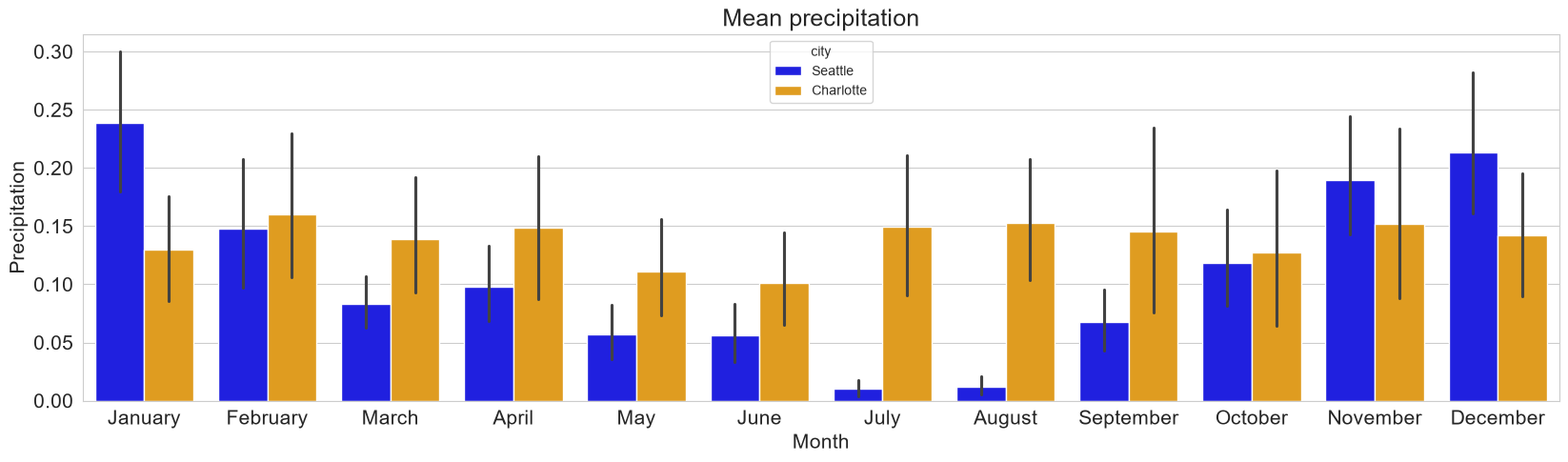
The chart above shows for majority of year, which means daily precipitation in Charlotte is higher than mean daily precipitation in Seattle.

However, if we look at the proportions of days with precipitation, Seattle receives more precipitation days than Charlotte.
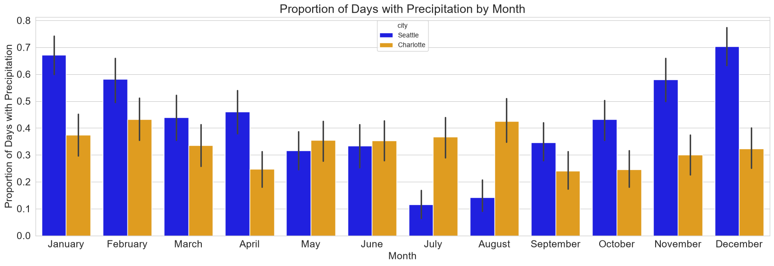
This chart shows that Seattle has a higher proportion of rainy days during most months, especially in the fall and winter.
Charlotte has fewer rainy days in many months, but earlier results showed higher mean precipitation in several months. This suggests that Seattle tends to experience precipitation more frequently, while Charlotte may receive more precipitation when rain does occur.
Additionally, Seattle's precipitation is influenced by seasonal differences where they experience wet/dry patterns. Charlotte, however, has a more consistent seasonal pattern.

Conclusion
Based on the analysis of precipitation data for 5 years from Seattle and Charlotte, we come to the following conclusions:
- Charlotte had higher average daily precipitation compared to Seattle.
- Seattle experienced precipitation higher proportions of days than Charlotte.
- Charlotte’s precipitation was evenly distributed through the year with less pronounced seasonal pattern.
- Seattle experiences a seasonal pattern with wet fall, winter, and spring. Summer months are much drier.

