1. Introduction
This report constitutes the architecture design and training approach of the Artificial Neural Network (ANN) to be created to predict customer churn. The prediction of customer churn is presented as a binary classification problem in which the model predicts whether a customer is a likely penalty of a service. The dependent variable takes the value of 0 (retained customer) and 1 (churned customer). The main goal of ANN model is to attain a high predictive accuracy and strong generalisation capacity and resistance to overfitting.

2. Input configuration and data preprocessing Data Preprocessing and Input Configuration.
Before developing the model, the data was subjected to various processes of preprocessing in order to make it work best. The categorical variables were coded in numerical form and all the features were standardised using the feature scaling techniques. Standardisation ensures input variables have mean of zero and a standard deviation of one which enhances the stability of the gradient and increases the rate of convergence of the model.
The ANN input layer was declared based on:
The input layer is directly proportional to the number of preprocessed features of the dataset. This will make sure that every feature will play its role in the learning process. The input layer does not use any activation function since it has the role of transferring scaled feature values to the network.

3. Hidden Layer Architecture
The ANN model comprises of three fully connected hidden layers that are aimed at modelling intricate nonlinear relationships in the data. The architecture is designed in progressive dimensional reduction fashion (512 to 256 to 128 neurons), and thus allows hierarchies to be learned.
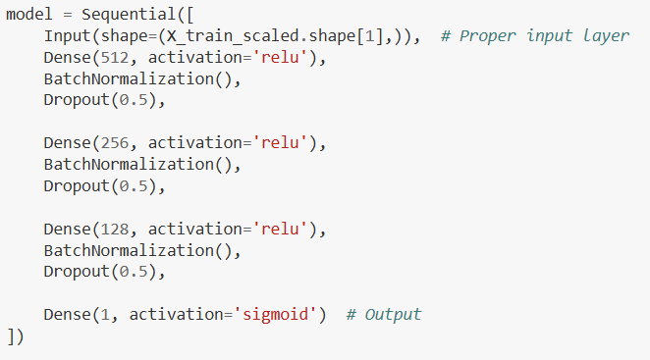

3.1 First Hidden Layer
The initial hidden layer has 512 neurons that have a Rectified Linear Unit (ReLU) activation function. ReLU was chosen because it is more efficient in its computation and it addresses vanishing gradient problem. The activation is normalised with Batch Normalization, which is implemented in the dense layer following it. This is followed by a Dropout layer with a rate of 0.5 which randomly switches off half of the neurons in the course of the training in order to reduce overfitting and enhance generalisation.

3.2 Second Hidden Layer
The second layer is a hidden layer that has 256 neurons and ReLU activation. Like the initial concealed layer, Batch Normalization and Dropout (0.5 rate) are implemented. This layer fines and compresses the learned representations in the previous layer, allowing the network to concentrate on the most significant interactions of features with each other and be robust.

3.3 Third Hidden Layer
The third hidden layer consists of 128 neurons that activate ReLU, and then there is Batch Normalization and Dropout (0.5 rate). The layer also further abstracts high-level patterns that are learnt based on customer attributes. The reduction of the number of neurons in the layers enhances efficient learning of representation and lowers the complexity of computations and maintains predictive performance.

4. Output Layer
Output layer is a single neuron whose activation function is Sigmoid:
The output is transformed to a probability ranging between 0 and 1 by the Sigmoid function, which is the probability of the customer churn. A classification level of 0.5 is used to transform the predicted probabilities into binary class label.

5. Model Compilation
The optimisation algorithm used to compile the model was the Adam optimisation algorithm in which the learning rate was set to 0.0001:
Adam optimizer was chosen because it has an adaptive learning rate mechanism, which improves the rate of convergence and convergence stability. The loss objective employed is Binary Crossentropy that suits binary classification issues and calculates the disparity between forecasted likelihood and genuine marks. The main metric of evaluation in the training was accuracy.

6. Regularisation and Optimisation Techniques.
A number of methods were applied to increase the robustness of models and avoid overfitting. To stabilise the distribution of activations and gradient flow, Batch Normalization was added after every hidden dense layer. Second, Dropout layers of rate 0.5 were used to decrease the dependence on a particular group of neurons and improve the performance of generalisation.
Early Stopping was also used to avoid overfitting: Training is terminated in case the validation loss has not decreased in 20 epochs in a row, and the best weights are automatically restored. Besides, class weights were used during the training process to solve the problem of class imbalance in churn prediction. Given that churn datasets have a smaller number of churned customers compared to the remaining, class weighting makes sure that the model assigns more weight to samples of minor classes.

7. Model Training Procedure
The ANN model was trained with the following set-up:
- Epochs: 100
- Batch size: 32
- Data used to validate: X test scale and y test.
- Class weights applied
- Early stopping enabled
The following resources were used in the training process: Training loss and validation loss were observed during training to measure the convergence and generalisation performance.

8. Architectural Justification
The large initial layers (512 neurons) of the deep architecture enables the model to understand complex patterns of customer behaviour. A gradual downsizing of the dimensions enhances computational performance and preserves predictive accuracy. The combination of the Batch Normalization, Dropout, Early Stopping and Class Weighting make the model to be able to generalise to unseen data and avoid overfitting and class-imbalance problems.
The ANN architecture is generally optimised to predictive performance, stability and scalability in actual customer churn prediction applications.

