The Waterfall model is one of the earliest and simplest Software Development Life Cycle (SDLC) models. It is a linear and sequential approach where each phase mustsca be completed before the next one begins, and there is no overlapping of phases. The model is called "Waterfall" because it flows steadily downwards like a waterfall through several phases.

**Phases of the Waterfall Model**

1. **Requirement Analysis:**
   * In this phase, all the requirements of the software to be developed are gathered from the client or stakeholders. This includes understanding the scope, objectives, and constraints of the project.
   * **Example:** For developing an e-commerce website, requirements might include user registration, product catalog, shopping cart, payment gateway, order tracking, etc.
2. **System Design:**
   * Based on the requirements gathered, the system design is prepared. This helps in specifying hardware and system requirements and also helps in defining the overall system architecture.
   * **Example:** Designing the architecture for the e-commerce website, including the database schema, application framework, user interface design, etc.
3. **Implementation:**
   * With the system design in place, the actual source code is written for each component. This phase involves coding and unit testing by developers.
   * **Example:** Developers start coding the user registration module, product catalog, shopping cart functionality, payment integration, etc.
4. **Integration and Testing:**
   * After coding, all the individual units are integrated into a complete system and tested for any faults or bugs. This phase ensures that the entire system works according to the specified requirements.
   * **Example:** Testing the integration of user registration with the shopping cart, ensuring that the payment gateway processes transactions correctly, etc.
5. **Deployment:**
   * Once the system is tested and verified, it is deployed to the production environment where it can be used by the end-users.
   * **Example:** The e-commerce website is launched on a web server and made accessible to users.
6. **Maintenance:**
   * After deployment, the system enters the maintenance phase. This includes fixing any issues that arise, making enhancements, and ensuring the system continues to operate smoothly.
   * **Example:** Providing support for any bugs reported by users, updating the website with new features, ensuring security patches are applied, etc.

**Example: Developing an Online Banking System**

1. **Requirement Analysis:**
   * Gather requirements from the bank for features such as user authentication, account management, funds transfer, bill payments, transaction history, etc.
2. **System Design:**
   * Design the system architecture including databases for storing user and transaction data, user interfaces for online banking, and security protocols.
3. **Implementation:**
   * Developers start coding modules for user login, account management, transaction processing, etc.
4. **Integration and Testing:**
   * Integrate all modules and conduct thorough testing to ensure the online banking system is secure, reliable, and performs all required transactions accurately.
5. **Deployment:**
   * Deploy the online banking system on the bank's servers and make it available to customers.
6. **Maintenance:**
   * Monitor the system for any issues, provide regular updates, and ensure the system remains secure and efficient.

**Advantages of the Waterfall Model**

* **Simplicity:** The model is easy to understand and use.
* **Structured Approach:** Each phase has specific deliverables and a review process.
* **Documentation:** Extensive documentation is produced at each phase.
* **Early Detection of Issues:** Problems can be identified early in the development process.

**Disadvantages of the Waterfall Model**

* **Inflexibility:** Changes in requirements can be difficult to accommodate once the process is underway.
* **Late Testing:** Testing is only done after implementation, which can lead to late discovery of issues.
* **Unsuitability for Complex Projects:** It is less effective for large, complex, or long-term projects where requirements might evolve over time.

The Waterfall model is best suited for projects with clear, fixed requirements and where the technology is well understood. It is less suited for projects where requirements might change or are not well understood from the beginning.

**E-commerce Website Development**

Let's consider the development of an e-commerce website using the Waterfall model to highlight these disadvantages:

1. **Requirement Analysis:**
   * Initially, requirements are gathered based on market analysis and stakeholder inputs.
   * However, during the later stages of development, new trends in e-commerce (e.g., voice search, AI-based recommendations) emerge, but the Waterfall model does not easily allow incorporating these new features.
2. **System Design:**
   * A comprehensive design is created based on initial requirements.
   * As the project progresses, the design might need changes to integrate new technologies or address unforeseen technical challenges, but going back to modify the design is cumbersome and costly.
3. **Implementation:**
   * Developers start coding based on the fixed design.
   * Midway through development, competitors launch new features that customers now expect. Adapting the system to include these features would require significant rework, which the Waterfall model does not easily support.
4. **Integration and Testing:**
   * The entire system is integrated and tested after implementation.
   * Major bugs and usability issues are found during this phase. Fixing these requires significant changes in code, which could have been identified and resolved earlier with incremental testing.
5. **Deployment:**
   * The website is deployed, but due to the time taken to complete the project, some features are already outdated or irrelevant.
   * Users start providing feedback, revealing several usability issues that were not anticipated.
6. **Maintenance:**
   * Post-deployment, fixing issues and adding new features is costly and complex due to the rigid structure of the initial development process.
   * The system requires continuous updates to stay competitive, but the Waterfall model's approach makes these updates difficult to manage.

**Summary**

The Waterfall model is most effective for projects with well-understood, stable requirements and short timelines. Its disadvantages, particularly in flexibility, user involvement, and iterative testing, make it less suitable for projects where requirements are expected to evolve or where user feedback and incremental improvements are crucial.

Scrum is an agile framework for managing and completing complex projects. It provides a structured yet flexible approach to project management, focusing on delivering value incrementally and iteratively. Scrum is particularly popular in software development but can be applied to various fields.

### Key Concepts in Scrum

1. **Roles:**
   * **Product Owner:** Responsible for defining the features of the product and prioritizing the work in the Product Backlog. The Product Owner represents the stakeholders and the voice of the customer.
   * **Scrum Master:** Ensures that the Scrum process is followed, removes impediments, and facilitates team meetings. The Scrum Master acts as a coach for the team, helping them to use Scrum effectively.
   * **Development Team:** A cross-functional group of professionals who do the actual work of developing the product. The team is self-organizing and decides how to accomplish the work set by the Product Owner.
2. **Artifacts:**
   * **Product Backlog:** A prioritized list of all the work that needs to be done on the project. Items in the backlog can include features, bug fixes, technical work, or knowledge acquisition.
   * **Sprint Backlog:** A list of tasks the team commits to completing during the current sprint. It is derived from the Product Backlog and is chosen by the Development Team during the Sprint Planning meeting.
   * **Increment:** The sum of all the Product Backlog items completed during a sprint, combined with all previous increments. It represents a complete and potentially shippable product.
3. **Events:**
   * **Sprint:** A time-boxed period (typically 2-4 weeks) during which the team works to complete the selected items from the Sprint Backlog.
   * **Sprint Planning:** A meeting at the beginning of each sprint where the team discusses what they can deliver in the upcoming sprint and how they will achieve it.
   * **Daily Scrum:** A short, daily meeting (usually 15 minutes) where team members synchronize their work and plan the next 24 hours. Each member answers three questions: What did I do yesterday? What will I do today? Are there any impediments?
   * **Sprint Review:** A meeting at the end of the sprint where the team demonstrates the work completed to the stakeholders and discusses what went well, what didn’t, and what can be improved.
   * **Sprint Retrospective:** A meeting after the Sprint Review where the team reflects on the past sprint and identifies areas for improvement.

### Example of Scrum in Action: Developing a Mobile Banking App

1. **Product Owner:**
   * Defines the features for the mobile banking app, such as account management, transaction history, fund transfer, bill payments, etc.
   * Prioritizes these features in the Product Backlog based on business value and stakeholder input.
2. **Sprint Planning:**
   * The team meets to select the highest-priority items from the Product Backlog that can be completed in the upcoming 2-week sprint.
   * The selected items are moved to the Sprint Backlog, and the team discusses the tasks needed to complete them.
3. **Sprint:**
   * Over the next two weeks, the Development Team works on the items in the Sprint Backlog, holding Daily Scrum meetings to synchronize their efforts and address any blockers.
   * Example tasks could include designing the user interface for the login screen, implementing the backend for fund transfers, or testing the transaction history feature.
4. **Sprint Review:**
   * At the end of the sprint, the team presents the completed features to stakeholders, demonstrating the functionality of the login screen, fund transfer, and transaction history.
   * The stakeholders provide feedback, which is then added to the Product Backlog for future consideration.
5. **Sprint Retrospective:**
   * The team reflects on what went well during the sprint, such as successful integration of new tools, and what didn’t go as planned, like challenges in testing.
   * They identify areas for improvement, such as better estimation techniques or improved communication channels, and agree on actionable steps to implement in the next sprint.

### Advantages of Scrum

* **Flexibility:** Scrum allows for changes in project requirements, accommodating new priorities and adjustments based on feedback.
* **Improved Quality:** Regular reviews and increments ensure continuous testing and refinement, leading to higher-quality products.
* **Increased Transparency:** Frequent communication and stakeholder involvement enhance transparency and collaboration.
* **Higher Productivity:** The team is empowered to self-organize and focus on delivering value in short, manageable sprints, improving productivity and morale.

### Disadvantages of Scrum

* **Requires Experience:** Teams new to Scrum may struggle with its practices and principles, leading to implementation challenges.
* **Scope Creep:** Without careful management, frequent changes and additions can lead to scope creep.
* **Intensive Collaboration:** The need for constant communication and collaboration can be demanding, especially for distributed teams.
* **Dependence on Commitment:** Scrum relies on the commitment and discipline of all team members, which can be a challenge if not everyone is equally engaged.

Scrum's iterative approach, focus on collaboration, and adaptability make it a powerful framework for managing complex projects and delivering high-quality products incrementally.

Agile is a set of principles and practices for software development that emphasizes flexibility, collaboration, and customer satisfaction. It is designed to accommodate change and deliver value quickly and efficiently. Agile methodologies are characterized by iterative development, where requirements and solutions evolve through the collaborative effort of cross-functional teams.

### Key Principles of Agile

1. **Customer Satisfaction:** Deliver valuable software continuously, with a preference for shorter timescales.
2. **Welcome Change:** Embrace changing requirements, even late in development, to provide competitive advantage.
3. **Frequent Delivery:** Deliver working software frequently, ranging from a couple of weeks to a couple of months.
4. **Collaboration:** Business stakeholders and developers must work together daily throughout the project.
5. **Support and Trust:** Build projects around motivated individuals, giving them the environment and support they need and trusting them to get the job done.
6. **Face-to-Face Communication:** The most efficient and effective method of conveying information within a development team is face-to-face conversation.
7. **Working Software:** Working software is the primary measure of progress.
8. **Sustainable Development:** Promote sustainable development, maintaining a constant pace indefinitely.
9. **Technical Excellence:** Continuous attention to technical excellence and good design enhances agility.
10. **Simplicity:** The art of maximizing the amount of work not done is essential.
11. **Self-Organizing Teams:** The best architectures, requirements, and designs emerge from self-organizing teams.
12. **Reflect and Adjust:** At regular intervals, the team reflects on how to become more effective, then tunes and adjusts its behavior accordingly.

### Agile Frameworks and Practices

1. **Scrum:**
   * **Roles:** Product Owner, Scrum Master, Development Team.
   * **Artifacts:** Product Backlog, Sprint Backlog, Increment.
   * **Events:** Sprint, Sprint Planning, Daily Scrum, Sprint Review, Sprint Retrospective.
2. **Kanban:**
   * **Visualize Work:** Use a Kanban board to visualize tasks and workflow.
   * **Limit Work in Progress (WIP):** Restrict the number of tasks in progress to improve focus and efficiency.
   * **Manage Flow:** Continuously monitor and improve the flow of work.
   * **Continuous Improvement:** Regularly review processes and make incremental improvements.
3. **Extreme Programming (XP):**
   * **Practices:** Pair programming, test-driven development (TDD), continuous integration, refactoring, and collective code ownership.
   * **Values:** Communication, simplicity, feedback, courage, and respect.
4. **Lean:**
   * **Principles:** Eliminate waste, build quality in, create knowledge, defer commitment, deliver fast, respect people, and optimize the whole.
   * **Practices:** Value stream mapping, pull systems, continuous improvement.

### Example of Agile in Action: Developing a Mobile Health Tracking App

1. **Initiation and Planning:**
   * **Kickoff Meeting:** The project begins with a kickoff meeting where the team discusses the overall vision, goals, and initial requirements for the health tracking app.
   * **User Stories:** The Product Owner creates user stories that describe features from the user's perspective, such as "As a user, I want to track my daily steps so that I can monitor my fitness progress."
2. **Iterations (Sprints):**
   * **Sprint Planning:** The team meets at the beginning of each sprint (typically 2 weeks) to select the highest-priority user stories from the Product Backlog and commit to completing them during the sprint.
   * **Daily Standups:** The team holds daily standup meetings to discuss progress, plan the day, and address any impediments.
   * **Development and Testing:** Developers and testers work collaboratively to implement and test the features. Pair programming and test-driven development (TDD) are commonly used practices.
   * **Sprint Review:** At the end of the sprint, the team demonstrates the completed features to stakeholders and gathers feedback.
   * **Sprint Retrospective:** The team reflects on the sprint to identify what went well, what didn’t, and how to improve in the next sprint.
3. **Continuous Feedback and Improvement:**
   * **User Feedback:** After each sprint, the team collects feedback from users and stakeholders, which is used to refine the Product Backlog.
   * **Iterative Development:** The process repeats, with the team continuously iterating on the product, adding new features, and improving existing ones based on feedback.

### Advantages of Agile

* **Flexibility:** Agile accommodates changes in requirements, even late in development.
* **Customer Satisfaction:** Frequent delivery of working software ensures that customers receive value early and continuously.
* **Collaboration:** Regular communication and collaboration among team members and stakeholders lead to better outcomes.
* **Transparency:** Continuous feedback and regular reviews provide transparency into the project's progress and direction.
* **Quality:** Emphasis on testing and technical excellence results in higher quality products.

### Disadvantages of Agile

* **Requires Discipline:** Agile practices require strong discipline and commitment from the entire team.
* **Scope Creep:** Without proper management, frequent changes can lead to scope creep.
* **Less Predictable:** The iterative nature of Agile can make it difficult to predict timelines and budgets accurately.
* **Documentation:** Agile focuses more on working software than comprehensive documentation, which can be a challenge for some projects.

Agile methodologies, by emphasizing flexibility, collaboration, and iterative development, provide a powerful framework for managing complex projects and delivering high-quality products that meet customer needs.

IDOR: (Insecure Direct Object references)

IDOR stands for Insecure Direct Object Reference. It's a vulnerability in web applications that arise from weak access control. Here's a breakdown of what it means:

* **Insecure:** Data or resources are not being protected properly.
* **Direct Object:** This refers to something specific within the application, like a user account, a file, or a record in a database. It's accessed directly using an identifier.
* **Reference:** The way the application refers to that specific object. This could be a user ID number in a URL, a filename, or an internal reference number.

An IDOR vulnerability happens when an attacker can manipulate the references to access objects they shouldn't have permission to see. Imagine a web application that lets you view your bank account information using a unique account ID in the URL. An IDOR vulnerability would exist if someone could change the ID in the URL to see someone else's account information.

Here are some common ways IDOR attacks happen:

* **Predictable IDs:** If IDs are simply sequential numbers, it might be easy for an attacker to guess the ID of another user.
* **Missing authorization checks:** The application might not check properly if a user is authorized to access the data they are requesting based on the reference.

IDOR vulnerabilities can be serious because they can allow attackers to access sensitive data, like financial information or personal records. They can also be used to perform actions they shouldn't be authorized for, like deleting files or modifying data.

There are several ways to mitigate IDOR vulnerabilities and protect your web application. Here are some key strategies:

* **Implement Strong Access Control:** This is the core defense. Always verify a user's permissions before granting access to any resource. This should be done on the server-side, not relying solely on client-side checks that can be tampered with. Many web frameworks have built-in features to help with access control.
* **Validate User Input:** Don't trust any input coming from the user. Validate all IDs and references to ensure they are in the expected format and don't contain unexpected characters. This helps prevent attackers from injecting malicious code that could manipulate references.
* **Use Indirect References:** Instead of exposing identifiers directly in URLs or forms, consider using more complex, random, and unguessable identifiers. This could include UUIDs (Universally Unique Identifiers) or cryptographically secure random strings. These can be mapped to the actual objects on the server-side.
* **Avoid Predictable Identifiers:** Don't use sequential numbers or easily guessable patterns for IDs. This makes it much easier for attackers to exploit the vulnerability.
* **Minimize Exposure of Identifiers:** If possible, avoid exposing identifiers in URLs or request bodies altogether. Look for ways to identify the user or object through session information or other secure methods.

Here are some additional resources you might find helpful:

* OWASP Insecure Direct Object Reference Prevention Cheat Sheet: <https://cheatsheetseries.owasp.org/cheatsheets/Insecure_Direct_Object_Reference_Prevention_Cheat_Sheet.html>
* Imperva - IDOR Best Practices: <https://docs.imperva.com/bundle/cloud-application-security/page/onboarding/setup-checklist.htm>

The HttpOnly attribute is a security feature that can be applied to cookies. When a cookie is set with the HttpOnly attribute, it tells the web browser that the cookie should only be accessible through HTTP(S) requests, and not via client-side scripts like JavaScript. This helps mitigate certain types of attacks, such as Cross-Site Scripting (XSS), by preventing malicious scripts from accessing sensitive information stored in cookies.

### How HttpOnly Works

When you set a cookie with the HttpOnly attribute, the browser will not expose the cookie to the client-side script environment. The cookie can still be sent to the server with HTTP requests, such as GET and POST requests, but it cannot be accessed, modified, or deleted using JavaScript.

### Example of Setting an HttpOnly Cookie

Here is an example of how to set an HttpOnly cookie in different environments:

#### 1. Using HTTP Headers in a Web Server

Set-Cookie: sessionId=abc123; HttpOnly

This HTTP header instructs the browser to store a cookie named sessionId with a value of abc123, and marks it as HttpOnly.

### Benefits of HttpOnly Cookies

1. **Improved Security:**
   * Prevents client-side scripts from accessing cookies, reducing the risk of sensitive information being exposed through XSS attacks.
2. **Reduced Attack Surface:**
   * Limits the ability of malicious scripts to interact with authentication tokens and session identifiers stored in cookies, thereby reducing the attack surface.

### Limitations and Considerations

1. **Not a Complete Solution:**
   * While HttpOnly cookies help mitigate XSS attacks, they are not a complete solution. Other security measures, such as Content Security Policy (CSP) and proper input validation, should also be implemented.
2. **Server-Side Access Only:**
   * Since HttpOnly cookies are not accessible via client-side scripts, any functionality that relies on reading or modifying cookies through JavaScript will not work. Ensure that your application design accounts for this limitation.
3. **Use in Conjunction with Secure:**
   * For enhanced security, especially when dealing with sensitive data, use the HttpOnly attribute in conjunction with the Secure attribute. This ensures that cookies are only transmitted over secure HTTPS connections.

### Example of Using HttpOnly and Secure Together

Set-Cookie: sessionId=abc123; HttpOnly; Secure

This example sets a cookie named sessionId with the HttpOnly and Secure attributes, ensuring that the cookie is only accessible via HTTP(S) requests and is only sent over secure HTTPS connections.

### Conclusion

The HttpOnly attribute is a simple yet effective way to enhance the security of cookies by preventing client-side scripts from accessing them. By using HttpOnly cookies, developers can reduce the risk of XSS attacks and protect sensitive information stored in cookies. However, it is important to use HttpOnly in conjunction with other security practices to ensure comprehensive protection.

### Where to Perform Input Validation

1. **Client-Side Validation:**
   * Perform basic validation on the client side to provide immediate feedback to users. However, this should not be relied upon for security purposes, as client-side validation can be bypassed by attackers.
2. **Server-Side Validation:**
   * **Always validate on the server side:** This is the primary line of defense against malicious inputs, as server-side validation cannot be bypassed by users.
   * **Form Inputs:** Validate inputs from form submissions to ensure they conform to expected formats.
   * **Query Parameters:** Validate query string parameters to prevent malicious data from being passed in URLs.
   * **API Inputs:** For APIs, validate the payloads received from clients to ensure they contain valid and expected data.
   * **File Uploads:** Validate file types, sizes, and contents to ensure they are safe and as expected.

### Input Validation

**Purpose:**

* Input validation ensures that user input conforms to expected formats, types, and values. It checks if the input data is valid and meets the predefined criteria.

**What It Does:**

* Checks data types (e.g., ensuring a number is provided where expected).
* Validates against a pattern (e.g., using regular expressions to check if an email address is correctly formatted).
* Ensures input falls within an acceptable range (e.g., age must be between 0 and 120).
* Verifies required fields are not empty.

**When and Where It’s Used:**

* At the point of data entry (both client-side and server-side) to prevent invalid data from being processed or stored.
* Before processing user input in application logic, database operations, or external API calls.

### Key Differences

* **Objective:**
  + **Input Validation:** Ensures data meets expected criteria and is in the correct format.
  + **Input Sanitization:** Cleans data to remove or neutralize any potentially harmful content.
* **Operation:**
  + **Input Validation:** Involves checking data types, patterns, and value ranges.
  + **Input Sanitization:** Involves removing or escaping special characters and scripts.
* **Use Case:**
  + **Input Validation:** Applied to all user inputs to ensure they are valid and expected.
  + **Input Sanitization:** Applied specifically to user inputs that will be rendered or executed in the application to prevent security risks.

### Combining Both Practices

To maximize security and data integrity, use both input validation and sanitization together. First, validate the input to ensure it meets the expected format and criteria. Then, sanitize the input to remove any potentially harmful content before processing or displaying it.

**Example Workflow:**

1. **Validate** the input to ensure it’s in the correct format.
2. **Sanitize** the validated input to remove any harmful content.
3. **Process** or **display** the sanitized input safely.

By implementing both input validation and sanitization, you significantly reduce the risk of security vulnerabilities and ensure that your application handles user inputs securely and correctly.

<https://www.youtube.com/watch?v=uK1aPKopA2c> youtube link for csp

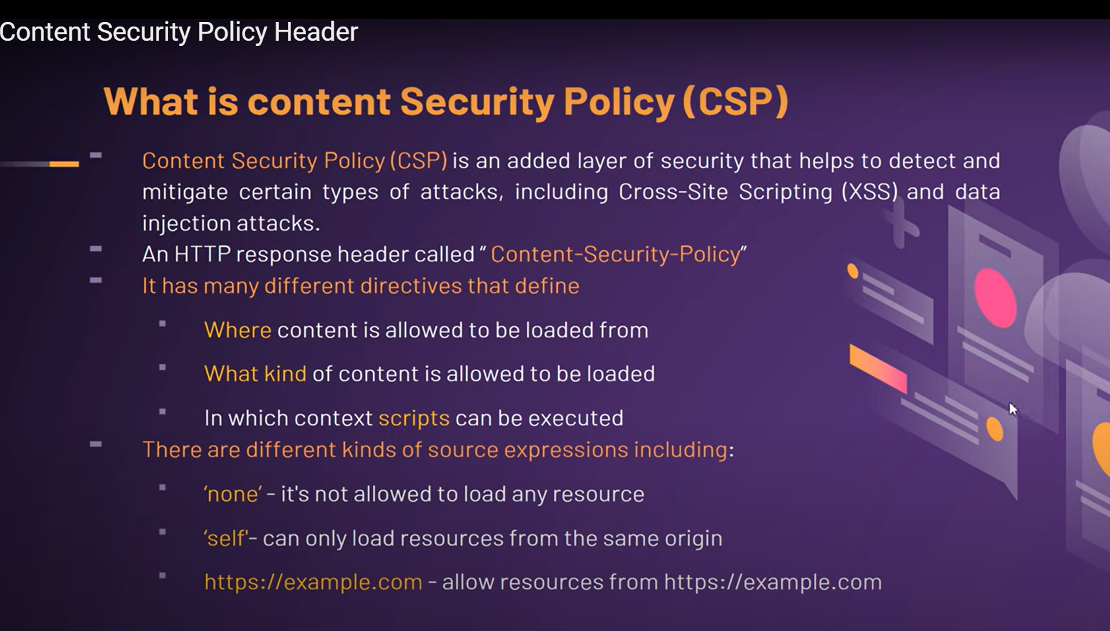

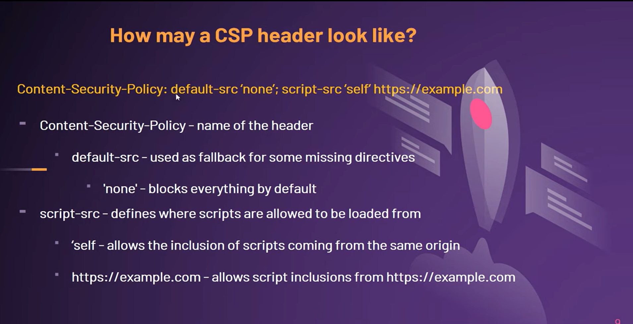

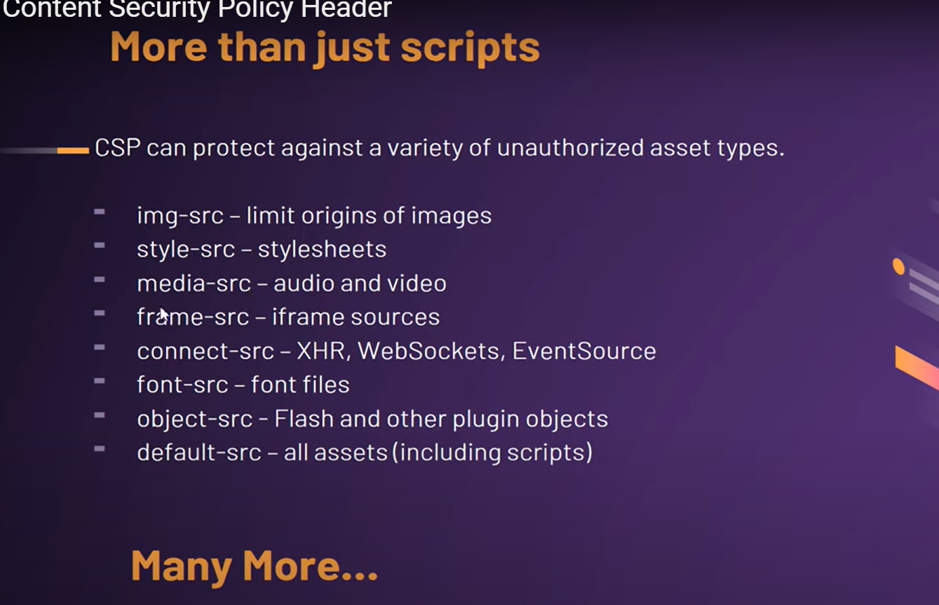

CSP prevents xss by whitelisting origins and contexts.

Example

Header set Content-Security-Policy "default-src 'self'; script-src 'self'; object-src 'none';"

**Cross-Site Request Forgery (CSRF)** is a type of security vulnerability that tricks a user into performing actions on a web application without their consent. In a CSRF attack, an attacker exploits the trust a web application has in the user's browser by making unauthorized requests on behalf of the user.

### How CSRF Works

1. **Victim Authentication:** The victim logs into a web application and authenticates themselves (e.g., by entering a username and password). The web application sets a session cookie in the victim's browser to maintain the session.
2. **Malicious Request:** The attacker crafts a malicious request that exploits the victim's authenticated session. This could be done by embedding a hidden form or an image tag in a malicious website or email.
3. **User Interaction:** The victim unknowingly triggers the malicious request by visiting the attacker's website, clicking on a link, or viewing an email with embedded content.
4. **Request Sent:** The browser automatically includes the victim's session cookie in the malicious request, making it appear legitimate to the web application.
5. **Action Executed:** The web application processes the request as if it were made by the victim, potentially resulting in actions such as transferring funds, changing account settings, or posting messages.

### Mitigating CSRF

1. **CSRF Tokens:** Include a unique token in forms and validate it on the server. The token should be tied to the user's session and regenerated for each request.

A CSRF token is a secure random token (e.g., synchronizer token or challenge token) that is used to prevent CSRF attacks. The token needs to be unique per user session and should be of large random value to make it difficult to guess.

A CSRF secure application assigns a unique CSRF token for every user session. These tokens are inserted within hidden parameters of HTML forms related to critical server-side operations. They are then sent to client browsers.

html

Copy code

<form action="/change-email" method="POST"> <input type="hidden" name="csrf_token" value="random_csrf_token_value"> <input type="email" name="email"> <input type="submit" value="Submit"> </form>

It is the application team’s responsibility to identify which server-side operations are sensitive in nature. The CSRF tokens must be a part of the HTML form—not stored in session cookies. The easiest way to add a non-predictable parameter is to use a secure hash function (e.g., SHA-2) to hash the user’s session ID. To ensure randomness, the tokens must be generated by a cryptographically secure random number generator.

Whenever a user invokes these critical operations, a request generated by the browser must include the associated CSRF token. This will be used by the application server to verify the legitimacy of the end-user request. The application server rejects the request if the CSRF token fails to match the test.

CSRF tokens, also known as anti-CSRF tokens or synchronization tokens, are a crucial defense mechanism against Cross-Site Request Forgery attacks. Here's how web applications verify these tokens to ensure the legitimacy of user requests:

**1. Token Generation:**

* When a user logs in or interacts with a web application that uses CSRF protection, the server generates a unique and unpredictable CSRF token. This token is typically a random string of characters or a cryptographically secure value.
* The token is then associated with the user's session. This association can happen in a few ways:
  + **Storing in Session:** The token can be stored on the server-side within the user's session data.
  + **Embedding in Cookie:** The token can be sent to the user's browser and stored in a cookie. This cookie is typically an HttpOnly cookie, meaning it cannot be accessed by JavaScript running on the client-side, adding an extra layer of security.

**Including the Token in Requests:**

* Whenever the user interacts with the web application by submitting a form or making an AJAX request that could potentially trigger a state-changing action (e.g., transferring money, changing password), the application ensures the CSRF token is included with the request.
* This inclusion can be done in two main ways:
  + **Hidden Form Field:** The token can be included as a hidden form field within the HTML form. When the form is submitted, the token is automatically sent along with the other form data.
  + **Request Header:** The token can be sent as a custom HTTP header with the request. This approach is often used for AJAX requests where traditional forms might not be involved.

**Token Verification on Server-Side:**

* When the server receives a request from the user's browser, it checks for the presence of the CSRF token. This verification happens on the server-side, not within the user's browser, to prevent manipulation by malicious scripts.
* The server retrieves the expected CSRF token associated with the user's session (either from server-side storage or the HttpOnly cookie).
* The server then compares the CSRF token received in the request with the expected token.

**Processing the Request (or Rejecting):**

* If the CSRF tokens match, the server recognizes the request as legitimate and proceeds with processing the user's action (e.g., transferring money, changing password).
* If the CSRF tokens don't match, or if the token is missing altogether, the server rejects the request. This indicates a potential CSRF attack, and the application can handle it by displaying an error message to the user or logging the suspicious activity.

**Benefits of CSRF Token Verification:**

* **Prevents Unauthorized Actions:** By verifying the token, the server ensures that only requests originating from the user's authenticated session can trigger state-changing actions.
* **Protects Against Malicious Links:** Even if an attacker tricks the user into clicking a malicious link or visiting a website that sends a crafted request, the lack of a valid CSRF token will prevent the attack from succeeding.

**Remember:** CSRF token verification is just one aspect of a comprehensive defense strategy against CSRF attacks. Other techniques like SameSite cookies and careful handling of user input also play a part in securing web applications.

1. **SameSite Cookies:** Set the SameSite attribute on session cookies to prevent them from being sent with cross-site requests.

**Example:**

http

Copy code

Set-Cookie: sessionId=abc123; SameSite=Strict

The introduction of the SameSite attribute (defined in [RFC6265bis](https://tools.ietf.org/html/draft-ietf-httpbis-cookie-same-site-00)) lets you declare whether your cookie is restricted to a first-party or same-site context. It's helpful to understand exactly what 'site' means here. The site is the combination of the domain suffix and the part of the domain just before it. For example, the www.web.dev domain is part of the web.dev site.

Key term: If the user is on www.web.dev and requests an image from static.web.dev, that's a same-site request.

Read more…

<https://web.dev/articles/samesite-cookies-explained>

1. **Referer and Origin Header Validation:** Validate the Referer or Origin header to ensure that requests originate from trusted sources.
2. **User Interaction Confirmation:** Require users to re-authenticate or provide additional confirmation (e.g., entering a password) for critical actions.
3. **Content Security Policy (CSP):** Implement CSP to restrict which domains can execute scripts, mitigating some attack vectors.

**Example (Nginx Configuration):**

nginx

Copy code

add_header Content-Security-Policy "default-src 'self'; script-src 'self'; object-src 'none';";

### Summary

CSRF attacks exploit the trust between a web application and a user's browser. To mitigate CSRF vulnerabilities:

* Use CSRF tokens to validate requests.
* Set cookies with the SameSite attribute.
* Validate the Referer or Origin headers.
* Require user interaction for sensitive actions.
* Implement a robust Content Security Policy (CSP).

By implementing these techniques, you can significantly reduce the risk of CSRF attacks and protect your web application from unauthorized actions.

Insecure design refers to a category of security vulnerabilities that arise due to inadequate security considerations during the design phase of software development. Unlike implementation flaws that occur during coding, insecure design issues are intrinsic to the application architecture, system workflows, or overall software design. These vulnerabilities can make systems inherently insecure and difficult to defend against attacks.

### Characteristics of Insecure Design

1. **Lack of Threat Modeling:** Failing to anticipate potential threats or not conducting thorough threat modeling can lead to designs that don't adequately protect against known attack vectors.
2. **Inadequate Security Controls:** Missing or weak security controls, such as authentication, authorization, and input validation, can leave the system vulnerable.
3. **Unsecure Default Configurations:** Systems shipped with default settings that are insecure can be easily exploited if not properly configured by the end-users.
4. **Poor Separation of Duties:** Not properly segmenting responsibilities and privileges within the system can lead to excessive access and potential abuse.
5. **Lack of Defense in Depth:** Relying on a single security measure instead of employing multiple, layered defenses can increase the risk of successful attacks.

### Examples of Insecure Design

#### Example 1: Lack of Input Validation and Output Encoding

**Scenario:** A web application accepts user input through forms but does not validate or sanitize this input before using it in SQL queries or displaying it on web pages.

**Impact:** This design flaw can lead to SQL Injection or Cross-Site Scripting (XSS) attacks, compromising the database and user data.

**Mitigation:**

* Implement input validation to ensure data conforms to expected formats.
* Sanitize user inputs and use parameterized queries for database interactions.
* Encode output to prevent XSS.

#### Example 2: Inadequate Authentication and Authorization

**Scenario:** A financial application allows users to access their accounts and perform transactions but lacks robust authentication mechanisms. User sessions do not expire, and session tokens are predictable.

**Impact:** Attackers can hijack sessions, predict session tokens, or use brute-force attacks to gain unauthorized access, leading to financial loss or data breaches.

**Mitigation:**

* Use strong, multi-factor authentication (MFA).
* Implement secure session management practices, such as using random, long session tokens and setting appropriate session expiration.
* Enforce strict access controls and regularly review permissions.

#### Example 3: Insecure Communication

**Scenario:** An application transmits sensitive information, such as passwords and personal data, over unencrypted HTTP connections.

**Impact:** Attackers can intercept and read the transmitted data, leading to data theft or credential compromise.

**Mitigation:**

* Use HTTPS for all communications to encrypt data in transit.
* Ensure that certificates are properly configured and maintained.
* Regularly audit the communication channels for potential vulnerabilities.

#### Example 4: Default Administrative Credentials

**Scenario:** A new software product is shipped with a default administrative username and password, which is not enforced to be changed upon initial setup.

**Impact:** Attackers can easily guess or find these default credentials in documentation, gaining administrative access to the system.

**Mitigation:**

* Enforce the change of default credentials during the initial setup.
* Disable default accounts if not necessary.
* Implement strong password policies and regularly audit accounts for weak credentials.

### Best Practices to Avoid Insecure Design

1. **Conduct Threat Modeling:** Regularly perform threat modeling during the design phase to identify potential security risks and address them early.
2. **Follow Secure Design Principles:** Adhere to principles such as least privilege, defense in depth, and fail-safe defaults to ensure robust security.
3. **Implement Security Controls:** Design and integrate necessary security controls, including input validation, authentication, authorization, encryption, and logging.
4. **Regular Security Reviews:** Conduct security reviews and audits of the design to identify and mitigate potential vulnerabilities.
5. **Educate Development Teams:** Train developers and designers on secure coding practices and the importance of security in the design phase.
6. **Use Security Frameworks and Standards:** Leverage established security frameworks and standards, such as OWASP, to guide the design and implementation of secure systems.

### Summary

Insecure design vulnerabilities stem from inadequate security considerations during the design phase of software development. By conducting thorough threat modeling, implementing robust security controls, following secure design principles, and educating development teams, organizations can significantly reduce the risk of insecure design and build more secure systems from the ground up.

### Open Redirect Vulnerability

An **open redirect** vulnerability occurs when a web application allows attackers to redirect users to arbitrary URLs without proper validation. This can lead to various security issues, including phishing attacks, malware distribution, and loss of user trust. Open redirects exploit the trust users have in a legitimate website, redirecting them to a malicious site that appears to be trusted.

### How Open Redirect Works

1. **User Trust:** A user visits a legitimate website they trust.
2. **Crafted URL:** An attacker crafts a URL that exploits the open redirect vulnerability, often including the malicious URL as a parameter.
3. **Redirection:** The user clicks the crafted URL, and the web application redirects them to the attacker's malicious site.
4. **Attack Execution:** The malicious site may then attempt to steal user credentials, install malware, or perform other malicious actions.

### Example of Open Redirect

Consider a web application with a redirect endpoint:

**Vulnerable URL:**

html

http://example.com/redirect?url=http://malicious-site.com

1. **Phishing Attacks:** Attackers can use open redirects to create convincing phishing URLs that appear to originate from a trusted domain.

html

Copy code

http://example.com/redirect?url=http://phishing-site.com

1. **Malware Distribution:** Redirecting users to sites that host malware or exploit kits.

html

Copy code

http://example.com/redirect?url=http://malware-site.com

1. **Loss of User Trust:** Users may lose trust in a legitimate website if they are frequently redirected to malicious sites.

### Mitigating Open Redirect Vulnerabilities

1. **Validate and Whitelist URLs:** Only allow redirection to trusted URLs. Maintain a whitelist of permitted redirect destinations.
2. **User Confirmation:** Ask users to confirm the redirection if the destination URL is not on a trusted list.
3. **Keenly test download links and login and password reset pages.**

In binary classification, the outcomes can be categorized as follows:

* **Positive**: The condition or attribute being tested for is present.
* **Negative**: The condition or attribute being tested for is absent.

Based on the actual condition and the test outcome, we can have four possible scenarios:

1. **True Positive (TP)**
2. **False Positive (FP)**
3. **True Negative (TN)**
4. **False Negative (FN)**

### True Positive (TP)

* **Definition**: The test correctly identifies the presence of the condition.
* **Example**: An intrusion detection system (IDS) correctly detects an actual attack.
* **Implication**: This is the desired outcome for a positive test result.

### False Positive (FP)

* **Definition**: The test incorrectly indicates the presence of the condition when it is not actually present.
* **Example**: An IDS incorrectly flags legitimate network traffic as an attack.
* **Implication**: False positives can lead to unnecessary alerts, wasted resources, and potential disruption of normal operations.

### True Negative (TN)

* **Definition**: The test correctly identifies the absence of the condition.
* **Example**: An IDS correctly identifies normal network traffic as non-malicious.
* **Implication**: This is the desired outcome for a negative test result.

### False Negative (FN)

* **Definition**: The test incorrectly indicates the absence of the condition when it is actually present.
* **Example**: An IDS fails to detect an actual attack, allowing it to proceed undetected.
* **Implication**: False negatives can be very dangerous as they allow threats to go unnoticed and unaddressed.

### Understanding the Four Cases

Here's a summary table for clarity:

| **Actual Condition** | **Test Outcome** | **Result** |
| --- | --- | --- |
| Present | Positive | True Positive |
| Absent | Positive | False Positive |
| Present | Negative | False Negative |
| Absent | Negative | True Negative |

### Visual Representation

Let's use a simple scenario: detecting email spam.

| **Email Type** | **Spam Detected (Yes)** | **Spam Detected (No)** |
| --- | --- | --- |
| **Spam** | True Positive (TP) | False Negative (FN) |
| **Not Spam** | False Positive (FP) | True Negative (TN) |

* **True Positive (TP)**: The system correctly identifies a spam email.
* **False Positive (FP)**: The system incorrectly identifies a legitimate email as spam.
* **True Negative (TN)**: The system correctly identifies a legitimate email as non-spam.
* **False Negative (FN)**: The system fails to identify a spam email, marking it as non-spam.
* • **True Positive:** This is the ideal outcome. The test correctly identifies a real vulnerability in the system.
* • **False Positive:** This is an error. The test identifies a potential vulnerability, but upon further investigation, it turns out there's no actual security risk. False positives can waste time and resources for developers who need to investigate these non-existent issues.
* • **True Negative:** This is a good outcome. The test correctly identifies that there is no vulnerability present. True negatives provide confidence that the system is secure in that specific aspect.
* • **False Negative:** This is a critical error. The test fails to identify a real vulnerability that exists in the system. This leaves the system exposed to potential attacks

**SAST (Static Application Security Testing)** and **DAST (Dynamic Application Security Testing)** are two types of security testing methodologies used to identify vulnerabilities in software applications. Here are examples of each:

### SAST (Static Application Security Testing):

SAST involves analyzing the source code, bytecode, or binary code of an application without executing the program. It is usually performed early in the development lifecycle (during coding and testing phases).

#### Example:

1. **Checkmarx:**
   * Checkmarx is a widely used SAST tool that scans source code to identify vulnerabilities and provide actionable remediation advice. It integrates with various development environments and CI/CD pipelines to provide continuous security feedback.
2. **SonarQube:**
   * SonarQube is a popular open-source platform that performs static code analysis to detect code quality issues, security vulnerabilities, and technical debt. It supports multiple programming languages and can be integrated into the build process to ensure code quality.
3. **Fortify Static Code Analyzer (SCA):**
   * Fortify SCA scans source code for security vulnerabilities. It supports a wide range of programming languages and provides detailed reports to help developers understand and fix security issues.

### DAST (Dynamic Application Security Testing):

DAST involves testing the application in its running state to identify vulnerabilities that an attacker could exploit. It simulates real-world attacks to find security issues that occur during the application's execution.

#### Example:

1. **OWASP ZAP (Zed Attack Proxy):**
   * OWASP ZAP is an open-source DAST tool that helps find security vulnerabilities in web applications. It simulates attacks and provides detailed reports on potential security issues. It is widely used for penetration testing and can be integrated into CI/CD pipelines.
2. **Burp Suite:**
   * Burp Suite is a comprehensive web vulnerability scanner used by security professionals to perform dynamic analysis of web applications. It can automatically scan web applications for vulnerabilities and provides tools for manual testing.
3. **Acunetix:**
   * Acunetix is a commercial DAST tool that scans web applications for vulnerabilities such as SQL injection, cross-site scripting (XSS), and other security flaws. It provides detailed reports and recommendations for remediation.

### Key Differences:

* **SAST:**
  + Analyzes static code without executing the application.
  + Identifies vulnerabilities early in the development process.
  + Requires access to source code or binaries.
  + Examples: Checkmarx, SonarQube, Fortify SCA.
* **DAST:**
  + Analyzes the running application in its dynamic state.
  + Identifies vulnerabilities that occur during execution.
  + Does not require access to source code.
  + Examples: OWASP ZAP, Burp Suite, Acunetix.

Both SAST and DAST are essential components of a comprehensive application security strategy, providing different perspectives and insights into potential security vulnerabilities.

4o

Below are examples of 15 common web application vulnerabilities that can be detected by both SAST (Static Application Security Testing) and DAST (Dynamic Application Security Testing) tools. For each vulnerability, I'll provide a brief description and how both types of tools can identify them.

### 1. **SQL Injection**

* **Description:** Injection of malicious SQL statements through user input fields.
* **SAST Detection:** Analyzes the source code for patterns of SQL query concatenation with user inputs.
* **DAST Detection:** Sends malicious SQL payloads to input fields and observes unexpected responses.

### 2. **Cross-Site Scripting (XSS)**

* **Description:** Injection of malicious scripts into web pages viewed by other users.
* **SAST Detection:** Scans the code for places where user input is included in HTML output without proper sanitization.
* **DAST Detection:** Injects script tags into input fields to see if they are executed in the browser.

### 3. **Cross-Site Request Forgery (CSRF)**

* **Description:** Forcing users to execute unwanted actions on a web application in which they are authenticated.
* **SAST Detection:** Looks for forms and requests without proper CSRF tokens.
* **DAST Detection:** Attempts to perform state-changing operations without the required CSRF token.

### 4. **Remote Code Execution (RCE)**

* **Description:** Execution of arbitrary code on the server due to improper handling of user input.
* **SAST Detection:** Identifies code that executes commands based on user input.
* **DAST Detection:** Sends payloads to input fields that attempt to execute commands.

### 5. **Directory Traversal**

* **Description:** Accessing files and directories outside the web root folder.
* **SAST Detection:** Scans for file path manipulation using user input.
* **DAST Detection:** Sends payloads containing ../ sequences to access restricted files.

### 6. **Insecure Deserialization**

* **Description:** Deserializing untrusted data leading to remote code execution or other attacks.
* **SAST Detection:** Identifies deserialization of untrusted data.
* **DAST Detection:** Sends crafted serialized objects to endpoints and monitors for unexpected behavior.

### 7. **Security Misconfiguration**

* **Description:** Improperly configured security settings or software.
* **SAST Detection:** Analyzes configuration files and code for insecure settings.
* **DAST Detection:** Probes for common misconfigurations such as default passwords or open ports.

### 8. **Broken Access Control**

* **Description:** Unauthorized access to restricted resources or functions.
* **SAST Detection:** Looks for missing or improper access control checks in the code.
* **DAST Detection:** Attempts to access restricted resources without proper authentication or authorization.

### 9. **Sensitive Data Exposure**

* **Description:** Exposure of sensitive data such as passwords, credit card numbers, etc.
* **SAST Detection:** Scans for improper handling or storage of sensitive data.
* **DAST Detection:** Analyzes responses to ensure sensitive data is not exposed in transit or in error messages.

### 10. **Insufficient Logging and Monitoring**

* **Description:** Lack of adequate logging and monitoring, which can delay the detection of security breaches.
* **SAST Detection:** Checks for the presence and proper configuration of logging in the code.
* **DAST Detection:** Tests the application for insufficient logging of critical actions.

### 11. **Server-Side Request Forgery (SSRF)**

* **Description:** Forcing the server to make requests to unintended locations.
* **SAST Detection:** Scans for code that makes requests based on user input.
* **DAST Detection:** Sends payloads that cause the server to make requests to internal resources.

### 12. **Unvalidated Redirects and Forwards**

* **Description:** Redirecting users to untrusted sites based on user input.
* **SAST Detection:** Looks for URL redirection code that uses user input without validation.
* **DAST Detection:** Attempts to redirect to malicious sites by manipulating input fields.

### 13. **Command Injection**

* **Description:** Execution of arbitrary commands on the host OS through vulnerable application input.
* **SAST Detection:** Scans for code that executes OS commands using user input.
* **DAST Detection:** Sends command injection payloads to input fields and observes the results.

### 14. **XML External Entities (XXE)**

* **Description:** Processing of external entities within XML documents leading to file disclosure or SSRF.
* **SAST Detection:** Identifies code that parses XML without properly configuring entity resolution.
* **DAST Detection:** Sends XML payloads with external entities to see if they are processed.

### 15. **Insecure Direct Object References (IDOR)**

* **Description:** Accessing objects directly using user-supplied input without proper authorization.
* **SAST Detection:** Looks for code where object access is based on user input without authorization checks.
* **DAST Detection:** Attempts to access objects by manipulating identifiers in URLs or parameters.

### Examples of SAST and DAST Tools

* **SAST Tools:** SonarQube, Checkmarx, Fortify, Veracode, Coverity.
* **DAST Tools:** OWASP ZAP, Burp Suite, Acunetix, Netsparker, AppSpider.

### Conclusion

Combining the strengths of both SAST and DAST tools helps in identifying a comprehensive set of vulnerabilities, providing a robust security posture for web applications. SAST tools are effective in detecting vulnerabilities early in the development cycle by analyzing the source code, while DAST tools validate these vulnerabilities by simulating real-world attacks on the running application.

4o

15 more with remediation

ChatGPT

Certainly! Here are 15 additional web application vulnerabilities detected by both SAST and DAST tools, along with their descriptions and remediation strategies:

### 1. **Unrestricted File Upload**

* **Description:** Allowing users to upload files without validation can lead to malicious files being uploaded.
* **SAST Detection:** Scans for file upload functionalities without validation.
* **DAST Detection:** Attempts to upload various file types to see if they are accepted.
* **Remediation:** Validate and restrict file types and sizes, and store uploads outside the web root.

### 2. **Buffer Overflow**

* **Description:** Writing more data to a buffer than it can hold, potentially leading to arbitrary code execution.
* **SAST Detection:** Identifies code where buffer boundaries are not properly checked.
* **DAST Detection:** Sends inputs larger than expected to test for buffer overflow.
* **Remediation:** Implement proper bounds checking and use safe functions to handle buffers.

### 3. **Information Leakage**

* **Description:** Exposing sensitive information in error messages or application responses.
* **SAST Detection:** Scans for code that returns detailed error messages or sensitive information.
* **DAST Detection:** Analyzes responses to see if they contain sensitive information.
* **Remediation:** Ensure error messages are generic and do not reveal internal details.

### 4. **HTTP Header Injection**

* **Description:** Injecting malicious content into HTTP headers.
* **SAST Detection:** Scans for places where user input is used in HTTP headers without sanitization.
* **DAST Detection:** Attempts to inject headers via input fields or URL parameters.
* **Remediation:** Validate and sanitize all user inputs used in HTTP headers.

### 5. **Weak Password Policy**

* **Description:** Allowing users to create weak passwords that are easily guessable.
* **SAST Detection:** Reviews code for password creation policies.
* **DAST Detection:** Attempts to create weak passwords to see if they are accepted.
* **Remediation:** Implement strong password policies (length, complexity, expiration).

### 6. **Session Fixation**

* **Description:** An attacker sets a user's session ID to a known value, allowing them to hijack the session.
* **SAST Detection:** Scans for session management code that does not regenerate session IDs upon login.
* **DAST Detection:** Attempts to fixate the session ID before and after login.
* **Remediation:** Regenerate session IDs upon user authentication.

### 7. **Unencrypted Communication**

* **Description:** Transmitting sensitive information over unencrypted channels.
* **SAST Detection:** Identifies code where sensitive data is transmitted without encryption.
* **DAST Detection:** Monitors network traffic to see if sensitive data is transmitted in plaintext.
* **Remediation:** Use TLS/SSL to encrypt all sensitive communications.

### 8. **Broken Authentication**

* **Description:** Insecure authentication mechanisms allowing unauthorized access.
* **SAST Detection:** Analyzes authentication logic for weaknesses.
* **DAST Detection:** Attempts to bypass authentication using various methods.
* **Remediation:** Implement strong authentication mechanisms and use multi-factor authentication (MFA).

### 9. **Unrestricted Redirects and Forwards**

* **Description:** Redirecting users to untrusted websites without proper validation.
* **SAST Detection:** Scans for redirect or forward logic using user input.
* **DAST Detection:** Attempts to redirect to malicious sites via manipulated inputs.
* **Remediation:** Validate and restrict URLs used in redirects and forwards.

### 10. **Improper Error Handling**

* **Description:** Improper handling of errors that could lead to information leakage or security issues.
* **SAST Detection:** Looks for code without proper error handling mechanisms.
* **DAST Detection:** Forces errors to see how they are handled by the application.
* **Remediation:** Implement consistent and secure error handling across the application.

### 11. **Use of Hardcoded Credentials**

* **Description:** Storing credentials directly in the source code.
* **SAST Detection:** Scans for hardcoded credentials within the codebase.
* **DAST Detection:** May not directly detect, but related vulnerabilities might be exploited.
* **Remediation:** Use secure vaults or environment variables for credentials.

### 12. **Clickjacking**

* **Description:** Tricks users into clicking on elements of a website through hidden frames.
* **SAST Detection:** Checks for missing X-Frame-Options headers.
* **DAST Detection:** Attempts to frame the application in an iframe.
* **Remediation:** Use X-Frame-Options or Content Security Policy (CSP) headers to prevent framing.

### 13. **Insufficient Transport Layer Protection**

* **Description:** Not using HTTPS or using weak ciphers for secure communication.
* **SAST Detection:** Identifies code/configurations where HTTPS is not enforced.
* **DAST Detection:** Analyzes SSL/TLS configurations for weaknesses.
* **Remediation:** Enforce HTTPS and use strong ciphers and secure protocols.

### 14. **Insufficient Session Expiration**

* **Description:** Sessions do not expire or have long expiration times, increasing the risk of session hijacking.
* **SAST Detection:** Reviews session management code for expiration settings.
* **DAST Detection:** Tests sessions to see if they expire as expected.
* **Remediation:** Implement proper session expiration and invalidation mechanisms.

### 15. **Command Injection**

* **Description:** Execution of arbitrary commands on the server through user input.
* **SAST Detection:** Scans for code executing system commands using user input.
* **DAST Detection:** Sends command injection payloads and observes for execution.
* **Remediation:** Validate and sanitize user inputs, and use safe APIs to execute system commands.

### Conclusion

These vulnerabilities demonstrate the importance of comprehensive security testing using both SAST and DAST tools. SAST tools help detect potential issues early in the development process by analyzing the source code, while DAST tools validate these issues and identify additional vulnerabilities by simulating real-world attacks on the running application. Proper remediation involves a combination of secure coding practices, configuration management, and regular security assessments.

Cryptographic algorithms are essential for ensuring data security through various means, such as encryption, hashing, and authentication. Here's an overview of several widely used cryptographic algorithms:

### Symmetric Key Algorithms

**1. Data Encryption Standard (DES):**

* **Type:** Symmetric key block cipher
* **Key Length:** 56 bits
* **Block Size:** 64 bits
* **Strengths:** Simplicity and speed
* **Weaknesses:** Short key length makes it vulnerable to brute-force attacks; considered insecure for modern use.
* **Usage:** Historically used for data encryption; now largely replaced by more secure algorithms like AES.

**2. Advanced Encryption Standard (AES):**

* **Type:** Symmetric key block cipher
* **Key Length:** 128, 192, or 256 bits
* **Block Size:** 128 bits
* **Strengths:** High security, efficiency, and flexibility
* **Weaknesses:** None significant; widely considered very secure.
* **Usage:** Encrypting sensitive data; standard for encrypting electronic data.

### Asymmetric Key Algorithms

**3. RSA (Rivest-Shamir-Adleman):**

* **Type:** Asymmetric key algorithm
* **Key Length:** Typically 2048 to 4096 bits
* **Strengths:** Security based on the difficulty of factoring large numbers; widely used for secure data transmission.
* **Weaknesses:** Computationally intensive, especially with very large keys.
* **Usage:** Secure key exchange, digital signatures, and encryption.

**4. Elliptic Curve Cryptography (ECC):**

* **Type:** Asymmetric key algorithm
* **Key Length:** Variable (commonly 256 bits for similar security to 3072-bit RSA)
* **Strengths:** Strong security with smaller key sizes, leading to faster computations and reduced storage requirements.
* **Weaknesses:** Complex mathematics behind it can be difficult to understand.
* **Usage:** Secure communications, digital signatures, and key exchange.

### Hash Functions

**5. Secure Hash Algorithm (SHA):**

* **Types:** SHA-1, SHA-2 (SHA-224, SHA-256, SHA-384, SHA-512), SHA-3
* **Output Length:** SHA-1 (160 bits), SHA-256 (256 bits), etc.
* **Strengths:** One-way hash functions, resistant to collision attacks (SHA-2 and SHA-3).
* **Weaknesses:** SHA-1 is considered broken and insecure for further use; SHA-2 and SHA-3 are currently secure.
* **Usage:** Data integrity verification, digital signatures, password hashing.

### Message Authentication Code (MAC) Algorithms

**6. Hash-based Message Authentication Code (HMAC):**

* **Type:** Message authentication code (MAC)
* **Underlying Hash Functions:** Often SHA-256 or SHA-512
* **Strengths:** Provides data integrity and authentication; resistant to length extension attacks.
* **Weaknesses:** Depends on the security of the underlying hash function.
* **Usage:** Ensuring data integrity and authenticity in communications.

### Additional Algorithms

**7. Diffie-Hellman Key Exchange:**

* **Type:** Asymmetric key exchange protocol
* **Key Length:** Typically 2048 bits or higher
* **Strengths:** Enables secure key exchange over an insecure channel without prior shared secrets.
* **Weaknesses:** Vulnerable to man-in-the-middle attacks if not authenticated.
* **Usage:** Establishing shared secrets for use with symmetric encryption algorithms.

**8. Digital Signature Algorithm (DSA):**

* **Type:** Asymmetric key algorithm for digital signatures
* **Key Length:** Typically 1024 to 3072 bits
* **Strengths:** Provides authenticity and non-repudiation.
* **Weaknesses:** Key generation and signing are computationally intensive.
* **Usage:** Digital signatures, document authentication.

### Overview of Usage and Strengths

* **Symmetric Key Algorithms (e.g., AES):** Best for encrypting large amounts of data due to their speed and efficiency. Requires secure key exchange.
* **Asymmetric Key Algorithms (e.g., RSA, ECC):** Ideal for secure key exchange, digital signatures, and establishing secure communications. More computationally intensive but highly secure.
* **Hash Functions (e.g., SHA-2, SHA-3):** Used for data integrity checks, digital signatures, and password hashing. One-way functions, meaning they can't be reversed to obtain the original input.
* **MAC Algorithms (e.g., HMAC):** Ensures data integrity and authenticity by combining a hash function with a secret key.

Understanding the difference between encryption, hashing, encoding, and Message Authentication Code (MAC) is essential for implementing secure systems. Here is a detailed explanation of each, along with examples:

### 1. Encryption

**Purpose:** Encryption is used to convert plaintext data into ciphertext to protect its confidentiality. The process is reversible, requiring a key to decrypt the ciphertext back into plaintext.

**Types:**

* **Symmetric Encryption:** Same key for encryption and decryption (e.g., AES, DES).
* **Asymmetric Encryption:** Public key for encryption and private key for decryption (e.g., RSA, ECC).

**Example:**

python

Copy code

from Crypto.Cipher import AES

from Crypto.Random import get_random_bytes

# Symmetric Encryption Example (AES)

key = get_random_bytes(16) # 128-bit key

cipher = AES.new(key, AES.MODE_EAX)

data = b'Secret Data'

nonce = cipher.nonce

ciphertext, tag = cipher.encrypt_and_digest(data)

# Decryption

cipher = AES.new(key, AES.MODE_EAX, nonce=nonce)

plaintext = cipher.decrypt(ciphertext)

print(plaintext) # b'Secret Data'

### 2. Hashing

**Purpose:** Hashing converts data into a fixed-size hash value or digest. It ensures data integrity and is a one-way process, meaning it cannot be reversed to obtain the original data.

**Examples:** SHA-256, MD5, SHA-1.

**Example:**

python

Copy code

import hashlib

# Hashing Example (SHA-256)

data = b'Secret Data'

hash_object = hashlib.sha256(data)

hash_value = hash_object.hexdigest()

print(hash_value) # Fixed-size hash value

### 3. Encoding

**Purpose:** Encoding transforms data into a different format using a scheme that is publicly available. It is used for data transmission and storage. Encoding is reversible without the need for a key.

**Examples:** Base64, URL encoding, UTF-8.

**Example:**

python

Copy code

import base64

# Encoding Example (Base64)

data = b'Secret Data'

encoded_data = base64.b64encode(data)

print(encoded_data) # Encoded data

# Decoding

decoded_data = base64.b64decode(encoded_data)

print(decoded_data) # b'Secret Data'

### 4. Message Authentication Code (MAC)

**Purpose:** MAC provides data integrity and authenticity by combining a secret key with the message data. It is used to verify that the data has not been altered and that it originates from a known sender.

**Examples:** HMAC (Hash-based Message Authentication Code).

**Example:**

python

Copy code

import hmac

import hashlib

# MAC Example (HMAC with SHA-256)

key = b'secret_key'

data = b'Message Data'

hmac_object = hmac.new(key, data, hashlib.sha256)

mac_value = hmac_object.hexdigest()

print(mac_value) # MAC value

### Summary of Differences

| **Feature** | **Encryption** | **Hashing** | **Encoding** | **Message Authentication Code (MAC)** |
| --- | --- | --- | --- | --- |
| **Purpose** | Protect confidentiality | Ensure data integrity | Transform data for transmission/storage | Ensure data integrity and authenticity |
| **Reversible** | Yes (with key) | No | Yes | No |
| **Key Required** | Yes | No | No | Yes |
| **Common Uses** | Secure communication, data storage | Data integrity checks, password storage | Data transmission, data storage | Data integrity, data authentication |
| **Examples** | AES, RSA | SHA-256, MD5 | Base64, URL encoding | HMAC-SHA256 |

By understanding these differences, you can choose the appropriate method for securing and handling data in your applications.

4o

RSA (Rivest-Shamir-Adleman) is one of the most widely used public-key cryptographic algorithms. It provides security through the use of two keys: a public key for encryption and a private key for decryption. RSA is utilized for securing data transmission, digital signatures, and key exchanges. Here's an in-depth explanation of how RSA works, along with its features, advantages, and potential vulnerabilities.

### How RSA Works

#### Key Generation

1. **Choose Two Large Prime Numbers:**
   * Select two large prime numbers, ppp and qqq.
   * Example: p=61p = 61p=61, q=53q = 53q=53.
2. **Compute nnn:**
   * Multiply ppp and qqq to get nnn, the modulus for both the public and private keys.
   * n=p×qn = p \times qn=p×q.
   * Example: n=61×53=3233n = 61 \times 53 = 3233n=61×53=3233.
3. **Compute ϕ(n)\phi(n)ϕ(n):**
   * Compute ϕ(n)\phi(n)ϕ(n) (Euler's totient function), where ϕ(n)=(p−1)×(q−1)\phi(n) = (p - 1) \times (q - 1)ϕ(n)=(p−1)×(q−1).
   * Example: ϕ(3233)=(61−1)×(53−1)=60×52=3120\phi(3233) = (61 - 1) \times (53 - 1) = 60 \times 52 = 3120ϕ(3233)=(61−1)×(53−1)=60×52=3120.
4. **Choose eee:**
   * Choose an integer eee such that 1<e<ϕ(n)1 < e < \phi(n)1<e<ϕ(n) and eee is coprime with ϕ(n)\phi(n)ϕ(n) (i.e., gcd⁡(e,ϕ(n))=1\gcd(e, \phi(n)) = 1gcd(e,ϕ(n))=1).
   * Example: e=17e = 17e=17.
5. **Compute ddd:**
   * Compute ddd as the modular multiplicative inverse of eee modulo ϕ(n)\phi(n)ϕ(n), which means d×e≡1 (mod ϕ(n))d \times e \equiv 1 \ (\text{mod} \ \phi(n))d×e≡1 (mod ϕ(n)).
   * Example: d=2753d = 2753d=2753 (since 17×2753≡1 (mod 3120)17 \times 2753 \equiv 1 \ (\text{mod} \ 3120)17×2753≡1 (mod 3120)).

#### Public and Private Keys

* **Public Key:** (e,n)(e, n)(e,n)
  + Example: (17,3233)(17, 3233)(17,3233)
* **Private Key:** (d,n)(d, n)(d,n)
  + Example: (2753,3233)(2753, 3233)(2753,3233)

#### Encryption

To encrypt a message mmm:

1. Convert the message mmm into an integer mmm such that 0≤m<n0 \leq m < n0≤m<n.
2. Compute the ciphertext ccc using the public key (e,n)(e, n)(e,n):
   * c=me (mod n)c = m^e \ (\text{mod} \ n)c=me (mod n).

Example:

* Message: m=65m = 65m=65
* Ciphertext: c=6517 (mod 3233)=2790c = 65^{17} \ (\text{mod} \ 3233) = 2790c=6517 (mod 3233)=2790

#### Decryption

To decrypt a ciphertext ccc:

1. Compute the original message mmm using the private key (d,n)(d, n)(d,n):
   * m=cd (mod n)m = c^d \ (\text{mod} \ n)m=cd (mod n).

Example:

* Ciphertext: c=2790c = 2790c=2790
* Original Message: m=27902753 (mod 3233)=65m = 2790^{2753} \ (\text{mod} \ 3233) = 65m=27902753 (mod 3233)=65

### Features of RSA

1. **Asymmetric:** Uses two keys—public for encryption and private for decryption.
2. **Security:** Based on the computational difficulty of factoring large integers, specifically the product of two large prime numbers.
3. **Versatile:** Used for both encryption/decryption and digital signatures.
4. **Widely Adopted:** Commonly used in SSL/TLS for securing internet communications, in email encryption (e.g., PGP), and for secure key exchanges.

### Advantages of RSA

1. **Security:** When large keys are used (e.g., 2048-bit or 4096-bit), RSA is highly secure.
2. **Integrity:** RSA ensures data integrity through digital signatures.
3. **Authentication:** Verifies the authenticity of the sender through digital signatures.
4. **Non-repudiation:** Prevents the sender from denying having sent the message.

### Vulnerabilities and Challenges

1. **Key Length:** Short keys (e.g., 512-bit) are vulnerable to brute-force attacks. Modern standards recommend using keys of at least 2048 bits.
2. **Speed:** RSA is slower compared to symmetric key algorithms like AES, making it less efficient for encrypting large amounts of data.
3. **Quantum Computing:** The advent of quantum computing could potentially break RSA encryption through Shor's algorithm, which can factor large numbers efficiently.
4. **Implementation Flaws:** Poor implementation, such as weak random number generation for key pairs, can compromise security.

DES (Data Encryption Standard) is a symmetric-key algorithm used for the encryption of digital data. It was developed in the early 1970s and adopted as a standard by the National Institute of Standards and Technology (NIST) in 1977. Despite its historical significance, DES is now considered insecure due to its relatively short key length.

**Key Features:**

* **Key Length:** 56 bits
* **Block Size:** 64 bits
* **Algorithm Type:** Symmetric key block cipher

**Encryption Process:** DES operates on a block of data at a time, using a series of complex transformations:

1. **Initial Permutation (IP):** The 64-bit plaintext block is permuted using a predefined table.
2. **Rounds:** The permuted block undergoes 16 rounds of processing, each involving:
   * Splitting the block into two 32-bit halves (left and right).
   * Applying an expansion permutation to the right half, expanding it to 48 bits.
   * Combining the expanded right half with a round-specific 48-bit subkey using XOR.
   * Substituting the result using 8 S-boxes (each S-box replaces 6 bits with 4 bits).
   * Permuting the substituted bits.
   * Combining the result with the left half using XOR.
   * Swapping the halves.
3. **Final Permutation (FP):** After 16 rounds, the halves are recombined and permuted using the inverse of the initial permutation to produce the ciphertext.

**Decryption Process:** Decryption in DES is essentially the reverse process of encryption, using the same key and reversing the order of the subkeys.

**Security:**

* **Strengths:** DES was a strong encryption standard at the time of its adoption, due to its complex permutations and S-boxes.
* **Weaknesses:** The primary weakness is the short key length (56 bits), making it vulnerable to brute-force attacks. Modern computing power can break DES encryption relatively quickly.

### Advanced Encryption Standard (AES)

**Overview:** AES (Advanced Encryption Standard) is a symmetric-key algorithm adopted by NIST in 2001 to replace DES. It is widely used across various applications for secure data encryption due to its robustness and efficiency.

**Key Features:**

* **Key Lengths:** 128, 192, or 256 bits
* **Block Size:** 128 bits
* **Algorithm Type:** Symmetric key block cipher

**Encryption Process:** AES operates on a 4x4 column-major order matrix of bytes, termed the "state." The number of rounds depends on the key length: 10 rounds for 128-bit keys, 12 for 192-bit keys, and 14 for 256-bit keys.

1. **Initial Round:**
   * **AddRoundKey:** Each byte of the state is combined with a round key using XOR.
2. **Main Rounds:**
   * **SubBytes:** A non-linear substitution step where each byte is replaced with another according to a lookup table (S-box).
   * **ShiftRows:** A transposition step where each row of the state is shifted cyclically by a certain number of bytes.
   * **MixColumns:** A mixing operation that operates on the columns of the state, combining the four bytes in each column.
   * **AddRoundKey:** Each byte of the state is combined with a round key using XOR.
3. **Final Round:**
   * Similar to the main rounds but without the MixColumns step.

**Decryption Process:** Decryption in AES involves reversing the encryption process, using the same key schedule but in the reverse order.

**Security:**

* **Strengths:** AES is highly secure due to its larger key sizes and complex structure. It is resistant to all known practical attacks.
* **Efficiency:** AES is also efficient in both hardware and software, making it suitable for a wide range of applications.

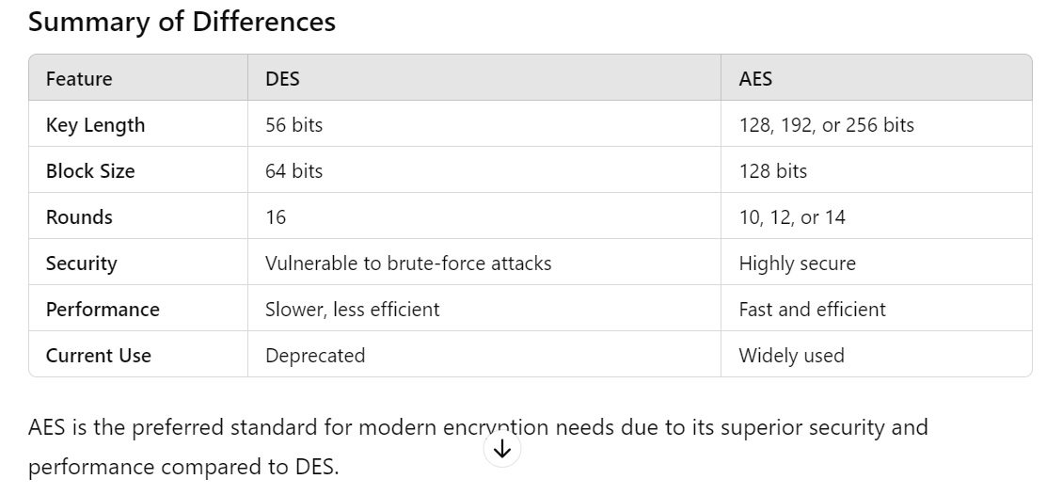

**Software Composition Analysis:**

It focuses on identifying and managing third party & open-source software components & dependencies that is used in software project. SCA is crucial for assessing the security and compliance of this dependencies and ensuring that they do not introduce vulnerabilities or any kind of risks into an application.

Process of SCA:

The Software Composition Analysis (SCA) process involves identifying and managing open-source and third-party components within a software application. SCA tools help ensure that these components are secure, compliant with licensing requirements, and up-to-date. Here’s a step-by-step overview of the SCA process:

1. **Inventory Creation**:
   * The first step is to create an inventory of all the open-source and third-party components used in the application. This includes libraries, frameworks, and any other dependencies.
2. **Component Identification**:
   * Use an SCA tool to scan the codebase and identify all the components and their versions. These tools often use a combination of file signatures, package managers, and metadata to accurately identify components.
3. **Vulnerability Detection**:
   * The SCA tool checks the identified components against a database of known vulnerabilities (such as the NVD - National Vulnerability Database). It identifies any vulnerabilities present in the components used.
4. **License Compliance Check**:
   * The tool also checks the licenses associated with each component to ensure compliance with legal and organizational policies. This is crucial to avoid legal issues related to the use of open-source software.
5. **Risk Assessment**:
   * Assess the risks associated with the identified vulnerabilities. This involves determining the severity of the vulnerabilities and the potential impact on the application.
6. **Remediation and Mitigation**:
   * Develop a plan to address the identified vulnerabilities. This may involve updating the vulnerable components to newer, patched versions, applying patches, or finding alternative components.
7. **Policy Enforcement**:
   * Define and enforce policies for the use of open-source components. This includes specifying acceptable licenses, version control practices, and guidelines for component selection.
8. **Continuous Monitoring**:
   * Continuously monitor the application and its components for new vulnerabilities. This involves regularly scanning the codebase and keeping the component inventory up to date.
9. **Reporting and Documentation**:
   * Generate reports on the findings, vulnerabilities, compliance status, and remediation efforts. Proper documentation helps in tracking the status of the components and ensuring transparency.
10. **Integration with Development Workflow**:
    * Integrate the SCA process into the development workflow, such as during the CI/CD pipeline. This ensures that any new or updated components are automatically scanned and evaluated for security and compliance.

By following these steps, organizations can effectively manage the risks associated with using open-source and third-party components in their software applications, ensuring both security and compliance

Security Assertion Markup Language (SAML) is a standard for exchanging authentication and authorization data between parties, particularly between an Identity Provider (IdP) and a Service Provider (SP). Here’s a detailed explanation of how SAML works with Single Sign-On (SSO):

### Components of SAML

1. **Identity Provider (IdP)**: The authority that authenticates users and issues SAML assertions (e.g., Keycloak, Okta, Azure AD).
2. **Service Provider (SP)**: The application or service that users want to access (e.g., Moodle, Guacamole).
3. **User (Principal)**: The entity (usually a person) that wants to access a service.

### SAML SSO Process

The SAML SSO process typically involves the following steps:

1. **User Accesses Service Provider**:
   * The user attempts to access a resource on the SP (e.g., Moodle or Guacamole).
2. **Service Provider Redirects to Identity Provider**:
   * The SP recognizes that the user is not authenticated and generates a SAML authentication request.
   * The user is redirected to the IdP with the SAML request.
3. **User Authenticates with Identity Provider**:
   * The user logs in to the IdP using their credentials.
   * The IdP verifies the user's identity.
4. **Identity Provider Issues SAML Assertion**:
   * Upon successful authentication, the IdP generates a SAML assertion (an XML document) containing user identity information and possibly other attributes.
   * The SAML assertion is signed with the IdP's private key to ensure authenticity and integrity.
5. **Assertion Sent to Service Provider**:
   * The IdP sends the SAML assertion to the user's browser, often within a form that automatically posts it to the SP's Assertion Consumer Service (ACS) endpoint.
6. **Service Provider Validates Assertion**:
   * The SP receives the SAML assertion and validates it using the IdP's public key.
   * The SP checks the assertion's integrity, authenticity, and that it hasn't expired.
7. **User Granted Access**:
   * If the assertion is valid, the SP grants access to the user and creates a session.
   * The user can now access the requested resource.

### Key Elements of SAML

1. **SAML Request**: An authentication request sent from the SP to the IdP.
2. **SAML Assertion**: A document issued by the IdP that contains user authentication and attribute information.
3. **SAML Response**: The message containing the SAML assertion sent from the IdP to the SP.
4. **Bindings**: Defines how SAML messages are transported (e.g., HTTP Redirect, HTTP POST).
5. **Profiles**: Define specific use cases for SAML (e.g., Web Browser SSO Profile).

### SAML Assertion Structure

A typical SAML assertion contains the following elements:

1. **Issuer**: Identifies the IdP that issued the assertion.
2. **Subject**: Information about the user (e.g., username, email).
3. **Conditions**: Specify restrictions on the assertion's usage (e.g., validity period).
4. **AuthnStatement**: Details about the authentication event (e.g., timestamp, method).
5. **AttributeStatement**: Additional attributes about the user (e.g., roles, groups).

### Example SAML Assertion

xml

Copy code

<saml:Assertion xmlns:saml="urn:oasis:names:tc:SAML:2.0:assertion">

<saml:Issuer>https://idp.example.com</saml:Issuer>

<saml:Subject>

<saml:NameID>john.doe@example.com</saml:NameID>

<saml:SubjectConfirmation Method="urn:oasis:names:tc:SAML:2.0:cm:bearer">

<saml:SubjectConfirmationData NotOnOrAfter="2024-06-19T00:00:00Z"

Recipient="https://sp.example.com/acs"/>

</saml:SubjectConfirmation>

</saml:Subject>

<saml:Conditions NotBefore="2024-06-18T00:00:00Z" NotOnOrAfter="2024-06-19T00:00:00Z">

<saml:AudienceRestriction>

<saml:Audience>https://sp.example.com</saml:Audience>

</saml:AudienceRestriction>

</saml:Conditions>

<saml:AuthnStatement AuthnInstant="2024-06-18T12:00:00Z">

<saml:AuthnContext>

<saml:AuthnContextClassRef>urn:oasis:names:tc:SAML:2.0:ac:classes:PasswordProtectedTransport</saml:AuthnContextClassRef>

</saml:AuthnContext>

</saml:AuthnStatement>

<saml:AttributeStatement>

<saml:Attribute Name="email">

<saml:AttributeValue>john.doe@example.com</saml:AttributeValue>

</saml:Attribute>

<saml:Attribute Name="role">

<saml:AttributeValue>admin</saml:AttributeValue>

</saml:Attribute>

</saml:AttributeStatement>

</saml:Assertion>

### Conclusion

SAML provides a robust framework for SSO by securely exchanging authentication and authorization data between an IdP and SP. This process allows users to authenticate once and gain access to multiple applications without needing to log in separately to each one.

The Transport Layer Security (TLS) handshake is a process that establishes a secure connection between a client (e.g., a web browser) and a server (e.g., a web server). This handshake ensures that both parties are authenticated, and an encrypted communication channel is established. Here's a detailed explanation of the TLS handshake process:

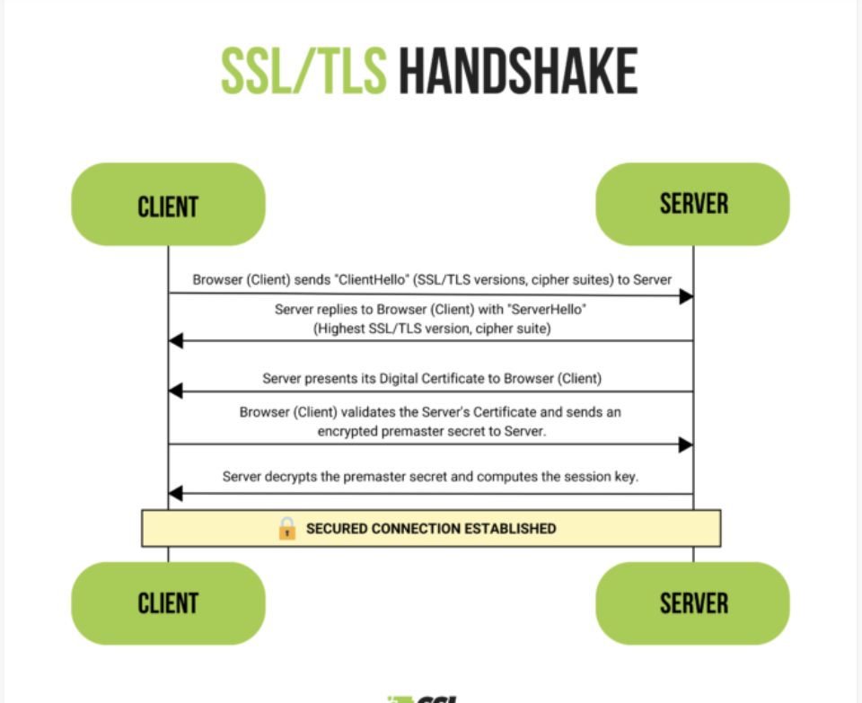

### Overview of the TLS Handshake

The TLS handshake can be divided into several key steps:

1. **Client Hello**
2. **Server Hello**
3. **Server Authentication and Key Exchange**
4. **Client Authentication and Key Exchange (optional)**
5. **Finalizing the Handshake**

### Detailed Steps of the TLS Handshake

#### 1. Client Hello

* **Client sends:**
  + **Protocol version**: The highest version of TLS that the client supports.
  + **Random number**: A random value generated by the client.
  + **Session ID**: An identifier for the session (used in session resumption).
  + **Cipher suites**: A list of cryptographic algorithms that the client supports.
  + **Compression methods**: A list of compression methods that the client supports (usually not used).
  + **Extensions**: Additional options such as supported elliptic curves, Server Name Indication (SNI), etc.

plaintext

Copy code

Client --> Server: ClientHello

#### 2. Server Hello

* **Server sends:**
  + **Protocol version**: The selected version of TLS.
  + **Random number**: A random value generated by the server.
  + **Session ID**: The session identifier.
  + **Cipher suite**: The selected cryptographic algorithm.
  + **Compression method**: The selected compression method (usually none).
  + **Extensions**: Additional options (e.g., selected elliptic curve).

plaintext

Copy code

Server --> Client: ServerHello

#### 3. Server Authentication and Key Exchange

* **Server sends:**
  + **Server certificate**: The server’s public key certificate, used to authenticate the server.
  + **Server key exchange**: Parameters for key exchange (if using Diffie-Hellman, Elliptic Curve Diffie-Hellman, etc.).
  + **Certificate request** (optional): Request for the client’s certificate, used in mutual authentication.
* **Server indicates the end of Server Hello messages**:
  + **Server Hello Done**: Indicates that the server has finished its part of the handshake.

plaintext

Copy code

Server --> Client: Certificate

Server --> Client: ServerKeyExchange (if required)

Server --> Client: CertificateRequest (if required)

Server --> Client: ServerHelloDone

#### 4. Client Authentication and Key Exchange (optional)

* **Client sends:**
  + **Client certificate** (if requested): The client’s public key certificate.
  + **Client key exchange**: The pre-master secret encrypted with the server’s public key.
  + **Certificate verify** (optional): Verification of the client’s certificate.

plaintext

Copy code

Client --> Server: Certificate (if requested)

Client --> Server: ClientKeyExchange

Client --> Server: CertificateVerify (if requested)

#### 5. Finalizing the Handshake

* **Client sends:**
  + **Change cipher spec**: Notification that the client will start using the negotiated cipher suite.
  + **Finished**: A message encrypted with the new session key, containing a hash of the entire handshake so far.
* **Server sends:**
  + **Change cipher spec**: Notification that the server will start using the negotiated cipher suite.
  + **Finished**: A message encrypted with the new session key, containing a hash of the entire handshake so far.

plaintext

Copy code

Client --> Server: ChangeCipherSpec

Client --> Server: Finished

Server --> Client: ChangeCipherSpec

Server --> Client: Finished

### Result of the Handshake

* **Secure Connection Established**: At this point, both the client and server have verified each other's identities (if mutual authentication was used) and have established a shared secret key. This shared secret key is used for encrypting the data exchanged during the session.

### Summary

The TLS handshake is a complex process that involves multiple steps to ensure both parties can communicate securely. It includes:

1. Exchanging supported cryptographic algorithms.
2. Authenticating the server (and optionally the client).
3. Exchanging key information to establish a shared secret.
4. Confirming that both parties have successfully established a secure connection.

This process ensures that any data exchanged between the client and server is encrypted and secure from eavesdropping and tampering.

TLS (Transport Layer Security) actually leverages both symmetric and asymmetric key cryptography for a secure connection:

* **Asymmetric keys** are used during the initial handshake process. This involves:
  + The server sending its public key (part of the TLS certificate) to the client.
  + The client verifying the certificate and using the public key to encrypt a secret key (called the pre-master secret) which is then sent back to the server.
  + The server decrypting the pre-master secret using its private key (which is never shared).
* **Symmetric keys** are used for the actual data encryption after the handshake.
  + Both the client and server generate a temporary symmetric key (session key) based on the pre-master secret exchanged earlier.
  + This session key is used for encrypting the data exchanged throughout the secure connection.

By combining both types of keys, TLS offers the benefits of both worlds:

* **Security of asymmetric keys:** Public keys are widely distributed, making it difficult to intercept and tamper with communication during the handshake.
* **Efficiency of symmetric keys:** Once the session key is established, symmetric encryption is much faster for encrypting large amounts of data.

In the TLS handshake, the generation of the symmetric key (also called the session key) involves a collaborative effort between the client and server, but they never directly share the key itself. Here's a breakdown of the process:

1. **Client Generates Pre-Master Secret:** The client initiates the handshake by generating a random secret piece of data called the pre-master secret. This is a critical piece for deriving the session key.
2. **Public Key Encryption:** The client doesn't send the pre-master secret directly. Instead, it retrieves the server's public key from its TLS certificate. This public key is designed to be widely distributed for verification purposes. The client then uses the server's public key to encrypt the pre-master secret.
3. **Server Decryption:** The encrypted pre-master secret is sent to the server. The server, possessing its private key (never shared publicly), can decrypt the message using the private key that corresponds to the public key sent in the certificate. This allows the server to recover the pre-master secret.
4. **Deriving the Session Key:** Both the client and server now have the same pre-master secret. However, they don't use it directly as the session key. Instead, they use a cryptographic function (often involving a hashing algorithm like PRF - Pseudo-Random Function) along with additional random data specific to each side (often called "nonce") to derive the final session key. This ensures even if an attacker intercepts the pre-master secret during the handshake, they wouldn't be able to derive the actual session key used for data encryption.

**Essentially, the public key infrastructure and the pre-master secret act as ingredients, while the derivation function acts as a recipe to create the final secure session key.** This approach leverages the strengths of both asymmetric and symmetric cryptography for a robust TLS connection.

HMAC (Hash-based Message Authentication Code) is a specific type of message authentication code (MAC) that involves a cryptographic hash function and a secret cryptographic key. HMAC is used to ensure data integrity and authenticity, providing a way to verify that a message has not been altered and that it comes from a legitimate source. Here’s a detailed explanation of how HMAC works and its components:

### Components of HMAC

1. **Cryptographic Hash Function**: Common hash functions used in HMAC include SHA-256, SHA-1, and MD5. The choice of hash function affects the security and performance of HMAC.
2. **Secret Key**: A private key shared between the sender and receiver. This key should be kept secret and secure.

### How HMAC Works

HMAC combines the hash function and the secret key in a specific way to produce a MAC. The process can be described in the following steps:

1. **Padding the Key**:
   * If the secret key is shorter than the block size of the hash function, it is padded with zeros to make it equal to the block size.
   * If the secret key is longer than the block size, it is hashed to reduce its length to the block size.
2. **Defining Inner and Outer Padding**:
   * **Inner Padding (ipad)**: A string of bytes, each byte being the result of XOR-ing the byte 0x36 with each byte of the key.
   * **Outer Padding (opad)**: A string of bytes, each byte being the result of XOR-ing the byte 0x5c with each byte of the key.
3. **Inner Hashing**:
   * The inner hash is computed by concatenating the ipad with the message, then applying the hash function to this concatenated string: InnerHash=Hash(ipad∥message)\text{InnerHash} = \text{Hash}( \text{ipad} \| \text{message} )InnerHash=Hash(ipad∥message)
4. **Outer Hashing**:
   * The outer hash is computed by concatenating the opad with the result of the inner hash, then applying the hash function again: HMAC=Hash(opad∥InnerHash)\text{HMAC} = \text{Hash}( \text{opad} \| \text{InnerHash} )HMAC=Hash(opad∥InnerHash)

### Formula for HMAC

The overall HMAC calculation can be summarized by the following formula:

HMAC(K,m)=Hash((K′⊕opad)∥Hash((K′⊕ipad)∥m))\text{HMAC}(K, m) = \text{Hash} \left( (K' \oplus \text{opad}) \| \text{Hash} \left( (K' \oplus \text{ipad}) \| m \right) \right)HMAC(K,m)=Hash((K′⊕opad)∥Hash((K′⊕ipad)∥m))

Where:

* KKK is the secret key.
* K′K'K′ is the key padded to the block size or hashed if it's too long.
* mmm is the message.
* ∥\|∥ denotes concatenation.
* ⊕\oplus⊕ denotes the XOR operation.
* ipad\text{ipad}ipad and opad\text{opad}opad are the inner and outer padding constants.

### Properties and Benefits of HMAC

1. **Data Integrity**: HMAC ensures that the message has not been altered. Any change in the message will result in a different HMAC value.
2. **Data Authenticity**: HMAC verifies that the message comes from a legitimate source, assuming the secret key is known only to the sender and receiver.
3. **Collision Resistance**: Using a cryptographic hash function ensures that it is computationally infeasible to find two different messages that produce the same HMAC.

### Example Usage of HMAC

HMAC is widely used in various security protocols and applications, such as:

* **TLS/SSL**: Ensures the integrity and authenticity of the messages exchanged between client and server.
* **IPSec**: Provides data integrity and authentication for IP packets.
* **JWT (JSON Web Tokens)**: Signs tokens to ensure their integrity and authenticity.
* **AWS API Requests**: Amazon Web Services uses HMAC to sign API requests for authentication.

### Conclusion

HMAC is a robust mechanism for verifying the integrity and authenticity of messages. By combining a cryptographic hash function with a secret key, HMAC provides a secure way to detect tampering and verify the source of the data. Its use in various security protocols highlights its importance in ensuring secure communications and data integrity.