------------------------------------Docker--------------------------------------

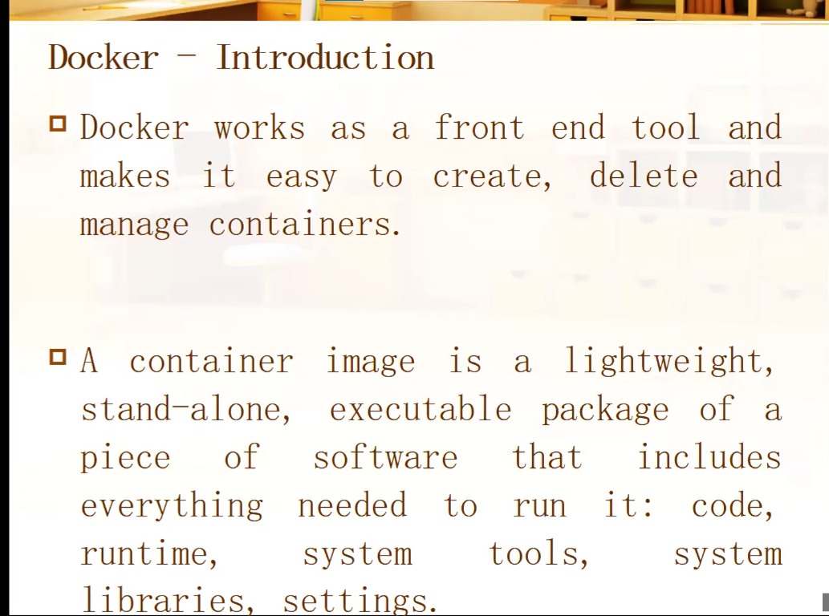

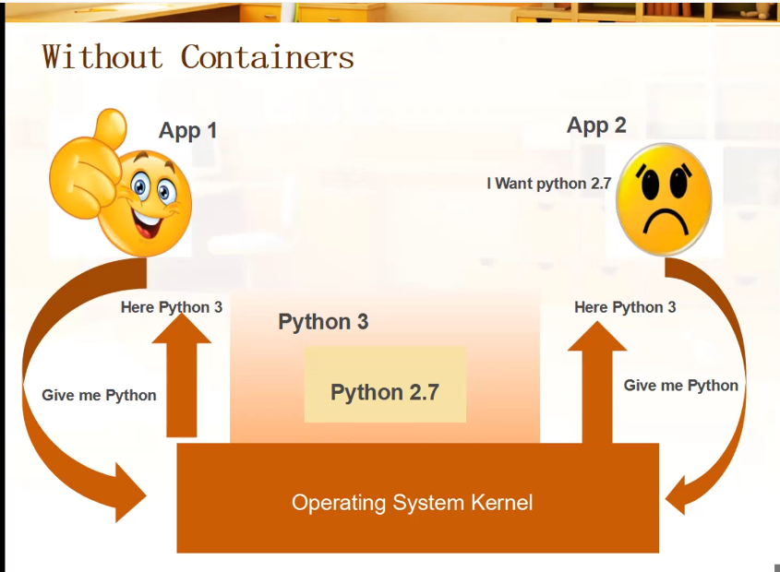

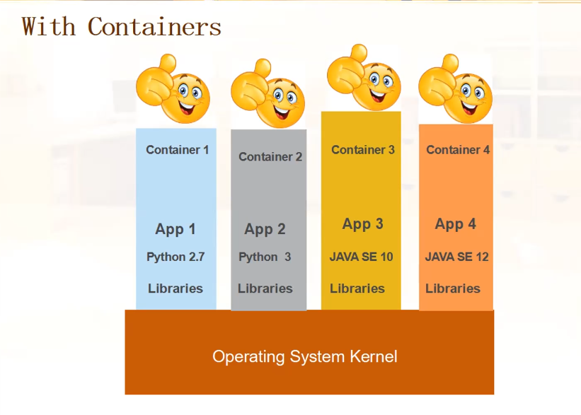

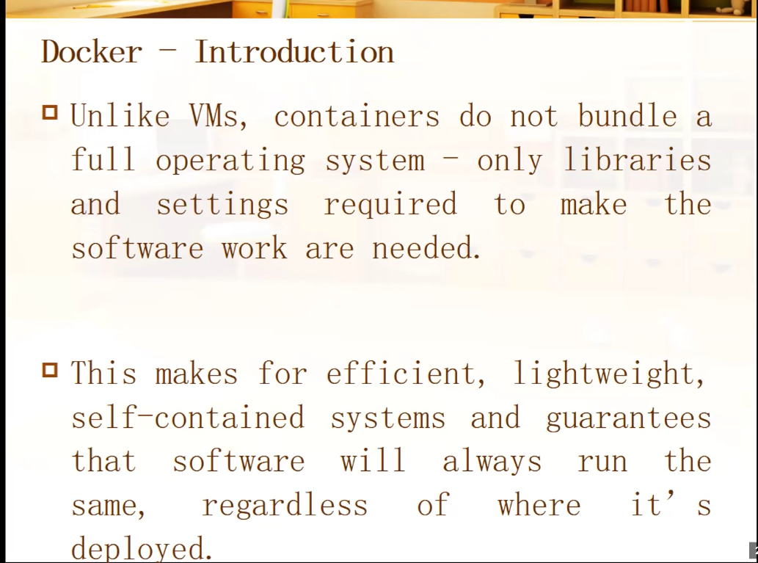

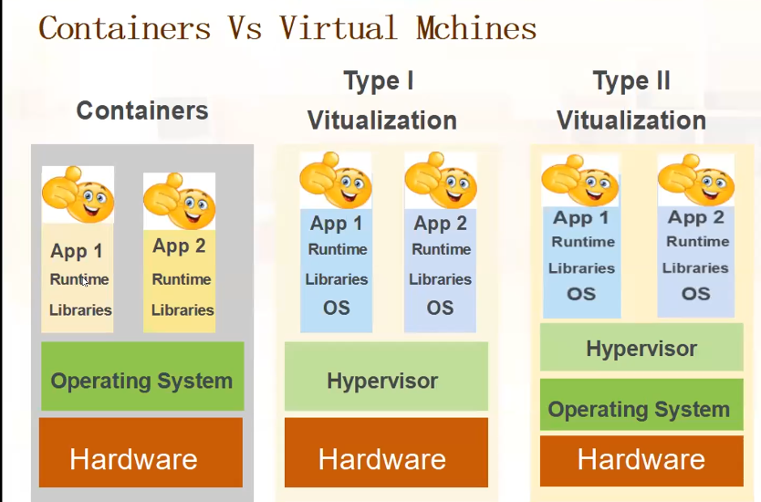

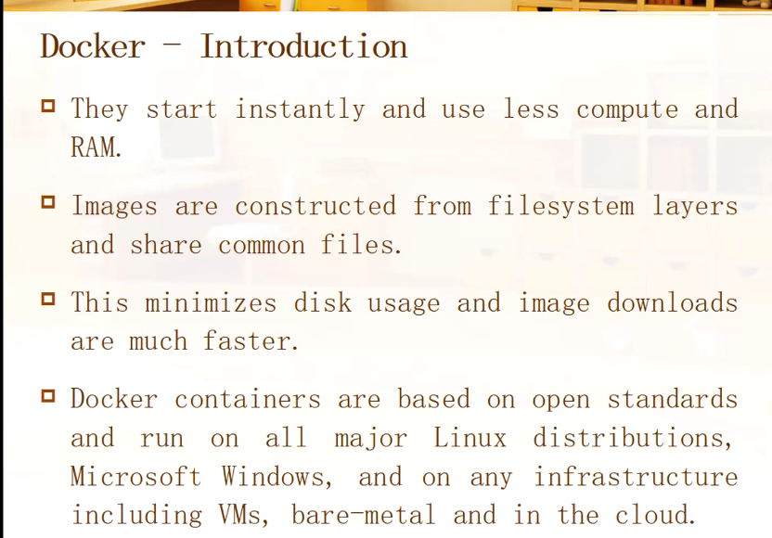

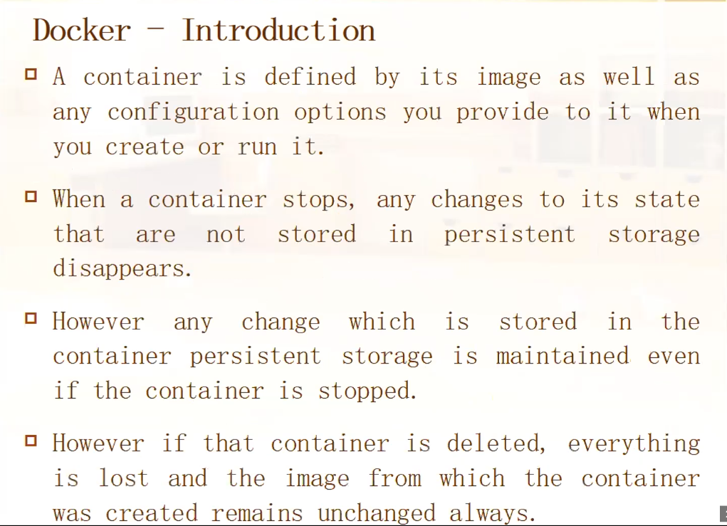

**------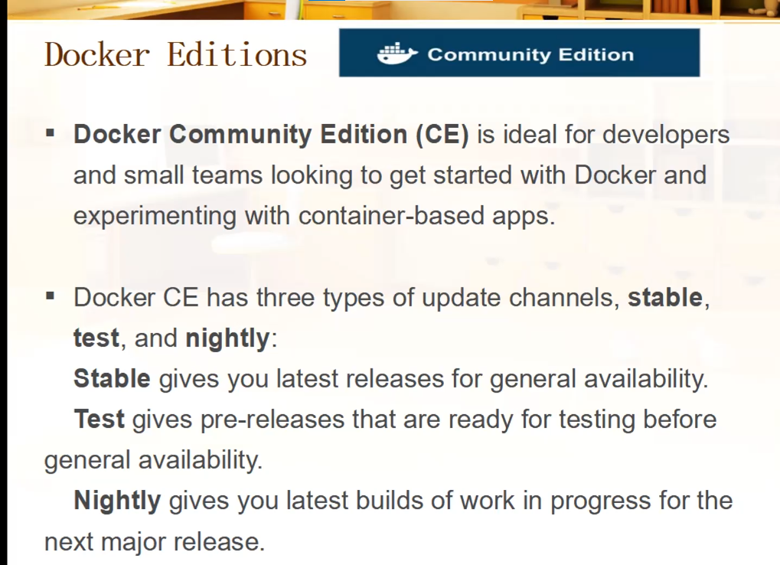------------Docker Installation-------------------------------------------------------**

Run the following command to uninstall all conflicting packages:

**for pkg in docker.io docker-doc docker-compose docker-compose-v2 podman-docker containerd runc; do sudo apt-get remove $pkg; done**

**# Add Docker's official GPG key:**

**sudo apt-get update**

**sudo apt-get install ca-certificates curl gnupg**

**sudo install -m 0755 -d /etc/apt/keyrings**

**curl -fsSL https://download.docker.com/linux/ubuntu/gpg | sudo gpg --dearmor -o /etc/apt/keyrings/docker.gpg**

**sudo chmod a+r /etc/apt/keyrings/docker.gpg**

**# Add the repository to Apt sources:**

**echo \**

**"deb [arch="$(dpkg --print-architecture)" signed-by=/etc/apt/keyrings/docker.gpg] https://download.docker.com/linux/ubuntu \**

**"$(. /etc/os-release && echo "$VERSION_CODENAME")" stable" | \**

**sudo tee /etc/apt/sources.list.d/docker.list > /dev/null**

**sudo apt-get update**

To install the latest version, run:

**sudo apt-get install docker-ce docker-ce-cli containerd.io docker-buildx-plugin docker-compose-plugin**

**sudo docker run hello-world**

**To check Images present in local repo:-**

$ sudo docker images

REPOSITORY TAG IMAGE ID CREATED SIZE

hello-world latest 9c7a54a9a43c 6 months ago 13.3kB

**To check Running Containers:-**

$ sudo docker ps

CONTAINER ID IMAGE COMMAND CREATED STATUS PORTS NAMES

**To download images from Docker hub:**

$ sudo docker pull ubuntu

Using default tag: latest

latest: Pulling from library/ubuntu

aece8493d397: Pull complete

Digest: sha256:2b7412e6465c3c7fc5bb21d3e6f1917c167358449fecac8176c6e496e5c1f05f

Status: Downloaded newer image for ubuntu:latest

docker.io/library/ubuntu:latest

binay@binay:~$ sudo docker images

REPOSITORY TAG IMAGE ID CREATED SIZE

ubuntu latest e4c58958181a 5 weeks ago 77.8MB

hello-world latest 9c7a54a9a43c 6 months ago 13.3kB

To create New Container we use, run command.

$ sudo docker run -ti Ubuntu -----------(-t Allocate a pseudo-TTY, i –interactive and Ubuntu is image name)

root@3b9a0b494599:/# pwd

On new Terminal:

~$ sudo docker ps

CONTAINER ID IMAGE COMMAND CREATED STATUS PORTS NAMES

3b9a0b494599 ubuntu "/bin/bash" 3 minutes ago Up 3 minutes strange_edison

root@3b9a0b494599:/# exit

exit -----------(Container Stopped…….)

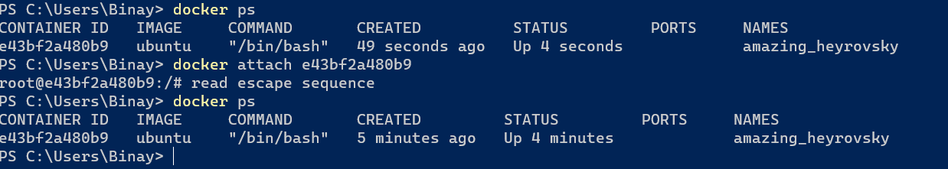If you exit from above container, the container will stop automatic. So to avoid this(To Detach from container) press Ctrl+P followed by Ctrl+Q

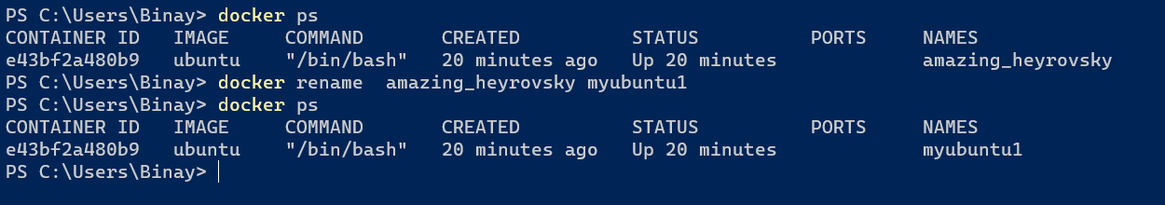To Rename a container:-

$ sudo docker ps

CONTAINER ID IMAGE COMMAND CREATED STATUS PORTS NAMES

$ sudo docker ps -a

CONTAINER ID IMAGE COMMAND CREATED STATUS PORTS NAMES

3b9a0b494599 ubuntu "/bin/bash" 7 minutes ago Exited (0) About a minute ago strange_edison

9a30b4e65ce0 hello-world "/hello" 4 days ago Exited (0) 4 days ago epic_ishizaka

20fa8b400ef9 hello-world "/hello" 4 days ago Exited (0) 4 days ago funny_ramanujan

Now we create centos container without interactive mode.

So when we direct use run command it will look into your local repo for images but if image is not present it will download image.

$ sudo docker run centos

Unable to find image 'centos:latest' locally

latest: Pulling from library/centos

a1d0c7532777: Pull complete

Digest: sha256:a27fd8080b517143cbbbab9dfb7c8571c40d67d534bbdee55bd6c473f432b177

Status: Downloaded newer image for centos:latest

$ sudo docker ps

CONTAINER ID IMAGE COMMAND CREATED STATUS PORTS NAMES

binay@binay:~$ sudo docker ps -a

CONTAINER ID IMAGE COMMAND CREATED STATUS PORTS NAMES

43c36af3c8c7 centos "/bin/bash" 34 seconds ago Exited (0) 32 seconds ago elated_nash

3b9a0b494599 ubuntu "/bin/bash" 9 minutes ago Exited (0) 3 minutes ago strange_edison

Container is just executing. It is just a environment. It is the image which tells container to what executes. This images are configured to execute bash shell.

**To Delete a Container:- docker rm <container id>**

$ sudo docker ps -a

CONTAINER ID IMAGE COMMAND CREATED STATUS PORTS NAMES

43c36af3c8c7 centos "/bin/bash" 2 hours ago Exited (0) 2 hours ago elated_nash

3b9a0b494599 ubuntu "/bin/bash" 3 hours ago Exited (0) 2 hours ago strange_edison

9a30b4e65ce0 hello-world "/hello" 4 days ago Exited (0) 4 days ago epic_ishizaka

20fa8b400ef9 hello-world "/hello" 4 days ago Exited (0) 4 days ago funny_ramanujan

binay@binay:~$ sudo docker rm 43c36af3c8c7

43c36af3c8c7

binay@binay:~$ sudo docker ps -a

CONTAINER ID IMAGE COMMAND CREATED STATUS PORTS NAMES

3b9a0b494599 ubuntu "/bin/bash" 3 hours ago Exited (0) 2 hours ago strange_edison

9a30b4e65ce0 hello-world "/hello" 4 days ago Exited (0) 4 days ago epic_ishizaka

20fa8b400ef9 hello-world "/hello" 4 days ago Exited (0) 4 days ago funny_ramanujan

**Images are read only.**

**To delete a Image, if any container is not using those image then we can delete those image.**

**docker rmi <image id>**

$ sudo docker images

REPOSITORY TAG IMAGE ID CREATED SIZE

ubuntu latest e4c58958181a 5 weeks ago 77.8MB

hello-world latest 9c7a54a9a43c 6 months ago 13.3kB

centos latest 5d0da3dc9764 2 years ago 231MB

binay@binay:~$ sudo docker rmi hello-world

Error response from daemon: conflict**: unable to remove repository reference "hello-world" (must** force) - container 20fa8b400ef9 is using its referenced image 9c7a54a9a43c

So first we have to delete those containers which are using hello-world image.

binay@binay:~$ sudo docker ps -a

CONTAINER ID IMAGE COMMAND CREATED STATUS PORTS NAMES

3b9a0b494599 ubuntu "/bin/bash" 3 hours ago Exited (0) 3 hours ago strange_edison

9a30b4e65ce0 hello-world "/hello" 4 days ago Exited (0) 4 days ago epic_ishizaka

20fa8b400ef9 hello-world "/hello" 4 days ago Exited (0) 4 days ago funny_ramanujan

binay@binay:~$ sudo docker rm 9a30b4e65ce0

9a30b4e65ce0

binay@binay:~$ sudo docker rm 20fa8b400ef9

20fa8b400ef9

binay@binay:~$ sudo docker ps -a

CONTAINER ID IMAGE COMMAND CREATED STATUS PORTS NAMES

3b9a0b494599 ubuntu "/bin/bash" 3 hours ago Exited (0) 3 hours ago strange_edison

**Now** We **will delete image**

binay@binay:~$ sudo docker rmi hello-world

Untagged: hello-world:latest

Untagged: hello-world@sha256:88ec0acaa3ec199d3b7eaf73588f4518c25f9d34f58ce9a0df68429c5af48e8d

Deleted: sha256:9c7a54a9a43cca047013b82af109fe963fde787f63f9e016fdc3384500c2823d

Deleted: sha256:01bb4fce3eb1b56b05adf99504dafd31907a5aadac736e36b27595c8b92f07f1

**To Start and End a container:-**

# docker ps -a

CONTAINER ID IMAGE COMMAND CREATED STATUS PORTS NAMES

3b9a0b494599 ubuntu "/bin/bash" 3 hours ago Exited (0) 3 hours ago strange_edison

root@binay:~# docker start 3b9a0b494599

3b9a0b494599

root@binay:~# docker ps

CONTAINER ID IMAGE COMMAND CREATED STATUS PORTS NAMES

3b9a0b494599 ubuntu "/bin/bash" 3 hours ago Up 3 seconds strange_edison

root@binay:~# docker stop 3b9a0b494599

3b9a0b494599

root@binay:~# docker ps

CONTAINER ID IMAGE COMMAND CREATED STATUS PORTS NAMES

root@binay:~#

**To get shell of running Container-**

#docker ps

CONTAINER ID IMAGE COMMAND CREATED STATUS PORTS NAMES

3b9a0b494599 ubuntu "/bin/bash" 3 hours ago Up 2 seconds strange_edison

root@binay:~# docker attach 3b9a0b494599

root@3b9a0b494599:/#

**But when we exit from shell, the container will be stop. (Default Behavior- Remember Very careful)**

/# exit

exit

root@binay:~# docker ps

CONTAINER ID IMAGE COMMAND CREATED STATUS PORTS NAMES

root@binay:~#

**To run command inside a container without Getting Shell:-**

**# docker exec <conainer id or name> <command>**

#docker ps

CONTAINER ID IMAGE COMMAND CREATED STATUS PORTS NAMES

3b9a0b494599 ubuntu "/bin/bash" 4 hours ago Up 4 seconds strange_edison

root@binay:~# docker exec 3b9a0b494599 ls

bin

boot

dev

**To copy a file from local machine to Container:-**

vi one.txt

root@binay:~# cat one.txt

this file is inside containe.

root@binay:~# docker cp one.txt 3b9a0b494599:/test

Successfully copied 2.05kB to 3b9a0b494599:/test (Here one.txt copied inside /test

root@binay:~# docker cp one.txt 3b9a0b494599:/data (here /data was not available so it created file named data but it will conatin data of your local file one.txt

Successfully copied 2.05kB to 3b9a0b494599:/data

oot@binay:~# docker exec 3b9a0b494599 cat /data

this file is inside containe.

**Container to local machine:-**

# docker cp myapp1:/container.txt .

Successfully copied 2.05kB to /root/.

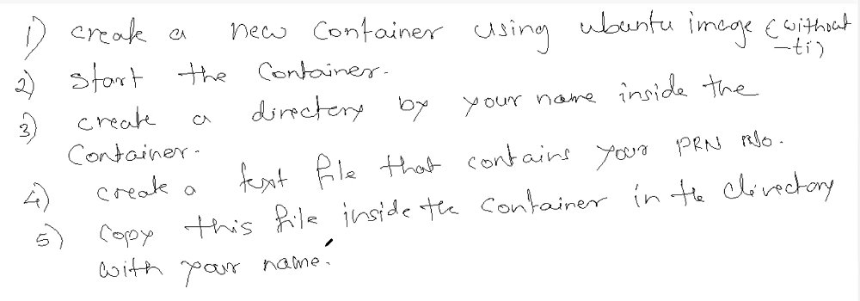**Assignment:-**

1. **Creating new Container named myapp1 using Ubuntu image(without ti option):-**

docker run --name myapp1 ubuntu

root@binay:~# docker ps -a

CONTAINER ID IMAGE COMMAND CREATED STATUS PORTS NAMES

802453ebefee ubuntu "/bin/bash" 3 seconds ago Exited (0) 2 seconds ago myapp1

1. **Starting container:-**

~# docker start myapp1

myapp1

root@binay:~# docker ps -a

CONTAINER ID IMAGE COMMAND CREATED STATUS PORTS NAMES

802453ebefee ubuntu "/bin/bash" 2 minutes ago Exited (0) 1 second ago myapp1

In first step, we created container without interactive option. Ubuntu or centos run bash command which requires interactive shell. That’s why, when we start above container got exited. So delete above container and create new container with interactive option. Other container do not required interactive session.

~# docker run -ti --name myapp1 ubuntu

root@05b63540f2fb:/# exit

exit

root@binay:~# docker ps

CONTAINER ID IMAGE COMMAND CREATED STATUS PORTS NAMES

root@binay:~# docker ps -a

CONTAINER ID IMAGE COMMAND CREATED STATUS PORTS NAMES

05b63540f2fb ubuntu "/bin/bash" 32 seconds ago Exited (0) 6 seconds ago myapp1

root@binay:~#

**Starting the container:-**

docker start myapp1

myapp1

root@binay:~# docker ps

CONTAINER ID IMAGE COMMAND CREATED STATUS PORTS NAMES

05b63540f2fb ubuntu "/bin/bash" About a minute ago Up 6 seconds myapp1

root@binay:~#

1. **Creating a directory inside a conatainer:-**

# docker exec myapp1 mkdir /binay

root@binay:~# docker exec myapp1 ls

bin

binay

1. **Creating a local file and copying to container:-**

# docker cp one.txt myapp1:/binay

Successfully copied 2.05kB to myapp1:/binay

root@binay:~# docker exec myapp1 cat /binay/one.txt

this file is inside container.

**HTTPD:**

**# docker pull httpd**

**Using default tag: latest**

**When we host website inside container, every container will have ip. So on those ip and port no 80 will be mapped but we can not access content through container ip. So we will map container port to any port of your machine. Ex.in container , webser is running on port no 80 so we can map on machine to any port like 8000 or 8080 (Own choice.)**

**Below 8000 is external port and 80 is conatiner’s port.**

# docker run --name web1 -p 8000:80 httpd

AH00558: httpd: Could not reliably determine the server's fully qualified domain name, using 172.17.0.2. Set the 'ServerName' directive globally to suppress this message

AH00558: httpd: Could not reliably determine the server's fully qualified domain name, using 172.17.0.2. Set the 'ServerName' directive globally to suppress this message

[Fri Nov 17 17:30:34.541832 2023] [mpm_event:notice] [pid 1:tid 139622624925568] AH00489: Apache/2.4.58 (Unix) configured -- resuming normal operations

[Fri Nov 17 17:30:34.541987 2023] [core:notice] [pid 1:tid 139622624925568] AH00094: Command line: 'httpd -D FOREGROUND'

-- resuming normal operations

[Fri Nov 17 17:30:34.541987 2023] [core:notice] [pid 1:tid 139622624925568] AH00094: Command line: 'httpd -D FOREGROUND'

192.168.142.128 - - [17/Nov/2023:17:31:30 +0000] "GET / HTTP/1.1" 200 45

192.168.142.128 - - [17/Nov/2023:17:31:30 +0000] "GET /favicon.ico HTTP/1.1" 404 196

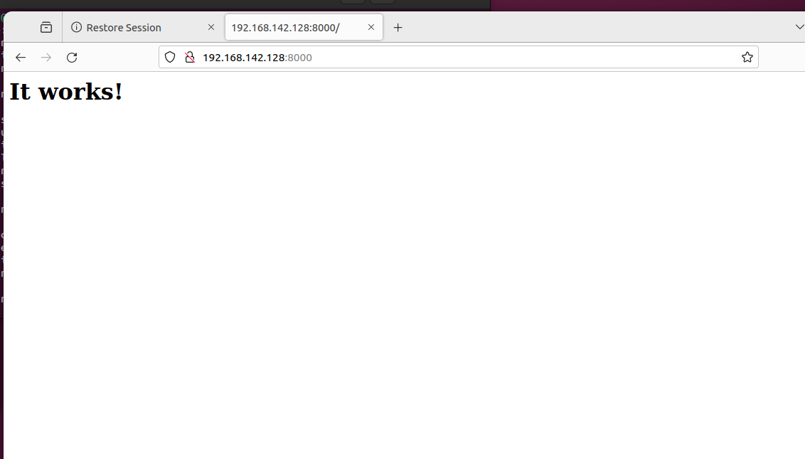

Location: /usr/local/apache2/htdocs -🡪 here apache looks for web pages.

**Press control + c to exit from container. Then container will stop. So we have to start manually container.**

# docker ps -a

CONTAINER ID IMAGE COMMAND CREATED STATUS PORTS NAMES

b025ae2d20b2 httpd "httpd-foreground" 20 minutes ago Up 3 seconds 0.0.0.0:8000->80/tcp, :::8000->80/tcp web1

05b63540f2fb ubuntu "/bin/bash" 23 hours ago Exited (0) 5 hours ago myapp1

# cat index.html

this is web1 inside container1.

# docker cp index.html web1:/usr/local/apache2/htdocs

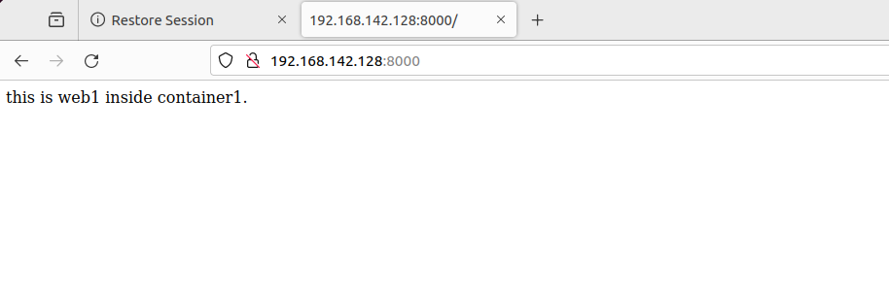Successfully copied 2.05kB to web1:/usr/local/apache2/htdocs

**So In above process, whenever we create container, we have to create index.html file and copy to /usr/local/apache2/htdocs. And if we want to modify contents then again we have to copy index.html to ALL containers. So to avoid this, we will mount /usr/local/apache2/htdocs to our own directory. So we will modify index.html which is inside our own directory, it will reflect to all containers.**

# mkdir /webdata

root@binay:~# cd /webdata/

root@binay:/webdata# vi index.html

root@binay:/webdata# docker run --name web2 -d -p 9000:80 -v /webdata/:/usr/local/apache2/htdocs/ httpd

befff73b82b06d65489365f508f47d177605057b5554b0d9ac7f419649815c23

In above command:-

-d: it will run container in background not in forground

-p: port

-v : Volume (map /webdata directory to /usr/.……/htdocs

Httpd:- image name

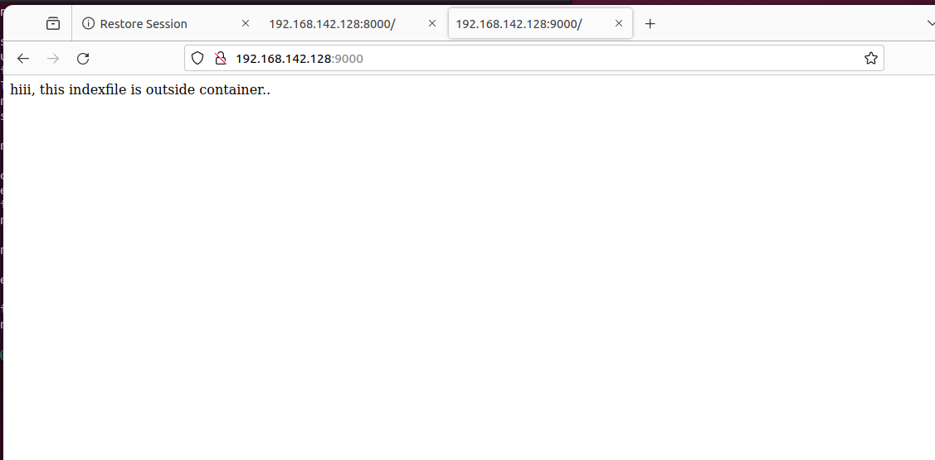

Now I will modify index.html

root@binay:/webdata# vi index.html

root@binay:/webdata#

:/webdata# docker run --name web3 -d -p 9001:80 -v /webdata/:/usr/local/apache2/htdocs/ httpd

4f1162627452eac14297e575f156b166bd5a10ba580f4827892aed563fc831fd

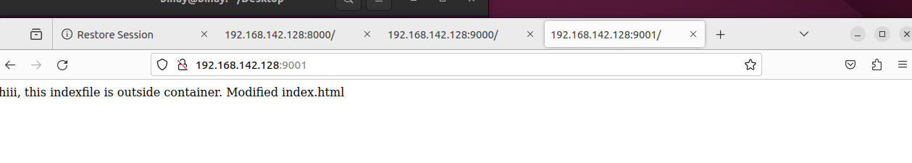

So similarly we can create multiple containers who will access machine’s index.html file.

**Script:**

#!/bin/bash

#To Create Multiple Httpd Container which uses one index.html file.

read -p "Please Enter No of containers you want to create:- " n

for (( i=1; i<=$n; i++ ))

do

docker run --name web$i -d -p 800$i:80 -v /webdata:/usr/local/apache2/htdocs/ httpd &> /dev/null

echo "Web$i Created.."

done

echo "No of Containers are running:-"

docker ps

**~**

bash multi_container.sh

Please Enter No of containers you want to create:- 5

Web1 Created..

Web2 Created..

Web3 Created..

Web4 Created..

Web5 Created..

No of Containers are running:-

CONTAINER ID IMAGE COMMAND CREATED STATUS PORTS NAMES

85f883fe03fc httpd "httpd-foreground" Less than a second ago Up Less than a second 0.0.0.0:8005->80/tcp, :::8005->80/tcp web5

a953d59f0954 httpd "httpd-foreground" 1 second ago Up Less than a second 0.0.0.0:8004->80/tcp, :::8004->80/tcp web4

461755843c67 httpd "httpd-foreground" 1 second ago Up Less than a second 0.0.0.0:8003->80/tcp, :::8003->80/tcp web3

485c7c9a4bfd httpd "httpd-foreground" 2 seconds ago Up 1 second 0.0.0.0:8002->80/tcp, :::8002->80/tcp web2

eccfa65f1d90 httpd "httpd-foreground" 2 seconds ago Up 2 seconds 0.0.0.0:8001->80/tcp, :::8001->80/tcp web1

root@binay:/webdata#

**To Delete all running container one by one:-**

for i in `docker ps | awk '{print $12}'`

> do

> docker stop $i

> docker rm $i

> done

web5

web5

web4

web4

web3

web3

web2

web2

web1

web1

**Docker inspect is a tool that enables you do get detailed information about your docker resources, such as containers, images, volumes, networks, tasks and services.**

# docker inspect web1

"SandboxKey": "/var/run/docker/netns/b8eb46afb3cf",

"SecondaryIPAddresses": null,

"SecondaryIPv6Addresses": null,

"EndpointID": "cb03b0eb8d70efd5e37ceff5f25975d2d220bc7cf02b28837e379be0be60c677",

"Gateway": "172.17.0.1",

"GlobalIPv6Address": "",

"GlobalIPv6PrefixLen": 0,

"IPAddress": "**172.17.0.2**", (ip add of container)

"IPPrefixLen": 16,

"IPv6Gateway": "",

"MacAddress": "02:42:ac:11:00:02",

"Networks": {

"bridge": {

"IPAMConfig": null,

"Links": null,

"Aliases": null,

"NetworkID": "22746b7ac00bd521623ea99006ca1f8fddea0952fce172246bd6a6cdc7c92a54",

"EndpointID": "cb03b0eb8d70efd5e37ceff5f25975d2d220bc7cf02b28837e379be0be60c677",

"Gateway": "172.17.0.1",

"IPAddress": "172.17.0.2",

"IPPrefixLen": 16,

"IPv6Gateway": "",

"GlobalIPv6Address": "",

"GlobalIPv6PrefixLen": 0,

"MacAddress": "02:42:ac:11:00:02",

"DriverOpts": null

}

}

}

}

]

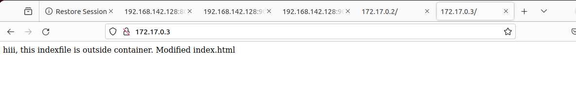Inside our linux machine, we can access container’s web page using container’s ip

**Creating our Own image:-**

To create our own image, we have to write a Dockerfile.

# vi Dockerfile

root@binay:/webdata# cat Dockerfile

From ubuntu

CMD [ "/bin/ls" ]

root@binay:/webdata# docker build -t myimage:1.0 .

[+] Building 1.3s (5/5) FINISHED docker:default

=> [internal] load build definition from Dockerfile 0.5s

=> => transferring dockerfile: 67B 0.3s

=> [internal] load .dockerignore 0.5s

=> => transferring context: 2B 0.2s

=> [internal] load metadata for docker.io/library/ubuntu:latest 0.0s

=> [1/1] FROM docker.io/library/ubuntu 0.1s

=> exporting to image 0.1s

=> => exporting layers 0.0s

=> => writing image sha256:96f0431bbafbabb500b3ee210da3c1aaa9cb96188c043643f96e6e789b167e24 0.0s

=> => naming to docker.io/library/myimage:1.0 0.0s

root@binay:/webdata# docker images

REPOSITORY TAG IMAGE ID CREATED SIZE

myimage 1.0 96f0431bbafb 6 weeks ago 77.8MB

Second Image:

# vi Dockerfile

# cat Dockerfile

From ubuntu

RUN mkdir /sc

COPY sc1.sh /sc

CMD [ "/sc/sc1.sh" ]

root@binay:/webdata# docker build -t script1 .

[+] Building 1.5s (8/8) FINISHED docker:default

=> [internal] load build definition from Dockerfile 0.0s

=> => transferring dockerfile: 101B 0.0s

=> [internal] load .dockerignore 0.0s

=> => transferring context: 2B 0.0s

=> [internal] load metadata for docker.io/library/ubuntu:latest 0.0s

=> CACHED [1/3] FROM docker.io/library/ubuntu 0.0s

=> [internal] load build context 0.0s

=> => transferring context: 101B 0.0s

=> [2/3] RUN mkdir /sc 1.0s

=> [3/3] COPY sc1.sh /sc 0.1s

=> exporting to image 0.2s

=> => exporting layers 0.2s

=> => writing image sha256:1497ffa72d786df84212048c94923d96a77acd48be6b9a9fee38d4ca7764c551 0.0s

=> => naming to docker.io/library/script1 0.0s

root@binay:/webdata# docker ps

CONTAINER ID IMAGE COMMAND CREATED STATUS PORTS NAMES

root@binay:/webdata# docker images

REPOSITORY TAG IMAGE ID CREATED SIZE

script1 latest 1497ffa72d78 15 seconds ago 77.8MB

**# docker run --name myscript script1**

Hello .

But it’s not interactive . So we have to use –i option to create container.

Assignment:

-Write a python program that 2 numbers from user and display the sum.

-Create an image for above program and test image by running it.

Step1: **Creating Dockerfile:-**

#cat Dockerfile

FROM ubuntu

RUN mkdir /py

#WORKDIR /py

COPY sum.py /py

RUN apt update

RUN apt install python3 -y

CMD [ "/py/sum.py" ]

Step 2**: Docker Build:-**

# docker build -t pyscript1 .

# docker images

REPOSITORY TAG IMAGE ID CREATED SIZE

app1 latest ab261c699135 18 hours ago 154MB

app3 latest 10f5af5427bc 19 hours ago 154MB

pyscript1 latest 10f5af5427bc 19 hours ago 154MB

Step3: **Creating Container:-**

# docker run -i --name conatiner1 pyscript1

Enter a number: 23

Enter a number: 12

Sum is 35

------------------------------------------------------------------------------------------------

Till now, we were creating images using Dockerfile. Now we will create images

Using container.

**Now Create a container using Ubuntu image:-**

# docker run --name ub1 -ti ubuntu

root@79fe71f8b62b:/# ls

bin boot dev etc home lib lib32 lib64 libx32 media mnt opt proc root run sbin srv sys tmp usr var

root@79fe71f8b62b:/# mkdir /script

# apt update

# apt install python3

Note: Now we got a shell of a container. But we cannot directly copy our script which is outside of container to container. So we will open new terminal and will copy to container.

**On new Terminal:-**

cd /webdata/

binay@binay:/webdata$ docker cp sum.py ub1:/script

**Copied to Container………**

root@79fe71f8b62b:/# ls /script/

sum.py

Now Exit From container and we have to save the container as image.

Data is inside the container, if we delete the container, data will be lost.

So to create an image form container we use **docker commit**

# docker commit

"docker commit" requires at least 1 and at most 2 arguments.

See 'docker commit --help'.

Usage: docker commit [OPTIONS] CONTAINER [REPOSITORY[:TAG]]

**Create a new image from a container's changes**

**Below ub1 is container name**

# docker commit ub1 pyscript2:01

sha256:dc98210801bff1a067c5ddd6936116961f34f92b6892c58eb11956d31d407257

root@binay:/webdata# docker images

REPOSITORY TAG IMAGE ID CREATED SIZE

pyscript2 01 dc98210801bf 9 seconds ago 154MB

Now we can remove container ub1

And we will create containers form image which we created.

# docker run pyscript2:01

root@binay:/webdata# docker ps

CONTAINER ID IMAGE COMMAND CREATED STATUS PORTS NAMES

root@binay:/webdata# docker ps -a

CONTAINER ID IMAGE COMMAND CREATED STATUS PORTS NAMES

ddd67d29fa69 pyscript2:01 "/bin/bash" 7 seconds ago Exited (0) 6 seconds ago wonderful_snyder

In docker ps command’s output, there is no running container running pyscript2 because there was no way to specify a command what to execute.

So by default Ubuntu executing /bin/bash.

So to run my container, I have to provide manually command like this:

root@binay:/webdata# **docker run -i pyscript2:01 ./script/sum.py**

Enter a number: 34

Enter a number: 23

Sum is 57

So this is the way we can create images from container but we cannot mark them to execute our command. We have to provide command manually.

That’s why we use Dockerfile. Because In dockerfile we can specify CMD

And whenever we run our image that application will always execute.

**Docker Network :**

In docker, Each Container gets different ip address. There is an adapter gets created that is like virtual switch which provide ips to containers. The default network adapter contains dhcp (like nat) which provide ips. So let’s assume we have three containers. Assigned ips are …3 , …4 and …5 to container1,2&3 respectively. Now Container 1 & 3 Goes down. And we start container3 so ip of container3 …3 will be assigned to container 5 and then we start container 1 . SO previpous ip of container3 will be assigned. So its quite difficult to communicate between containers. So we use dns to communicate . But Default Adapter doesn’t have DNS. So we have to create our own adapter.

**# docker network create ditis1**

8d3ded103b59b841c8a8f4488412807873a7ffa9803f6a9abb328617f6ae6483

root@binay:/webdata# docker network ls

NETWORK ID NAME DRIVER SCOPE

22746b7ac00b bridge bridge local

8d3ded103b59 ditis1 bridge local

Now **Creating New Container with new Network:-**

**# docker run --name ub2 --network ditis1 -ti ubuntu**

root@f786772d4cf6:/#

Now we will see ip of container ub2 on different terminal using inspect command:-

# docker inspect ub2

"Gateway": "172.18.0.1",

"IPAddress": "172.18.0.2",

"IPPrefixLen": 16,

"IPv6Gateway": "",

"GlobalIPv6Address": "",

"GlobalIPv6PrefixLen": 0,

"MacAddress": "02:42:ac:12:00:02",

"DriverOpts": null

=============================================================

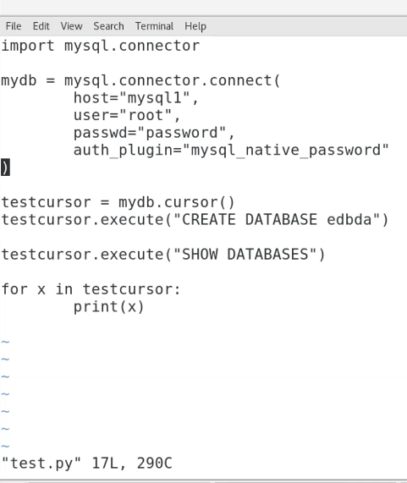

#cat test.py

import mysql.connector

mydb = mysql.connector.connect(

host="mysqldb",

user="root",

passwd="password",

auth_plugin="mysql_native_password"

)

testcursor = mydb.cursor()

testcursor.execute("CREATE DATABASE ditiss")

testcursor.execute("SHOW DATABASES")

for x in testcursor:

print(x)

#cat Dockerfile

FROM python:3.7-buster

RUN pip install mysql-connector-python

RUN mkdir /test

COPY test.py /test

CMD ["python", "/test/test.py" ]

Creating Image:

#**docker build -t py-mysql .**

[+] Building 101.9s (9/9) FINISHED

#docker images

REPOSITORY TAG IMAGE ID CREATED SIZE

py-mysql latest b0ce81c83460 About a minute ago 1.01GB

# docker pull mysql

# docker network ls

NETWORK ID NAME DRIVER SCOPE

22746b7ac00b bridge bridge local

8d3ded103b59 ditis1 bridge local

3e305900a9d0 host host local

82222d793c1f none null local

Creating Container:

In below command,

-d:- Detach

-e:- Environment

root@binay:/webdata# docker run --name mysqldb -d -e MYSQL_ROOT_PASSWORD=password --network ditis1 mysql

46933777c5c87d81afba707b934d04a3aa32abdd918599b2a57a47f506399028

root@binay:/webdata#

# docker ps

CONTAINER ID IMAGE COMMAND CREATED STATUS PORTS NAMES

46933777c5c8 mysql "docker-entrypoint.s…" About a minute ago Up About a minute 3306/tcp, 33060/tcp mysqldb

root@binay:/webdata#

Creating Container:

# **docker run --name p1 --network ditis1 py-mysql**

('ditiss',)

('information_schema',)

('mysql',)

('performance_schema',)

('sys',)

++++++++++++++++++++++++++++++++++++++++++++++++++++++++++++++

To push docker image to Dockerhub:-

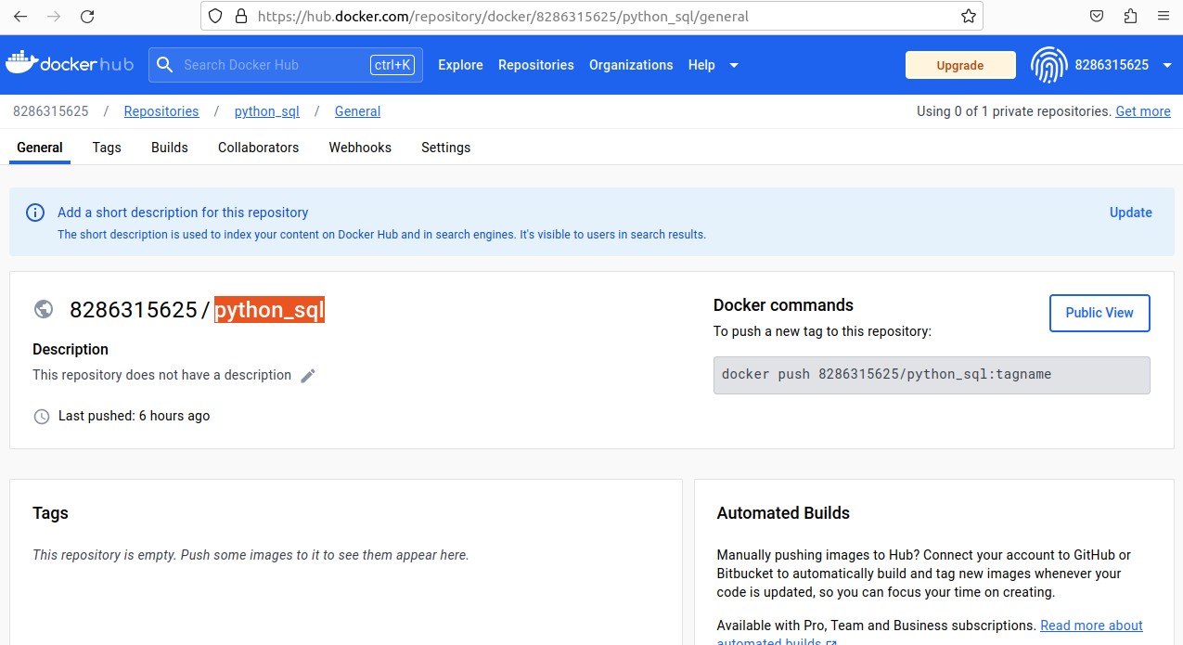Step1: Create a repo on Dockurhub

Step2: Rename your image same as repo name

# docker images

REPOSITORY TAG IMAGE ID CREATED SIZE

py-mysql latest 0ac60838db91 16 hours ago 1.01GB

# **docker tag py-mysql 8286315625/python_sql**

#docker images

REPOSITORY TAG IMAGE ID CREATED SIZE

8286315625/python_sql latest 0ac60838db91 16 hours ago 1.01GB

# **docker push 8286315625/python_sql**

Using default tag: latest

The push refers to repository [docker.io/8286315625/python_sql]

Step3: login to your Dockerhub Account:-

# docker login

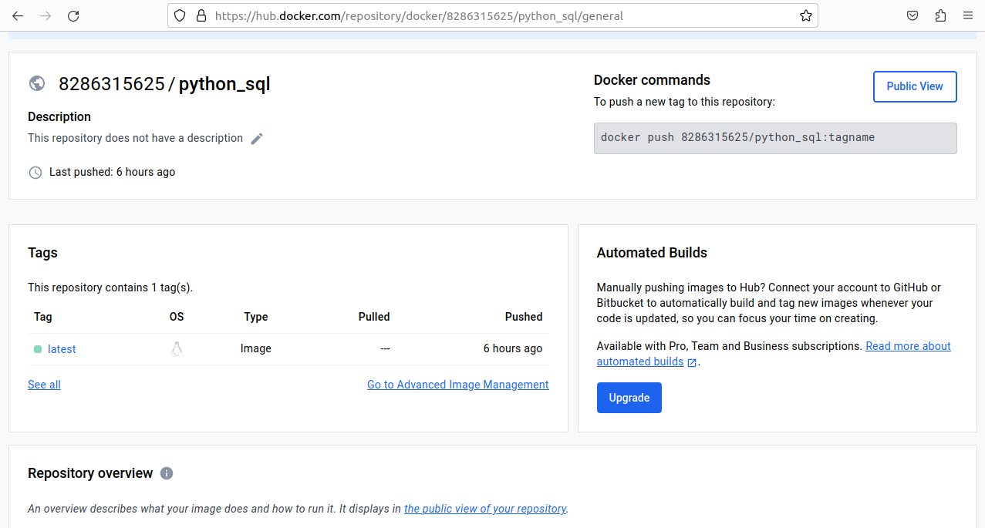# docker push 8286315625/python_sql

DOCKER COMPOSE:---

]# cat myfirst.yaml

services:

web:

image: "nginx"

container_name: apache2

ports:

- "80:80"

volumes:

- /root:/usr/share/nginx/html

web2:

image: "httpd"

container_name: nginx

ports:

- "81:80"

volumes:

- /root:/usr/local/apache2/htdocs

#docker compose -f myfirst.yaml up -d

#chmod 755 /root

Interview Questions:

What is command to create a container with bash shell?

docker run -it --name my-ubuntu-container ubuntu /bin/bash (For ubuntu image)

docker run -it --name my-ubuntu-container ubuntu /bin/bash