To run a single commands on terminal:-

$ ruby -e 'puts "hello to Ruby"'

hello to Ruby

To run through a file:

cat myfirst.rb

#!/usr/bin/ruby

puts "welcome to ruby programming0."

binay@LAPTOP-D4EUDO0E:/mnt/d/Ruby$ ruby myfirst.rb

welcome to ruby programming0.

Interactive Mode:-

$ irb

irb(main):001:0> quit

binay@LAPTOP-D4EUDO0E:/mnt/d/Ruby$ irb --simple-prompt

>> puts "welcome to ruby"

welcome to ruby

=> nil #(Every line in ruby code, return something, here it returning nil)

>> 1+1

=> 2

>> 3\*3

=> 9

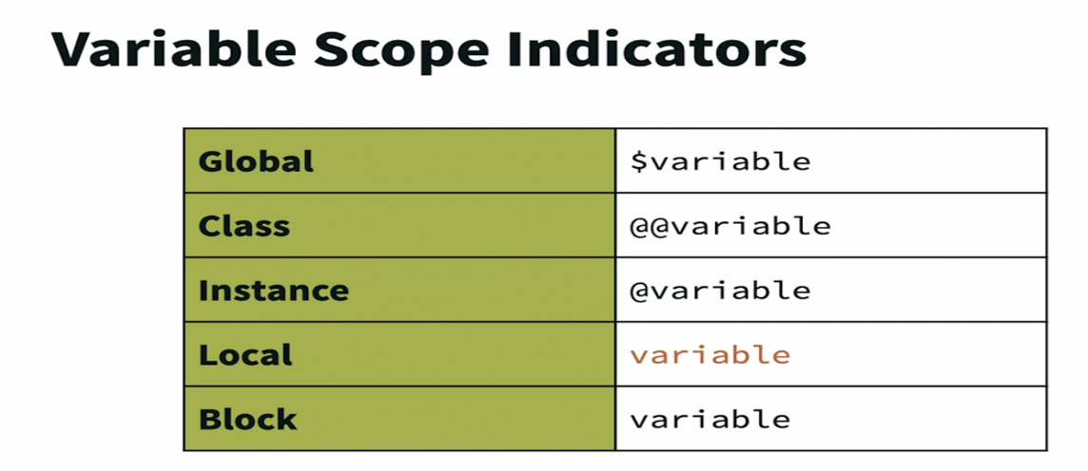

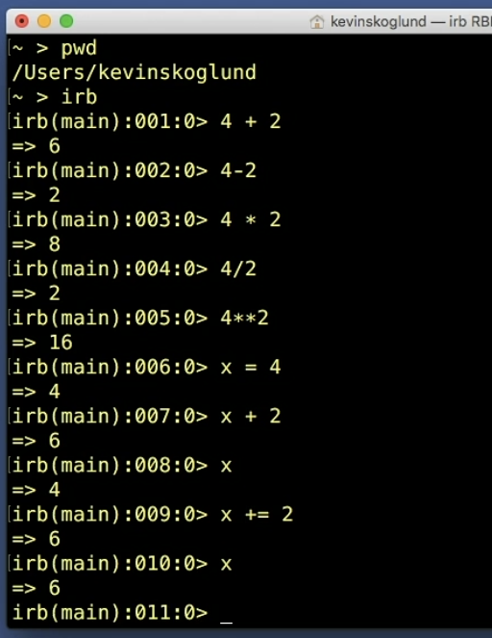Numbers:-