**Programming Assignment 2 (50 points)**

1. (25 points) Implement the best search algorithm as the modified Dijkstra’s shortest path algorithm, where it returns a shortest path from a source to a target. The pseudo code is given below:

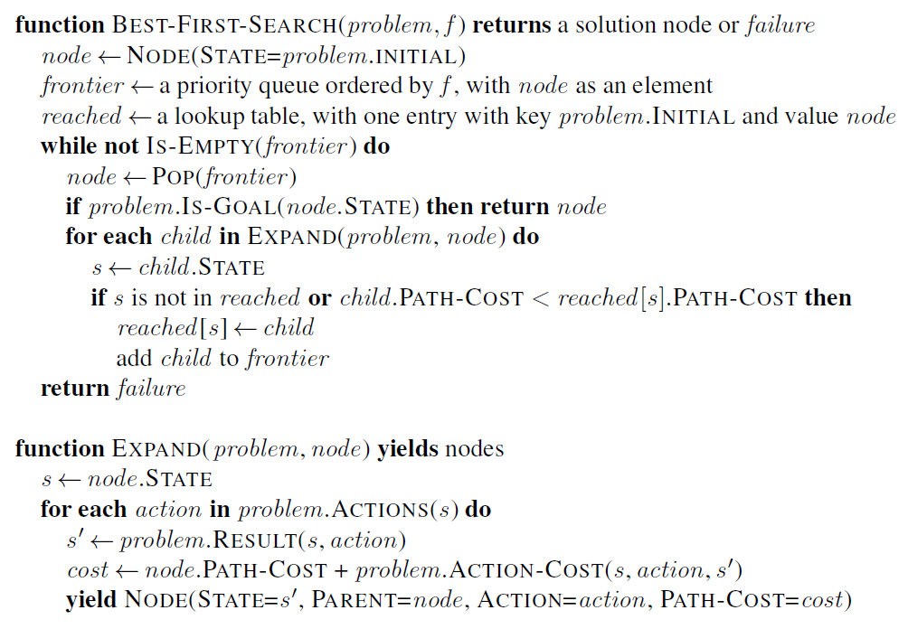

You are provided with a python file that contains some existing code. DO NOT MAKE CHANGES TO THE CODE. Simply complete your implementation for the two functions using the file and then provide, at least, 5 test cases. The expected outcome for the testing case, where Arad is the source and Bucharest is the target, should look like:

['Arad', 'Sibiu', 'Rimnicu Vilcea', 'Pitesti', 'Bucharest'] 418

Your program should be able to display the outcomes in the format above.

1. 25 points) Modify the PathFindingAgent class so that the agent can return better results. Specifically, the modified code should meet the following two requirements:
   1. The agent should no longer visit the cities that have been visited.
   2. The agent should perform the search based on a budget constraint. This means the solve method will have one more parameter called budget. And the search result should include a cost that is lower or equal to a given budget. If the budget is too low, the method should stop after a few tries and display a message telling users to increase the budget.