1. **GIT Documentation:**

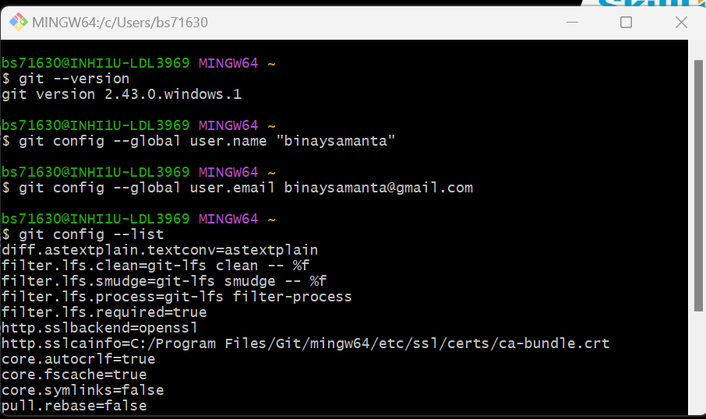

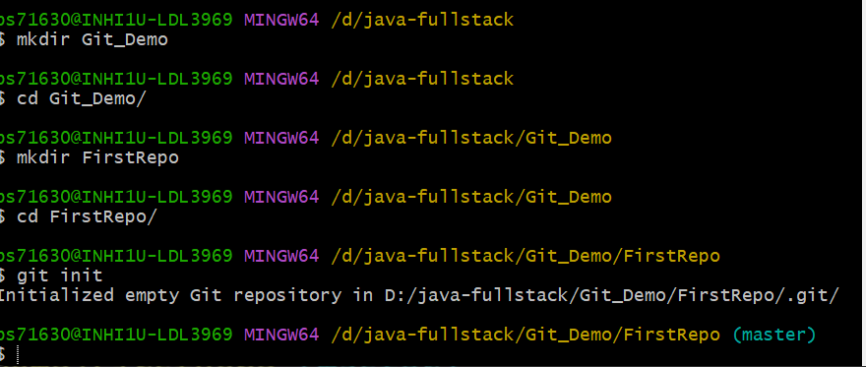

$ touch master.txt

$ notepad master.txt

$ git status

$ git add .

$ git commit -m "This is first commit"

$ git log

$ touch master1.txt

$ notepad master1.txt

$ git status

$ git add .

$ git commit -m "This is second commit"

$ git log

**//To connect github repo**

$ git remote add origin https://github.com/binaysamanta/FirstRepo.git

$ git remote -v

**$** git push -u origin master

**//To generate SSH key and connect**

(Git_Demo)$ ssh-keygen -t rsa -C [binaysamanta@gmail.com](mailto:binaysamanta@gmail.com)

(Git_Demo)$ ssh -T [git@github.com](mailto:git@github.com)

**//To fresh copy of server repo into local**

$ git clone Server_Repo_URL

**//Create a branch and switch to branch**

bs71630@INHI1U-LDL3969 MINGW64 /d/java-fullstack/Git_Demo

$ mkdir Org_Details

bs71630@INHI1U-LDL3969 MINGW64 /d/java-fullstack/Git_Demo

$ cd Org_Details/

bs71630@INHI1U-LDL3969 MINGW64 /d/java-fullstack/Git_Demo/Org_Details

$ git init

Initialized empty Git repository in D:/java-fullstack/Git_Demo/Org_Details/.git/

bs71630@INHI1U-LDL3969 MINGW64 /d/java-fullstack/Git_Demo/Org_Details (master)

$ notepad name.txt

bs71630@INHI1U-LDL3969 MINGW64 /d/java-fullstack/Git_Demo/Org_Details (master)

$ notepad employee.txt

bs71630@INHI1U-LDL3969 MINGW64 /d/java-fullstack/Git_Demo/Org_Details (master)

$ git add .

bs71630@INHI1U-LDL3969 MINGW64 /d/java-fullstack/Git_Demo/Org_Details (master)

$ git commit -m "First commit"

bs71630@INHI1U-LDL3969 MINGW64 /d/java-fullstack/Git_Demo/Org_Details (master)

$ git branch kolkata_branch

bs71630@INHI1U-LDL3969 MINGW64 /d/java-fullstack/Git_Demo/Org_Details (master)

$ git branch -v

kolkata_branch 38e0a68 First commit

* master 38e0a68 First commit

bs71630@INHI1U-LDL3969 MINGW64 /d/java-fullstack/Git_Demo/Org_Details (master)

$ git checkout kolkata_branch

Switched to branch 'kolkata_branch'

bs71630@INHI1U-LDL3969 MINGW64 /d/java-fullstack/Git_Demo/Org_Details (kolkata_branch)

$

bs71630@INHI1U-LDL3969 MINGW64 /d/java-fullstack/Git_Demo/Org_Details (kolkata_branch)

$ notepad address.txt

bs71630@INHI1U-LDL3969 MINGW64 /d/java-fullstack/Git_Demo/Org_Details (kolkata_branch)

$ git add .

bs71630@INHI1U-LDL3969 MINGW64 /d/java-fullstack/Git_Demo/Org_Details (kolkata_branch)

$ git commit -m "kolkata branch commit"

**Note: - Now create new repository in github.com with name “Org_Details”**

bs71630@INHI1U-LDL3969 MINGW64 /d/java-fullstack/Git_Demo/Org_Details (kolkata_branch)

$ git remote add origin <https://github.com/binaysamanta/Org_Details.git>

bs71630@INHI1U-LDL3969 MINGW64 /d/java-fullstack/Git_Demo/Org_Details (kolkata_branch)

$ git checkout master

bs71630@INHI1U-LDL3969 MINGW64 /d/java-fullstack/Git_Demo/Org_Details (master)

$ git push -u origin master

bs71630@INHI1U-LDL3969 MINGW64 /d/java-fullstack/Git_Demo/Org_Details (master)

$ git push -u origin Kolkata_branch

**//Now merging file from Kolkata_branch to master branch**

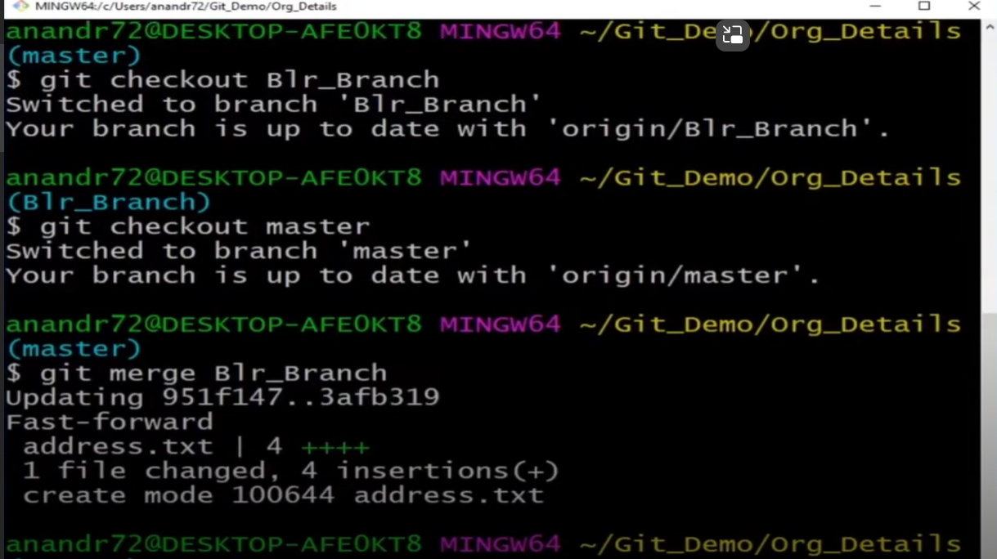

bs71630@INHI1U-LDL3969 MINGW64 /d/java-fullstack/Git_Demo/Org_Details (master)

$ git push origin master

**//To delete branch**

bs71630@INHI1U-LDL3969 MINGW64 /d/java-fullstack/Git_Demo/Org_Details (master)

$ git push origin –-delete Kolkata_branch