<https://www.youtube.com/watch?v=AiiFbsAlLaI>

**Step0: Nodejs routes below**

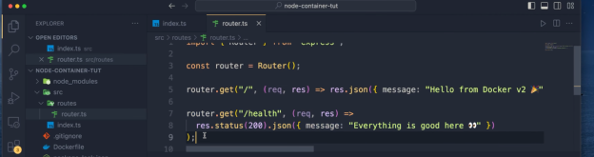

**Step1: Create Elastic container registry (ECR) in AWS**

**Step2: Push commands for ECR**

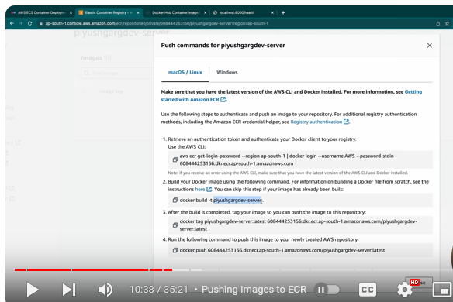

**Step3: Connect with AWS**

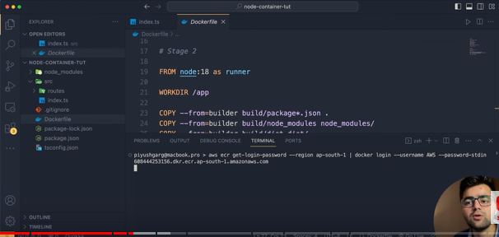

Then build the image below

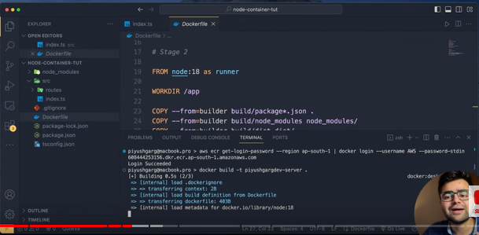

Tag the image and push the image in ECR below

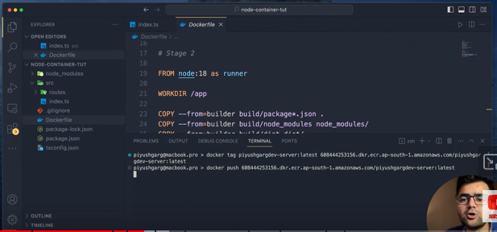

**Step4: - Go to ECS and create cluster**

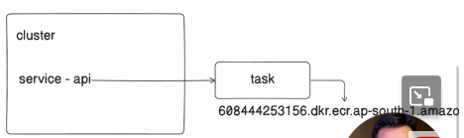

**Step5: - Then create a task from “Task Definition”**

And link up image URL here in Container-1

And provide port like 8000

And put Health check URL from your nodejs project

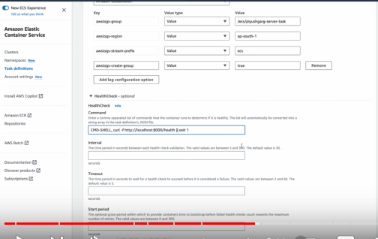

**Step6: - Then go to cluster and create service below**

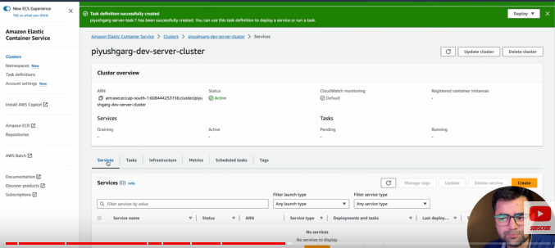

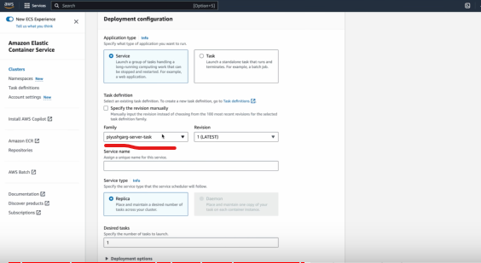

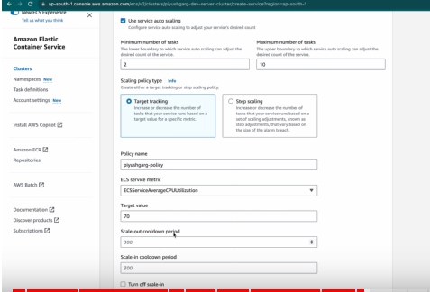

**Step7: If we change code then, how to do “rolling and update”**

Then update the service and check the “force deployment” option & click on update

