**Project Proposal On**

**Bike Rental System**

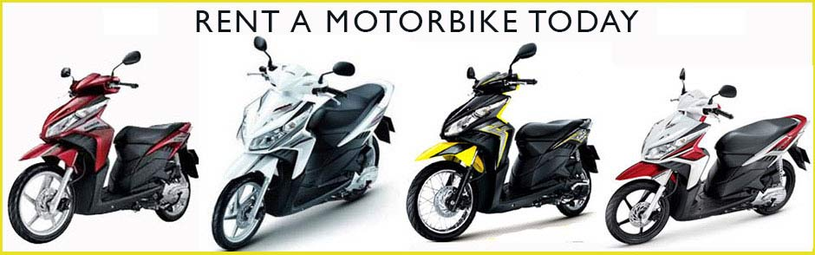

**Summited To**

**Sudeep Bajimaya**

**Summited by**

**Binay Thapa**

**NCC ID: 00175903**

**Batch: 23**

**Softwarica Collage of IT and E-commerce**

Table of Contents

1 Introduction 2

1.1 Introduction of the system 2

1.2 Background of the system 2

1.2.1 Problem statement 2

1.3 Justification of the project 2

1.4 Overview of the proposed system 3

2 Scope 3

2.1 Aims of the project 3

2.2 Objective of the project 3

2.3 Feature of the system 3

2.4 Overview of the project 4

3 Development methodology 4

3.1 Methodology to be use 4

3.2 Design pattern 5

3.3 System architecture 6

4 Scheduling 7

4.1 Work Breakdown Structure 7

4.2 Milestone 9

3.3 Gantt Chart 10

5 Risk management 12

6 Configuration management 13

7 Conclusion 15

References 15

# 1 Introduction

## Introduction of the system

This is project of bike rental system where user can rent the bike through the online. This system is made for Everest bike hire. Everest bike hire is establish in 2014. So they want to increase their business so they want us to develop the application so their customer can hire the bike through the online.

This system provide the user to register, login, view the bike details, price to the hired the bike, requires documents that will need to hire bike, hired the bike. By using this application user do not have visit the company for the details. User can look which bikes brand available. They also can select the date they wants to hire.

## Background of the system

This company is running from 2014. They provides the facilities to hired bike for customer. Now business in growing rapidly. So they are planning to make online system where their customer can hire bike through online and they also can look data of their customer who hired their bikes. With this system user can know price to hire bike and requires document to hire the bike so they don’t have the came to office for small information. System provides will provides every details about their company. To take hire bike they have to visit the services center.

### Problem statement

Employee can find difficult to use the system. Employee can does not know how use computer. Miscommunicate between developer and customer. Request to add new feature after the development complete. Because of lack of testing software can be crash.

## Justification of the project

The main reason of developing this system is to increase services to the customers. To make the more customer. Because of busy life user can’t visit service center frequently. Through the websites they can see every details of the services of company and they also can contact to company.

## Overview of the proposed system

To overall, this system provide the facilities to customer view details of the bike requires documents to hire the bikes so they can book the bikes also can contact company through the website. It also provide open time closing time of the company. This system will be very easy to use for the user.

# Scope

## Aims of the project

The main scope of the system are.

* To provide the customer easy access to book bikes.
* To view details of the bike.
* To know the price to hired the bike.
* To communicate between user and company.

## Objective of the project

The objective of this project are

* Sitting the functional website.
* To analyze bike are in good service so they can listed in websites.
* To make less bugs software by testing all system.
* To secure and functional the website.
* Arrange the server and locale the database for the system.

## Feature of the system

The feature to include in the system are.

* Register and login system

User have to login to book the bike. User also can register in website.

* Easy online booking

After user will register they can book the bike as they want.

* Information about the bike

User can view details about the bike like which brand bike. Also price of the bike for per day.

* Managing the booking

Information like booked bike, date provide by the user are save in database and later on admin read message.

* Managing the information about bike

Admin can add the information of the bike and edit, delete information. User can cancel the booking.

## Overview of the project

To sum up, we have listed feature that are going to include in the system and the objectives also. It main aims is to gives easy service to the customer. To increase the business of the company. The limitation of the system to book the bike user have to register. This is only limitation of the system.

# Development methodology

## Methodology to be use

For this project I going use waterfall model.

The Waterfall model is the earliest Software Development Life Cycle approach that was used for software development. Waterfall model is an example of a Sequential model. So it is also referred to as a linear-sequential life cycle model. In waterfall each stage must be complete before next stage can start. (Olic, 2017)

I am going to use this model because project is not large so requirement of the project also small and unlikely requirement will not change. Another reason is only single person going to develop the software so all analyzing, designing, developing, testing and maintenance there will be less chance of software failure.

The advantage of the waterfall model are.

* It is easy to use and understand.
* Easy to manage
* Work are smaller and easy to use understand the requirements.
* All task are easily arrange.
* All stages are clearly defined.
* All the stages are well documented.

There are some disadvantage of waterfall model.

* High amounts of risk and uncertainty.
* Not a good model for complex and object-oriented projects.
* It is difficult to measure progress within stages.

The diagram of waterfall model.

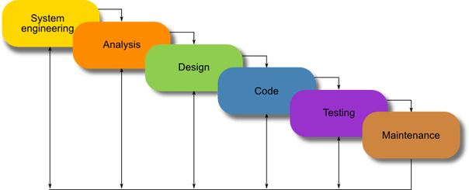

Figure 1: waterfall model

## Design pattern

Design pattern is use find the problem and their solution. In this project I going to use Model Controller View (MVC) design pattern. Because in MVC if one gets error other two will not be affect. In MVC code can be easily reusable. (Anon., 2014)

Model: Model operation database like fetch data, update data. It conserves data of the application.

View: It display the data using model to the user. In here user can interface.

Controller: it holders user request. Provides the links between view and model.

The diagram of the MVC (Model Controller View)

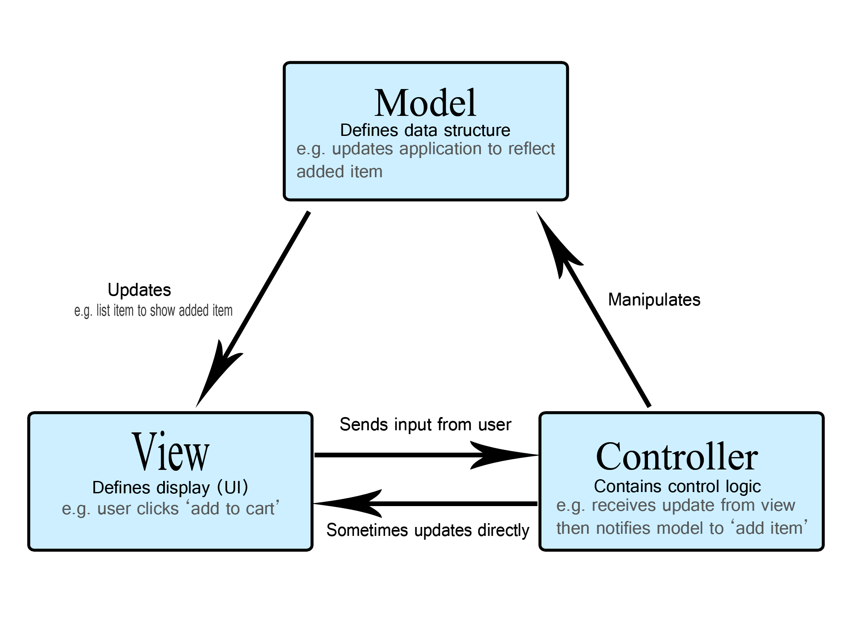

Figure 2: Model view controller

## System architecture

For the system architecture I am going to use 3 tier architecture because all data ask by user does not have go database application server gives data.so our application will run fast. For example if client request [www.facebook.com](http://www.facebook.com) then pages will open by the application server. After that user will login data will goes to application server then application checks in database if valid the facebook home will be open.

The diagram of 3 tier architecture

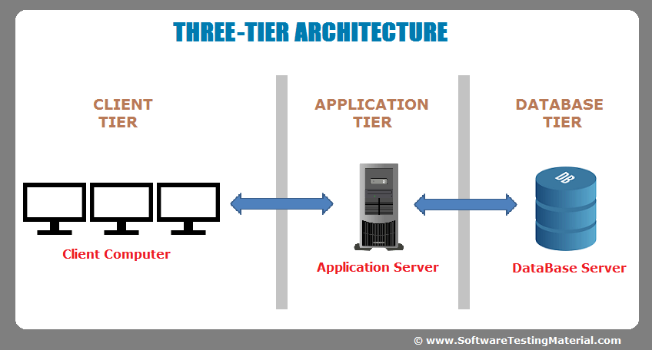

Figure 3: 3 tier architecture

# Scheduling

## Work Breakdown Structure

Work breakdown structure break down into small components so we make better planning for our project. In work breakdown structure we can discovery project cost performance and problem in the project organization. This is reason I have choose work breakdown structure for this project.

Final

Report

Presentation

Black box

Testing

White box

Testing

Integration

Testing

Unit

Testing

Database

Coding

GUI

Coding

Database

Design

UI Design

Behavioral

Model

Structural

Model

Use case

Requirement

Analysis

Proposal

Submission

Configuration

Management

WBS

Risk management

Project management

Documentation

Testing

Coding

Design

Analysis

**Bike rental system**

Figure: WBS diagram

## Milestone

|  |  |  |
| --- | --- | --- |
| **Milestone** | **Start data** | **Final Date** |
| **Project management**  Risk management  WBS  Configuration Management    Proposal Submission | 6/16/2019  6/16/2019  6/23/2019  6/26/2019  6/29/2019 | 7/02/2019  6/22/2019  6/25/2019  6/28/2019  6/01/2019 |
| **Analysis**    Requirement Analysis  Use case | 7/03/2019  7/03/2019  7/18/2019 | 7/29/2019  7/16/2019  7/25/2019 |
| **Design**  Structural Model  Behavioral  UI Design  Database Design | 7/30/2019  8/01/2019  8/08/2019  8/12/2019  8/18/2019 | 8/23/2019  8/07/2019  8/11/2019  8/17/2019  8/22/2019 |
| **Coding**  GUI Coding  Database Coding | 8/25/2019  8/26/2019  9/11/2019 | 9/20/2019  9/10/2019  9/18/2019 |
| **Testing**  Unit Testing    Integration Testing  White box Testing    Black box Testing | 9/20/2019  9/20/2019  9/24/2019  9/28/2019  9/30/2019 | 9/30/2019  9/23/2019  9/27/2019  9/29/2019  6/30/2019 |
| **Documentation**  Presentation  Final Report | 10/1/2019  10/1/2019  10/08/2019 | 10/12/2019  10/12/2019  10/12/2019 |

Table: Milestone

In here I allocate milestone to manage time so that our project can complete in time. Milestone helps to manage the time. So milestone importance in the project.

## 3.3 Gantt Chart

Gantt chart provides a graphical illustration of a schedule that helps to plan, coordinate, and track specific tasks in a project. This also overview the project. So Gantt chart will be using in this project.

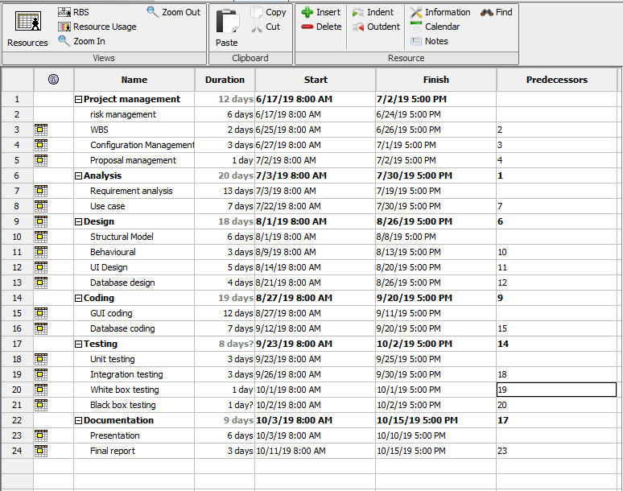

Figure 4: scheduling

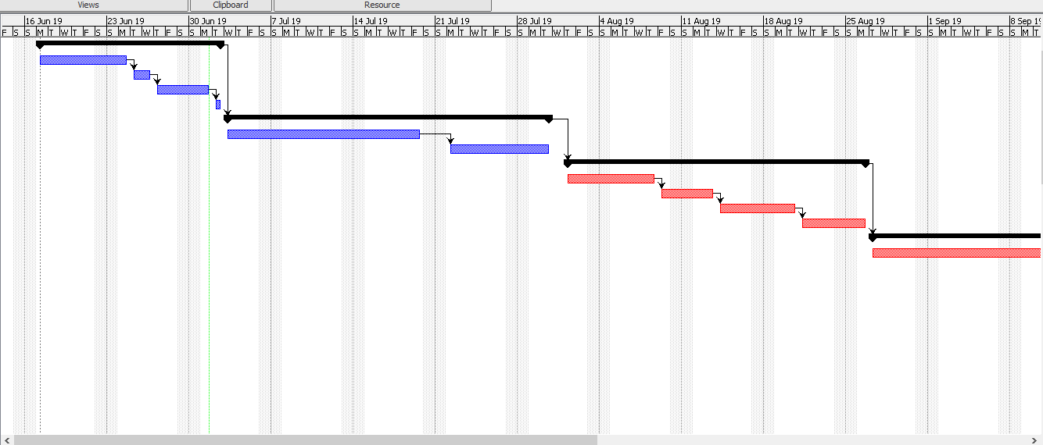

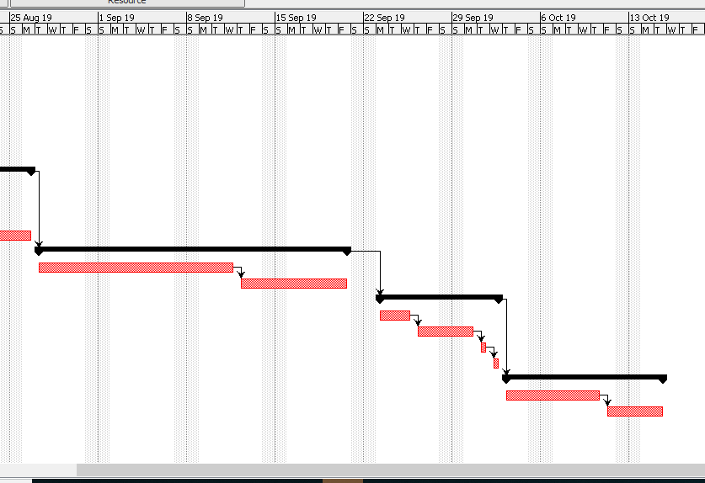

Figure 5: Gantt chart

# Risk management

Risk management is the process of identifying, assessing and controlling threats to an organization. In here risk management will three sector likelihood, risk consequence and impact. In likelihood is probability of threats in the project, in consequence effect or result of the threats in my project, thirdly impact means threats effects on the project. To do risk management helps to access the risk, controls the risk, review the risk that’s why risk management system is necessary for my project. (Anon., 2016)

|  |  |
| --- | --- |
| **Likelihood** | **Value** |
| Low | 1 |
| Medium | 2 |
| High | 3 |

Table: Likelihood

|  |  |
| --- | --- |
| **Consequence** | **Value** |
| Very low | 1 |
| Low | 2 |
| Medium | 3 |
| High | 4 |
| Very high | 5 |

Table: Consequence

**Impact= Likelihood*Consequence**

|  |  |  |  |  |  |
| --- | --- | --- | --- | --- | --- |
| **Risk no** | **Risk** | **Likelihood** | **Consequence** | **Impact** | **Action** |
| 1 | Hardware crash | 2 | 5 | 10 | Back up data is require |
| 2 | Lack of time and budget | 2 | 5 | 10 | Proper management planning should require on time and budget |
| 3 | Requirement does not meet | 1 | 4 | 4 | Proper analysis is require |
| 4 | Changes of government rules | 2 | 4 | 8 | Should monitor changes of the government policy |
| 5 | Misdirection of requirement | 1 | 5 | 5 | Proper analysis should be done |

Table: Risk management

# Configuration management

Configuration management is the set of police, process and tool which is use to manage the changes in software. Some reason why it is necessary in my project

* We can track of the change request coming from the customers and developers.
* It also check the cost and impact of the changes.

For the configuration management I have created backup in local pc and git-hub.

Figure 6 show the directory of the local.

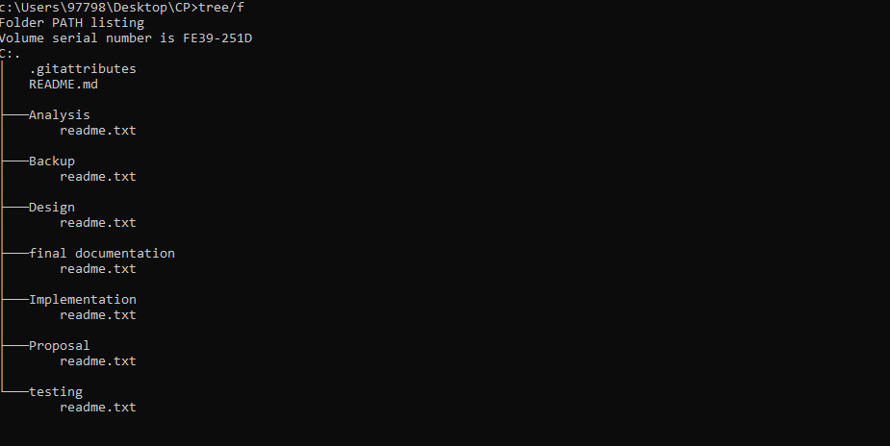

Figure 6: Project local directory

Github: Github is an online platform to manage and backup the file. Also using this platform we can edit and update codes. This is also use for version controlling of software and system. I cerate account on git hub name as **“binaythapa01”** where all folder are store.

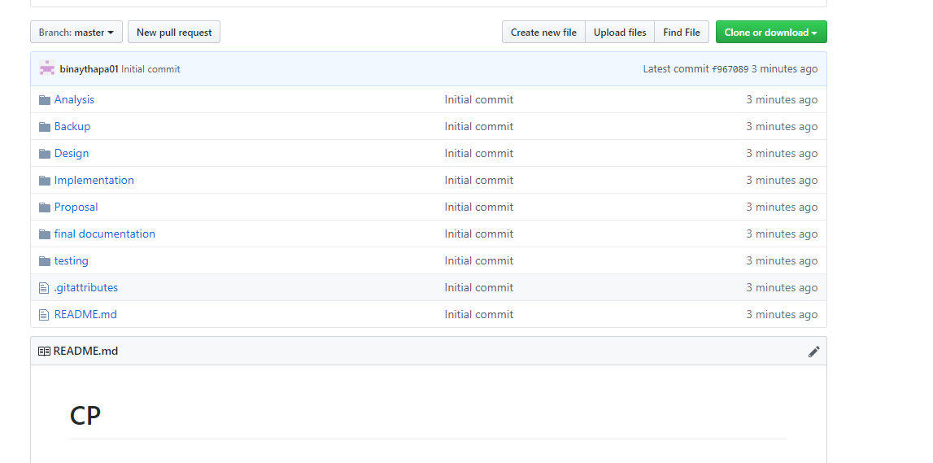

Figure 7: Git directory

# 7 Conclusion

Overall, in bike rental system where customer can book, view the information about bike and admin has all control like manage the booking, bike. I am using waterfall model for this project, time of the project also allocate it is shown in Gantt chart. In this proposal risk of the project and their impact on project and their solution also include. For the project management and back up I will use Git hub.

# References

Anon., 2014. *MVC.* [Online]   
Available at: https://www.tutorialspoint.com/struts_2/basic_mvc_architecture.htm  
[Accessed 20 june 2014].

Anon., 2016. *risk management.* [Online]   
Available at: https://www.worksafe.qld.gov.au/news/2016/four-steps-to-manage-hazardous-manual-task-risks-in-the-workplace  
[Accessed 05 sep 2016].

Olic, A., 2017. *water fall model.* [Online]   
Available at: https://activecollab.com/blog/project-management/waterfall-project-management-methodology  
[Accessed 24 may 2017].