# Chapter 5 Testing

Testing is the process of evaluating a system or its component(s) with the intent to find whether it satisfies the specified requirements or not. There are different type of testing I have choose black box and unit testing for my project.

## 5.1 Black box testing

Black-box testing is a method of software testing that examines the functionality of an application without peering into its internal structures or workings

Reason why I choose this test

* To do black testing it does not require to write code it is done by end user
* It only show what program does not how program is running
* In here it show either program is pass or fail.

**Login testing**

|  |  |  |  |  |  |  |
| --- | --- | --- | --- | --- | --- | --- |
| **Test case**  **ID** | **Test scenario** | **Test description** | **Test date** | **Expected** | **Actual** | **Status**  **(Fail/pass)** |
| 1 | Login | Valid email and password | 9/28/2019 | User dashboard should be open | User dashboard has been open | Pass |
| 2 | Login | Invalid email and password | 9/28/2019 | Message should be show | Message has been shown invalid password /email | Fail |
| 3 | Login | Incorrect password | 9/28/2019 | Should bock for 3 minute | Block for 3 minute | Pass |

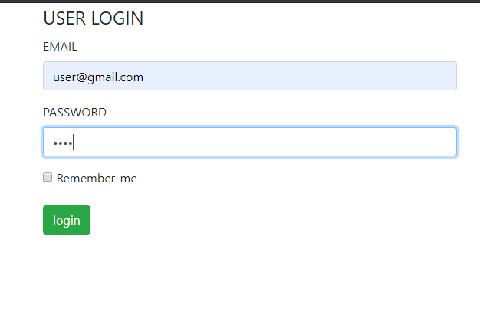

Figure 1: test 1

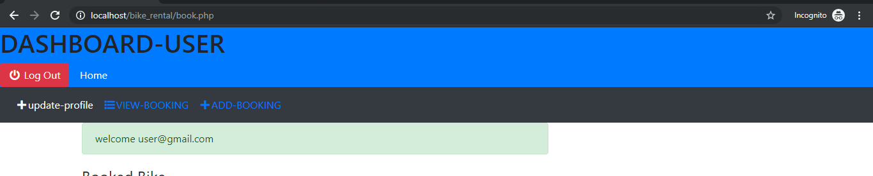

Figure 2: test 1 result

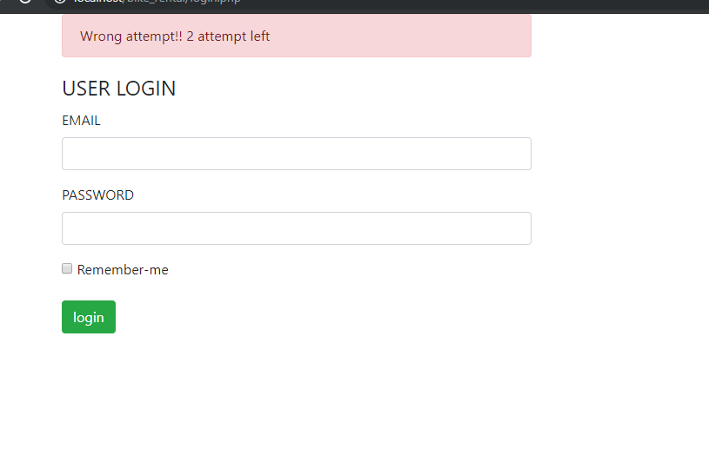

Figure 3: test 2

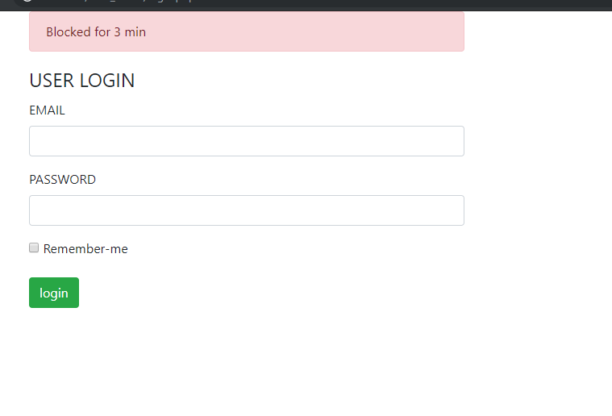

Figure 4: test 4 for invalid password

**Registration testing**

|  |  |  |  |  |  |  |
| --- | --- | --- | --- | --- | --- | --- |
| **Test case**  **ID** | **Test scenario** | **Test description** | **Test date** | **Expected** | **Actual** | **Status**  **(Fail/pass)** |
| 4 | Register for user | User can register | 9/28/2019 | User can register | User is Register | Pass |
| 5 | Register | User can not register same email that is already register | 9/28/2019 | Message should be came | Message came email has already register | Pass |
| 6 | Register | User have to fill all detail to register | 9/28/2019 | Message should be shown | Message is shown | Pass |

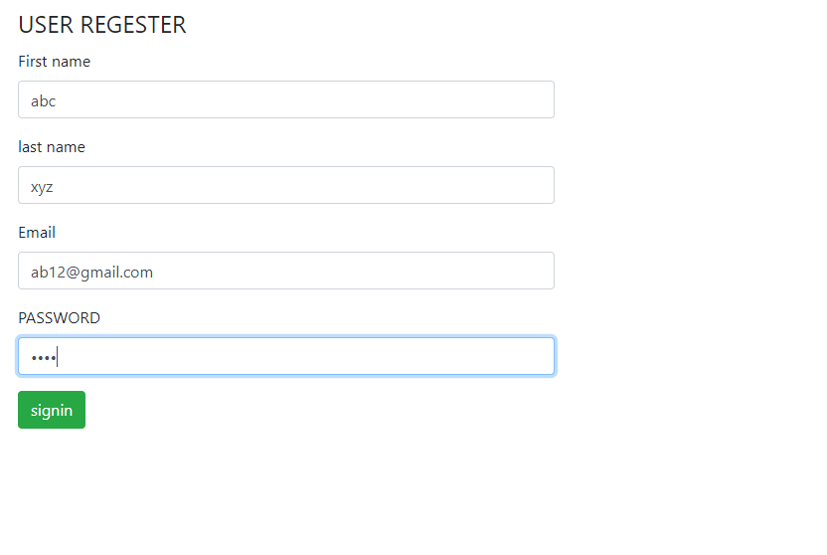

Figure 5: test 4 for registration

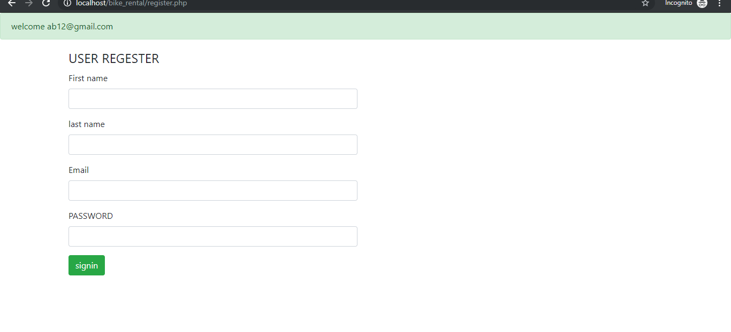

Figure 6: test 4 register success

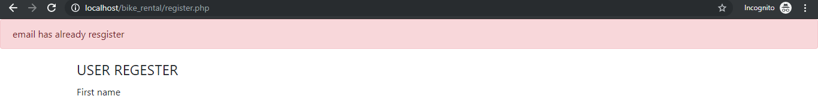

Figure 7: test 5 email already register

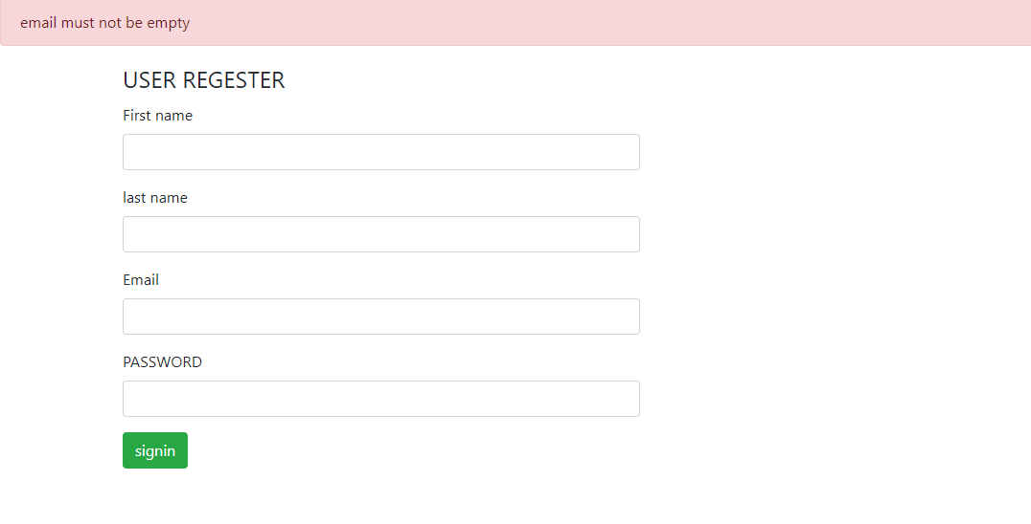

Figure 8: test 6 email empty

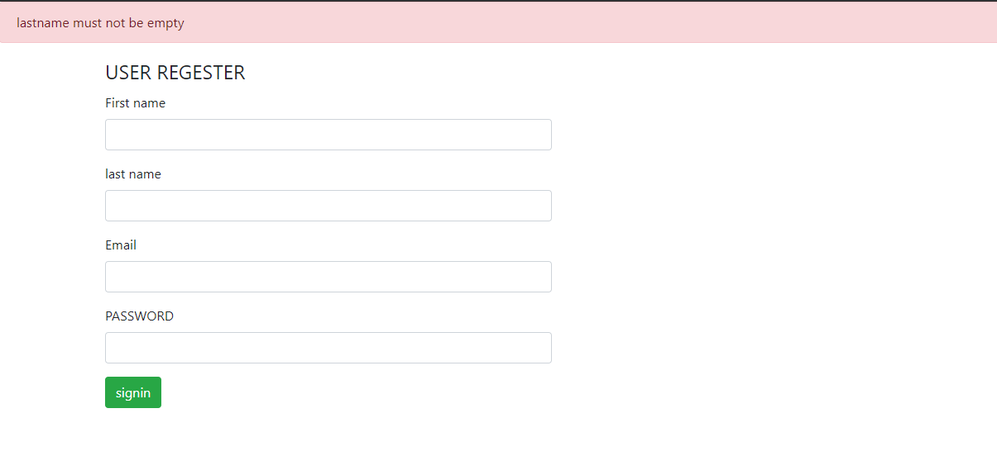

Figure 9: test 6 last name empty

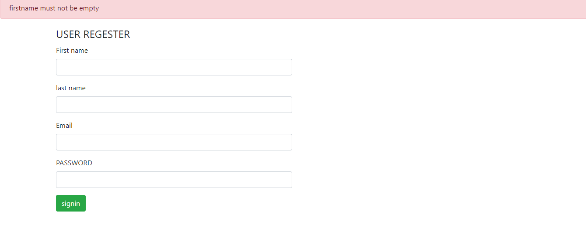

Figure 10: test 6 first name empty

Booking testing

|  |  |  |  |  |  |  |
| --- | --- | --- | --- | --- | --- | --- |
| **Test case**  **ID** | **Test scenario** | **Test description** | **Test date** | **Expected** | **Actual** | **Status**  **(Fail/pass)** |
| 7 | User can book the bike | To book bike user have fill the form | 9/28/2019 | Booking should be done | Booking has been done | Pass |
| 8 | View booking | User can view the booking | 9/28/2019 | User should view booking | User can view booking | Pass |
| 9 | Cancel booking | User can cancel booking | 9/28/2019 | User should able to cancel booking | User can cancel booking | Pass |

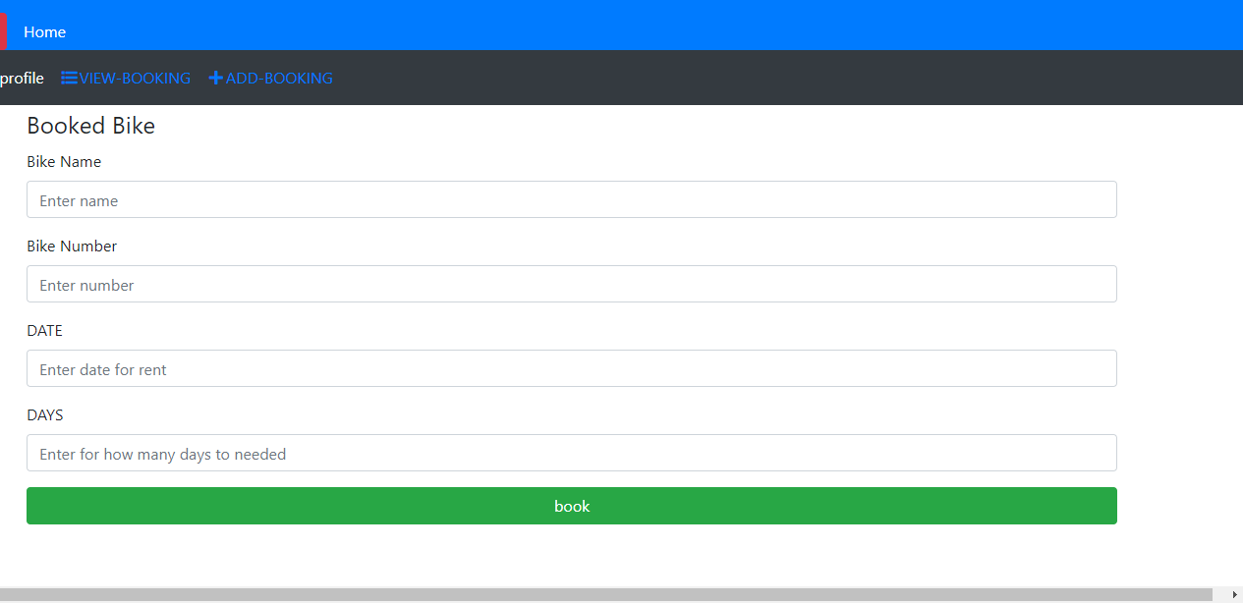

Figure 11: test 7 to book the bike

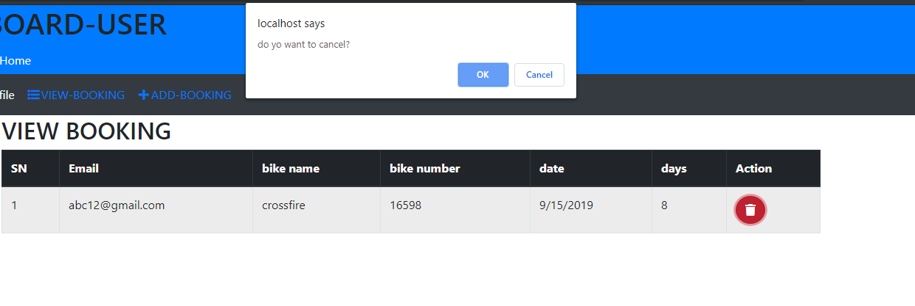

Figure 12: test 8, 9 view booking and for cancel booking

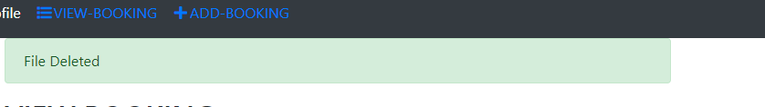

Figure 13: test 9 after booking cancel successfully

**Admin testing**

|  |  |  |  |  |  |  |
| --- | --- | --- | --- | --- | --- | --- |
| **Test case**  **ID** | **Test scenario** | **Test description** | **Test date** | **Expected** | **Actual** | **Status**  **(Fail/pass)** |
| 10 | Add bike information | Admin can add bike information | 9/28/2019 | Admin able to bike information | Admin can add bike information | Pass |
| 11 | View bike information | Admin can view information | 9/28/2019 | Admin should view the information about bike | Admin can view the information of bike | Pass |
| 12 | Update bike | Admin can update bike information | 9/28/2019 | Admin able to update bike information | Admin can update bike information | Pass |
| 13 | Delete information | Admin can delete information | 9/28/2019 | Admin able to delete information of bike | Admin able to delete bike information | Pass |
| 14 | Booking | Admin can view book | 9/28/2019 | Admin should able to view booking done by the user | Admin can view booking by the user | Pass |
| 15 | View bike information | User can view information about bike | 9/28/2019 | User should view bike information add by the admin | User can view the information about bike | Pass |

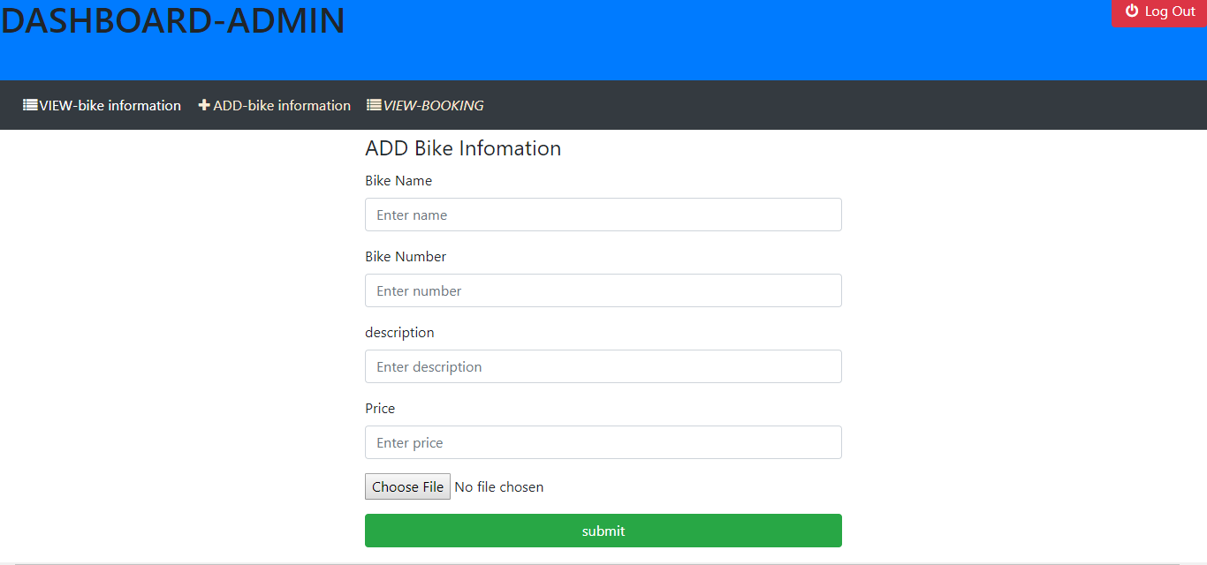

Figure 14: test 10 to add bike information

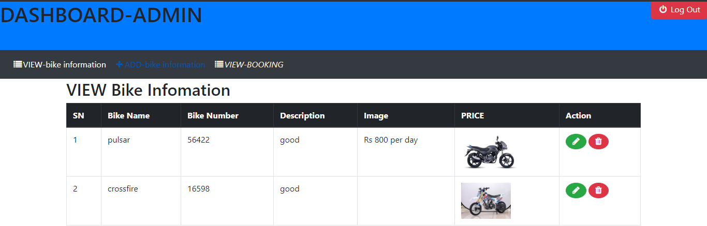

Figure 15: test 11 to view bike information

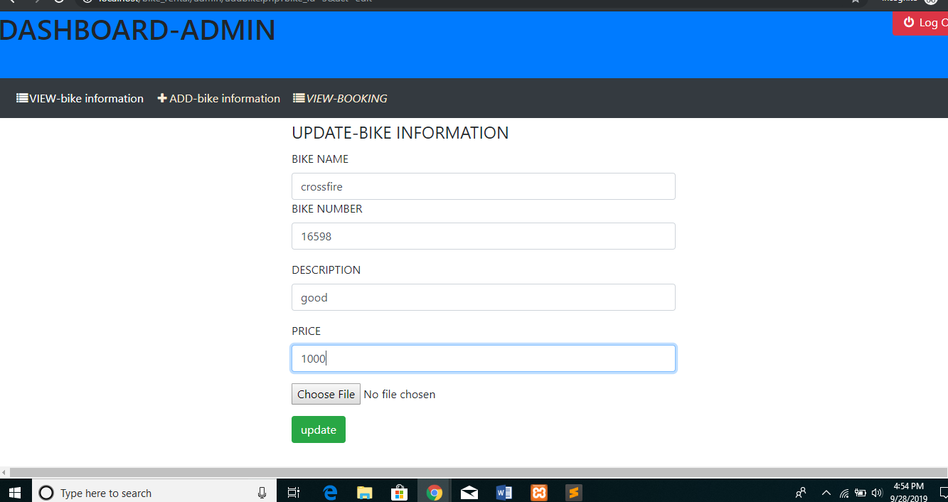

Figure 16: test 12 to update bike

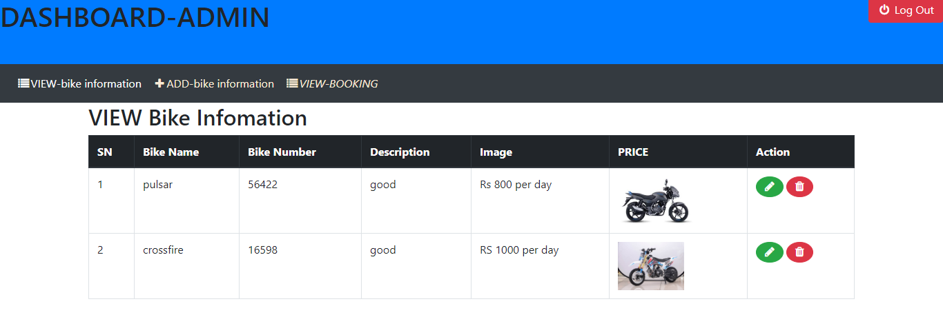

Figure 17: test 12 update success

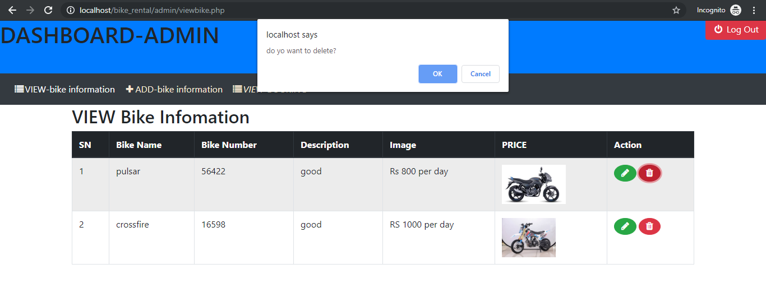

Figure 18: test 13 to delete bike information

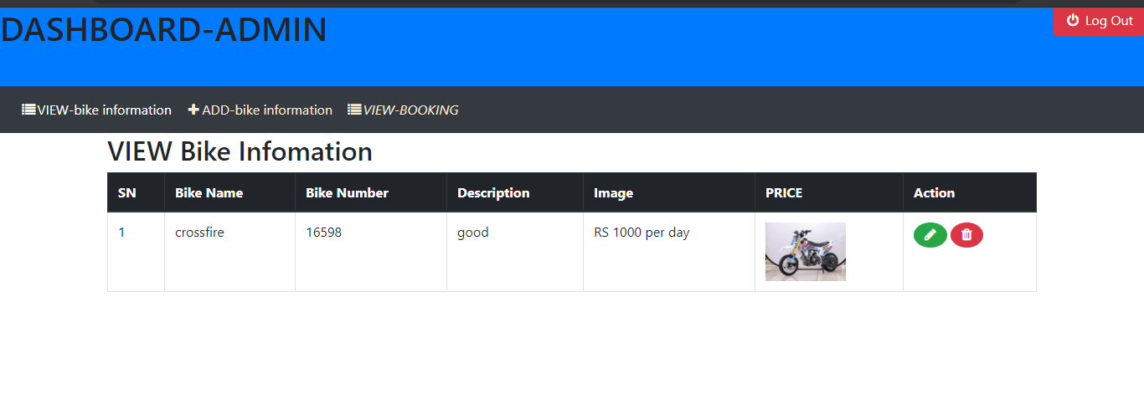

Figure 19: test 13 bike delete

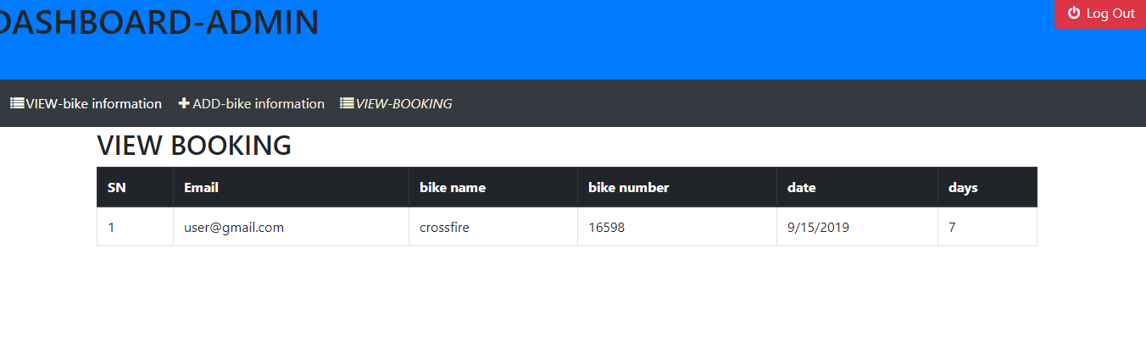

Figure 20: test 14 to view booking bike by user

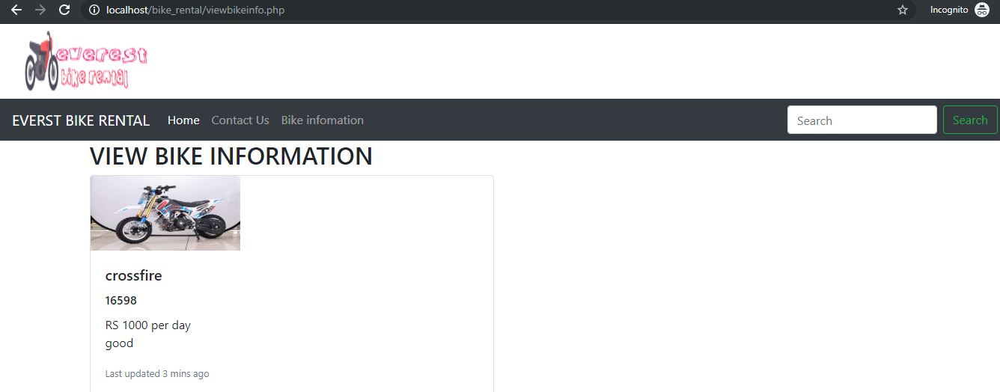

Figure 21: test 15 user can view bike .information

**Admin login**

|  |  |  |  |  |  |  |
| --- | --- | --- | --- | --- | --- | --- |
| **Test case**  **ID** | **Test scenario** | **Test description** | **Test date** | **Expected** | **Actual** | **Status**  **(Fail/pass)** |
| 16 | Login | Admin login | 9/28/2019 | After login success dashboard should be open | Login success dashboard open | Pass |
| 17 | Login | Username and password | 9/28/2019 | To login username and password should be valid | Invalid username and password message pop up | Pass |

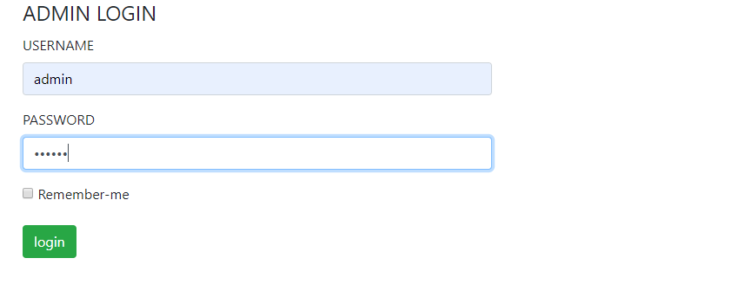

Figure 22: test 16 login by admin

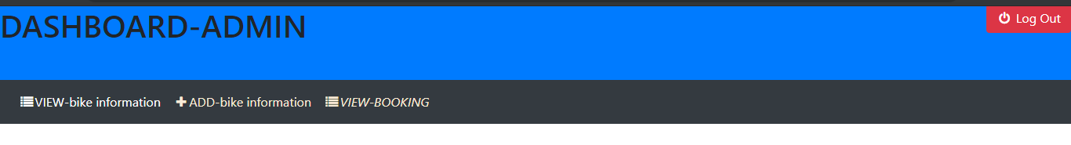

Figure 23: test 16 login success

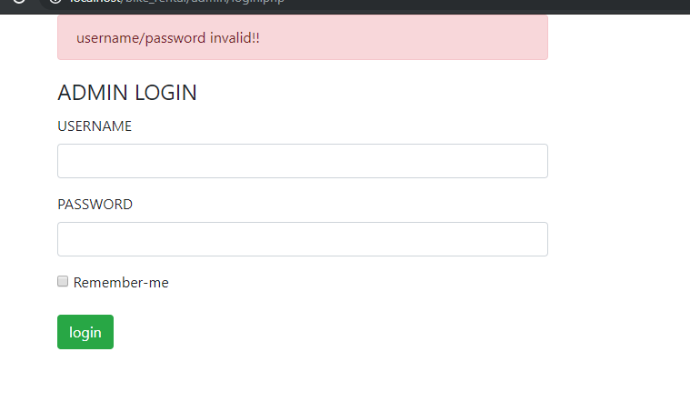

Figure 24: test 17 invalid username and password