3/7/2017

Team 7

Binh Bui – e1300518

Nguyen Cong danh – e1400467

THANH VUONG – e1400489

Project Plan

Web-based Dating Application

Table of Contents

I. Introduction 3

A. Scope and purpose of document 3

B. Project objectives 3

1. Objectives 3

2. Major functions 3

3. Performance issues 3

4. Management and technical constraints 3

II. Project estimate 3

A. Historical data used for estimates 3

B. Estimation techniques 4

C. Estimates 4

III. Project risks 4

A. Risk analysis 4

B. Risk management 5

1. Risk aversion options 5

2. Risk monitoring procedures 5

IV. Schedule 7

A. Project work breakdown structure 7

B. Task network 7

C. Time-line chart (Gantt chart) 8

D. Resource table 9

V. Project resources 9

A. People 9

B. Hardware and software 9

1. Hardware 9

2. Software 9

C. Special resources 9

VI. Staff organization 9

A. Team structure 9

B. Management reporting 10

VII. Tracking and control mechanisms 10

VIII. Appendices 10

# 

# Introduction

## Scope and purpose of document

This document is the project plan for the application to be developed during the Software engineering course. The purpose of this web-based application is to give students and teachers the possibility to get information about courses, enrol, add or modify them. It covers all necessary information for the validation of the application, such as needed resources, process of work, validation criteria, possible risks, estimating etc for developing a successful project

## Project objectives

### Objectives

The purpose of the application is for connecting people to be couples. User can access and register with personal information, the application takes those information and relate to people with same preferences.

The application also provides sending and receiving service between users.

The main objectives of the application is:

* Collecting information from users then connect users with mutual preferences in an area.

### Major functions

* Registration: Users can register for an account, which has personal info such as name, location, age, sex, preferences, etc.
* Displaying users: The application will show people with same interest, with many mutual preferences in the same area or different location. Therefore, users can make friends and get the chances to know each other.
* Chat: The application allows user to chat with other users, send message and make a contact list.

### Performance issues

There are a few issues that we address as below:

* User-friendly and simple design
* Responsive for mobile using.
* Adequate storage in the server to manage the dataset

### Management and technical constraints

Necessary elements for running the application, like the version of Java run time machine (on app3.cc.puv.fi it is Java 7.0) type and version of container (at school we have Tomcat7), type of DBMS (e.g. MySQL, Oracle, etc.) and necessary tables, etc.

# Project estimate

## Historical data used for estimates

The team consists of two 3rd year students and one 4th year students, all have knowledge of Java, JSP and also working with database & server (MySQL, Apache).

The front-end developer, Thanh Vuong, has a specfic skillset of technologies related to front-end (MeteorJS, Bootstrap)

The leade, Binh Bui, also possess skills of version control system (git, github) and mobile application development.

## Estimation techniques

For estimation of the time and cost needed to complete the project, following procedures should be taken into consideration:

* Software requirement need to be analyzed
* Addition time for the team to get familiar with the new software techniques, it might need some time to learn.
* Breakdown the projects work in smaller tasks for easier estimation.
* Historical data can be analyzed and some conclusions can be made.
* Analyzing the historical data and drawing some conclusions based on it.
* Take all the risks involved in the project while developing it.

## Estimates

Time estimation:

|  |  |
| --- | --- |
| **Task** | **Hours** |
| Project management and planning | 20 |
| Analysis | 30 |
| Getting familiar with new technology | 30 |
| Design | 50 |
| Develop | 100 |
| Testing | 30 |
| Total | 260 |

* By estimating the time for the project to be fully developed is 260 hours by 3 developers.

# Project risks

## Risk analysis

Using a risk register, we can keep track of possible known risk for the project. It also shows how much it will impedance the project (records in the number of days).

|  |  |  |  |  |
| --- | --- | --- | --- | --- |
| **Category** | **Risk Description** | **Probability of  Occurrence** | **Loss Size  (Days)** | **Risk Exposure  (Days)** |
| Client | Not enough time to be able to fully analyze the  customer’s needs | 40 % | 2 | 0,8 |
| Client | Extra requirements from the customers | 20 % | 8 | 1,6 |
| Client | Wrong information given by the customer due to their low understanding of the system | 5 % | 10 | 0,5 |
| Developing team | Overdue deadline from the team member | 30 % | 5 | 1,5 |
| Developing team | Inability to estimate possible major bugs and failures | 15 % | 8 | 1,2 |
| Developing team | Not enough man power for the project | 10 % | 5 | 0,5 |
| Others | Lack of necessary hardware or loss of hardware due. | 20 % | 10 | 2 |
| **Total Risk Exposure 8,1** | | | | |

## Risk management

### Risk aversion options

* Being precise and prepared for the Q&A sessions in order to have as much insight of the customer’s needs as possible
* Making back-up during developing process.
* Dividing workloads into as small as possible chunk so that if one part is overdue, it work affect the whole project as much as it could have
* Being active and investigate the possible environments that the project might be in, and ask the customer about it, in case they forgot to mention it.
* Encourage frequent testing and debugging

### Risk monitoring procedures

* Identify the risks and their causes
* Making back-up during developing process.
* Identify the controls which you have over the risks.
* Estimate the likelihood and consequence of such risk.
* Add possible controls.
* Make a decision on whether to proceed despite the risks or not.

# Schedule

## Project work breakdown structure

## Task network

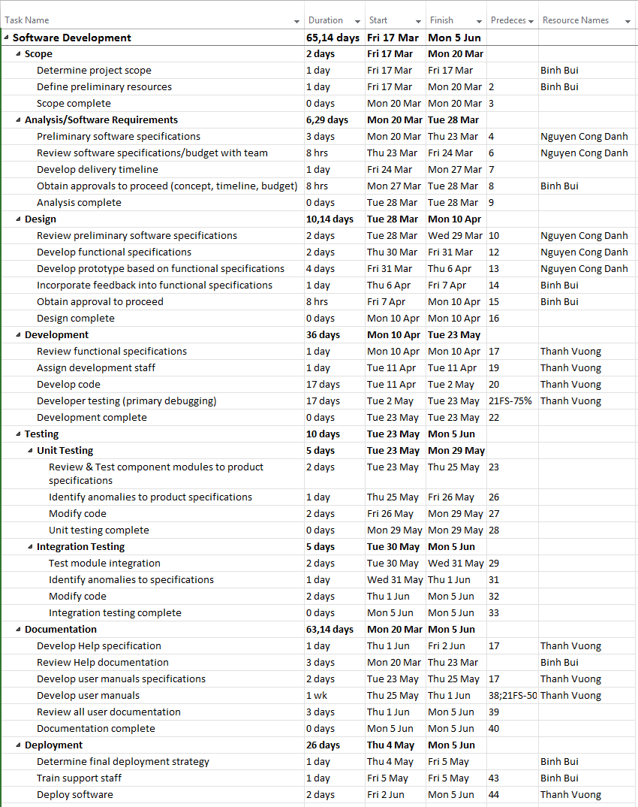

## Time-line chart (Gantt chart)

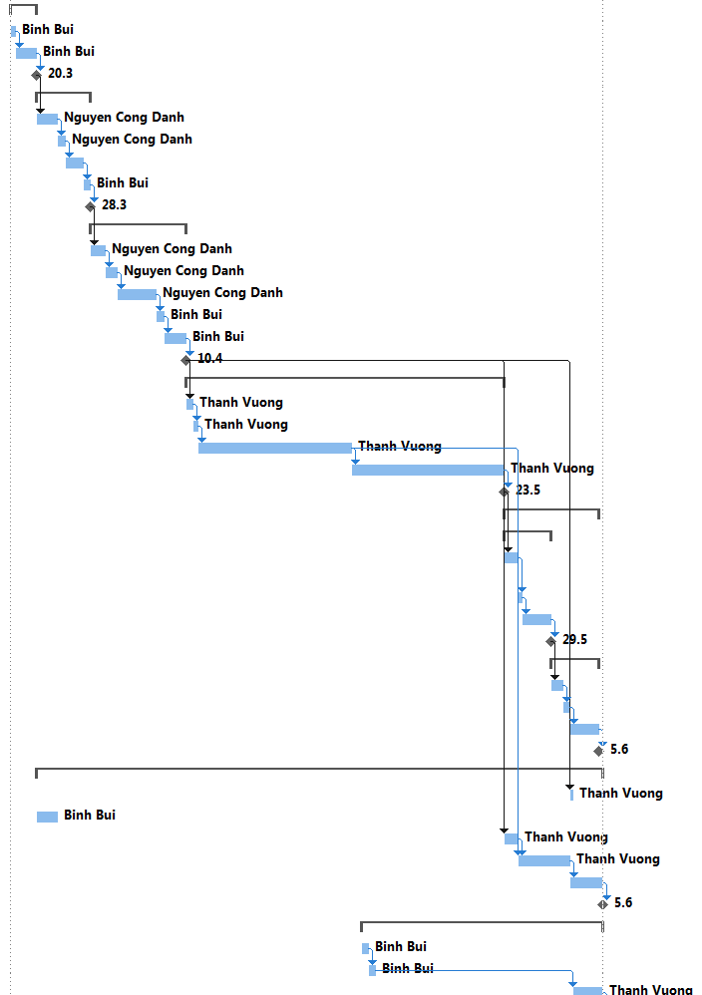

## Resource table

# Project resources

## People

The team consists of 3 members.

## Hardware and software

### Hardware

No specific hardware needed for this project

### Software

|  |  |
| --- | --- |
| **Server** | App3.cc.puv.fi (Tomcat 7 Server) |
| **IDE** | Eclipse |
| **Main programming language** | Java |
| **Front-end** | HTML, CSS |
| **Reports** | Microsoft Office Word |

## Special resources

* Version Control System: Git
* JSP

# Staff organization

## Team structure

The development team is comprised of 3 members with respective roles which are:

|  |  |
| --- | --- |
| **Member** | **Role(s)** |
| Binh Bui | Team Leader |
| Nguyen Cong Danh | Developer |
| Thanh Vuong | Developer |

## Management reporting

The development is done in iterations, thus after each finished iterations, the team will produce a progress report.

In addition, during the process of development, it is compulsory for all the team members to report if there are any changes related to tasks, technologies used or development techniques.

This can be achieved through weekly meetings which allows the team members to review past work and assign new tasks. All issues detected during the previous week will be reported to the other members.

# Tracking and control mechanisms

The team will agree upon a weekly meeting date. This period will be used for presenting the current prototypes, what have been done and what should be done next. These meetings are meant for progress reporting and new task assignment.

Team members will also keep in close touch with each other through message platform and notice each other of their progress in order for each member to keep track.

# Appendices