mysql测试题

**stu表：学生信息表**  **score表：分数表**

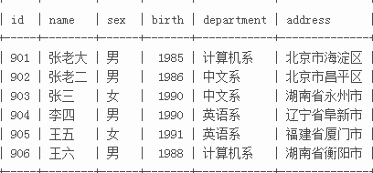 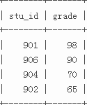

**需求：**

1 写出一条sql语句，查出所有学生的信息(2分)

Select \* from stu;

2写出一条sql语句，查出表中从第2条到第4条学生的信息。(3分)

Select \* from stu limit 2,3;

3写出一条sql语句，查出年龄最小的那个学生的信息。(3分)

Select \* from stu order by `birth` asc limit 1;

4写出一条sql语句，查出“计算机系”和‘英语系’的所有学生信息。(3分)

Select \* from stu where `department` = “计算机系” or `department` = “英语系”；

5 写出一条sql语句，查出每一个的系总共有多少个学生。(4 分)

Select `departmeng`,count(\*) from stu group by `departmeng`;

6 写出一条sql语句，查出每一个系的最高分是多少，包括对应的系名信息。(4分)

Select max(a.grade),b.department from score as a left join stu as b on a.stu\_id = b.id group by b.department;

7 写出一条sql语句，查出每一个系的最高分的那个学生信息。

Select max(a.grade),b.\* from score as a left join stu as b on a.stu\_id = b.id left join (select max(a.grade),a.stu\_id as stu\_id from score as a left join stu as b on a.stu\_id = b.id group by b.department) as c on a.stu\_id = c.stu\_id where a.stu\_id =c.stu\_id group by b.department;

8写出一条sql语句，查出 ’李四’的个人信息和考试分数。

Select a.\*,b.grade from stu as a left join sore as b on a.id = b.stu\_id where `a.name`=”李四”；

9写出一条sql语句，查出年龄在18~22之间的学生的个人信息和与之对应的考试分数。

Select a.\* ,b.grade from stu as a left join score as b on a.id = b.stu\_id where a.birth >18 and a.birth <22;

10 写出一条sql语句，查出考试成绩低于90分的所有学生信息。

Select a.\* ,b.grade from stu as a left join score as b on a.id = b.stu\_id where b.grade <90;

**person表**

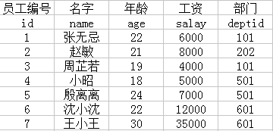

**需求：**

12查出整个公司中，工资最高的那个员工所属的部门中工资最低的那个员工的个人信息。

select \* from person where deptid = (select deptid from person order by salary desc limit 1) order by salary asc limit 1;

13 查出各个部门中，工资高于其（所属的这个部门所有员工平均工资）的员工信息们。

Select a.\* from person as a left join(select deptid,avg(salay) s from person gropu by deptid) as b on a.deptid = b.deptid where a.salay > b.s;

**stu表:**

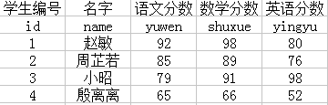

**14 需求：**查询出至少有两门课在90分以上的学生信息。（不包括90）

Select \* from (select \* from stu where yuwen > 90 union all select \* from stu where shuxue> 90 union all select \* from stu where yingyu> 90 ) as a group by a.name having(count(a.name)>=2);

15：需求：用sql语句实现，商品销售额大于5万元的商品信息。

（用到的知识点：两个表如何相乘）

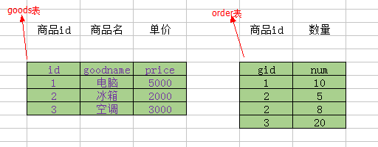

Select a.\* from `goods` as a left join (select a.id as mid,a.price\*b.num as mun from goods as a left join order as b on a.id =b.gid ) as c on a.id =c.mid where c.mun > 50000 group by a.id;

16：需求：使用sql语句把上面的两张表变成最下面的那张表的结构

（用户的知识点：列转行）

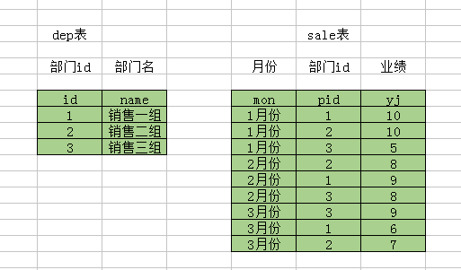

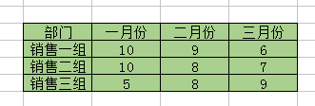

[SELECT](http://localhost/phpmyadmin/url.php?url=https://dev.mysql.com/doc/refman/5.5/en/select.html" \t "http://localhost/phpmyadmin/mysql_doc) a.name ,[MAX](http://localhost/phpmyadmin/url.php?url=https://dev.mysql.com/doc/refman/5.5/en/group-by-functions.html" \l "function_max" \t "http://localhost/phpmyadmin/mysql_doc)( [CASE](http://localhost/phpmyadmin/url.php?url=https://dev.mysql.com/doc/refman/5.5/en/control-flow-functions.html" \l "operator_case" \t "http://localhost/phpmyadmin/mysql_doc) WHEN b.mon = '一月份' THEN b.yj ELSE null END) AS '一月份',[MAX](http://localhost/phpmyadmin/url.php?url=https://dev.mysql.com/doc/refman/5.5/en/group-by-functions.html" \l "function_max" \t "http://localhost/phpmyadmin/mysql_doc)( [CASE](http://localhost/phpmyadmin/url.php?url=https://dev.mysql.com/doc/refman/5.5/en/control-flow-functions.html" \l "operator_case" \t "http://localhost/phpmyadmin/mysql_doc) WHEN b.mon = '二月份' THEN b.yj ELSE null END) AS '二月份',[MAX](http://localhost/phpmyadmin/url.php?url=https://dev.mysql.com/doc/refman/5.5/en/group-by-functions.html" \l "function_max" \t "http://localhost/phpmyadmin/mysql_doc)( [CASE](http://localhost/phpmyadmin/url.php?url=https://dev.mysql.com/doc/refman/5.5/en/control-flow-functions.html" \l "operator_case" \t "http://localhost/phpmyadmin/mysql_doc) WHEN b.mon = '三月份' THEN b.yj ELSE null END) AS '三月份' FROM dep a [LEFT](http://localhost/phpmyadmin/url.php?url=https://dev.mysql.com/doc/refman/5.5/en/string-functions.html" \l "function_left" \t "http://localhost/phpmyadmin/mysql_doc) JOIN sale b on a.id = b.pid GROUP BY a.name