FAQ:

General questions about Yearbook Printing and Publishing
Come across a term during your yearbook or graduation book production and want to find out exactly what it mean… this is a yearbook glossary that that translates yearbook jargon into plain English!
Questions about Fusion Books Online Yearbook System
Have a question about the Fusion Books Online Yearbook system- your answer should be found in here- if not give one of our friendly staff a buzz or email.

General questions about Yearbook Printing and Publishing
Have a question about yearbook or graduation book printing and publishing? Below are some questions we are asked frequently that may be able to provide you with your answer. Otherwise contact us and one of our friendly staff can help you out.
What is a yearbook?
What is a graduation book?
What is the difference between a yearbook and a Graduation Book?
We are designing our yearbook at school, in what format should we send it to Fusion Books?
We are designing our yearbook at school, in what format should we send it to Fusion Books?
What is GSM?
What is bleed?
What is crop-marks?
What is resolution?
What is the difference between gloss or matt paper?
What is the difference between offset and digital printing?
What does laminate mean?
Is one page two sides of a page?
What kind of paper stock do you use?
What size do your yearbooks come in?
How much does a Fusion Book cost?
Who owns copyright in the Fusion Book?
When do we pay?
What is the difference between inc. GST and ex. GST (or + GST)?
Is there a minimum order?
What is the production timeline?
Is the ‘deposit’ an additional charge on top of the cost of our books?
Where are your clients based?
Our students would like to create a Graduation Book although they cannot afford it. Do you have any suggestions?

What is a yearbook?
A yearbook is often an annual publication produced by schools, sports clubs and businesses to commemorate the events of the year. They often include a message from the principal, staff and students and are used to celebrate the schools achievements, community spirit and special events throughout the year.
What is a graduation book?
Graduation Books are typically used for the graduating class from primary school, high-school or university to capture their memories and great times in a special book that most people keep forever.
What is the difference between a yearbook and a Graduation Book?
In a school environment yearbooks are typically used to commemorate a year of the entire school, while Graduation Books are created to reflect upon the years at school of the graduating class.
We are designing our yearbook at school, in what format should we send it to Fusion Books?
Send your completed file in its ‘raw’ format (for example as a Publisher Document (.pub), Indesign Document (.indd) or Word Document (.doc / .docx) and as a PDF. If you need instructions for your specific requirements call us and speak to one of our friendly staff.
What is GSM?
GSM (technically ‘grams per square meter’) is a measure of the thickness of your inside paper or cover. Typically the thicker the paper the higher-quality your book will feel. Fusion Books soft-cover books are typically printed with 150 gsm inside pages and 350 gsm cover. The exception is a very large book (over 150 pages) where it may be preferable to have a thinner stock to prevent having an old-school encyclopaedia.
If you want to have a look at Fusion’s high-quality stock, request our free sample book.
What is bleed?
Bleed is the (3mm) area around the perimeter of your page that will be cut-off during the trimming process. When designing your book you should continue your design for 3mm beyond the perimeter of your page (for example an A4 book should be 216 mm X 303 mm).
What is crop-marks?
With Fusion Books you don’t have to worry about adding in ‘crop-marks’, as we will do this for you. Although when designing (in Fusion Books online system or any other program) always ensure you leave a 1.5cm around the perimeter of the page free from faces and text. This will not only provide a more professional look, but will prevent faces and text from being cut-off in the binding or in the crop-marks.
However, this does not mean you cannot have design patterns and backgrounds in the 1.5cm perimeter, in fact this is encouraged.
What is resolution?
The resolution of an image refers to the images quality. Always use the best quality images you have available. If you are using our Premium Design Service, send your images through to us in the format that comes straight off your camera.
What is the difference between gloss or matt paper?
Fusion Books typically uses gloss paper for our yearbooks. It has a shiny, bright appearance like a magazine. However, you can also request matt paper, which is typically used for a more ‘earthy’ and textured book.
What is the difference between offset and digital printing?
Digital printing is used for smaller quantities of yearbooks (approximately any orders below 500 copies) and offset printing is used for large quantities of yearbooks (above 500 copies). When more copies are ordered it becomes more cost-effective per book ordered.
What does laminate mean?
All Fusion’s premium soft-cover yearbooks come with a gloss or matt laminate cover. The laminate is a protective covering on the cover of your book that will help to preserve the book over time. It also provides an attractive finishing to your book.
Is one page two sides of a page?
“One page” is considered one printed side of the page. For example a 50 page book is 25 leafs of paper.
What kind of paper stock do you use?
All our books are printed on high-quality 150 gram paper. Our soft covers are printed on premium 300 GSM gloss-laminate stock. Large orders are printed using offset printing, while smaller orders are printed using digital printing technology.
What size do your yearbooks come in?
Most yearbooks and graduation books are printed as an A4 book (210 mm X 297 mm). Some schools choose to design the yearbook themselves or use our Premium Design Service and create an A5 book or even a square book.
How much does a Fusion Book cost?
We guarantee our prices are competitive. All our prices include full-access to the Fusion Books system throughout the year, printing and delivery. Prices depend on the number of pages in your book and the number of copies ordered. We offer a variety of options to suit your budget. Contact us to obtain a quote.
Who owns copyright in the Fusion Book?
You must ensure you have the rights for all content included in your Fusion Book. Copyright in the content lies with the person who created the image or took the photograph. Copyright of the page designs lies with Fusion Books.
When do we pay?
- Use your free trial account, with no commitment to order.
- Pay your deposit to gain full access to Fusion Books’ system and book in your printing and delivery dates.
- Give out log in details to staff and students who can then start uploading photos and content.
- Download a full copy of your book via the ‘Preview Book’ button. With your schools’ editing committee check over your book and make any changes necessary.
- When you are ready to print click ‘Book Now’ on the ‘Home’ menu.
- Get your stylish books delivered to your school on time. And make the final payment on delivery.
What is the difference between inc. GST and ex. GST (or + GST)?
GST (Goods and Services Tax) is a 10% tax added to the total cost of your books (ex. GST). Most schools are able to claim this tax back from the government and may be able to lower the cost of the yearbooks and graduation books by charging the students the price (ex. GST). For example, if the price is displayed as:
$10 (excl. GST) which is the same as $11 (inc. GST)
You may be able to charge the students $10 per book and the school will be able to pay the $1 per book GST as they may be able to claim this back.
Is there a minimum order?
The minimum order is $600. Small schools have found it is more cost effective to combine their Yearbook and Graduation Book into one book.
What is the production timeline?
Fusion Books typically allows 1 month between the Editors’ deadline and your Delivery date. This allows time to print, laminate and finish your books, as well as deliver the books to your school. As soon as you have paid your deposit we can book in your printing and delivery dates.
Is the ‘deposit’ an additional charge on top of the cost of our books?
No, your deposit is subtracted from the total cost of your books. With Fusion Books you only pay for the number of books you order, there are no other set-up charges or fees.
Where are your clients based?
Fusion Books is able to service schools throughout Australia- we have schools from metropolitan Sydney and Melbourne to remote schools in the Northern Territory.
Our students would like to create a Graduation Book although they cannot afford it. Do you have any suggestions?
Local businesses may be willing to sponsor your yearbook. To recognise their contribution you could set aside a page to display their logo and contact details.
Questions about Fusion Books Online Yearbook System
Fusion Books offers three great ways to create your yearbooks and Graduation Books:
- Fusion Books easy to use online system
- Fusion Books premium design service
- Fusion Books Printing Service
Fusion Books online system is a particularly popular option for Graduation Books (also known as Profile Books, Leavers Books and Year 12 Yearbooks). Click on a link below to have some of your questions answers:
I have been hearing a lot about Fusion Books, how does Fusion Books save time?
I have been given a trial account how do I get started?
What is the best Internet Broswer to use?
Can I upload multiple images onto the Fusion website?
Can I upload my own custom backgrounds?
How do I invite new Editors/Contributors?
Can I upload multiple images onto the Fusion system?
Are there any computer requirements? Do I have to download any software?
Our media class usually creates our yearbook. Are they still able to contribute?
Is there a certain layout we have to follow?
What type of pages can we have in our book?
Is the Fusion Books site secure? How do you protect the privacy of the images?
Do we have to pay to use the software?
Do we get a proof of our book before printing?
What does upload mean?
What does download mean?
What happens if we get stuck? Or have a question?

I have been hearing a lot about Fusion Books, how does Fusion Books save time?
Every aspect of Fusion Books has been designed to be quick and fun, while ensuring only the highest quality product.
- Reordering pages in your book? Simply drag and drop.
- Need people to contribute? Add their email address or print an invitation.
- Need a proof copy? Click ‘Preview Book’ and have a high-quality PDF proof.
- Formatting? Choose from an array of artist-designed layouts.
- Contents page? Auto-created!
...Fusion Books has been designed to save you time.
I have been given a trial account how do I get started?
- Go to www.fusionbooks.com.au
- Login with your username and password (supplied by Fusion Books)
- A short video will appear that will give you a guided tour of the Fusion Books system.
If you don’t have a trial account contact Fusion Books and we will set you up a free trial account, so you can see for yourself how easy it is to use our online yearbook system.
What is the best Internet Broswer to use?
Fusion Books works on all browsers. However, we recommend using Mozilla Firefox (this browser also has Spellcheck). If you do not have Mozilla Firefox, it can be downloaded for free at www.mozilla.com
Can I upload multiple images onto the Fusion website?
Yes, although you need to have a Flash player installed. If you don't have a Flash player go to http://get.adobe.com/flashplayer/ and download a Flash player for free.
Can I upload my own custom backgrounds?
Yes, after creating the page in the Book Planner:
- Go to the “Background” tab.
- Scroll to the bottom of the page
- The option for “Upload Background Images” appear. Click “Upload” to select the images from your computer.
- If this option does not appear- you probably require a “Flash Player”- go to http://get.adobe.com/flashplayer/ and download a Flash Player for free.
How do I invite new Editors/Contributors?
Below is a quick tutorial and worksheet on how to invite new users. You can download a copy of the New Users tutorial for your reference or download the New Users Worksheet to hand out to your class. If you don’t have your Group Username and Group Password contact Fusion Books.

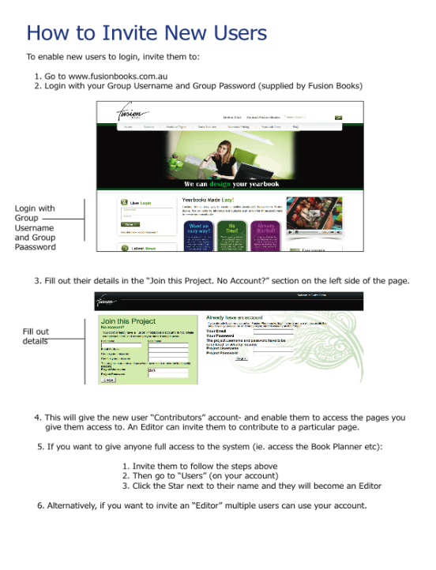
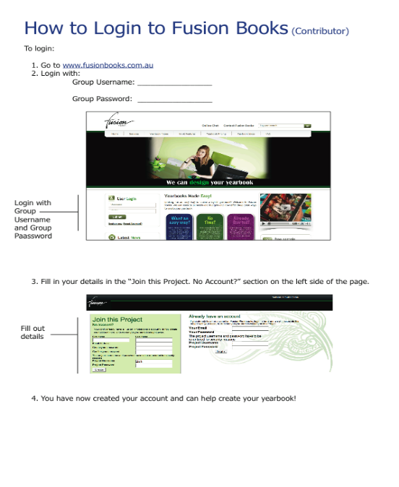
Can I upload multiple images onto the Fusion system?
I have attached a sheet that explains how to add Editors and Contributors.
Are there any computer requirements? Do I have to download any software?
Fusion Books does not require you to download any software. So you can access your book anywhere you can access the Internet. Fusion Books works on both Windows and Macs.
Our media class usually creates our yearbook. Are they still able to contribute?
We believe Fusion Books makes creating a yearbook or a Graduation book a more manageable task for students. Instead of creating the entire yearbook from scratch, the students can create several pages in PhotoShop or any other design program and upload them as a full-page in the book. These would create interesting feature pages, for example; a collage.
Is there a certain layout we have to follow?
Not at all. Fusion Books has been designed to be flexible. You can choose which pages to include and their order. You can create your own backgrounds or select backgrounds from our artist designed library.
What type of pages can we have in our book?
Fusion Books has been especially designed to enable you to easily create Article pages, Photo Pages, Profiles, Passport Photos and Group Photos. You can also ‘create your own’ page by uploading a full-page image- this is a particularly popular option to create your front-cover.
Is the Fusion Books site secure? How do you protect the privacy of the images?
We take your privacy very seriously. All accounts are password protected and are hosted in a secure environment. All images are stored securely online via your password protected login and are not shared with any parties external to the yearbook creation process, without your explicit permission.
Do we have to pay to use the software?
No, you only have to pay for the books you order, access to our system throughout the year is part of the Fusion Books package.
Do we get a proof of our book before printing?
With Fusion Books your Yearbook committee can have a full-quality preview of your entire book any time you require. Simply click the ‘Preview Book’ button and you will get a full-quality preview of your book which you can print and proof.
What does upload mean?
Upload is when you put anything from your computer onto the Internet. For example, if you are using the Fusion Books online system, you can ‘upload’ your photos onto the Fusion Books system to use in your book.
What does download mean?
Download is when you take anything down from the Internet. For example, if you are using the Fusion Books online system, you can ‘download’ a preview of your book for proofing.
What happens if we get stuck? Or have a question?
Give us a buzz on 1800 637 515 or Contact Us

