**"Smart forms-Billing Document"**

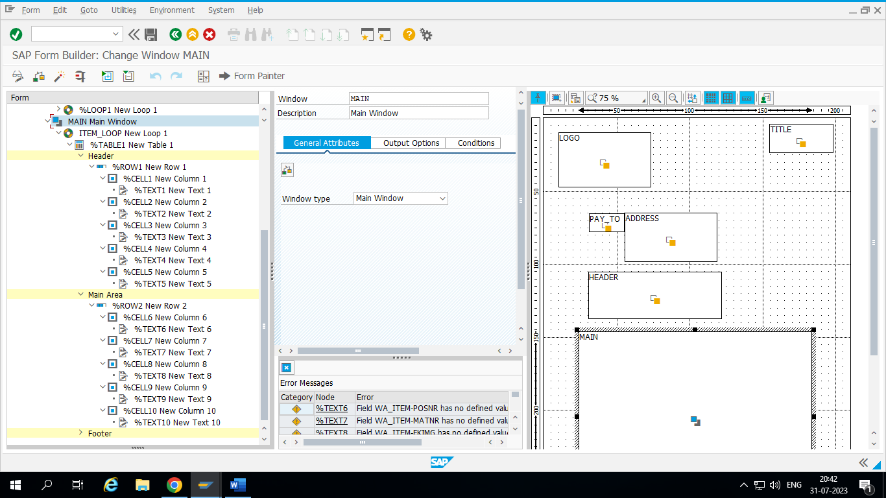

*&---------------------------------------------------------------------*  
*& Report ZBINCY_BILLING_SMARTFORMS  
*&---------------------------------------------------------------------*  
*&  
*&---------------------------------------------------------------------*  
REPORT zbincy_billing_smartforms.  
  
  
DATA : it_header TYPE STANDARD TABLE OF zvbrk_01.  
DATA : it_item TYPE zvbrp_011_TYPE.  
  
PARAMETERS v_vbeln TYPE zvbrp_011-vbeln.  
DATA fm_name TYPE RS38L_FNAM.  
  
START-OF-SELECTION.  
  SELECT * FROM zvbrk_01 INTO TABLE it_header WHERE vbeln EQ v_vbeln.  
     SELECT * FROM zvbrp_011 INTO TABLE it_item FOR ALL ENTRIES IN it_header WHERE vbeln EQ it_header-vbeln .  
  
       CALL FUNCTION 'SSF_FUNCTION_MODULE_NAME'  
         EXPORTING  
           formname                 = 'ZBINCY_BILLINGDOC_FORM_NEW'  
*          VARIANT                  = ' '  
*          DIRECT_CALL              = ' '  
        IMPORTING  
          FM_NAME                  = fm_name  
        EXCEPTIONS  
          NO_FORM                  = 1  
          NO_FUNCTION_MODULE       = 2  
          OTHERS                   = 3  
                 .  
       IF sy-subrc <> 0.  
* Implement suitable error handling here  
       ENDIF.  
  
CALL FUNCTION fm_name  
  EXPORTING  
*   ARCHIVE_INDEX              =  
*   ARCHIVE_INDEX_TAB          =  
*   ARCHIVE_PARAMETERS         =  
*   CONTROL_PARAMETERS         =  
*   MAIL_APPL_OBJ              =  
*   MAIL_RECIPIENT             =  
*   MAIL_SENDER                =  
*   OUTPUT_OPTIONS             =  
*   USER_SETTINGS              = 'X'  
    it_header                  = it_header  
    it_item                    = it_item  
* IMPORTING  
*   DOCUMENT_OUTPUT_INFO       =  
*   JOB_OUTPUT_INFO            =  
*   JOB_OUTPUT_OPTIONS         =  
 EXCEPTIONS  
   FORMATTING_ERROR           = 1  
   INTERNAL_ERROR             = 2  
   SEND_ERROR                 = 3  
   USER_CANCELED              = 4  
   OTHERS                     = 5  
          .  
IF sy-subrc <> 0.  
* Implement suitable error handling here  
ENDIF.

