**Package**

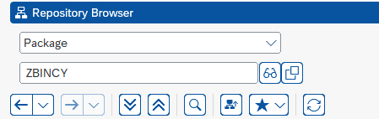

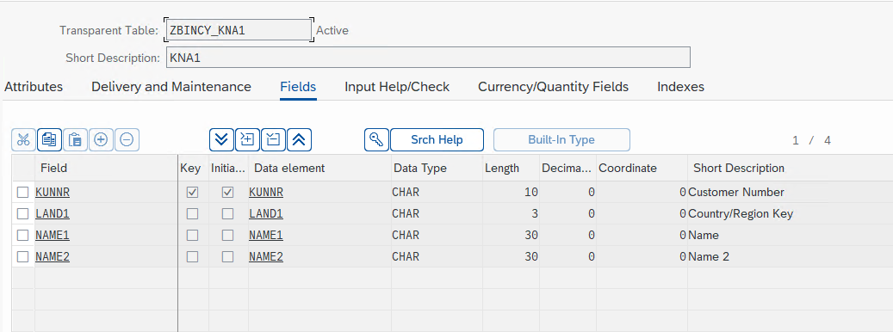

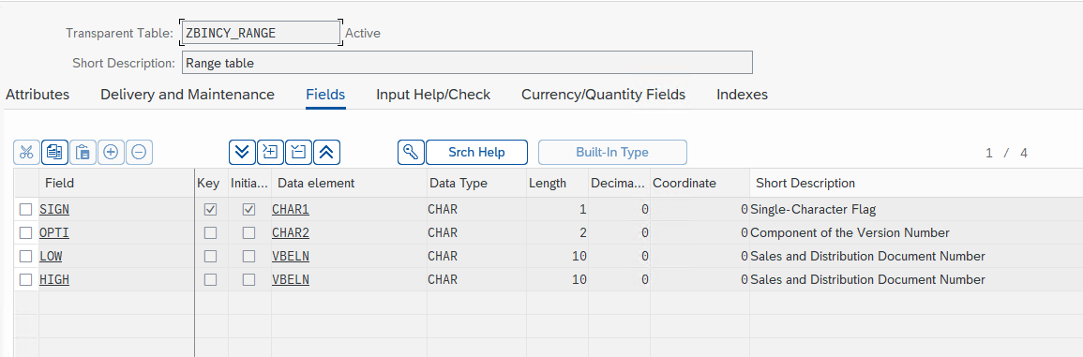

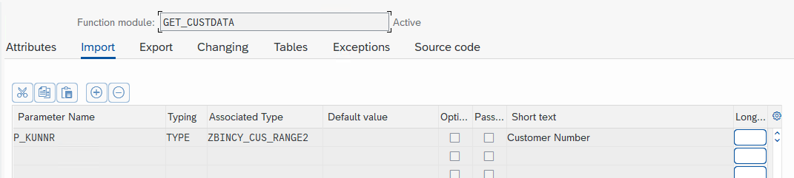

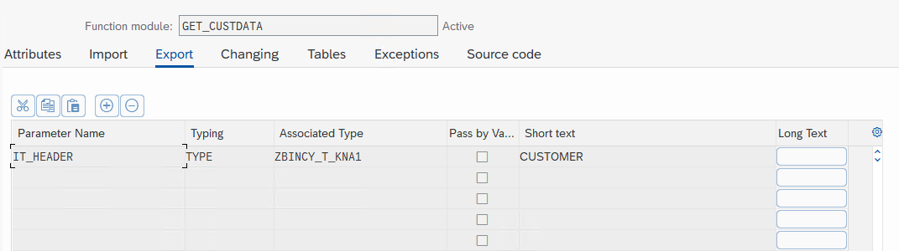

**Main program**

*\*&---------------------------------------------------------------------\**  
*\*& Report ZBINCT_ASSESMENT_CUST_DET*  
*\*&---------------------------------------------------------------------\**  
*\*&*  
*\*&---------------------------------------------------------------------\**  
REPORT ZBINCT_ASSESMENT_CUST_DET.  
  
DATA : it_header TYPE table of zbincy_kna1,  
 lw_header LIKE LINE OF it_header.  
  
  
DATA v_kunnr TYPE zbincy_kna1-kunnr.  
SELECT-OPTIONS s_KUNNR FOR v_KUNNR.  
  
START-OF-SELECTION.  
PERFORM get_data.  
  
END-OF-SELECTION.  
PERFORM DISPLAY.  
  
FORM get_data .  
  
CALL FUNCTION 'GET_CUSTDATA'  
 EXPORTING  
 P_kunnr = S_KUNNR[]  
 IMPORTING  
 IT_HEADER = it_header  
 .  
 ENDFORM.  
 FORM display .  
  
  
LOOP AT it_header INTO lw_header.  
 READ TABLE it_header INTO lw_header WITH KEY s_kunnr.  
 WRITE : / 'Customer number:', lw_header-kunnr,  
 / 'Name 1:', lw_header-name1,  
 / 'Name 2:', lw_header-name2,  
 / 'Country :', lw_header-land1.  
  
 SKIP.  
 ENDLOOP.  
  
  
endform.

**Function Module**

FUNCTION GET_CUSTDATA.  
*\*"----------------------------------------------------------------------*  
*\*"*"Local Interface:*  
*\*" IMPORTING*  
*\*" REFERENCE(P_KUNNR) TYPE ZBINCY_CUS_RANGE2*  
*\*" EXPORTING*  
*\*" REFERENCE(IT_HEADER) TYPE ZBINCY_T_KNA1*  
*\*"----------------------------------------------------------------------*  
DATA: lt_kna1 TYPE TABLE OF kna1,  
 lw_kna1 LIKE LINE OF lt_kna1.  
  
DATA lw_header LIKE LINE OF IT_HEADER.  
  
SELECT * FROM kna1 INTO TABLE lt_kna1 WHERE kunnr IN P_KUNNR.  
  
 LOOP AT lt_kna1 INTO lw_kna1.  
  
 MOVE-CORRESPONDING lw_kna1 TO lw_header.  
  
 APPEND lw_header TO IT_header.  
 CLEAR lw_header.  
  
 ENDLOOP.  
  
  
ENDFUNCTION.

