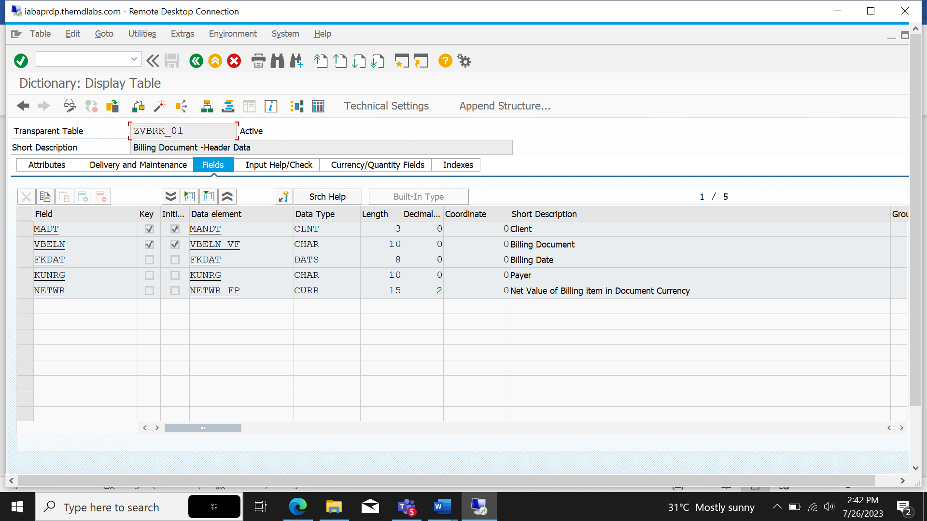

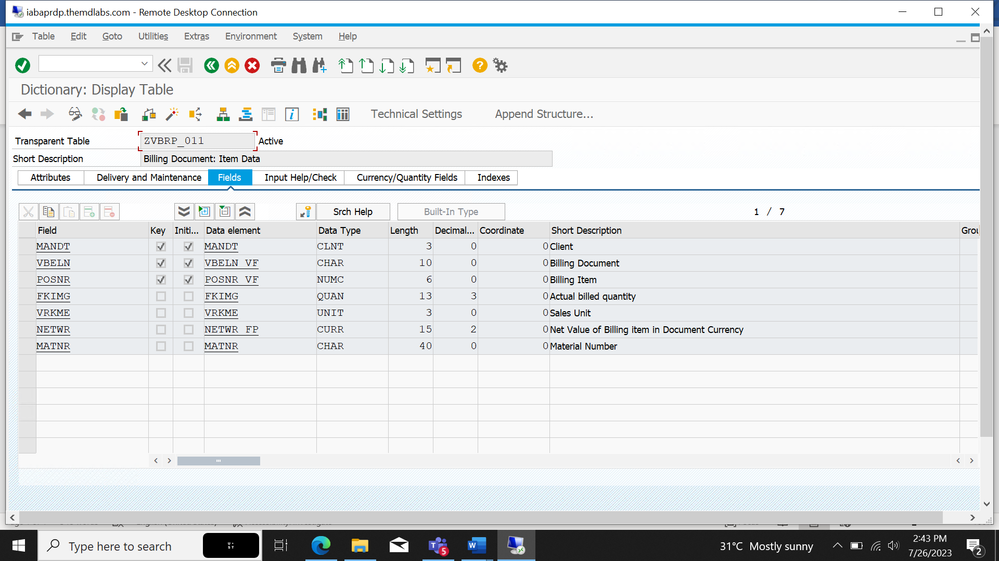

*\*&---------------------------------------------------------------------\**  
*\*& Report ZBINCY_BILLINGDOC_ASSESMENT*  
*\*&---------------------------------------------------------------------\**  
*\*&*  
*\*&---------------------------------------------------------------------\**  
REPORT zbincy_billingdoc_assesment.  
  
DATA : it_header TYPE STANDARD TABLE OF zvbrk_01,  
 wa_header LIKE LINE OF it_header.  
DATA : it_item TYPE STANDARD TABLE OF zvbrp_011,  
 wa_item LIKE LINE OF it_item.  
  
TYPES ty_zvbrk_01 TYPE TABLE OF zvbrk_01.  
TYPES ty_zvbrp_011 TYPE TABLE OF zvbrp_011.  
TYPES tr_vbeln TYPE RANGE OF zvbrk_01-vbeln.  
SELECT-OPTIONS s_vbeln FOR wa_header-vbeln.  
  
START-OF-SELECTION.  
 PERFORM get_header USING s_vbeln[] CHANGING it_header.  
  
END-OF-SELECTION.  
 PERFORM get_display.  
  
FORM get_header USING f_s_vbeln TYPE tr_vbeln CHANGING f_it_header TYPE ty_zvbrk_01.  
 IF sy-subrc IS INITIAL.  
 SELECT * FROM zvbrk_01 INTO TABLE it_header WHERE vbeln IN s_vbeln.  
 ENDIF.  
ENDFORM.  
  
FORM get_display.  
  
 CALL FUNCTION 'REUSE_ALV_GRID_DISPLAY'  
 EXPORTING  
*\* I_INTERFACE_CHECK = ' '*  
*\* I_BYPASSING_BUFFER = ' '*  
*\* I_BUFFER_ACTIVE = ' '*  
 i_callback_program = 'ZBINCY_BILLINGDOC_ASSESMENT'  
*\* I_CALLBACK_PF_STATUS_SET = ' '*  
 i_callback_user_command = 'USER_COMMAND'  
*\* I_CALLBACK_TOP_OF_PAGE = ' '*  
*\* I_CALLBACK_HTML_TOP_OF_PAGE = ' '*  
*\* I_CALLBACK_HTML_END_OF_LIST = ' '*  
 i_structure_name = 'ZVBRK_01'  
*\* I_BACKGROUND_ID = ' '*  
*\* I_GRID_TITLE =*  
*\* I_GRID_SETTINGS =*  
*\* IS_LAYOUT =*  
*\* IT_FIELDCAT = lt_fcat*  
*\* IT_EXCLUDING =*  
*\* IT_SPECIAL_GROUPS =*  
*\* IT_SORT =*  
*\* IT_FILTER =*  
*\* IS_SEL_HIDE =*  
*\* I_DEFAULT = 'X'*  
*\* I_SAVE = ' '*  
*\* IS_VARIANT =*  
*\* IT_EVENTS =*  
*\* IT_EVENT_EXIT =*  
*\* IS_PRINT =*  
*\* IS_REPREP_ID =*  
*\* I_SCREEN_START_COLUMN = 0*  
*\* I_SCREEN_START_LINE = 0*  
*\* I_SCREEN_END_COLUMN = 0*  
*\* I_SCREEN_END_LINE = 0*  
*\* I_HTML_HEIGHT_TOP = 0*  
*\* I_HTML_HEIGHT_END = 0*  
*\* IT_ALV_GRAPHICS =*  
*\* IT_HYPERLINK =*  
*\* IT_ADD_FIELDCAT =*  
*\* IT_EXCEPT_QINFO =*  
*\* IR_SALV_FULLSCREEN_ADAPTER =*  
*\* O_PREVIOUS_SRAL_HANDLER =*  
*\* IMPORTING*  
*\* E_EXIT_CAUSED_BY_CALLER =*  
*\* ES_EXIT_CAUSED_BY_USER =*  
 TABLES  
 t_outtab = it_header  
 EXCEPTIONS  
 program_error = 1  
 OTHERS = 2.  
 IF sy-subrc <> 0.  
*\* Implement suitable error handling here*  
 ENDIF.  
  
ENDFORM.  
  
  
  
FORM user_command USING r_ucomm LIKE sy-ucomm  
 rs_selfield TYPE slis_selfield.  
 DATA v_vbeln TYPE vbeln.  
 IF r_ucomm EQ '&IC1' AND rs_selfield-fieldname EQ 'VBELN'.  
 v_vbeln = rs_selfield-value.  
 CALL FUNCTION 'CONVERSION_EXIT_ALPHA_INPUT'  
 EXPORTING  
 input = v_vbeln  
 IMPORTING  
 output = v_vbeln.  
 SELECT * FROM zvbrp_011 INTO TABLE it_item WHERE vbeln EQ v_vbeln .  
 CALL FUNCTION 'REUSE_ALV_GRID_DISPLAY'  
 EXPORTING  
*\* I_INTERFACE_CHECK = ' '*  
*\* I_BYPASSING_BUFFER = ' '*  
*\* I_BUFFER_ACTIVE = ' '*  
 i_callback_program = 'ZBINCY_BILLINGDOC_ASSESMENT'  
*\* I_CALLBACK_PF_STATUS_SET = ' '*  
 i_callback_user_command = 'USER_COMMAND1'  
*\* I_CALLBACK_TOP_OF_PAGE = ' '*  
*\* I_CALLBACK_HTML_TOP_OF_PAGE = ' '*  
*\* I_CALLBACK_HTML_END_OF_LIST = ' '*  
 i_structure_name = 'ZVBRP_011'  
*\* I_BACKGROUND_ID = ' '*  
*\* I_GRID_TITLE =*  
*\* I_GRID_SETTINGS =*  
*\* IS_LAYOUT =*  
*\* IT_FIELDCAT =*  
*\* IT_EXCLUDING =*  
*\* IT_SPECIAL_GROUPS =*  
*\* IT_SORT =*  
*\* IT_FILTER =*  
*\* IS_SEL_HIDE =*  
*\* I_DEFAULT = 'X'*  
*\* I_SAVE = ' '*  
*\* IS_VARIANT =*  
*\* IT_EVENTS =*  
*\* IT_EVENT_EXIT =*  
*\* IS_PRINT =*  
*\* IS_REPREP_ID =*  
*\* I_SCREEN_START_COLUMN = 0*  
*\* I_SCREEN_START_LINE = 0*  
*\* I_SCREEN_END_COLUMN = 0*  
*\* I_SCREEN_END_LINE = 0*  
*\* I_HTML_HEIGHT_TOP = 0*  
*\* I_HTML_HEIGHT_END = 0*  
*\* IT_ALV_GRAPHICS =*  
*\* IT_HYPERLINK =*  
*\* IT_ADD_FIELDCAT =*  
*\* IT_EXCEPT_QINFO =*  
*\* IR_SALV_FULLSCREEN_ADAPTER =*  
*\* O_PREVIOUS_SRAL_HANDLER =*  
*\* IMPORTING*  
*\* E_EXIT_CAUSED_BY_CALLER =*  
*\* ES_EXIT_CAUSED_BY_USER =*  
 TABLES  
 t_outtab = it_item  
 EXCEPTIONS  
 program_error = 1  
 OTHERS = 2.  
 IF sy-subrc <> 0.  
*\* Implement suitable error handling here*  
 ENDIF.  
  
 ELSEIF r_ucomm EQ '&IC1' AND rs_selfield-fieldname EQ 'KUNRG'.  
 SET PARAMETER ID 'KUN' FIELD rs_selfield-value.  
 CALL TRANSACTION 'XD03'.  
 ENDIF.  
*\*ENDIF.*  
ENDFORM.  
FORM user_command1 USING r_ucomm LIKE sy-ucomm  
 rs_selfield TYPE slis_selfield.  
 IF r_ucomm EQ '&IC1' AND rs_selfield-fieldname EQ 'MATNR'.  
 SET PARAMETER ID 'MAT' FIELD rs_selfield-value.  
 CALL TRANSACTION 'MM03'.  
 ENDIF.  
ENDFORM.

**Output**

