ASSIGNMENT-9.3

Htno-2403A51285

Batch-12

9.3_1:
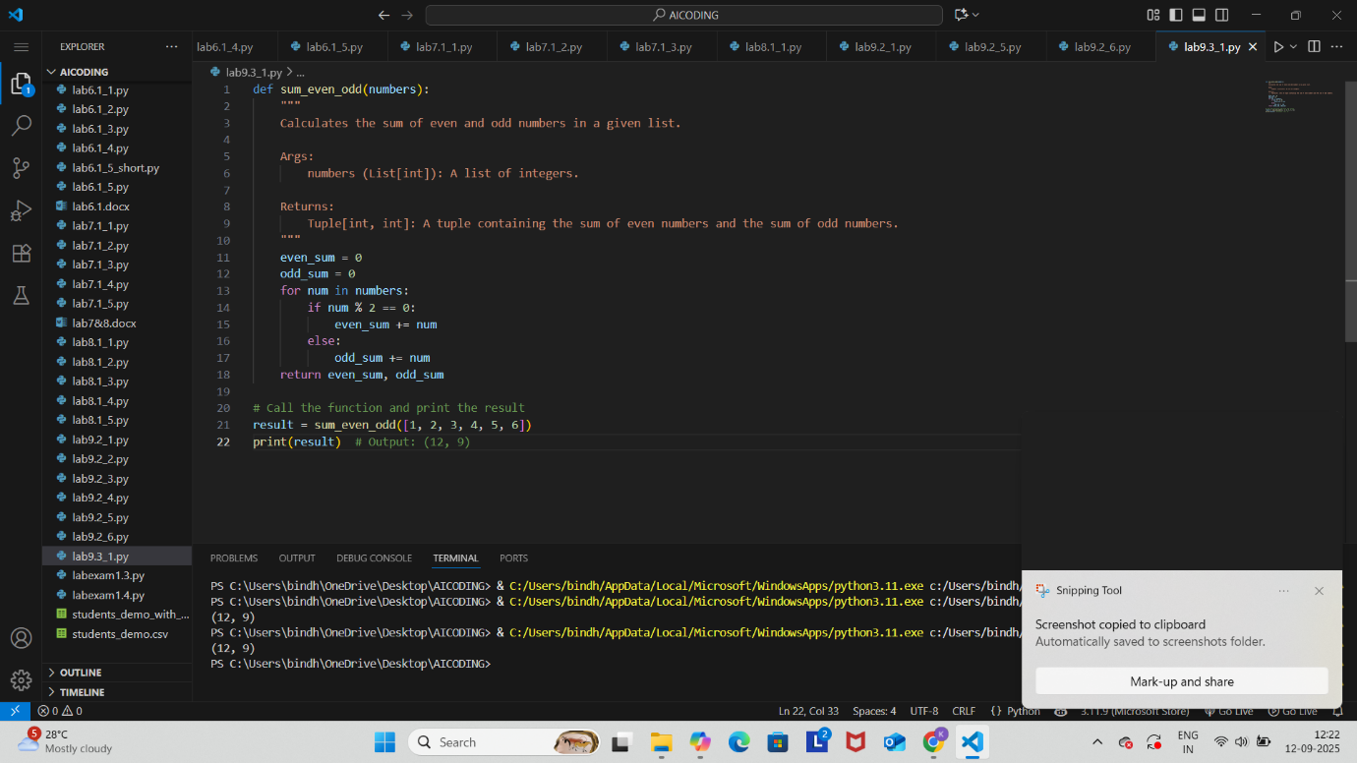

9.3_2:
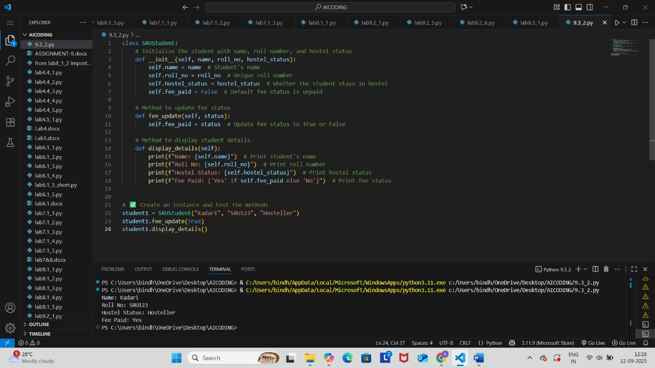

9.3_3:

Code
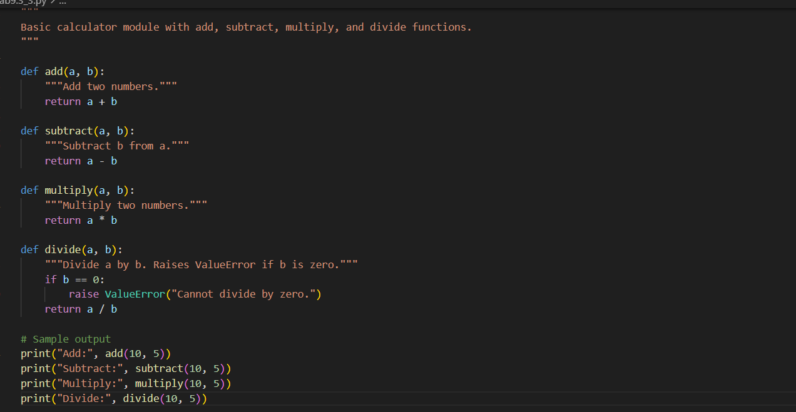

Output:
