Keycloak and Its Configuration

What is Keycloak?
Keycloak is an open-source Identity and Access Management solution aimed at modern applications and services. It supports single sign-on (SSO), user federation, identity brokering, and standard protocols such as OAuth2.0, OpenID Connect, and SAML.

Setting Up Keycloak

Step 1: Start Keycloak Using Docker
To start Keycloak in a development environment:
- Pull the latest Keycloak image:
- Run the Keycloak container:
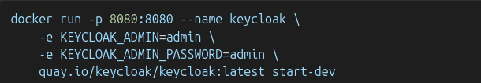
Keycloak will now be accessible at http://localhost:8080.

Step 2: Configure Keycloak for Azure AD Integration

1. Create a Realm
- Log in to the Keycloak Admin Console.
- Create a new realm named myrealm.

2. Add Identity Provider (Azure AD)
- Navigate to Identity Providers.
- Add a provider of type OIDC.

3. Configure Identity Provider Settings
- Alias: azuread
- Display Name: Azure AD
- Authorization URL: From Azure Application Endpoints - OAuth 2.0 authorization endpoint (v2)
- Token URL: From Azure Application Endpoints - OAuth 2.0 token endpoint (v2)
- Client ID: (Get this from your Azure AD app registration)
- Client Secret: (Get this from your Azure AD app registration)
- Scopes: openid profile email
- Trust Email: Enable
- Sync Mode: Import

4. Configure Mappers
- Add mappers to map user attributes from Azure AD to Keycloak:
  - Mapper 1:
    - Name: email
    - Sync Mode Override: Inherit
    - Mapper Type: Attribute Importer
    - Claim: email
    - User Attribute Name: email
  - Mapper 2:
    - Name: username
    - Sync Mode Override: Inherit
    - Mapper Type: Attribute Importer
    - Claim: preferred_username
    - User Attribute Name: username
  - Mapper 3:
    - Name: name
    - Sync Mode Override: Inherit
    - Mapper Type: Attribute Importer
    - Claim: name
    - User Attribute Name: firstname

Step 3: Create a Client in Keycloak
- Navigate to Clients and create a new client:
  - Client ID: (Use Azure AD client ID)
  - Name: A descriptive name like temp name/admin
  - Root URL: http://localhost:5000/
  - Valid Redirect URIs: http://localhost:5000/callback
  - Web Origins: http://localhost:5000
  - Admin URL: http://localhost:5000/
  - Client Authentication: Enable
  - Authentication Flow: Enable Standard Flow, Direct Access Grants, and Implicit Flow
- Copy the client secret from the Credentials tab.

Step 4: Update Python Code
Ensure the following Python code matches your configuration:
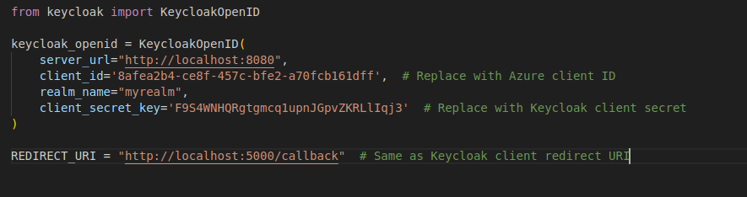
Step 5: Test the Integration
- Run your Python application.
- Log in using Azure AD credentials.
- Verify that the user attributes (email, username, name) are correctly imported into Keycloak.

