**Name: Bindiya Chaudhari**

**Roll No: 30**

**Practical No 8: Use git merge to merge your change to the primary branch**

comp@comp255 MINGW32 ~ (master)

$ git clone https://github.com/bindiya7385/KBCNMU.git

fatal: destination path 'KBCNMU' already exists and is not an empty directory.

comp@comp255 MINGW32 ~ (master)

$ cd KBCNMU

comp@comp255 MINGW32 ~/KBCNMU (main)

$ touch demo.txt

comp@comp255 MINGW32 ~/KBCNMU (main)

$ git add demo.txt

comp@comp255 MINGW32 ~/KBCNMU (main)

$ git commit -m "First commit"

[main cdc74b5] First commit

1 file changed, 0 insertions(+), 0 deletions(-)

create mode 100644 demo.txt

comp@comp255 MINGW32 ~/KBCNMU (main)

$ git branch branch1

comp@comp255 MINGW32 ~/KBCNMU (main)

$ git checkout branch1

Switched to branch 'branch1'

comp@comp255 MINGW32 ~/KBCNMU (branch1)

$ touch exe.txt

comp@comp255 MINGW32 ~/KBCNMU (branch1)

$ git add exe.txt

comp@comp255 MINGW32 ~/KBCNMU (branch1)

$ git commit -m "Second commit"

[branch1 e2f5e73] Second commit

1 file changed, 0 insertions(+), 0 deletions(-)

create mode 100644 exe.txt

comp@comp255 MINGW32 ~/KBCNMU (branch1)

$ git merge main

Already up to date.

comp@comp255 MINGW32 ~/KBCNMU (branch1)

$ git branch --list

* branch1

main

comp@comp255 MINGW32 ~/KBCNMU (branch1)

$

**Before Merge to local Repository:**

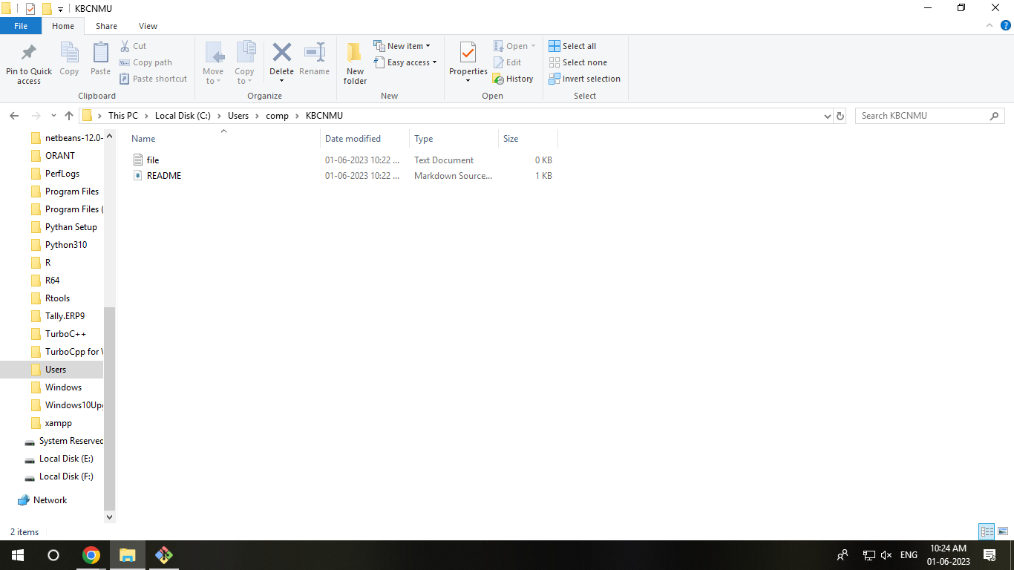

**After Merge to local Repository:**

