**Schema Diagram:**

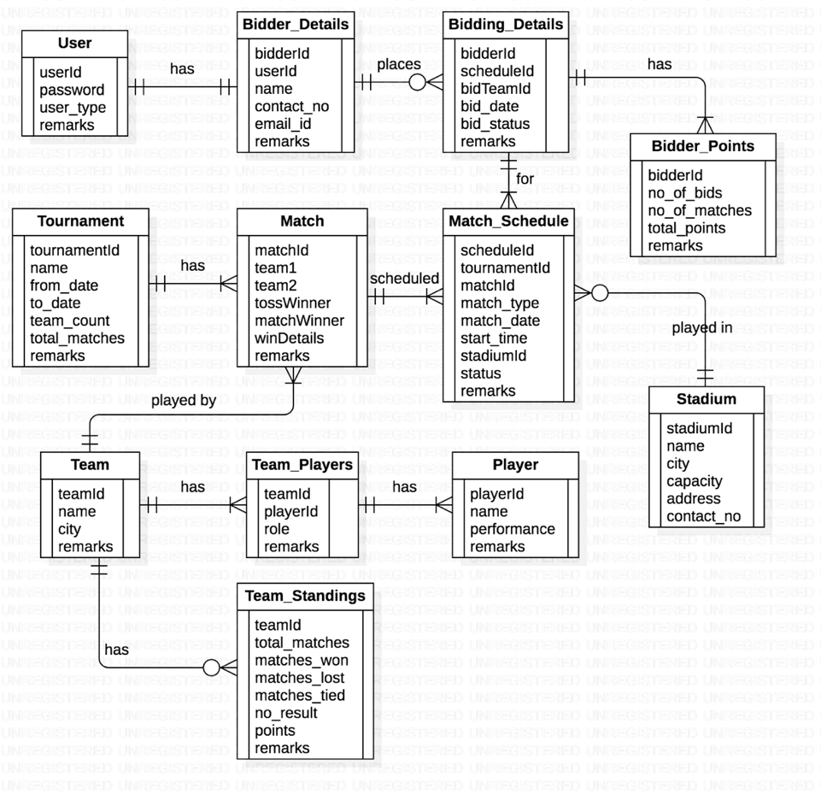

**Instructions:**

1. Create these tables in the database by running the database script provided
2. The script also has statements to insert appropriate data into all these tables
3. Test the successful execution of the script by selecting some rows from few tables
4. Clearly understand the structure of each table and relationships among them
5. Insert / update appropriate rows into relevant tables if you need to get more rows in the output to verify your answers

**Questions – Write SQL queries to get data for following requirements:**

1. Show the percentage of wins of each bidder in the order of highest to lowest percentage.
2. Display the number of matches conducted at each stadium with stadium name, city from the database.
3. In a given stadium, what is the percentage of wins by a team which has won the toss?
4. Show the total bids along with bid team and team name.
5. Show the team id who won the match as per the win details.
6. Display total matches played, total matches won and total matches lost by team along with its team name.
7. Display the bowlers for Mumbai Indians team.
8. How many all-rounders are there in each team, Display the teams with more than 4

all-rounder in descending order.