Korai Viktor - koraiviktor@hotmail.com

Bindics Gergely - bindicsgeri@gmail.com

[E-mail cím]

Epitome

We are building a spectacular drawing unit that is easily controllable and programmable for everyone without any relevant professional knowledge via the self-designed image processing software developed specifically for this machine.

Project I.

Drawing machine

Table of contents

Introduction 2

Requirements 2

Features 3

Input 3

Output 3

Block diagram 3

Implementation description 4

Verification against requirements 10

Timetable 10

Cost estimation 11

Milestones 11

Difficulties and solutions 12

Summary 13

***Specification***

# Introduction

We are going to implement an automatic drawing machine, with a user friendly image processing software designed and written for this specific task.

The aim of this project is to make this machine usable for people with no related programming knowledge. Also, with this robotic arm, we can draw figures very precisely to avoid human mistakes, or to be able to draw under different extreme environmental circumstances. For example, using an air-brush combined with this tool, no worker has to suffer from the negative side effects of the toxic gases emitted during the painting.

We are splitting up the project described above into 2 parts.

In the first part we are going to assemble a self-designed manipulator which can move along 2 dimensions. It working with a pre-defined coordinate array which contains integer numbers.

In the second part, we are going to develop the user friendly driver software for this hardware and implement the third axis which is responsible for the movement of the plotting head. (Touches the drawing surfaces or lifts it up.) We are also planning to design a monitoring feature which will display graphically the current state of the ongoing process. Finally, we are going to change the USB communication to Bluetooth.

# Requirements

We have the following requirements stated against the final product: the arm can paint and reproduce the same picture that we loaded into our software. Then, this software should be able to calculate the drawing routes from the input image and save them as individual projects, so that we can load them later in case we want to reuse them. Finally, anyone without related programming knowledge should be able to program the robotic arm with the help of our image processing software.

In the end, the manipulator should reach 1mm precision.

As for the time requirements, the drawing machine will be able to draw a 500x500 pixel image in 5 minutes.

At the end of the whole project, after the 2 semester, it will be able to draw a picture using one color. The plan is to make it easy to implement an improvement, where the unit will be able to use several colors.

# Features

The robotic arm is portable, and can reproduce the input image under extreme environmental circumstances. Also, with this software we can observe and monitor the ongoing process.

# Input

At the end of the first semester for the input we will load a pre-defined coordinate map which will contain the colored points of the final image that the unit will draw.

By the end of the second semester the input of our tool will be a single BMP image, that we have to load into our software, which will define the final picture.

# Output

The drawn black and white picture of the robotic arm on a piece of paper.

# Block diagram



# Implementation description

1. **Hardware list**
   * Microcontroller
     + Arduino Leonardo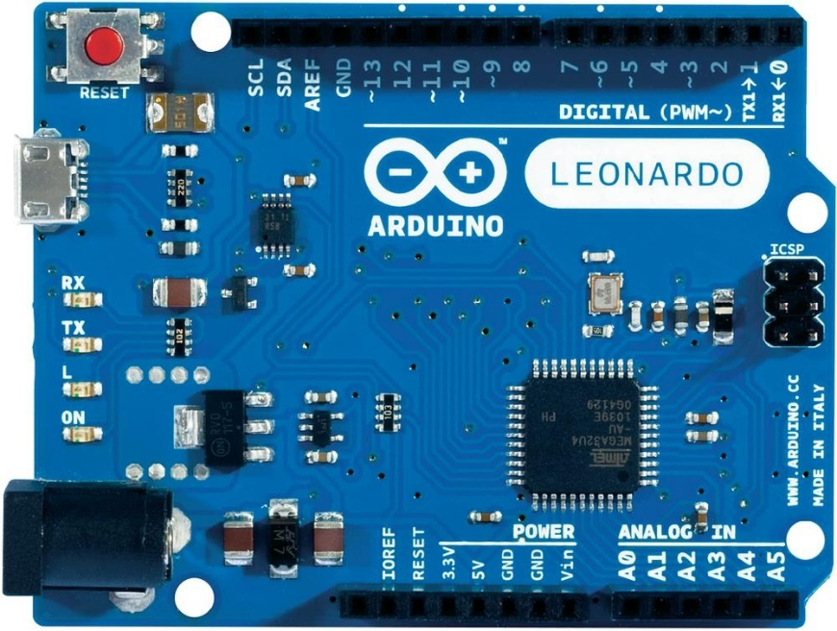
       - Microcontroller ATmega32u4
       - Operating Voltage 5V
       - Input Voltage (recommended) 7-12V
       - Input Voltage (limits) 6-20V
       - Digital I/O Pins 20
       - PWM Channels 7
       - Analog Input Channels 12
       - DC Current per I/O Pin 40 mA
       - DC Current for 3.3V Pin 50 mA
       - Flash Memory 32 KB (ATmega32u4) of which 4 KB used by bootloader
       - SRAM 2.5 KB (ATmega32u4)
       - EEPROM 1 KB (ATmega32u4)
       - Clock Speed 16 MHz
       - Length 68.6 mm
       - Width 53.3 mm
       - Weight 20g
   * Laptop

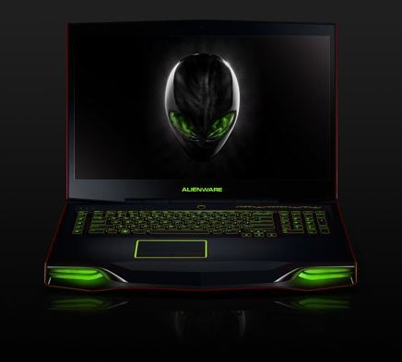

* + Wooden skeleton and other components (gears etc.)

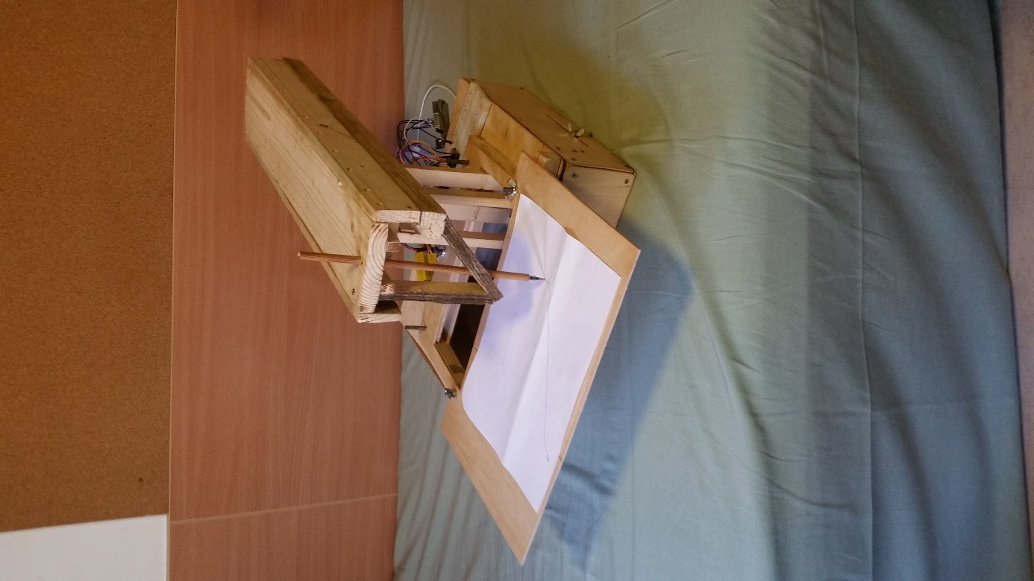

* + - Birchplywood4 mm (1525x1525 mm BB/CP)

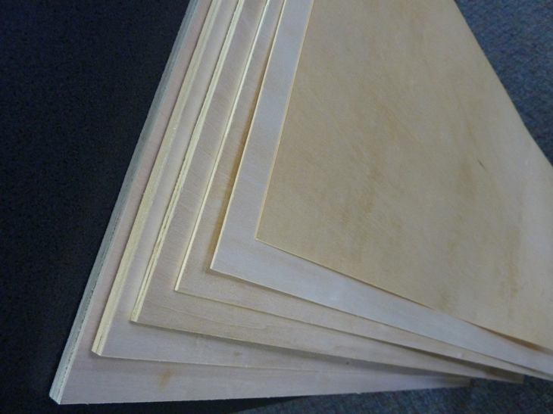

* + - * Density:Medium density, but excellent strength
      * Values (kg/m3):air dry: 650-830, absolute dry: 610-800
      * Its strength characteristics are similar to beech, but it has lower density, so it is more optimal to manufacture furniture construction
      * It has extraordinary flexibility and toughness
      * Quality: BB/CP  
          BB side: smaller, healthy ingrown knots and slight discoloration may occur  
          CP: smaller branch failures and slight discoloration may occur  
        Easily workable, it is possible to manufacture it rapidly
  + Self-designed manipulator
    - 3 NEMA 17 stepper motor

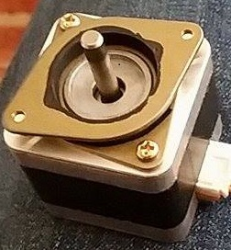

* + - * 1.8o step angle
      * 200 steps per revolution
      * Size: 42.3 mm square × 48 mm, not including the shaft (NEMA 17)
      * Weight: 350 g (13 oz.)
      * Shaft diameter: 5 mm “D”
      * Steps per revolution: 200
      * Current rating: 1.2 A per coil
      * Voltage rating: 4 V
      * Resistance: 3.3 Ω per coil
      * Holding torque: 3.2 kg-cm (44 oz.-in)
      * Inductance: 2.8 mH per coil
      * Lead length: 30 cm (12″)
      * Output shaft supported by two ball bearings
    - 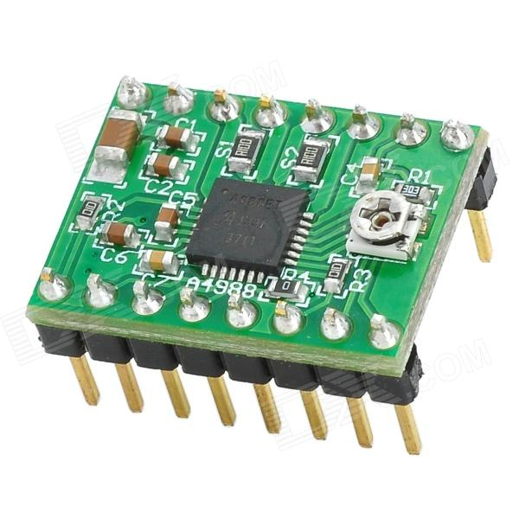3 stepper motor driver  
      * Dimensions
      * Size: 0.6″ × 0.8″
      * Weight: 1.3 g1
      * General specifications
      * Minimum operating voltage: 8 V
      * Maximum operating voltage: 35 V
      * Continuous current per phase: 1 A2
      * Maximum current per phase: 2 A3
      * Minimum logic voltage: 3 V
      * Maximum logic voltage: 5.5 V
      * Micro step resolutions: full, 1/2, 1/4, 1/8, and 1/16
      * Reverse voltage protection: N
      * Bulk packaged: N
      * Header pins soldered: N4
    - Breadboard

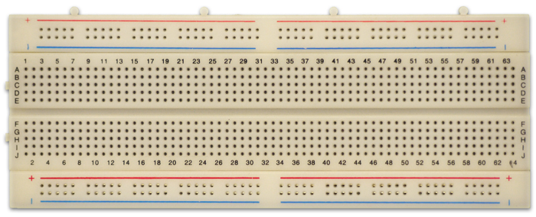

* + - Jumper wires

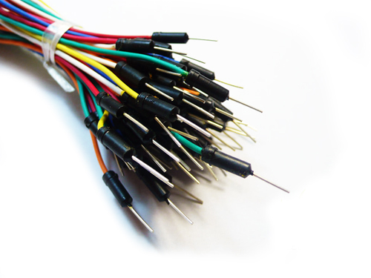

* + - 2x 9V battery

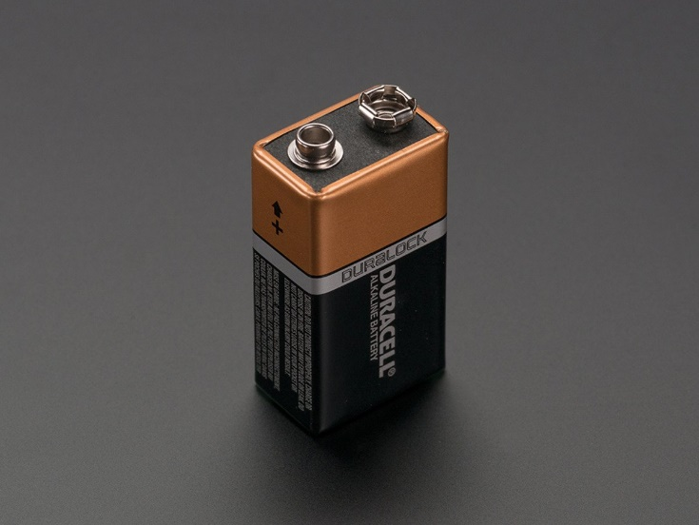

1. **Software list**
   * Windows operation system
   * Graphic design software for e.g. Paint
   * Self-developed image processing software
   * Arduino IDE
   * Manipulator controlling software developed in Arduino IDE
2. **Control logic**



# Verification against requirements

We would like to show the unit while it is recreating the image from the pre-defined coordinate map that we loaded into the image processing software.

We would like to measure the precision with a ruler, and the time taken to draw the image with a timer.

# Timetable

# Cost estimation

# 

# Milestones

* Connecting the circuit including the Arduino and 1 stepper motor and successfully drive them
* Manufacturing and assembling the wooden skeleton
* Attaching 1 gear-rack combination to a motor and moving it along 1 dimension
* Assembling the second motor and its gear(s), and being able to move to the desired coordinate in a 2D coordinate system
* Reach the target resolution
* Testing against requirements

# Difficulties and solutions

1. **Friction**

Problem:

Our biggest challenge was to minimize the friction between the sliding surfaces.

Solution:



We manufactured sliding surface extensions from birch plywood and covered it with soap. Also, lightened the wood structure where it was possible.

1. **Motor performance**

Problem:

The two motor couldn’t reach the maximum torque with a single 9V battery.

Solution: 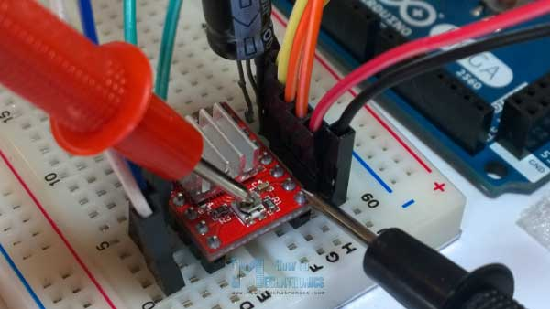

We adjusted the pot meters on the drivers and connected another 9V battery in series.

# Summary

We had hard time realizing our project, but it was a great experience. We enjoyed every moment of the process, even if we had our ups and downs. We encountered a lot of new problems and solutions that we haven’t met before, so after all we could learn a lot from this project. We are really proud of our machine, and we are happy that we could make it work at the end!