HOL – Working with Azure Graph DB

Objective

Objective of this HOL is to help you create a “Movie Recommendation” program using Azure Graph DB. You will be uploading large dataset contains User, Movie and Movie rating data to Graph DB and you can follow along set of Gremlin Queries to perform data analysis.
Pre-requisite
- Download and install Java https://java.com/en/download/ . Also, don’t forget to update the Environment Variables in your computer for Java PATH
- Download and install Gremlin Console from - http://tinkerpop.apache.org/
- Download and install Node JS from https://nodejs.org/en/download/
- Use your own choice of code editor for working with Node JS

Installing Gremlin Console

- Go to http://tinkerpop.apache.org/ , download and install “Gremlin Console” for windows. The gremlin console is a REPL Environment, which also provides a nice way to learn Gremlin as you get immediate feedback for the code you enter. If your install is successful, go the “bin” folder and you will find “gremlin.bat”. Double click to open the Gremlin console and you should see the gremlin console window as shown below 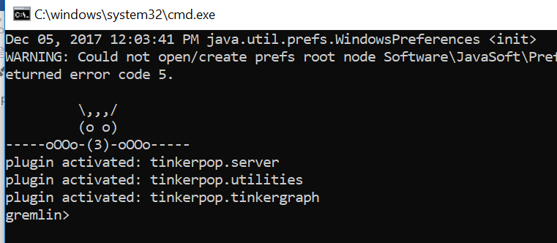

Creating Azure Graph DB

Follow the steps and details provided in https://docs.microsoft.com/en-us/azure/cosmos-db/create-graph-gremlin-console to create an Azure Graph DB account

- Go to https://portal.azure.com
- Click “Create a resource” on the top left corner of the page 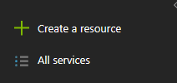
- Click on “Cosmos DB” 
- Provide ID, API, Subscription and Resource Group based on your preference, you need to select “Gremlin” as the API. You could create a new resource group per your need. As this will be demonstration purpose, you don’t need to select “Enable geo-redundancy” , and finally click “create”
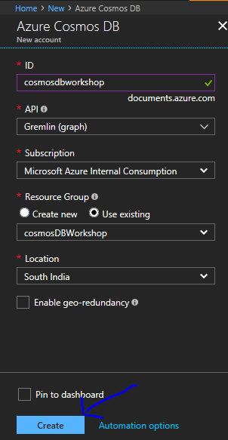
- Go to the created cosmos DB account, and in “Overview” click on “Add Graph” 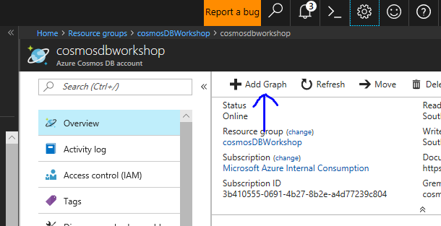
- Provide Database ID, Graph ID and click “OK”

Creating Node JS program to upload data to Graph DB
- npm init
- npm install documentdb –save
- npm install gremlin --save
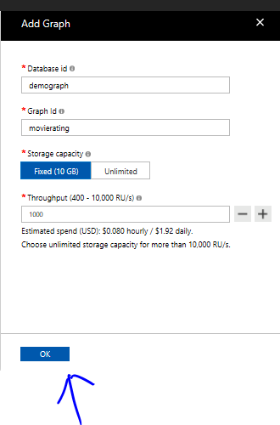
- Now, go back to the created cosmos DB account and go to section “Keys” and make a note of the keys and you would this to use in Gremlin configuration file later.

Configuring Gremlin Console with Azure Cosmos Graph DB

- Go to Gremlin install folder in your computer and open “remote-secure.yaml” file from the “conf” directory (Note – take a backup of this file just to be in the safer side)
- After updating remote-secure.yaml, the file should looks like this
hosts: [your_database_server.graphs.azure.com]
port: 443
username: /dbs/your_database_account/colls/your_collection
password: your_primary_key
connectionPool: {
enableSsl: true
}
serializer: { className: org.apache.tinkerpop.gremlin.driver.ser.GraphSONMessageSerializerV1d0, config: { serializeResultToString: true }}
- Open Gremlin console and run command “:remote connect tinkerpop.server conf/remote-secure.yaml” this will use the configuration in the remote-secure.yaml file and connect to your Graph DB
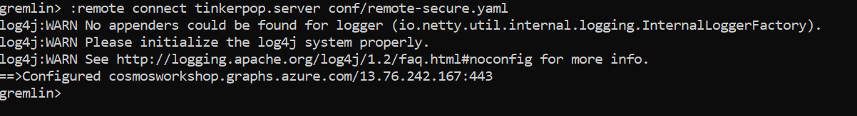
- Then type the following Gremlin Query “:> g.V().count()” and it should produce an output with number of nodes in the Graph DB.
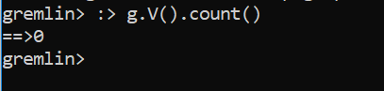

Loading bulk data to Graph DB

Go to the Git Hub Repo https://github.com/binduchinnasamy/cosmos-graph-movie-rating and follow the instruction in the “Read Me” file, this Node JS program will help you to load bulk data to Azure Cosmos Graph DB

Working with Movie Graph Data for Analyzing & Recommendation

In the Gremlin Console, you can punch-in the following commands to work with data you just uploaded to Azure Cosmos Graph DB
Purpose | Query
Connect to Azure Graph DB | :remote connect tinkerpop.server conf/remote-secure.yaml
Get total count of Vertex in DB | :> g.V().count()
Find total number of ‘movie’ vertex | :> g.V().has('label','movie').count()
Find total number of ‘user’ vertex | :> g.V().has('label','user').count()
Find total number of users who are age >40 | :> g.V().hasLabel('user').has('age', gt(40)).count()
Find total number of users with occupation as artist (id ‘o2’) | :> g.V().hasLabel('user').outE('hasOccupation').inV().has('id','o2').count()
How many ratings movie “Toy Story” got totally? | :> g.V().hasLabel('movie').has('title','Toy Story ').inE('rated').count()
How many users rated movie “Toy Story”? | :> g.V().hasLabel('user').outE('rated').inV().has('id','1').count()
Get all the ratings given for movie “Toy Story”? | g.V().hasLabel('movie').has('title','Toy Story ').inE('rated').properties('stars').value()
What is the average rating movie “Toy Story” received? | :> g.V().hasLabel('movie').has('title','Toy Story ').inE('rated').properties('stars').value().mean()
List the users who are more than 40 years old and rated movie “Toy Story”? | :> g.V().hasLabel('movie').has('title','Toy Story ').inE('rated').outV().has('age',gt(40))
Which user gave “Toy Story “ more than 3 stars | :> g.V().hasLabel('movie').has('title','Toy Story ').inE('rated').has('stars',gt(3)).outV()
Which user gave “Toy Story” more than 4 starts and what other movies did they give more than 4 stars to? | :> g.V().hasLabel('movie').has('title','Toy Story ').inE('rated').has('stars',gt(3)).outV().outE('rated').has('stars',gt(3)).inV().properties('title').value()
The above query might return many duplicate values, this is due to the fact that user who liked “Toy Story “ also liked many other movies, the dedup() step in this query filters out the duplicates.  Given that there are 17933 highly rated paths from Toy Story to other movies and only 1961 of those movies are unique, it is possible to use these duplicates as a ranking mechanism–ultimately, a recommendation. | :> g.V().hasLabel('movie').has('title','Toy Story ').inE('rated').has('stars',gt(4)).outV().outE('rated').has('stars',gt(4)).inV().properties('title').value().dedup()  ========================= Ref===============  gremlin> :> g.V().hasLabel('movie').has('title','Toy Story ').inE('rated').has('stars',gt(4)).outV().outE('rated').has('stars',gt(4)).inV().properties('title').value().count()  ==>17933  gremlin> :> g.V().hasLabel('movie').has('title','Toy Story ').inE('rated').has('stars',gt(4)).outV().outE('rated').has('stars',gt(4)).inV().properties('title').value().dedup().count()  ==>1961  gremlin>
Which movies are most highly co-rated with Toy Story? | :> g.V().hasLabel('movie').has('title','Toy Story ').inE('rated').has('stars',gt(4)).outV().outE('rated').has('stars',gt(4)).inV().groupCount().by('title')
Movies that are genre “Comedy” and highly co-rated with “Toy Story”? | :> g.V().hasLabel('movie').has('title','Toy Story ').as('x').inE('rated').has('stars',gt(4)).outV().outE('rated').has('stars',gt(4)).inV().dedup().as('y').outE('hasGenere').inV().has('id','Comedy').select('y').by('title')

Conclusion

You have used NodeJS program to upload large dataset to Azure Cosmos Graph DB, and used bunch of Gremlin queries to analyze the Graph DB

