**ASSIGNMENT FDP**

**PRACTICE PAPER-1**

1) HTML Stands for

HTML stands for HyperText Markup Language.

2) What is current version of HTML

The current version of HTML is HTML5.

3) IDE Stands for

IDE stands for Integrated Development Environment.

4) Which IDE Is Suitable IDE to develop web applications

A suitable IDE to develop web applications is Visual Studio Code.

5) CSS Stans for

Cascading Style Sheets

6) Why CSS? Write minimum 3 points

7) What is the Current version of CSS

8) What is Bootstrap?

Bootstrap is a front-end framework for developing responsive and mobile-first websites.

**PRACTICE PAPER-2**

1) Write the Tags to create Headings in HTML

To create headings in HTML, we can use the <h1> to <h6> tags

Ex:

<h1>This is Heading 1</h1>

<h2>This is Heading 2</h2>

<h3>This is Heading 3</h3>

2) How to apply external CSS?

We need to link an external CSS file to HTML document using the <link> tag inside the <head> section .

Ex:

<head>

<link rel="stylesheet" href="styles.css">

</head>

3) What is padding in CSS?

Padding in CSS is the space between the content of an element and its border.

Ex:

div {

padding: 20px;

}

4) What are Block Level Elements?

5) Are Headings Block Level Elements? (yes/no)

Yes

6) write the html code to develop below application with headings

Headdings.html

<!DOCTYPE html>

<html lang="en">

<head>

<link rel="stylesheet" href="hedings.css">

</head>

<body>

<div class="container">

<div class="main-heading1">main heading</div>

<div class="main-heading2">sub heading</div>

<div class="main-heading3">sub heading</div>

<div class="main-heading4">sub heading</div>

<div class="main-heading5">sub heading</div>

<div class="main-heading6">sub heading</div>

</div>

</body>

</html>

Headdings.css:

.container {

max-width: 800px;

margin: 0 auto;

padding: 16px;

}

.main-heading1 {

background-color: #fbbf24;

color: #dc2626;

font-size: 60px;

font-weight: bold;

text-align: center;

margin: 40px;

padding: 16px;

border: 2px solid #dc2626;

border-bottom-left-radius: 40px;

border-top-right-radius: 40px;

}

.main-heading2 {

background-color: #fbbf24;

color: #dc2626;

font-size: 50px;

font-weight: bold;

text-align: center;

margin: 40px;

padding: 16px;

border: 2px solid #dc2626;

border-bottom-left-radius: 40px;

border-top-right-radius: 40px;

}

.main-heading3 {

background-color: #fbbf24;

color: #dc2626;

font-size: 40px;

font-weight: bold;

text-align: center;

margin: 40px;

padding: 16px;

border: 2px solid #dc2626;

border-bottom-left-radius: 40px;

border-top-right-radius: 40px;

}

.main-heading4 {

background-color: #fbbf24;

color: #dc2626;

font-size:30px;

text-align: center;

font-weight: bold;

margin: 40px;

padding: 16px;

border: 2px solid #dc2626;

border-bottom-left-radius: 40px;

border-top-right-radius: 40px;

}

.main-heading5 {

background-color: #fbbf24;

color: #dc2626;

text-align: center;

font-size: 20px;

font-weight: bold;

margin: 40px;

padding: 16px;

border: 2px solid #dc2626;

border-bottom-left-radius: 40px;

border-top-right-radius: 40px;

}

.main-heading6 {

background-color: #fbbf24;

color: #dc2626;

text-align: center;

font-size: 10px;

font-weight: bold;

margin: 40px;

padding: 16px;

border: 2px solid #dc2626;

border-bottom-left-radius: 40px;

border-top-right-radius: 40px;

}

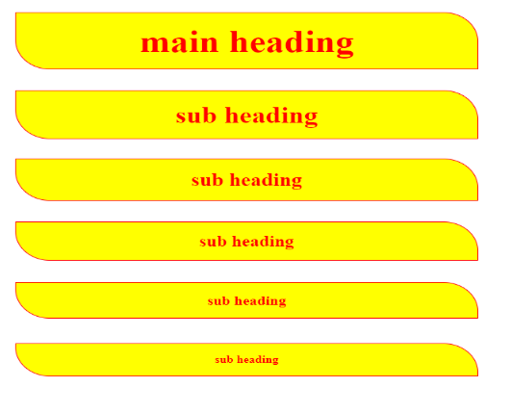

**PRACTICE PAPER-3:**

1) which tag is used to create the Paragraphs _

Ex:

<p>This is a P tag Element.</p>

2) Are Paragraphs Block Level Elements? (yes/no)

Yes

3) how to convert block to inline

We can use the display property with the value inline.

Ex:

div {

display: inline;

}

4) how to convert inline to block

Ex:

span {

display: block;

}

5) complete the below application with paragraphs:

Paragraphs.html

<!DOCTYPE html>

<html>

<head>

<title>Paragraphs</title>

<link rel="stylesheet" href="Paragraphs.css">

</head>

<body>

<div class="one">

<p>

Lorem ipsum dolor sit amet consectetur adipisicing elit. Magnam cum

numquam, ab blanditiis laudantium nemo odit perspiciatis officia itaque

tenetur ut. Natus praesentium dolore magnam.

</p>

<p>

Lorem ipsum dolor sit amet consectetur adipisicing elit. Magnam cum

numquam, ab blanditiis laudantium nemo odit perspiciatis officia itaque

tenetur ut. Natus praesentium dolore magnam.

</p>

<p>

Lorem ipsum dolor sit amet consectetur adipisicing elit. Magnam cum

numquam, ab blanditiis laudantium nemo odit perspiciatis officia itaque

tenetur ut. Natus praesentium dolore magnam.

</p>

<p>

Lorem ipsum dolor sit amet consectetur adipisicing elit. Magnam cum

numquam, ab blanditiis laudantium nemo odit perspiciatis officia itaque

tenetur ut. Natus praesentium dolore magnam.

</p>

</div>

<div class="two">

<p>

Lorem ipsum dolor sit amet consectetur adipisicing elit. Magnam cum

numquam, ab blanditiis laudantium nemo odit perspiciatis officia itaque

tenetur ut. Natus praesentium dolore magnam.

</p>

<p>

Lorem ipsum dolor sit amet consectetur adipisicing elit. Magnam cum

numquam, ab blanditiis laudantium nemo odit perspiciatis officia itaque

tenetur ut. Natus praesentium dolore magnam.

</p>

<p>

Lorem ipsum dolor sit amet consectetur adipisicing elit. Magnam cum

numquam, ab blanditiis laudantium nemo odit perspiciatis officia itaque

tenetur ut. Natus praesentium dolore magnam.

</p>

<p>

Lorem ipsum dolor sit amet consectetur adipisicing elit. Magnam cum

numquam, ab blanditiis laudantium nemo odit perspiciatis officia itaque

tenetur ut. Natus praesentium dolore magnam.

</p>

</div>

</body>

</html>

Paragraphs.css

p{

border: 1px solid red;

width: 20%;

display: flex;

padding: 10px;

margin: 20px;

border-radius: 20px;

text-align: justify;

font-family: Comic Sans MS;

color: white;

background: linear-gradient(15deg,red,black,green);

}

.one{

display: flex;

}

.two{

display: flex;

}

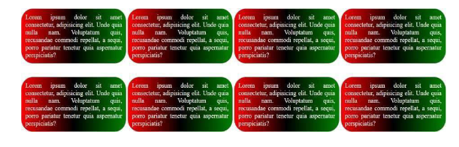

**PRACTICE PAPER-4:**

1) How to apply internal styles to the web pages

To apply internal styles to a web page, we can use the <style> tag within the <head> section of our HTML document.

Ex:

<!DOCTYPE html>

<html>

<head>

<title>My Web Page</title>

<style>

h1 {

color: darkblue;

}

p {

font-size: 16px;

color: black;

}

</style>

</head>

<body>

<h1>Welcome to My KL University Web Page</h1>

<p>This is a paragraph with internal styling.</p>

</body>

</html>

2) write the Differences between external CSS and Internal CSS?

3) how to create Divisions in HTML

Using <div> tag

Ex:

<div>

My First Page

</div>

4) Explain Selectors in CSS?

Universal Selector (*), Type Selector (p), Class Selector (.),Id Selector (#).

5) Class selector should start with

Class Selector (.): Selects elements with a specific class attribute.

Ex:

.dv_selector {

background-color: orange;

}

6) ID Selector should start with

ID Selector (#): Selects a unique element with a specific id attribute.

Ex:

#main-header {

font-size: 24px;

}

7) Differences Between Class selector and ID Selector?

8) How to create universal selector

Universal Selector (*): Selects all elements in the document.

Ex:

* {

margin: 0;

padding: 0;

}

9) Write the code for below application:

Technolycard.html

<!DOCTYPE html>

<html lang="en">

<head>

<meta charset="UTF-8">

<meta name="viewport" content="width=device-width, initial-scale=1.0">

<title>Card with Button</title>

<link rel="stylesheet" href="technologycard.css">

</head>

<body>

<div class="allcontainers">

<h1>Types of Technnologys</h1>

<div class="card-container">

<div class="card">

<button class="Button">HTML</button>

<p>HTML (HyperText Markup Language) is the standard language used to create and structure content on the web. HTML (HyperText Markup Language) is the standard language used to create and structure content on the web.HTML (HyperText Markup Language) is the standard language used to create and structure content on the web.</p>

</div>

<div class="card">

<button class="Button">CSS</button>

<p>CSS is designed to enable the separation of content and presentation, including layout, colors, and fonts.CSS is designed to enable the separation of content and presentation, including layout, colors, and fonts.CSS is designed to enable the separation of content and presentation, including layout, colors, and fonts.</p>

</div>

<div class="card">

<button class="Button">Javascript</button>

<p>JavaScript is a high-level, often just-in-time compiled language that conforms to the ECMAScript standard.JavaScript is a high-level, often just-in-time compiled language that conforms to the ECMAScript standardJavaScript is a high-level, often just-in-time compiled language that conforms to the ECMAScript standard</p>

</div>

</div>

<div class="card-container">

<div class="card">

<button class="Button">Reactjs</button>

<p>React is a free and open-source front-end JavaScript library for building user interfaces based on components.React is a free and open-source front-end JavaScript library for building user interfaces based on components.React is a free and open-source front-end JavaScript library for building user interfaces based on components.</p>

</div>

<div class="card">

<button class="Button">Angularjs</button>

<p>AngularJS is a discontinued JavaScript-based web framework for developing single-page applications.AngularJS is a discontinued JavaScript-based web framework for developing single-page applications.AngularJS is a discontinued JavaScript-based web framework for developing single-page applications.</p>

</div>

</div>

</div>

</body>

</html>

technolofycard.css

/* Container for all cards */

.allcontainers {

display: flex;

flex-direction: column;

align-items: center;

justify-content: center;

min-height: 100vh;

}

/* Container for rows of cards */

.card-container {

display: flex;

justify-content: center;

margin-bottom: 20px;

}

/* Styling for individual cards */

.card {

width: 300px;

border: 1px solid #ddd;

border-radius: 10px;

padding: 20px;

font-family: Arial, sans-serif;

box-shadow: 0 4px 8px rgba(0, 0, 0, 0.1);

margin: 10px;

text-align: center;

border-style: solid;

border-color: gray;

}

/* Button styling */

.card button {

background: radial-gradient(circle, red, black);

color: white;

padding: 10px 20px;

border: none;

border-radius: 5px;

cursor: pointer;

font-size: 16px;

width: 100%;

}

.card button:hover {

background-color: #007acc;

}

/* Text in the card */

.card p {

font-size: 16px;

margin-bottom: 20px;

color: #666;

}

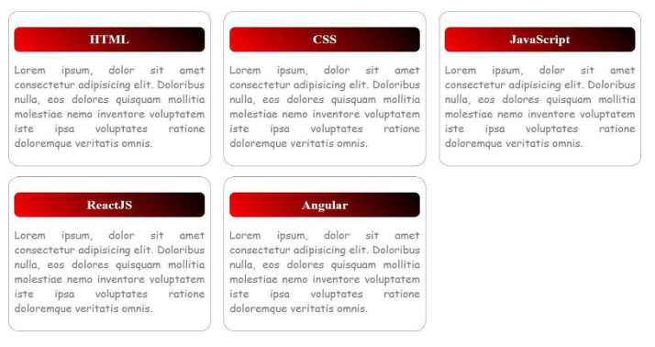

**PRACTICE PAPER-5:**

1) How to Create Button and Write Basic Example

Using <button> tag

Ex:

<button class=”btn btn-primary”>Submit</button>

2) Explain <span> tag in HTML?

The <span> tag does not start on a new line and only takes up as much width as necessary, allowing it to be used within paragraphs and other block-level elements.

Ex:

<span>This is my First HTML Page</span>

3) Are Button Span and img tags are inline (yes/no)

Yes

4) How to write inline CSS

To write inline CSS in HTML, we can use the style attribute directly within an HTML element's opening tag.

Ex:

<p style="color: blue; font-size: 20px;">This is a paragraph with inline CSS.</p>

5) In How Many ways we can apply CSS?

Inline CSS, Internal CSS, External CSS.

6) Explain CSS Specificity?

7) How to display images in HTML _

To display images in HTML, we can use the <img> tag.

Ex:

<img src="KL_universitylogo.png" alt="Description of image" width="500" height="300">

8) Is <img> tag paired tag? _

No

9) Write <img> tag attributes

Src,Alt,Width,Height,style,class,Id.

10) Explain hover in CSS?

The :hover pseudo-class is added to a selector to define styles that should be applied when the element is hovered over

Ex:

a:hover {

color: blue;

text-decoration: underline;

}

11) write the code for below application:

Images.html

<!DOCTYPE html>

<html lang="en">

<head>

<meta charset="UTF-8">

<meta name="viewport" content="width=device-width, initial-scale=1.0">

<title>Card with Button</title>

<link rel="stylesheet" href="images.css">

</head>

<body>

<div class="container">

<div class="card">

<img src="https://encrypted-tbn0.gstatic.com/images?q=tbn:ANd9GcT03q0B7-iOY3AeQ9lT9AiBi-hu5snwVUzpXA&s" class="Image"/>

</div>

<div class="card">

<img src="https://encrypted-tbn0.gstatic.com/images?q=tbn:ANd9GcTZc_a1slRn5pUNe8xDv5BrzH8pyV6-2hazjw&s" class="Image"/>

</div>

<div class="card">

<img src="https://encrypted-tbn0.gstatic.com/images?q=tbn:ANd9GcR9c3LVD7bLxtXfq_sT-udsGq_LefRoWoMxwQ&s" class="Image"/>

</div>

</div>

</body>

</html>

images.css

.container {

display: flex;

justify-content: center;

align-items: center;

gap: 20px;

height: 100vh;

}

.card {

height: 280px;

width: 280px;

border-radius: 20px;

display: flex;

justify-content: center;

align-items: center;

border: 2px solid brown;

}

.Image {

border-radius: 20px;

height: 100%;

width: 100%;

object-fit: cover;

}

**PRACTICE PAPER-6:**

1) How to create Hyper Links in HTML?

To create hyperlinks in HTML, we can use the <a> (anchor) tag.

Ex:

<a href="URL">Link Text</a>

2) Write Attributes of Anchor Tag?

Href, target, rel.

3) implement the below application with anchor tag

Flipkart -> https://www.flipkart.com/

Amazon -> https://www.amazon.in/

AJIO -> https://www.ajio.com/

Myntra -> https://www.myntra.com/

Load above web sites in new tab

4) implement the below application with anchor tag

**PRACTICE PAPER-7:**

1. Design the Below Application with fieldset and legend

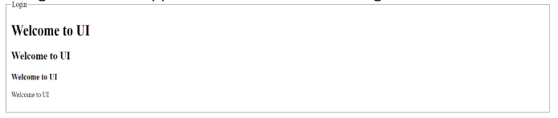

PRACTICE PAPER-8:

1) which tag used to create tables

The <table> tag is used to create tables in HTML.

Ex:

<table>

<tr>

<th>Header 1</th>

<th>Header 2</th>

</tr>

<tr>

<td>Data 1</td>

<td>Data 2</td>

</tr>

</table>

2) write the tags to create tables with diagram

To create tables in HTML, we use a combination of tags: <table>, <tr>, <th>, and <td>.

|  |  |
| --- | --- |
| Header 1 | Header 2 |
| Data 1 | Data 2 |
| Data 3 | Data 4 |

3) write table attributes with explanation

**<table>**: Defines the table.

**<tr>**: Defines a table row.

**<th>**: Defines a table header cell (for headers).

**<td>**: Defines a table data cell (for data).

4) write the code for below diagram in practice paper and execute in laptop:

<html>

<head> <title> Tables Example</title> </head>

<body>

<table border="1" align="center" cellspacing="10px" cellpadding ="10px" >

<tr> <th>sno</th> <th>p_id</th> <th>p_name</th> <th>p_cost</th> </tr>

<tr> <td>1</td> <td>p101</td> <td>p_one</td> <td>10000</td> </tr>

<tr> <td>2</td> <td>p102</td> <td>p_two</td> <td>20000</td> </tr>

<tr> <td>3</td> <td>p103</td> <td>p_three</td><td>30000</td> </tr>

<tr> <td>4</td> <td>p104</td> <td>p_four</td> <td>40000</td> </tr>

<tr> <td>5</td> <td>p105</td> <td>p_five</td> <td>50000</td> </tr>

</table>

</body>

</html>

5) write the code for below diagram in practice paper and execute in laptop:

<html>

<head> <title> Tables Example</title>

<style>

table{ text-align:center; }

h1{ text-align: center; }

.c1{ color:orange; }

.c2{ color:blue; }

.c3{ color:violet; }

.c4{ color:green; }

.c5{ color:red; }

.c6{ vertical-align: middle;}

.lunch {

writing-mode:vertical-lr;

text-align: center;

font-weight: bold;

align-content: center;

}

</style>

</head>

<body>

<h1>COLLEGE TIMETABLE</h1><BR><BR>

<table border="2" align="center">

<tr>

<th></th>

<th>8:30-9:30</th>

<th>9:30-10:30</th>

<th>10:30-11:30</th>

<th>11:30-12:30</th>

<th>12:30-2:00</th>

<th>2:00-3:00</th>

<th>3:00-4:00</th>

<th colspan="2">4:00-5:00</th>

</tr>

<!--Row1-->

<tr>

<td>MONDAY</td>

<td>----</td>

<td class="c1">SUB1</td>

<td class="c2">SUB2</td>

<td class="c3">SUB3</td>

<td rowspan="6"> L<br>U<br>N<br>C<br>H</td>

<td class="c4">SUB4</td>

<td class="c5">SUB5</td>

<td colspan="2">COUNSCELLING CLASS</td>

</tr>

<!--Row2-->

<tr>

<td>TUESDAY</td>

<td class="c1">sub1</td>

<td class="c2">sub2</td>

<td class="c3">SUB3</td>

<td>---</td>

<td class="c2">SUB2</td>

<td class="c2">sub2</td>

<td colspan="2">LIBRARY</td>

</tr>

<!--Row3-->

<tr>

<td>WEDNESDAY</td>

<td class="c1">sub1</td>

<td class="c2">sub2</td>

<td class="c5">SWA</td>

<td>----</td>

<td colspan="4">LAB</td>

</tr>

<!--Row4-->

<tr>

<td>TURSDAY</td>

<td class="c1">SUB1</td>

<td class="c2">SUB2</td>

<td class="c3">SUB3</td>

<td>---</td>

<td class="c2">SUB2</td>

<td class="c2">SUB2</td>

<td>LIBRARY</td>

</tr>

<!--Row5-->

<tr>

<td>FRIDAY</td>

<td class="c1">SUB1</td>

<td class="c2">SUB2</td>

<td class="c3">SUB3</td>

<td>----</td>

<td class="c4">SUB4</td>

<td class="c5">SUB5</td>

<td>LIBRARY</td>

</tr>

<!--Row6-->

<tr>

<td>SATURDAY</td>

<td class="c1">SUB1</td>

<td colspan="3">SEMINAR</td>

<td class="c4">SUB4</td>

<td class="c5">SUB5</td>

<td >LIBRARY</td>

</tr>

</table>

</body>

</html>

6) write the code for below diagram in practice paper and execute in laptop:

<html>

<head><title>tABLES</title></head>

<body>

<br>

<img src="logo1.png" height =50px width=50px style ="float:left;" >

<h1>Create Tables In Html</h1>

<table border="2">

<!--ROW0 -->

<tr>

<td>Column1</td>

<td>Column2</td>

<td>Column3</td>

</tr>

<!--ROW1 -->

<tr>

<td rowspan="2">ROW1 CELL1</td>

<td>ROW1 CELL2</td>

<td>ROW1 CELL3</td>

</tr>

<!--ROW2 -->

<tr>

<td>ROW2 CELL2</td>

<td>ROW2 CELL3</td>

</tr>

<!--ROW3 -->

<tr>

<td colspan="3">ROW3 CELL1</td>

</tr>

</table>

</body>

</html>

7) write the code for below diagram in practice paper and execute in laptop:

<body>

<table border="2">

<tr> <td rowspan="3">Day</td> <td colspan="3">Seminar</td> </tr>

<tr> <td colspan="2">Shedule</td> <td rowspan="2">Topic</td> </tr>

<tr> <td>Begin</td><td>End</td> </tr>

<tr> <td rowspan="2">Monday</td> <td rowspan="2">8:00am</td> <td rowspan="2">5:00pm</td> <td>Introducton to xml</td> </tr>

<tr> <td>Validity and FlexNG</td> </tr>

<tr> <td rowspan="3">Tuesday</td><td>8:00</td><td>11:00</td> <td rowspan="2">XPATH</td> </tr>

<tr> <td>11:00</td> <td>2:00</td> </tr>

<tr> <td>2:00</td> <td>5:00</td> <td>XSL Transformation</td> </tr>

<tr> <td>Wendsday</td><td>8:00</td><td>12:00</td><td colspan="2">XML Formatting Objects</td> </tr>

</table>

</body>

</html>

8) write the code for below diagram in practice paper and execute in laptop:

<html>

<head><title>tABLES</title>

<style>

table

{

width:20vw;

height:20vh;

font-size:24;

}

</style>

</head>

<body>

<br>

<table border="2">

</tr>

<!--ROW1 -->

<tr>

<td rowspan="3">Table1</td>

<td colspan=2 rowspan=2>Table2

<table border="2">

<tr><td>Table2</td><td>Table2</td></tr>

<tr><td>Table2</td><td>Table2</td></tr>

</table>

</td>

</tr>

<!--ROW2 -->

<tr>

</tr>

<!--ROW3 -->

<tr>

</tr>

<!--ROW4 -->

<tr>

<td>Table1</td>

<td colspan="2">Table1</td>

</tr>

</table>

</body>

</html>

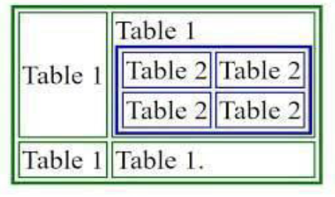

9) write the code for below diagram in practice paper and execute in laptop:

<html>

<head><title>tABLES</title>

<style>

th,td

{

width:20px;

}

.d

{

background-color:black;

color:white;

text-align:right;

}

.o

{

background-color:lightgrey;

}

.e

{

background-color:orange;

}

</style>

</head>

<body>

<br>

<table border="2">

<!--R0W1-->

<tr>

<td colspan=4 class="d">0</td>

</tr>

<!--R0W2-->

<tr>

<td class="o"> +</td>

<td class="o">- </td>

<td class="o">* </td>

<td class="o"> /</td>

</tr>

<!--R0W3-->

<tr>

<td>7 </td>

<td>8 </td>

<td>9 </td>

<td rowspan=4 class="e"> =</td>

</tr>

<!--R0W4-->

<tr>

<td>4 </td>

<td> 5</td>

<td>6 </td>

</tr>

<!--R0W5-->

<tr>

<td>1 </td>

<td> 2</td>

<td>3 </td>

</tr>

<!--R0W6-->

<tr>

<td>0 </td>

<td>. </td>

<td> AC</td>

</tr>

</table>

</body>

</html>

10) write the code for below diagram in practice paper and execute in laptop:

images.html

<!DOCTYPE html>

<html lang="en">

<head>

<meta charset="UTF-8" />

<meta name="viewport" content="width=device-width, initial-scale=1.0" />

<link rel="stylesheet" href="images.css" />

</head>

<body>

<div class="container">

<table>

<thead>

<tr class="pink-row">

<th>SNO</th>

<th>NAME</th>

<th>COST</th>

<th>UPDATE</th>

<th>DELETE</th>

</tr>

</thead>

<tbody>

<tr class="brown-row">

<td>1</td>

<td>LAPTOP</td>

<td>₹50000.00</td>

<td><button class="icon-button">✏️</button></td>

<td>

<button class="icon-button">

<svg

xmlns="http://www.w3.org/2000/svg"

class="icon icon-tabler icon-tabler-trash"

width="24"

height="24"

viewBox="0 0 24 24"

stroke-width="2"

stroke="currentColor"

fill="none"

stroke-linecap="round"

stroke-linejoin="round"

>

<path stroke="none" d="M0 0h24v24H0z" fill="none" />

<path d="M4 7h16" />

<path d="M10 11v6" />

<path d="M14 11v6" />

<path d="M5 7l1 14h12l1 -14z" />

<path d="M6 7v-3a2 2 0 0 1 2 -2h8a2 2 0 0 1 2 2v3" />

</svg>

</button>

</td>

</tr>

<tr class="pink-row">

<td>2</td>

<td>Mobile</td>

<td>$50</td>

<td><button class="icon-button">✏️</button></td>

<td><button class="icon-button"><svg

xmlns="http://www.w3.org/2000/svg"

class="icon icon-tabler icon-tabler-trash"

width="24"

height="24"

viewBox="0 0 24 24"

stroke-width="2"

stroke="currentColor"

fill="none"

stroke-linecap="round"

stroke-linejoin="round"

>

<path stroke="none" d="M0 0h24v24H0z" fill="none" />

<path d="M4 7h16" />

<path d="M10 11v6" />

<path d="M14 11v6" />

<path d="M5 7l1 14h12l1 -14z" />

<path d="M6 7v-3a2 2 0 0 1 2 -2h8a2 2 0 0 1 2 2v3" />

</svg>

</button></td>

</tr>

<tr class="brown-row">

<td>3</td>

<td>Shoes</td>

<td>€10</td>

<td><button class="icon-button">✏️</button></td>

<td><button class="icon-button"><svg

xmlns="http://www.w3.org/2000/svg"

class="icon icon-tabler icon-tabler-trash"

width="24"

height="24"

viewBox="0 0 24 24"

stroke-width="2"

stroke="currentColor"

fill="none"

stroke-linecap="round"

stroke-linejoin="round"

>

<path stroke="none" d="M0 0h24v24H0z" fill="none" />

<path d="M4 7h16" />

<path d="M10 11v6" />

<path d="M14 11v6" />

<path d="M5 7l1 14h12l1 -14z" />

<path d="M6 7v-3a2 2 0 0 1 2 -2h8a2 2 0 0 1 2 2v3" />

</svg>

</button></td>

</tr>

</tbody>

</table>

</div>

</body>

</html>

**images.css**

body {

font-family: Arial, sans-serif;

margin: 0;

padding: 20px;

}

.container {

max-width: 1000px;

margin: auto;

padding: 20px;

background: white;

border-radius: 8px;

}

h1 {

text-align: center;

color: #333;

}

table {

width: 100%;

border-collapse: collapse;

margin-top: 20px;

}

th, td {

border: 1px solid red;

padding: 10px;

text-align: center;

}

th {

color: white;

}

.brown-row {

background-color: #D99A7A;

}

.pink-row {

background-color: #F9B9D1;

}

.icon-button {

background: none;

border: none;

cursor: pointer;

font-size: 20px;

color: #555;

}

.icon-button:hover {

color: #B17457;

}

11) write few points related to font-awesome

12) cart symbol

13) trash symbol

14) edit symbol

15) rupee symbol

16) dollar symbol

17) user profile

18) how to use font-awesome

19) CDN Stands for

20) is Font Awesome CSS library?

**PRACTICE PAPER-8:**

1) Types of Lists in HTML?

Ordered List, Unordered List

2) Write the Syntax for Ordered List?

Ex:

<ol>

<li>First item</li>

<li>Second item</li>

<li>Third item</li>

</ol>

3) Write the Attributes of Ordered List?

4) Write the Syntax for Unordered List?

Ex:

<ul>

<li>List Item 1</li>

<li>List Item 2</li>

<li>List Item 3</li>

</ul>

5) Write the Unordered List Attributes?

6) Write the Syntax for Definition List

**<dl>**: Contains the entire definition list.

**<dt>**: Represents a term being defined.

**<dd>**: Provides the definition or description of the term.

7) <dt></dt> stands for

Definition Term

8) <dd></dd> stands for

Definition Description

9) <li></li> stands for

List Item

10) <dl></dl> stands for

Definition List

11) Write the code for below application and execute in laptop:

<!DOCTYPE html>

<html>

<head>

<title>Ordered List</title>

<link rel="stylesheet" href="lists.css">

</head>

<body>

<ol>

<li>HTML</li>

<li>CSS</li>

<li>JAVASCRIPT</li>

<li>REACTJS</li>

<li>ANGULAR</li>

</ol>

<ol type="A">

<li>HTML</li>

<li>CSS</li>

<li>JAVASCRIPT</li>

<li>REACTJS</li>

<li>ANGULAR</li>

</ol>

<ol type="a">

<li>HTML</li>

<li>CSS</li>

<li>JAVASCRIPT</li>

<li>REACTJS</li>

<li>ANGULAR</li>

</ol>

<ol type="I">

<li>HTML</li>

<li>CSS</li>

<li>JAVASCRIPT</li>

<li>REACTJS</li>

<li>ANGULAR</li>

</ol>

<ol type="i">

<li>HTML</li>

<li>CSS</li>

<li>JAVASCRIPT</li>

<li>REACTJS</li>

<li>ANGULAR</li>

</ol>

<ol start="5" reversed>

<li>HTML</li>

<li>CSS</li>

<li>JAVASCRIPT</li>

<li>REACTJS</li>

<li>ANGULAR</li>

</ol>

<ol start="10" >

<li>HTML</li>

<li>CSS</li>

<li>JAVASCRIPT</li>

<li>REACTJS</li>

<li>ANGULAR</li>

</ol>

<ul type="disc" >

<li>HTML</li>

<li>CSS</li>

<li>JAVASCRIPT</li>

<li>REACTJS</li>

<li>ANGULAR</li>

</ul>

</body>

</html>

Lists.css

ol,ul {

background-color: pink;

width: 15%;

display: inline-block;

margin: 20px;

border: 2px solid black;

border-radius: 20px;

}

li {

color: white;

background-color: red;

margin: 10px;

padding: 10px;

border: 2px solid white;

border-radius: 20px;

}

12) Write the code for below application and execute in laptop:

<!DOCTYPE html>

<html>

<head>

<title>QUIZ</title>

</head>

<body>

Quiz

<br><br>

<ol>

<li>

HTML is an _______?

<ol type="i">

<li>HTML is an Markup Language</li>

<li>Programming Language</li>

<li>none of These</li>

</ol>

</li>

<li>

CSS is used for

<ol type="i">

<li>Styling</li>

<li>Scripting</li>

<li>None of these</li>

</ol>

</li>

<li>

Which of the following is dynamic form of HTML?

<ol type="i">

<li>XML</li>

<li>DHTML</li>

<li>None of these</li>

</ol>

</li>

<li>

Which of the following can be linked with HTML and CSS?

<ol type="i">

<li>javascript</li>

<li>c++</li>

<li>None of these</li>

</ol>

</li>

</body>

</html>

13) Write the code for below application and execute in laptop:

<!DOCTYPE html>

<html>

<head>

<title>Text</title>

</head>

<body>

<b>

Preceding Text

<ol type="I">

<li>List Item1 <ol type="a"> <li>NestedItem1.1</li> <li>NestedItem1.2</li> </ol> </li>

<li>List Item2 <ol type> <li>NestedItem2.1</li> <li>NestedItem2.2 <ul type="circle"> <li>NestedItem2.2.1</li> <li>NestedItem2.2.2 <ul type="square"> <li>NestedItem2.2.2.1</li> <li>NestedItem2.2.2.2 </li> </ul> </li> <li>NestedItem2.2.3</li> </ul> </li> </ol> </li>

<li>List Item3 <ul type="disc"> <li>NestedItem3.1</li> <li>NestedItem3.1</li> <li>NestedItem3.1</li> </ul> </li>

</ol>

</b>

</body>

</html>

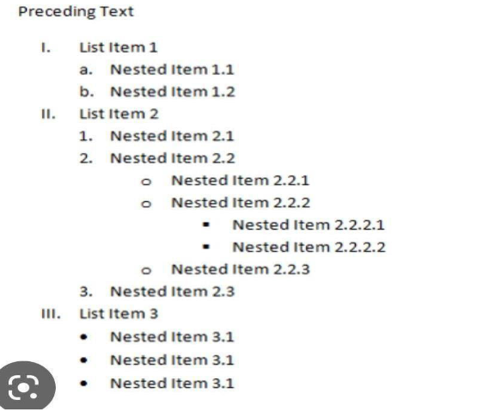

14) Write the code for below application and execute in laptop:

<!DOCTYPE html>

<html>

<head>

<title>Definition List</title>

<style>

dl {

border: 2px solid red;

width: 25%;

padding: 20px;

border-radius: 20px;

}

dt {

border-bottom: 1px solid red;

background-color:red;

color:white;

}

dd {

border-bottom: 1px solid red;

}

</style>

</head>

<body>

<dl>

<dt>A</dt>

<dd>Hello_1</dd>

<dd>Hello_2</dd>

<dd>Hello_3</dd>

<dd>Hello_4</dd>

<dd>Hello_5</dd>

<dt>B</dt>

<dd>Hello_1</dd>

<dd>Hello_2</dd>

<dd>Hello_3</dd>

<dd>Hello_4</dd>

<dd>Hello_5</dd>

<dt>C</dt>

<dd>Hello_1</dd>

<dd>Hello_2</dd>

<dd>Hello_3</dd>

<dd>Hello_4</dd>

<dd>Hello_5</dd>

<dt>D</dt>

<dd>Hello_1</dd>

<dd>Hello_2</dd>

<dd>Hello_3</dd>

<dd>Hello_4</dd>

<dd>Hello_5</dd>

</dl>

</body>

</html>

**PRACTICE PAPER-9:**

1) How to create Forms in HTML

2) Write form attributes

3) Why placeholder attribute in <input></input> tag

4) How to create dropdown in Forms write basic example

5) How to create address field in HTML Forms

6) Single selection controls called as

7) Multi selection controls called as

8) implement the below form with text field

**Home.html:**

<html>

<head>

<style>

h1{

color:red;

}

</style>

</head>

<body><center>

<h1>EMPLOYEE MANAGEMENT SYSTEM </h1>

<br><br>

<a href="./aboutus.html" style =" font-size:24;">About</a>&nbsp;&nbsp;&nbsp;

<a href="./contact.html" style =" font-size:24;">Contact</a>&nbsp;&nbsp;&nbsp;

<a href="./loginform.html" style =" font-size:24;">Login</a>&nbsp;&nbsp;&nbsp;

<a href="./registration.html" style =" font-size:24;">Register</a>&nbsp;&nbsp;&nbsp;

</div>

<br><br><br>

<h2 style =" font-size:32;"><b>Welcome to Home Page</b><h2>

</center>

</body>

</html>

**ABOUTUS.HTML:**

<html>

<head>

<style>

h1{

color:red;

}

</style>

</head>

<body>

<h1>EMPLOYEE MANAGEMENT SYSTEM </h1>

<br><br>

<a href="./aboutus.html" style =" font-size:24;">About</a>&nbsp;&nbsp;&nbsp;

<a href="./contact.html" style =" font-size:24;">Contact</a>&nbsp;&nbsp;&nbsp;

<a href="./loginform.html" style =" font-size:24;">Login</a>&nbsp;&nbsp;&nbsp;

<a href="./registration.html" style =" font-size:24;">Register</a>&nbsp;&nbsp;&nbsp;

</div>

<br><br><br>

<h2 style =" font-size:32;"><b>Welcome to About Us... Page</b><h2>

<h1 style =" font-size:32;"><b><u>About</u></b><h2>

<p>A is a form of hypertext publication on the internet which is collaboratively edited and managed by its audience directly through a web browser. A typical wiki contains multiple pages that can either be edited by the public or limited to use within an organization for maintaining its internal knowledge base. <p>

</body>

</html>

**CONTACT.HTML**

<html>

<head>

<style>

h1{

color:red;

}

</style>

</head>

<body>

<h1>EMPLOYEE MANAGEMENT SYSTEM </h1>

<br><br>

<a href="./aboutus.html" style =" font-size:24;">About</a>&nbsp;&nbsp;&nbsp;

<a href="./contact.html" style =" font-size:24;">Contact</a>&nbsp;&nbsp;&nbsp;

<a href="./loginform.html" style =" font-size:24;">Login</a>&nbsp;&nbsp;&nbsp;

<a href="./registration.html" style =" font-size:24;">Register</a>&nbsp;&nbsp;&nbsp;

</div>

<br><br><br>

<h2 style =" font-size:32;">Welcome to Contact Page<h2>

<br> Mobile:

<br> Website Name:

<br>Mail Id:

</body>

</html>

**LOGINFORM.HTML:**

<html>

<head>

<style>

h1{

color:red;

}

</style>

</head>

<body><center>

<h1>EMPLOYEE MANAGEMENT SYSTEM </h1>

<br><br>

<a href="./aboutus.html" style =" font-size:24;">About</a>&nbsp;&nbsp;&nbsp;

<a href="./contact.html" style =" font-size:24;">Contact</a>&nbsp;&nbsp;&nbsp;

<a href="./loginform.html" style =" font-size:24;">Login</a>&nbsp;&nbsp;&nbsp;

<a href="./registration.html" style =" font-size:24;">Register</a>&nbsp;&nbsp;&nbsp;

</div>

<br><br><br>

<h2 style =" font-size:32;"><b>Welcome to Employee Login Form</b><h2>

Name:<input type="text" size=20><br>

Password:<input type="password" size=20><br>

<input type="button" value="login" >

</center>

</body>

</html>

**Registrationpage.html:**

<html>

<head>

<style>

h1{

color:red;

}

</style>

</head>

<body>

<h1>EMPLOYEE MANAGEMENT SYSTEM </h1>

<br><br>

<a href="./aboutus.html" style =" font-size:24;">About</a>&nbsp;&nbsp;&nbsp;

<a href="./contact.html" style =" font-size:24;">Contact</a>&nbsp;&nbsp;&nbsp;

<a href="./loginform.html" style =" font-size:24;">Login</a>&nbsp;&nbsp;&nbsp;

<a href="./registration.html" style =" font-size:24;">Register</a>&nbsp;&nbsp;&nbsp;

</div>

<br><br><br>

<h2 style =" font-size:32;"><b>Employee Registration Form</b><h2>

Name:<input type="text" size=20><br><br>

Password:<input type="password" size=20><br><br>

Email:<input type="text" size=20><br><br>

Gender:<input type="radio" name="radio">

Male<input type="radio" name="radio">Female<br>

Mobile Number:<input type="text" size=20><br><br>

Address:<input type="textarea" size=20><br><br>

<input type="button" value="Register" >

</body>

</html>

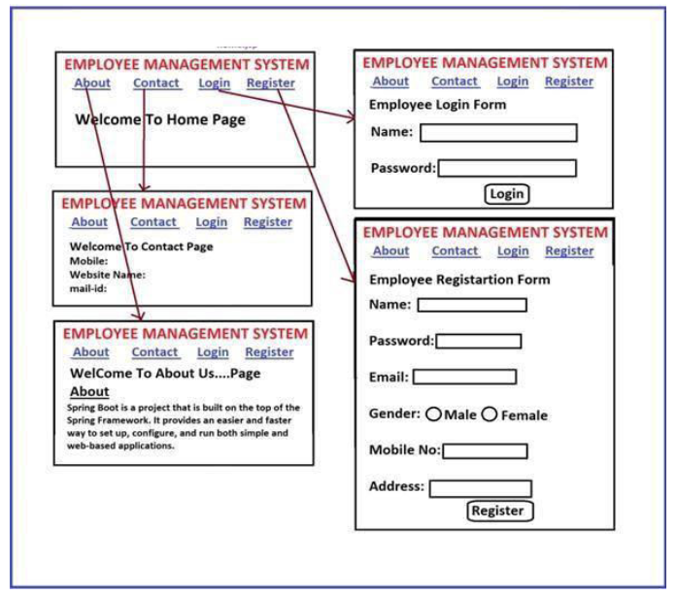

9) implement the below form:

<html>

<head>

<style>

td

{

font-size:24;

}

</style>

</head>

<body>

<h1>Fill Below Form to Register</h1>

<br>

<form name="r">

<table>

<tr><td>Enter your Id: </td><td> <input type="text" size="10"> </td></tr>

<tr><td>Enter your Name: </td> <td> <input type="text" size="10"></td></tr>

<tr><td> Enter your Password:</td> <td><input type="text" size="10"> </td></tr>

<tr><td><input type="button" value="Register"> </td> <td> </td></tr>

</table>

</form>

</body>

</html>

10) implement the below form:

<html>

<head>

<style>

td

{

font-size:24;

}

h1{

color:green;

}

</style>

</head>

<body>

<h1>Customer Login Page</h1>

<br>

<form name="r">

<table border="2">

<tr><td>Enter your Name: </td><td> <input type="text" size="10"> </td></tr>

<tr><td>Enter your Password: </td> <td> <input type="text" size="10"></td></tr>

<tr><td><input type="button" value="login"> </td> <td> </td></tr>

</table>

</form>

</body>

</html>

11) Write HTML code to get following text box?

<html>

<head>

<link rel="stylesheet" href="https://cdnjs.cloudflare.com/ajax/libs/font-awesome/5.15.4/css/all.min.css">

<style>

input[type=text] {

border: 2px solid red;

border-radius: 4px;

}

input[type=password] {

border: 2px solid red;

border-radius: 4px;

}

body

{

color:red;

font-size:24;

}

</style>

</head>

<body>

<form name="r">

User Name: <input type="text" size="10" placeholder="username">

<hr>

User Name: <input type="text" size="10" >

<hr>

Password: <input type="password" size="10" >

<hr>

Company Name <input list="Tech">

<datalist id="Tech">

<option value="Tech Mahindra">

<option value="Tech Sathya">

<option value="Tech Anand">

</datalist>

<i class="fab fa-whatsapp"></i>WhatsAppNumber <input type="number" id="b" name="b" value="8074864650">

<input type="checkbox" checked> I accept License Agreement

Company Name <select name="Tech">

<option value="P">Please Select</option>

<option value="India">India</option>

<option value="US">US</option>

<option value="Uk">UK</option>

</select>

</form>

</body>

</html>



12) Write HTML Code for following output

13) Write code for following output

14) Write Code for following output

15) Write code for following output

16) Write HTML code to for following Output



17) Write HTML Code for following output



18) Write HTML code for following output

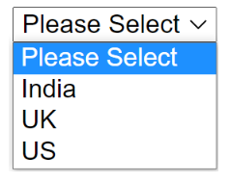

19) implement the below form

**PRACTICE PAPER-10:**  
1) Explain Positions in CSS?

Static, Relation, Absolute, sticky, fixed.

2) What are the Differences Between Absolute and Relative Positions?

Relative: Depends on the original position of the element.

Absolute: Depends on the nearest positioned ancestor; if none, it references the viewport.

3) Implement The Below Application Absolute Position:

<!DOCTYPE html>

<html>

<head>

    <meta charset="UTF-8">

    <meta name="viewport" content="width=device-width, initial-scale=1.0">

    <title>Absolute Position</title>

    <style>

        .container {

*position*: relative;

*width*: 200px;

*height*: 400px;

*border*: 2px solid gray;

        }

        .block {

*position*: absolute;

*width*: 100px;

*height*: 100px;

*border*: 2px solid gray;

*font-size*: 20px;

*color*: white;

        }

        .c1 {

*background-color*: red;

*top*: 0;

*left*: 0;

        }

        .c2 {

*background-color*: aquamarine;

*top*: 20px;

*left*: 20px;

        }

        .c3 {

*background-color*: blueviolet;

*top*: 40px;

*left*: 40px;

        }

        .c4 {

*background-color*: chartreuse;

*top*: 60px;

*left*: 60px;

        }

        .c5 {

*background-color*: brown;

*top*: 80px;

*left*: 80px;

        }

    </style>

</head>

<body>

    <div class="container">

        <div class="block c1">1</div>

        <div class="block c2">2</div>

        <div class="block c3">3</div>

        <div class="block c4">4</div>

        <div class="block c5">5</div>

    </div>

</body>

</html>

4) Implement the Below Application with CSS Relative Position:

<!DOCTYPE html>

<html lang="en">

<head>

    <meta charset="UTF-8">

    <meta name="viewport" content="width=device-width, initial-scale=1.0">

    <title>Relative position</title>

    <style>

        .common{

*width*: 100px;

*height*: 100px;

*border*: 2px solid gray;

        }

        .c1{

*background-color*: red;

        }

        .c2

        {

*position*:relative;

*left*:20px;

*bottom*: 80px;

*background-color*: aquamarine;

        }

        .c3

        {

*position*:relative;

*left*:30px;

*bottom*: 160px;

*background-color*: blueviolet;

            /* z-index: 50; */

        }

        .c4

        {

*position*:relative;

*left*:60px;

*bottom*: 240px;

*background-color*: chartreuse;

        }

        .c5

        {

*position*:relative;

*left*:80px;

*bottom*: 320px;

*background-color*: brown;

        }

    </style>

</head>

<body>

   <div class="common c1">1</div>

   <div class="common c2">2</div>

   <div class="common c3">3</div>

   <div class="common c4">4</div>

   <div class="common c5">5</div>

</body>

</html>

5) What is Z-Index in CSS?

The z-index is a CSS property that controls how elements stack on top of each other when they overlap on a page. Elements with a higher z-index value will appear in front of elements with a lower z-index value. It's called "z-index" because it determines the order of elements along the z-axis, which represents depth.

Ex:

<!DOCTYPE html>

<html lang="en">

<head>

    <meta charset="UTF-8">

    <meta name="viewport" content="width=device-width, initial-scale=1.0">

    <title>Relative position</title>

    <style>

        .common{

*width*: 100px;

*height*: 100px;

*border*: 2px solid gray;

        }

        .c1{

*background-color*: red;

        }

        .c2

        {

*position*:relative;

*left*:20px;

*bottom*: 80px;

*background-color*: aquamarine;

        }

        .c3

        {

*position*:relative;

*left*:30px;

*bottom*: 160px;

*background-color*: blueviolet;

***z-index*: 50;**

        }

        .c4

        {

*position*:relative;

*left*:60px;

*bottom*: 240px;

*background-color*: chartreuse;

        }

        .c5

        {

*position*:relative;

*left*:80px;

*bottom*: 320px;

*background-color*: brown;

        }

    </style>

</head>

<body>

   <div class="common c1">1</div>

   <div class="common c2">2</div>

   <div class="common c3">3</div>

   <div class="common c4">4</div>

   <div class="common c5">5</div>

</body>

</html>

6) Which one is the default position in CSS

7) How to display Element in center of webpage

Ans:

8) What is border-box in CSS?

When we are having width:500px, when we give padding and border then 500px will change it to 542px . this is a drawback in css. So, we are using border-box in box-sizing.

Ex:

<!DOCTYPE html>

<html lang="en">

<head>

    <meta charset="UTF-8">

    <meta name="viewport" content="width=device-width, initial-scale=1.0">

    <title>Document</title>

    <style>

        .c1

        {

            width: 500px;

            height: 500px;

            border: 2px solid red;

            padding: 20px;

            box-sizing: border-box;

        }

    </style>

</head>

<body>

    <div class="c1">

        KL University

    </div>

</body>

</html>