**Software Project**

***Submitted by***

1. Netra Ramesh (2862120)

2. Bindu Manjunath Raju (2862245)

3. Aradhana Nandhikeswaran (2861686)

**EDU-LEARN**

**User-Manual**

**About:**

**Edu-Learn** is a web based application, a learning platform that offers students and faculties to upload, download and view study materials shared. This is a modern solution to exchange ideas and notes by professors to students. Finding and governing contemporary ideas and thoughts of getting everything online are quickly changing as the world is built with current technologies.

**Overview:**

In this we application, students and faculties can communicate from anywhere, anytime. Faculties can create classes, create assignments, upload study materials, reward the submitted assignments, view feedbacks, download students work. The student user can join classes, view assignments, submit assignments, provide feedbacks and download noted. These are the feature included in the project. The user interface for the entire project appears to be simple and can view all the features. In addition, the users need to register and login to the application in order to access the application.

**USER GUIDE:**

1. Register page: where user can register themselves as student or faculty based on their role.

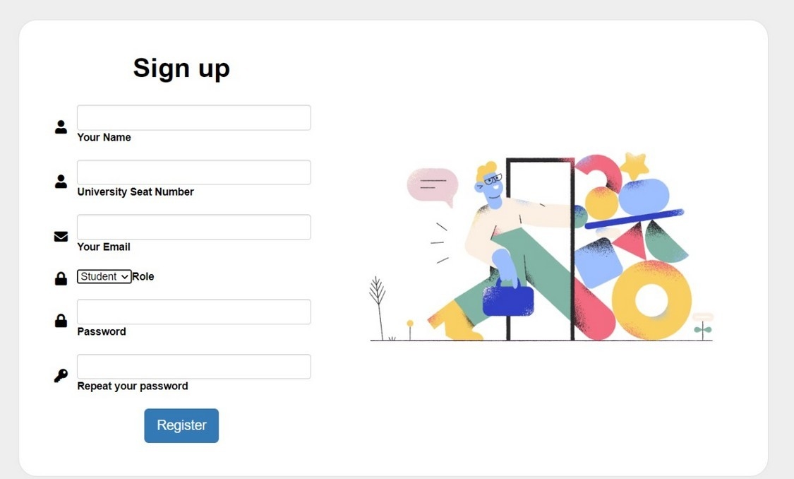

1. Login Page: User needs to login in order to access the application.

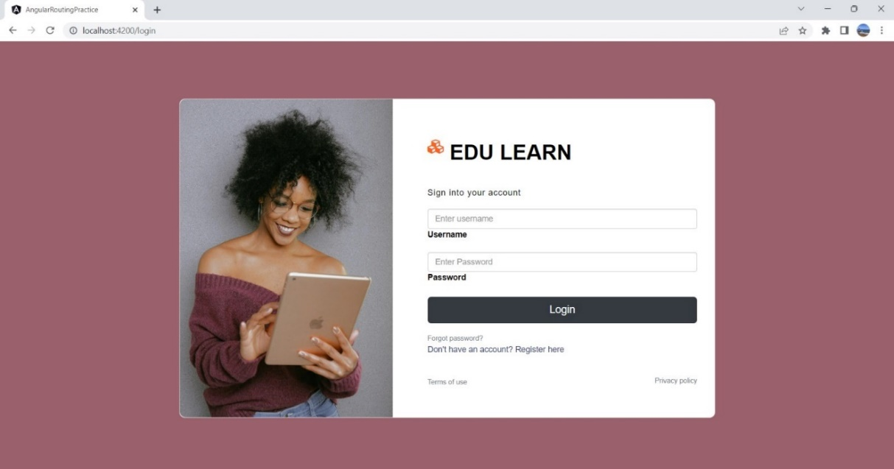

1. Faculty role: As a faculty, he can create class, create assignments, download assignments, view feedback, reward assignment.

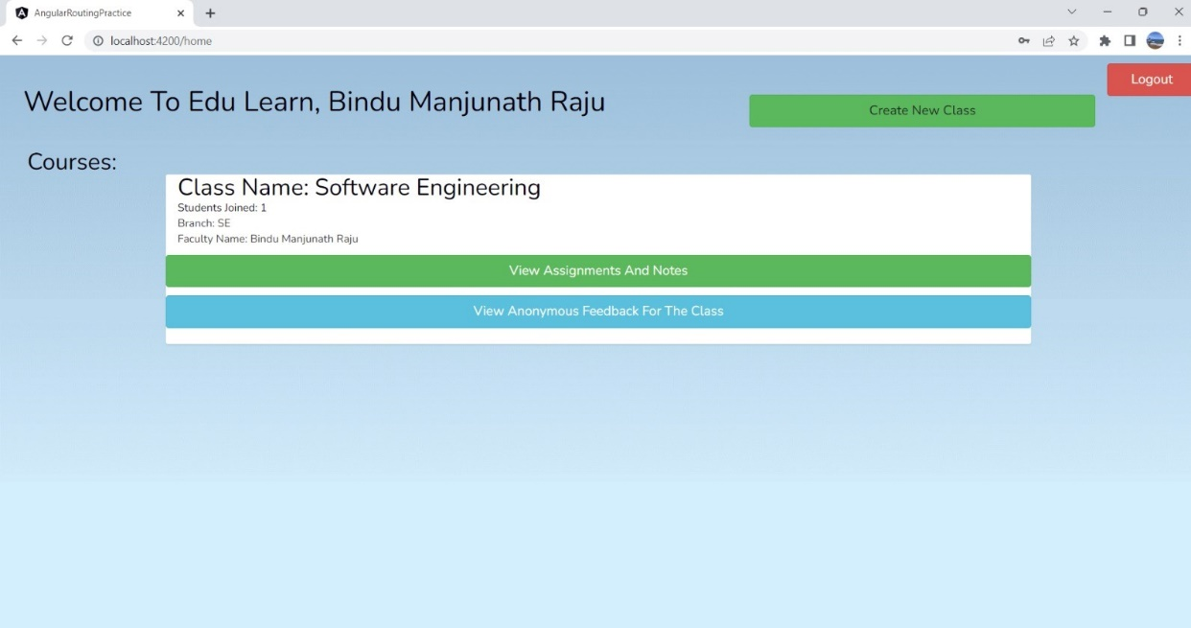

* 1. Fig: Faculty homepage

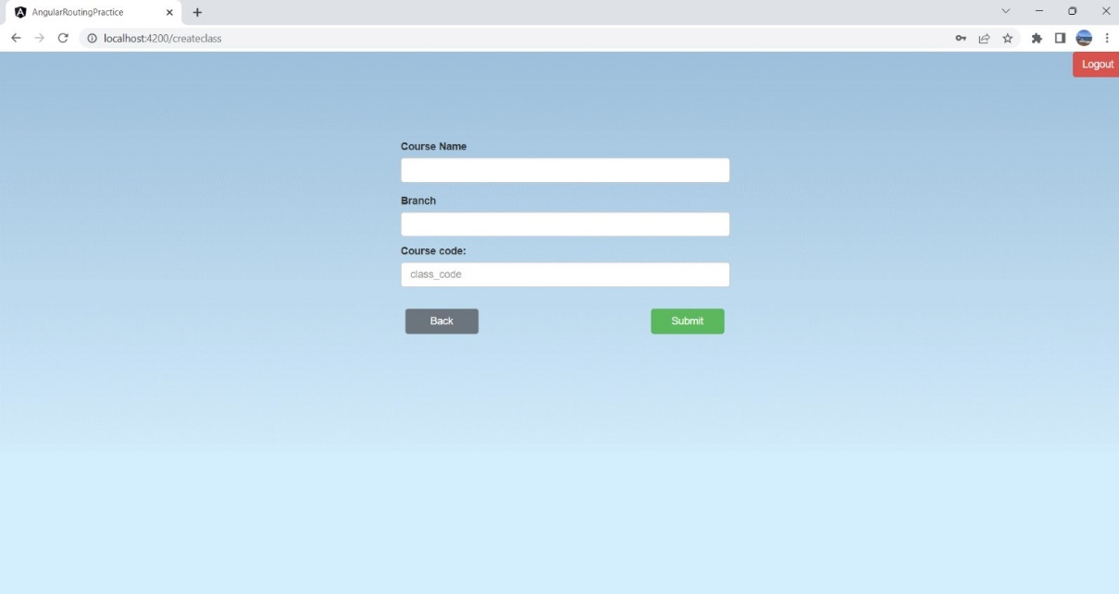

* 1. Fig : Create class page

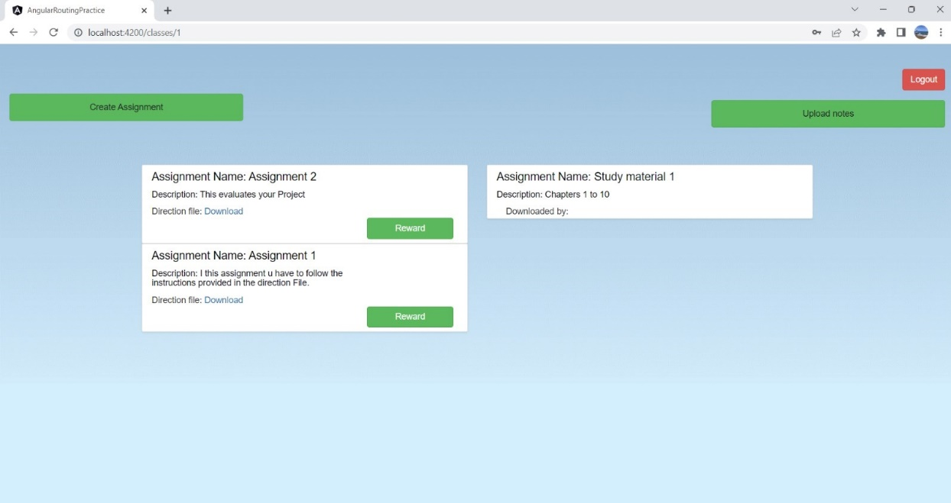

* 1. Fig: View created assignments

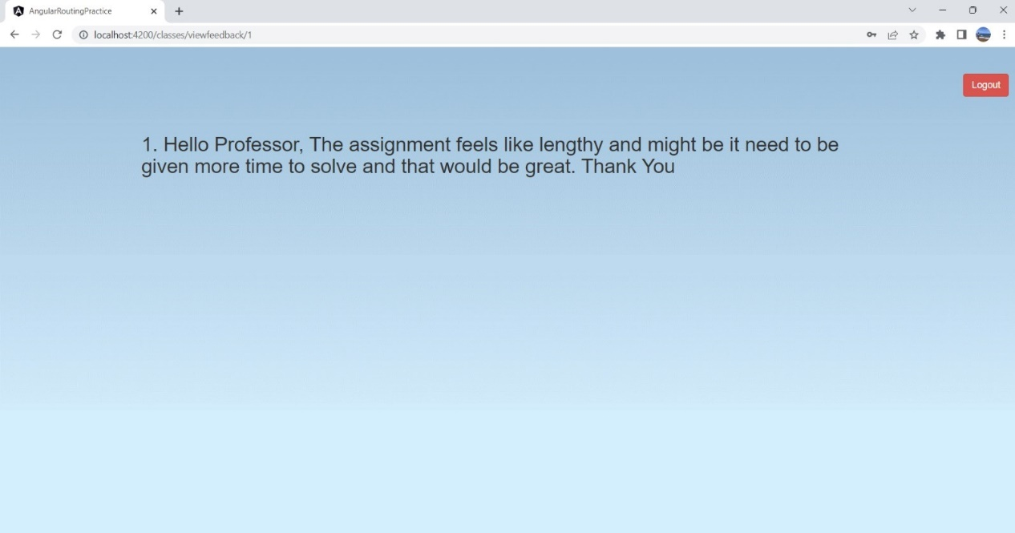

* 1. Fig: View feedbacks.

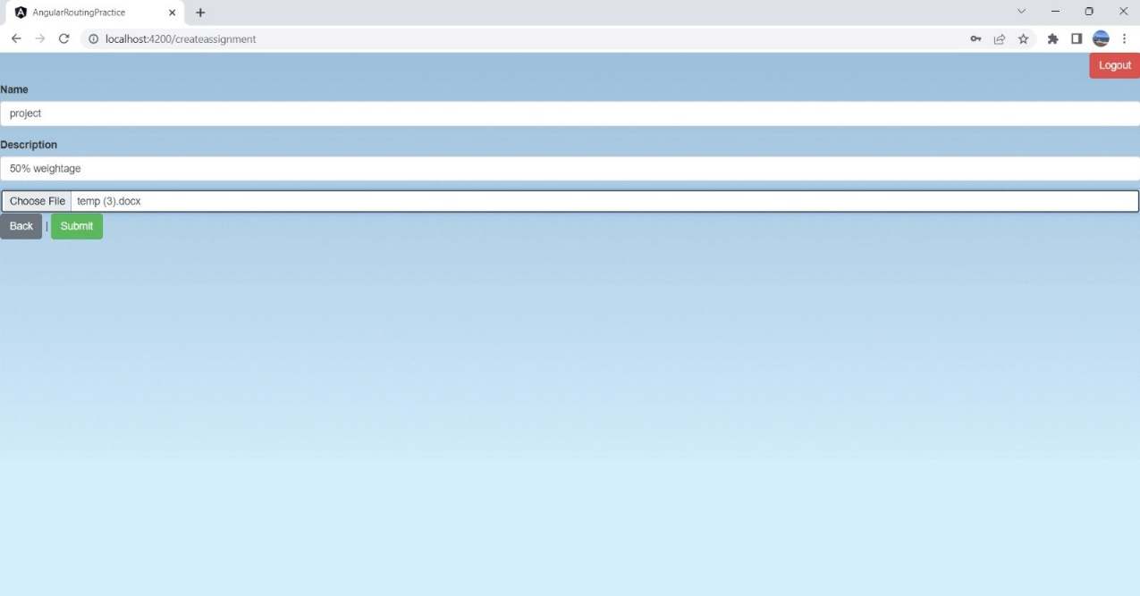

* 1. Fig: Create assignment

1. Student Role: Join new class

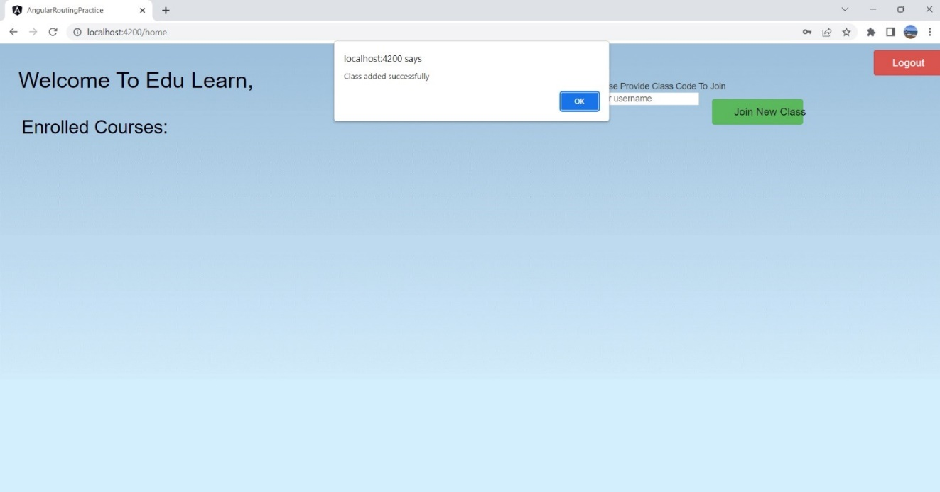

* 1. Fig: Join class

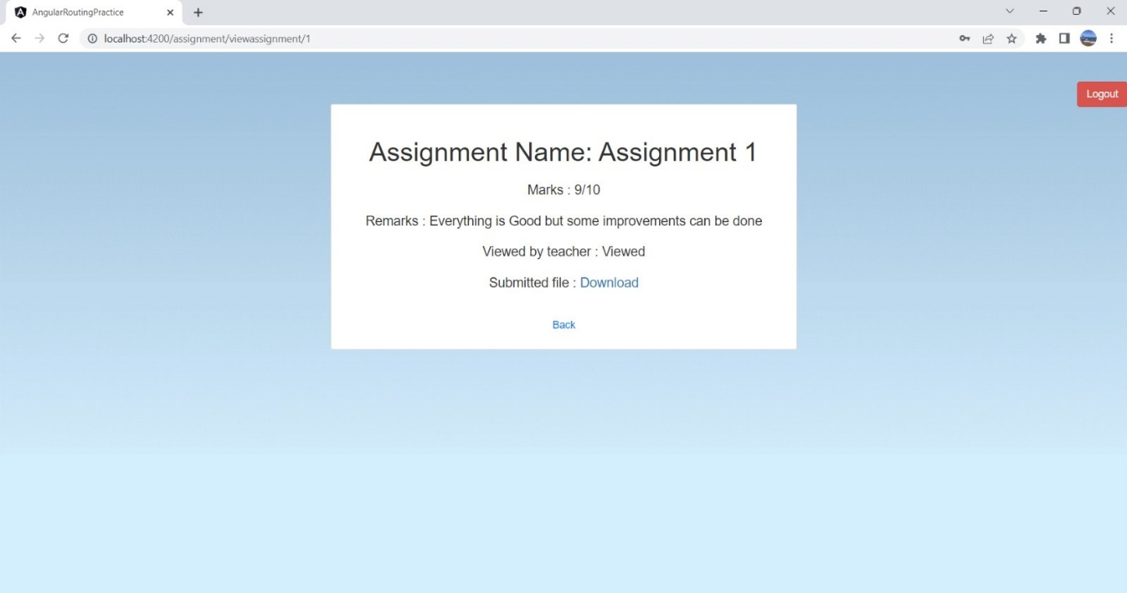

* 1. Fig: View correct assignment

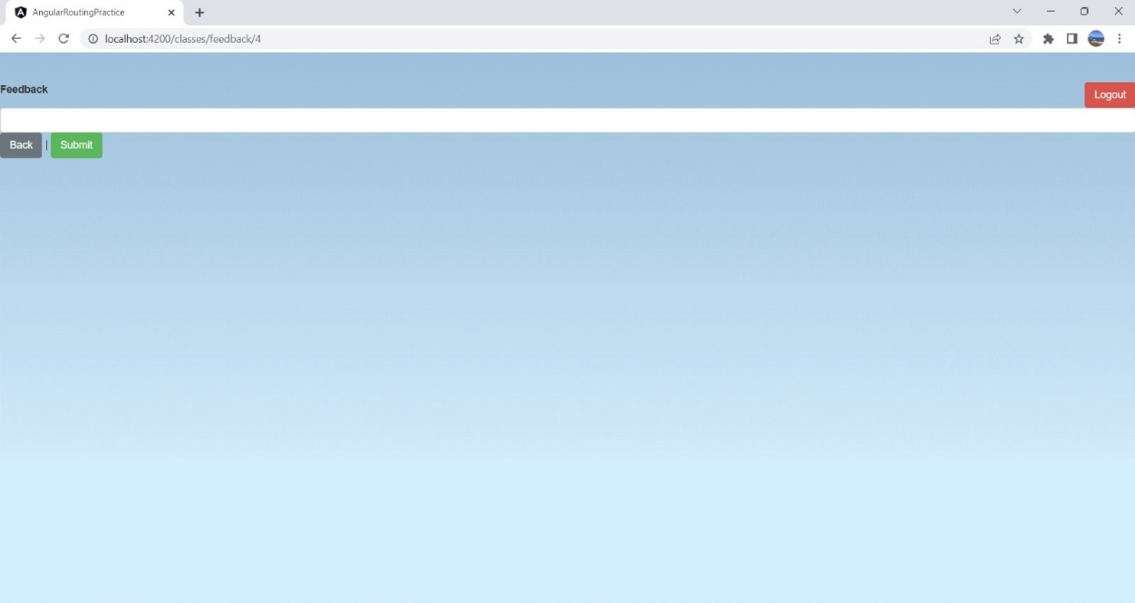

* 1. Fig: Provide feedback