Software Quality Assurance
Spring 2023 EEC 623



Team Members
Jagadish Paled - 2812076
Bindu Manjunath Raju - 2862245

- Introduction

The project entailed conducting a comprehensive software testing exercise on an ecommerce platform called thirty bees, with the overarching goal of ensuring that the website was of high quality. In pursuit of this objective, we devised four test objectives. Firstly, we aimed to confirm that all functions and features of the platform were performing as intended and meeting project requirements. Secondly, we sought to ensure that all graphical user interfaces (GUIs) of the platform were operating seamlessly. Thirdly, we verified that the platform was user-friendly, and finally, we aimed to identify and report any defects, bugs, or issues that could potentially impact the functionality and usability of the platform.

To accomplish these test objectives, we implemented various testing methodologies, including functionality testing, usability testing, and compatibility testing. Functionality testing focused on testing the various functions of the platform, including product management, order management, payment processing, shipping, and tax management, among others. The primary goal of functionality testing was to ensure that all the functions were performing as expected and meeting the requirements of the project.

Usability testing was aimed at evaluating the platform's user interface and user experience. We aimed to ascertain that the platform was intuitive, easy to navigate, and met the needs of users. We conducted various user tests, including testing the platform's layout, colors, fonts, and icons to ensure that they were aesthetically appealing and easy on the eye. We also tested the platform's ease of use and responsiveness.

Lastly, we performed compatibility testing to evaluate the platform's compatibility with different browsers, devices, and operating systems. The goal was to ensure that the platform worked correctly across all platforms, regardless of the device or browser used. We thoroughly tested the platform on various devices, including desktops, laptops, and mobile devices, to ensure that it worked seamlessly.

- Software Under Test

The software which we chose for our testing was “Thirty Bees”. Thirty bees is a comprehensive and powerful ecommerce platform that is designed to meet the needs of online merchants. The software is written in PHP, a widely used programming language that is known for its versatility and ease of use. The version of the website which is tested was v1.4.0. With a focus on providing merchants with a flexible and scalable platform, thirty bees is designed to help businesses of all sizes to create and manage their online stores efficiently.

The platform is built on the LAMP stack, which stands for Linux, Apache, MySQL, and PHP. This combination of technologies provides users with a robust and secure environment in which to run their ecommerce stores. Additionally, the platform is designed to be highly customizable, with a wide range of modules and themes that can be used to create unique and engaging storefronts. With its intuitive and user-friendly interface, powerful features, and extensive documentation, thirty bees is a top choice for businesses that are looking for an ecommerce platform that can help them to grow and succeed in the competitive online marketplace.
Requirement specification is an important part of the system testing that outlines the functional and non-functional requirements of a software system. Below mentioned are few of the requirement specifications that were used in our testing:
- Functional Requirements: These specify the functions and features that the software system should perform. Few of the functional requirements were:
- The platform should allow user to create a new account without any hassle.
- The platform should allow user to Sign in into their account.
- The platform should allow users to browse products.
- The browsed products should have all the details regarding the products enlisted.
- The platform should allow users to add items to the cart.
- The platform should allow users to create an account on the forum so they can interact with the user community.
- The platform should allow the users to leave a comment and a review for the products.
- User Interface Requirements: These specify the design and the layout of the user interface, including the placement of the buttons, menus, and icons. The thirty bees platform should have all the interfaces such as buttons, menus, icons, hyperlinks, dropdown menus functioning properly and oriented in a right format.
- Compatibility Requirements: The platform should be able to open on the web browsers namely Google Chrome, Mozilla Firefox, Microsoft Edge, Safari installed on Windows 11, macOS 10.14, android 13 and iOS 16 operating systems.

Features that are Tested | Features that are not Tested
Sign Up | Payment options
Sign In | Billing and delivery
Product search | Performance
Product details | Accessibility options
Adding and deleting items from the cart | Security
Sign Up for Forum community page | Admin Sing In
Posting on Forum community page
Download menu
Feature requesting
Contact menu
Marketplace menu
Back-office demo feature

- Test Design

In order to perform the necessary testing and ensure that the platform meets all the specified requirements outlined in Section 2, we utilized carefully designed test case design parameters. These parameters served as a blueprint for creating comprehensive test cases that would effectively evaluate the platform's functionality and performance.
The test case design parameters are mentioned below:
- Test Case Identifier: A test case identifier is a unique code assigned to each individual test case within a test suite, used to help testing teams organize and keep track of individual tests throughout the testing process.
- Test Item/Features: A test item or feature in testing refers to a specific component or aspect of a software system that is being tested.
- Precondition: Preconditions are used to ensure that the software system is in the proper state to be tested, and that all necessary resources and data are available for the test. These preconditions help to improve the accuracy and effectiveness of the testing process.
- Test Steps: In software testing, test steps refer to the individual actions or tasks that are performed during a specific test.
- Output Specifications: In software testing, output specifications refer to the expected outputs or results of a specific test case. These specifications outline the criteria that must be met for the test to be considered successful and help to ensure that the software system is functioning as intended.
- Inter-case Dependencies: In software testing, inter-case dependencies refer to the relationships and interactions between different test cases within a test suite. These dependencies can occur when the results of one test case impact the ability to execute or interpret the results of another test case and must be carefully managed to ensure accurate and effective testing.
- Test Result: In software testing, test results refer to the outcomes or findings of a particular test case or test suite.
Based on the input space partitioning technique, we employed a coverage criterion similar to the "each choice" criterion to design our test cases.
For example: let us consider test cases for Sign Up functionality. The input parameters present in Sign Up functionality are First name, Last name, Email Id, Password and Date of Birth.
Consider a test case, in this test case all parameters are valid, and the test is carried out. In another test case relating to the Sign up, first name is considered as in valid, and all other inputs are considered as valid and the test case in carried out. Consider one more test case where last name is considered as invalid, and all other parameters are considered as valid, and the test is carried out. In this similar way the criterion coverage is used, and the test cases are designed.

- Test case Specifications

Below mentioned are the Test case Specifications.
Test Case Identifier | TF 001
Test Items/feature | Interfacing of the Download button
Preconditions | User should be on the Thirty Bees home page
Test Steps | - Click on Download in the navigation menu
Output Specifications | Takes the user to the download page
Inter-case Dependencies | none
Test Result | PASS

Test Case Identifier | TF 002
Test Items/feature | Download the thirty bees php version
Preconditions | User should be in the download page by clicking on download option in the home page.
Test Steps | - Click on “Version 1.4.0 Download”
Output Specifications | A zip file is downloaded
Inter-case Dependencies | none
Test Result | PASS

Test Case Identifier | TF 003
Test Items/feature | Interfacing of the Forum button
Preconditions | User should be present on Thirty Bees Homepage
Test Steps | - Click on forum in the navigation menu
Output Specifications | Takes the user to the Forum page
Inter-case Dependencies | none
Test Result | PASS

Test Case Identifier | TF 004
Test Items/feature | Sign Up
Preconditions | User should be present on the Forum page of Thirty Bees.
Test Steps | - Click on “Sign Up” Button present in the navigation menu on the left side of the forum page.  - Enter “Student 123” in the Display Name  - Enter “smtpjaga@gmail.com” in Email Address  - Enter “Thir+yb335” in Password  - Enter “Thir+yb335” in Confirm Password  - Select to “I agree to the Terms of Use.”  - Click CREATE MY ACCOUNT  - Verify the email ID by logging into your email address.  - Click on the email from thirty bee’s forum.  - Click on Validate my Email address.  - After validating your email address, it takes you back to thirty bees forum webpage there click “VALIDATE MY ACCOUNT”
Output Specifications | A toast message of “your email has been confirmed” and you can see your username on the left part on the navigation bar on thirty bee’s forum pages.
Inter-case Dependencies | none
Test Result | PASS

Test Case Identifier | TF 005
Test Items/feature | User SIGN IN Functionality
Preconditions | User should have created the account and be present on the Forum page of the Thirty Bees
Test Steps | - Click on “SIGN IN” button present either on the left side of the thirty bees forum page or below the heading “Welcome, Guest”.  - Enter “Student 123” in the “Display Name or Email Address” section.  - Enter “Thir+yb335” as Password.  - Click “SIGN IN”
Output Specifications | User is signed into their existing account
Inter-case Dependencies | TC004 : User sign up functionality
Test Result | PASS

Test Case Identifier | TF 006
Test Items/feature | Functionality of the button “START NEW TOPIC”
Preconditions | User should be logged into or Signed in’ to their Account on Forum page of Thirty Bees
Test Steps | - Click on “START NEW TOPIC” button present on the top right corner of the forum page.  - Select one of the options from the drop now menu under which is present in the pop-up box with the heading “Select Forum”.  - We selected “English” option from the drop-down menu.  - CLICK “Continue” button.  - Type “Thirty Bees Forum” in the title bar.  - Type “Hello” in the body of the topic.  - Click Submit.
Output Specifications | The user’s topic is posted on the forum page.
Inter-case Dependencies | none
Test Result | PASS

Test Case Identifier | TF 007
Test Items/feature | Functionality of the “FORUMS” button Present in the left-hand side of the forum page in navigation menu
Preconditions | User should be present on forum page of Thirty Bees.
Test Steps | - Click on the “FORUMS” in the navigation menu.
Output Specifications | User is taken to the forum bulletin board
Inter-case Dependencies | none
Test Result | PASS

Test Case Identifier | TF 008
Test Items/feature | Functionality of the “MEMBER BLOGS” button present in the navigation menu of forum page
Preconditions | User should be present on forum page of Thirty Bees.
Test Steps | - Click on “MEMBER BLOGS” in the navigation menu
Output Specifications | User is taken to the Member Blog page
Inter-case Dependencies | none
Test Result | PASS

Test Case Identifier | TF 009
Test Items/feature | Functionality of “LEADERBOARD” button present in the navigation menu
Preconditions | User should be present on forum page of Thirty Bees.
Test Steps | - Click on “LEADERBOARD” in the navigation menu
Output Specifications | User is taken to the leaderboard page
Inter-case Dependencies | none
Test Result | PASS

Test Case Identifier | TF 010
Test Items/feature | Functionality of the “STAFF” button present in the navigation menu of forum page
Preconditions | User should be present on forum page of Thirty Bees.
Test Steps | - Click on “STAFF” in the navigation menu
Output Specifications | User is taken to the Staff information page with heading “Staff Directory”
Inter-case Dependencies | none
Test Result | PASS

Test Case Identifier | TF 011
Test Items/feature | Functionality of the “SUPPORT THIRTY BEES” button present in the navigation menu of forum page
Preconditions | User should be present on forum page of Thirty Bees.
Test Steps | - Click on “SUPPORT THIRTY BEES” in the navigation menu
Output Specifications | User is taken to the Support page with heading the heading “Become a thirty bees’ supporter”
Inter-case Dependencies | none
Test Result | PASS

Test Case Identifier | TF 012
Test Items/feature | Functionality of the “MARKETPLACE” button present in the navigation menu of forum page
Preconditions | User should be present on forum page of Thirty Bees.
Test Steps | - Click on “MARKETPLACE” in the navigation menu
Output Specifications | User is taken to a separate website which shows market trends
Inter-case Dependencies | none
Test Result | PASS

Test Case Identifier | TF 013
Test Items/feature | Functionality of “Contribute” button in the menu bar of the home page
Preconditions | User should be present in the home page of Thirty Bees.
Test Steps | - Click on “Contribute” present in the menu bar
Output Specifications | User is taken to a Contribute webpage with heading “Contribute”.
Inter-case Dependencies | None
Test Result | PASS

Test Case Identifier | TF 014
Test Items/feature | Functionality of “Feature Request” option
Preconditions | User should be logged into their account and present in the Contribute page of Thirty Bees
Test Steps | - Click on “Feature Request” option present under the contribute heading.  - The button will take the user to a new web page.  - Click on “Submit feature” button.
Output Specifications | Submit Feature Form pop-up should be displayed
Inter-case Dependencies | none
Test Result | FAIL

Test Case Identifier | TF 015
Test Items/feature | Functionality of “Report Bugs” option present right below feature request
Preconditions | User should be Logged into their account and present in the Contribute page of Thirty Bees
Test Steps | - Hover the arrow key on the “Report Bugs” option.  - Click on “REPORT A BUG” button.  - Describe the Bug “Not able to submit Feature Requests” in the give space.  - Click Submit
Output Specifications | User successfully reported the bug
Inter-case Dependencies | none
Test Result | FAIL

Test Case Identifier | TF 016
Test Items/feature | Functionality of “Contribute Code” option present right next to Report Bugs
Preconditions | User should be Logged into their account and present in the Contribute page of Thirty Bees
Test Steps | - Hover the arrow key on the “Contribute Code” option.  - Click on “WRITE CODE” button.
Output Specifications | User is taken to the GitHub page of thirty bees
Inter-case Dependencies | none
Test Result | PASS

Test Case Identifier | TF 017
Test Items/feature | Functionality of “Post in our forums” button
Preconditions | User should be logged in and present in Contribute page.
Test Steps | - Click on “Post in our forums” button
Output Specifications | User is taken to the forum page of Thirty Bees
Inter-case Dependencies | TC004 and TC005
Test Result | PASS

Test Case Identifier | TF 018
Test Items/feature | Functionality of “Learn” button
Preconditions | User should be logged in and present in the home page of thirty bees and the “Learn” option is present in the menu bar present at top of the home page
Test Steps | - Click on “Learn” button
Output Specifications | User is taken to the learn page of the Thirty Bees
Inter-case Dependencies | none
Test Result | FAIL

Test Case Identifier | TF 019
Test Items/feature | Functionality of “Partners” button
Preconditions | User should be logged in and present in-home page and the Partners option is present in the top menu bar.
Test Steps | - Click on “Partners” option.  - Enter “Student 123” in Your Name section  - Enter “smtpjaga@gmail.com” in Your Email section  - Enter “Hello! We want to partner with Thirty Bees” in the Your message section.  - Click Send
Output Specifications | User is able to submit a note to the thirty bees describing their company
Inter-case Dependencies | None
Test Result | PASS

Test Case Identifier | TF 020
Test Items/feature | Functionality of “Contact” button
Preconditions | User should be logged in and present in the home page of thirty bees and the “Contact” option is present in the menu bar present at top of the home page
Test Steps | - Click on “Contact” button
Output Specifications | User is taken to the “Contact” page of the Thirty Bees
Inter-case Dependencies | none
Test Result | PASS

Test Case Identifier | TF 021
Test Items/feature | Functionality of “About” button
Preconditions | User should be logged in and present in the home page of thirty bees and the “About” option is present in the menu bar present at top of the home page
Test Steps | - Click on “About” button
Output Specifications | User is taken to the About page of the Thirty Bees
Inter-case Dependencies | None
Test Result | PASS

Test Case Identifier | TF 022
Test Items/feature | Functionality of “Marketplace” button
Preconditions | User should be logged in and present in the home page of thirty bees and the “Marketplace” option is present in the menu bar present at top of the home page
Test Steps | - Click on “Marketplace” button
Output Specifications | User is taken to the Marketplace page of the Thirty Bees
Inter-case Dependencies | none
Test Result | PASS

Test Case Identifier | TF 023
Test Items/feature | Functionality of “Get Started” Button
Preconditions | User should be present in the home page of thirty bees
Test Steps | - Click on “Get Started” button
Output Specifications | User should be taken to download page
Inter-case Dependencies | none
Test Result | PASS

Test Case Identifier | TF 024
Test Items/feature | Functionality of “View Demos” Button
Preconditions | User should be present in the home page of thirty bees
Test Steps | - Click on “View Demos” button
Output Specifications | Thirty bees demos page should be displayed
Inter-case Dependencies | none
Test Result | PASS

Test Case Identifier | TF 025
Test Items/feature | Functionality of “View Front Office Demo” Button
Preconditions | User should be present in home page of thirty bees
Test Steps | 1. Hover on download  2.Click on View front office demo button
Output Specifications | User should be taken to view front office demo page
Inter-case Dependencies | None
Test Result | PASS

Test Case Identifier | TF 026
Test Items/feature | Functionality of “My cart” feature
Preconditions | User should be present in Thirty bees demos page of thirty bees
Test Steps | - Click on My Cart icon
Output Specifications | Shopping cart Summary page should be displayed
Inter-case Dependencies | None
Test Result | PASS

Test Case Identifier | TF 027
Test Items/feature | Functionality of “View Back Office Demo” Button
Preconditions | User should be present in home page of thirty bees
Test Steps | - Hover on download  - Click on “View Back office Demo” button
Output Specifications | User should be taken to View back office page
Inter-case Dependencies | none
Test Result | PASS

Test Case Identifier | TF 028
Test Items/feature | Functionality of Catalog feature
Preconditions | User should be present in View Back office Demo page of thirty bees
Test Steps | - Hover on “Catalog”
Output Specifications | Dropdown should be displayed
Inter-case Dependencies | none
Test Result | PASS

Test Case Identifier | TF 029
Test Items/feature | Functionality of Add New product feature
Preconditions | User should be present in View Back office Demo page of thirty bees
Test Steps | - Click on Add new product icon  - Fill the name field  - Click on save
Output Specifications | Successful creation message should be displayed and product should be added to the product list
Inter-case Dependencies | none
Test Result | PASS

Test Case Identifier | TF 030
Test Items/feature | Functionality of “View more features” Button
Preconditions | User should be present in the home page of thirty bees
Test Steps | - Click on “View more features” button
Output Specifications | Thirty bees features page should be displayed
Inter-case Dependencies | none
Test Result | PASS

Test Case Identifier | TF 031
Test Items/feature | Functionality of “Download” Button
Preconditions | User should be present in the home page of thirty bees
Test Steps | - Hover on “Download” button
Output Specifications | Download dropdown with all the features should be displayed
Inter-case Dependencies | none
Test Result | PASS

Test Case Identifier | TF 032
Test Items/feature | Functionality of “Shop now” Button in Front office demo
Preconditions | User should be present in the Front office demo page of thirty bees
Test Steps | - Click on “Shop now! Button for Shop tea
Output Specifications | All the products related to Tea should be listed in the front office demo page
Inter-case Dependencies | none
Test Result | FAIL

Test Case Identifier | TF 033
Test Items/feature | User Sign Up functionality
Preconditions | Sign up page should be accessible
Test Steps | - Click on the link “Marketplace” in Thirty bee’s homepage. The “Marketplace is present in top right corner of the main menu bar.  - Click on the “Sign in” button present on topmost menu bar of the “Market Place beta” webpage.  - Enter a valid email ID “smptjaga@gmail.com” in the empty space, present right below “Create an account” dialog box.  - Select as “Mr.” in title present right below the heading Your personal information.  - Enter a valid First name “James” in the empty space present right below First name.  - Enter a valid Last name “Hooper” in the empty space present right below Last name.  - Enter the same Email address used in the step 3 in the empty space present right below email.  - Enter a valid Password “J@mesH00per” in the empty space provided right below the Password.  - Provide date of birth by selecting  - “12” as the date from the 1st drop down menu.  - “April” as the month from the 2nd drop down menu.  - “1990” as the year from the 3rd drop down menu.  - Select the box “Sign up for our newsletter!”  - Click on “Register” button.
Output Specifications | The user has to be taken to the home page of their account and a toast should pop mentioning that users account has been successfully created.
Inter-case Dependencies | none
Test Result | PASS

Test Case Identifier | TF 034
Test Items/feature | User Sign Up functionality
Preconditions | Sign up page should be accessible
Test Steps | - Click on the link “Marketplace” in Thirty bee’s homepage. The “Marketplace is present in top right corner of the main menu bar.  - Click on the “Sign in” button present on topmost menu bar of the “Market Place beta” webpage.  - Enter an invalid email ID “1234567@takemehomeWV.c” in the empty space, present right below “Create an account” dialog box.  - Select as “Mrs.” in title present right below the heading Your personal information.  - Enter a valid First name “Alice” in the empty space present right below First name.  - Enter a valid Last name “Homer” in the empty space present right below Last name.  - Enter the same Email address used in the step 3 in the empty space present right below email.  - Enter a valid Password “123456” in the empty space provided right below the Password.  - Provide date of birth by selecting  - “12” as the date from the 1st drop down menu.  - “April” as the month from the 2nd drop down menu.  - “1990” as the year from the 3rd drop down menu.  - Select the box “Sign up for our newsletter!”  - Click on “Register” button.
Output Specifications | The users account shouldn’t be created, and an error message should be displayed saying “invalid Email address”
Inter-case Dependencies | none
Test Result | FAIL

Test Case Identifier | TF 035
Test Items/feature | User Sign Up functionality
Preconditions | Sign up page should be accessible
Test Steps | - Click on the link “Marketplace” in Thirty bee’s homepage. The “Marketplace is present in top right corner of the main menu bar.  - Click on the “Sign in” button present on topmost menu bar of the “Market Place beta” webpage.  - Enter a valid email ID “12345678@gmail.com” in the empty space, present right below “Create an account” dialog box.  - Select as “Mrs.” in title present right below the heading Your personal information.  - Enter an invalid First name “10000” in the empty space present right below First name.  - Enter a valid Last name “Homer” in the empty space present right below Last name.  - Enter the same Email address used in the step 3 in the empty space present right below email.  - Enter a valid Password “1234567” in the empty space provided right below the Password.  - Provide date of birth by selecting  - “12” as the date from the 1st drop down menu.  - “April” as the month from the 2nd drop down menu.  - “1990” as the year from the 3rd drop down menu.  - Select the box “Sign up for our newsletter!”  - Click on “Register” button.
Output Specifications | The users account shouldn’t be created, and an error message should be displayed saying “First name is invalid”
Inter-case Dependencies | none
Test Result | PASS

Test Case Identifier | TF 036
Test Items/feature | User Sign Up functionality
Preconditions | Sign up page should be accessible
Test Steps | - Click on the link “Marketplace” in Thirty bee’s homepage. The “Marketplace is present in top right corner of the main menu bar.  - Click on the “Sign in” button present on topmost menu bar of the “Market Place beta” webpage.  - Enter a valid email ID “12345678@gmail.com” in the empty space, present right below “Create an account” dialog box.  - Select as “Mrs.” in title present right below the heading Your personal information.  - Enter an invalid First name “CONEY” in the empty space present right below First name.  - Enter a invalid Last name “000000” in the empty space present right below Last name.  - Enter the same Email address used in the step 3 in the empty space present right below email.  - Enter a valid Password “1234567” in the empty space provided right below the Password.  - Provide date of birth by selecting  - “12” as the date from the 1st drop down menu.  - “April” as the month from the 2nd drop down menu.  - “1990” as the year from the 3rd drop down menu.  - Select the box “Sign up for our newsletter!”  - Click on “Register” button.
Output Specifications | The users account shouldn’t be created, and an error message should be displayed saying “Last name is invalid”
Inter-case Dependencies | none
Test Result | PASS

Test Case Identifier | TF 037
Test Items/feature | User Sign Up functionality
Preconditions | Sign up page should be accessible
Test Steps | - Click on the link “Marketplace” in Thirty bee’s homepage. The “Marketplace is present in top right corner of the main menu bar.  - Click on the “Sign in” button present on topmost menu bar of the “Market Place beta” webpage.  - Enter a valid email ID “12345678@gmail.com” in the empty space, present right below “Create an account” dialog box.  - Select as “Mrs.” in title present right below the heading Your personal information.  - Enter an invalid First name “10000” in the empty space present right below First name.  - Enter a valid Last name “Homer” in the empty space present right below Last name.  - Enter a different Email address “1268@gmail.com” other than the one used in the step 3 in the empty space present right below email.  - Enter a valid Password “1234567” in the empty space provided right below the Password.  - Provide date of birth by selecting  - “12” as the date from the 1st drop down menu.  - “April” as the month from the 2nd drop down menu.  - “1990” as the year from the 3rd drop down menu.  - Select the box “Sign up for our newsletter!”  - Click on “Register” button.
Output Specifications | The users account shouldn’t be created, and an error message should be displayed saying “Email entered doesn’t match”
Inter-case Dependencies | none
Test Result | FAIL

Test Case Identifier | TF 038
Test Items/feature | User Sign Up functionality
Preconditions | Sign up page should be accessible
Test Steps | - Click on the link “Marketplace” in Thirty bee’s homepage. The “Marketplace is present in top right corner of the main menu bar.  - Click on the “Sign in” button present on topmost menu bar of the “Market Place beta” webpage.  - Enter a valid email ID “12345678@gmail.com” in the empty space, present right below “Create an account” dialog box.  - Select as “Mrs.” in title present right below the heading Your personal information.  - Enter an invalid First name “10000” in the empty space present right below First name.  - Enter a valid Last name “Homer” in the empty space present right below Last name.  - Enter the same Email address used in the step 3 in the empty space present right below email.  - Enter an invalid Password “hey” in the empty space provided right below the Password.  - Provide date of birth by selecting  - “12” as the date from the 1st drop down menu.  - “April” as the month from the 2nd drop down menu.  - “1990” as the year from the 3rd drop down menu.  - Select the box “Sign up for our newsletter!”  - Click on “Register” button.
Output Specifications | The users account shouldn’t be created, and an error message should be displayed saying “Password is invalid”
Inter-case Dependencies | none
Test Result | PASS

Test Case Identifier | TF 039
Test Items/feature | User Sign in functionality
Preconditions | Sign in page should be accessible
Test Steps | - Click on the link “Marketplace” in Thirty bee’s homepage. The “Marketplace is present in top right corner of the main menu bar.  - Click on the “Sign in” button present on topmost menu bar of the “Market Place beta” webpage.  - Enter a valid email ID “smptjaga@gmail.com” in the empty space provided right below Email address heading present in the “Already Registered” dialog box.  - Enter a valid Password “J@mesH00per” in the empty space provided right below Password heading present in the “Already Registered” dialog box.  - Click the button Sign in.
Output Specifications | The user should be Signed into their account
Inter-case Dependencies | The user should be registered or signed up to begin with
Test Result | PASS

Test Case Identifier | TC 040
Test Items/feature | User Sign in functionality
Preconditions | Sign in page should be accessible
Test Steps | - Click on the link “Marketplace” in Thirty bee’s homepage. The “Marketplace is present in top right corner of the main menu bar.  - Click on the “Sign in” button present on topmost menu bar of the “Market Place beta” webpage.  - Enter an invalid email ID “1234567@takemehomeWV.c” in the empty space provided right below Email address heading present in the “Already Registered” dialog box.  - Enter a valid Password “123456” in the empty space provided right below Password heading present in the “Already Registered” dialog box.  - Click the button Sign in.
Output Specifications | The user shouldn’t be Signed into their account and an error message should be displayed saying “Authentication failed” as the Syntax of the email ID is not right
Inter-case Dependencies | The user should be registered or signed up to begin with
Test Result | FAIL

Test Case Identifier | TF 041
Test Items/feature | User Sign in functionality
Preconditions | Sign in page should be accessible
Test Steps | - Click on the link “Marketplace” in Thirty bee’s homepage. The “Marketplace is present in top right corner of the main menu bar.  - Click on the “Sign in” button present on topmost menu bar of the “Market Place beta” webpage.  - Enter a valid email ID “12345678@gmail.com” in the empty space provided right below Email address heading present in the “Already Registered” dialog box.  - Enter an invalid Password “1234” in the empty space provided right below Password heading present in the “Already Registered” dialog box.  - Click the button Sign in.
Output Specifications | The user shouldn’t be Signed into their account and an error message should be displayed saying “Authentication failed” as the Syntax of the Password is not right
Inter-case Dependencies | The user should be registered or signed up to begin with
Test Result | PASS

Test Case Identifier | TF 042
Test Items/feature | Search functionality
Preconditions | - Sign in page should be accessible.  - The user should be Logged into their account.
Test Steps | - Type a valid search term “Cookies” in the search bar and hit Enter.  - Click on the First search result which comes up.
Output Specifications | The user should be able to type the valid search term, search results should be displayed, and the user should be able to access all the related data of the selected item.
Inter-case Dependencies | Sign in
Test Result | PASS

Test Case Identifier | TF 043
Test Items/feature | Search functionality
Preconditions | - Sign in page should be accessible.  - The user should be Logged into their account.
Test Steps | - Type a different valid search term “Support” in the search bar and hit Enter.  - Click on the First search result which comes up.
Output Specifications | The user should be able to type the valid search term, search results should be displayed, and the user should be able to access all the related data of the selected item.
Inter-case Dependencies | Sign in
Test Result | PASS

Test Case Identifier | TF 044
Test Items/feature | Search functionality
Preconditions | - Sign in page should be accessible.  - The user should be Logged into their account.
Test Steps | Type an invalid search term “Honey” in the search bar and hit Enter.
Output Specifications | A message saying “No results were found for your search “honey”” should be displayed.
Inter-case Dependencies | Sign in
Test Result | PASS

Test Case Identifier | TC 045
Test Items/feature | Search functionality
Preconditions | - Sign in page should be accessible.  - The user should be Logged into their account.
Test Steps | Type a different invalid search term “0000000” in the search bar and hit Enter.
Output Specifications | A message saying “No results were found for your search “0000000”” should be displayed.
Inter-case Dependencies | Sign in
Test Result | PASS

Test Case Identifier | TF 046
Test Items/feature | Currency Dropdown list
Preconditions | Market place page should be accessible
Test Steps | - Click on the link “Marketplace” in Thirty bee’s homepage. The “Marketplace is present in top right corner of the main menu bar.  - Click on the Currency dropdown
Output Specifications | The user should be able to see different currency option
Inter-case Dependencies | None
Test Result | PASS

Test Case Identifier | TF 047
Test Items/feature | Currency dropdown
Preconditions | Market place page should be accessible
Test Steps | - Click on the link “Marketplace” in Thirty bee’s homepage. The “Marketplace is present in top right corner of the main menu bar.  - Click on the Currency dropdown and select EURO
Output Specifications | The user should be able see the products with Euro currency in the marketplace welcome page
Inter-case Dependencies | None
Test Result | PASS

Test Case Identifier | TF 048
Test Items/feature | Product search and currency change in marketplace
Preconditions | Market place page should be accessible
Test Steps | - Click on the link “Marketplace” in Thirty bee’s homepage. The “Marketplace is present in top right corner of the main menu bar.  - Click on “search”  - Enter “Package” in the search field and click on search button  - Click on the Currency dropdown and select EURO
Output Specifications | The user should be able to see all the listed results with Euro currency
Inter-case Dependencies | Search functionality
Test Result | PASS

Test Case Identifier | TF 049
Test Items/feature | Product search and sort
Preconditions | Market place page should be accessible
Test Steps | - Click on the link “Marketplace” in Thirty bee’s homepage. The “Marketplace is present in top right corner of the main menu bar.  - Click on “search”  - Enter “Package” in the search field and click on search button  - Click on sort by and select Lowest first
Output Specifications | The products should be sorted from lowest to highest
Inter-case Dependencies | Search functionality
Test Result | PASS

Test Case Identifier | TF 050
Test Items/feature | Product search and grid view
Preconditions | Market place page should be accessible
Test Steps | - Click on the link “Marketplace” in Thirty bee’s homepage. The “Marketplace is present in top right corner of the main menu bar.  - Click on “search”  - Enter “Package” in the search field and click on search button  - Click on grid view icon
Output Specifications | The products should be displayed in grid view
Inter-case Dependencies | Search functionality
Test Result | PASS

Test Case Identifier | TF 051
Test Items/feature | Product search and add to cart
Preconditions | Market place page should be accessible
Test Steps | - Click on the link “Marketplace” in Thirty bee’s homepage. The “Marketplace is present in top right corner of the main menu bar.  - Click on “search”  - Enter “Package” in the search field and click on search button  - Select a product and click on add to cart
Output Specifications | Product should be added to the cart and pop up with “product successfully added to your shopping cart” should be displayed
Inter-case Dependencies | Search functionality
Test Result | PASS

Test Case Identifier | TF 052
Test Items/feature | Product search and cart view
Preconditions | Market place page should be accessible
Test Steps | - Click on the link “Marketplace” in Thirty bee’s homepage. The “Marketplace is present in top right corner of the main menu bar.  - Click on “search”  - Enter “Package” in the search field and click on search button  - Select a product and click on add to cart  - Click on Proceed to checkout
Output Specifications | User should be able to see shopping cart summary page
Inter-case Dependencies | Search functionality
Test Result | PASS

Test Case Identifier | TF 053
Test Items/feature | Product search and cart dropdown functionality
Preconditions | Market place page should be accessible
Test Steps | - Click on the link “Marketplace” in Thirty bee’s homepage. The “Marketplace is present in top right corner of the main menu bar.  - Click on “search”  - Enter “Package” in the search field and click on search button  - Select a product and click on add to cart  - Click on close icon  - Hover on Cart dropdown
Output Specifications | User should be able to see cart summary in the dropdown
Inter-case Dependencies | Search functionality
Test Result | PASS

Test Case Identifier | TF 054
Test Items/feature | Delete product in cart
Preconditions | Market place page should be accessible
Test Steps | - Click on the link “Marketplace” in Thirty bee’s homepage. The “Marketplace is present in top right corner of the main menu bar.  - Select a product  - Click on add to cart  - Click on Proceed to checkout  - Click on Delete icon
Output Specifications | The product should be deleted
Inter-case Dependencies | Shopping Cart functionality
Test Result | PASS

Test Case Identifier | TF 055
Test Items/feature | Contact submit form feature
Preconditions | User should be logged in and present in the home page of thirty bees and the “Contact” option is present in the menu bar present at top of the home page
Test Steps | - Click on contact  - Enter name, email ,subject and message  - Click on checkbox for “I’m not a robot”  - Click on Submit Form button
Output Specifications | A toast message “THANK YOU FOR USING OUR CONTACT FORM! YOUR EMAIL WAS SUCCESSFULLY SENT!” should be displayed.
Inter-case Dependencies | None
Test Result | PASS

Test Case Identifier | TC 001
Test Items/feature | Browser compatibility for the software
Preconditions | User should open Internet explorer browser
Test Steps | - Insert website URL
Output Specifications | User should be able to open the website in Internet explorer
Inter-case Dependencies | none
Test Result | PASS

Test Case Identifier | TC 002
Test Items/feature | Browser compatibility for the software
Preconditions | User should open safari browser on iPhone
Test Steps | - Insert website URL
Output Specifications | User should be able to open the website in safari browser
Inter-case Dependencies | none
Test Result | PASS

Test Case Identifier | TC 003
Test Items/feature | Browser compatibility for the software
Preconditions | User should open Google chrome browser
Test Steps | - Insert website URL
Output Specifications | User should be able to open the website in google chrome browser
Inter-case Dependencies | none
Test Result | PASS

Test Case Identifier | TC 004
Test Items/feature | Browser compatibility for the software
Preconditions | User should open Mozilla Firefox browser
Test Steps | - Insert website URL
Output Specifications | User should be able to open the website in Mozilla Firefox browser
Inter-case Dependencies | none
Test Result | PASS

Test Case Identifier | TU 001
Test Items/feature | Front office demo “blog” page
Preconditions | User should be present in front office demos page of thirty bees
Test Steps | - Scroll down the page  - Click on recent post “ ORGANIC ROASTED”
Output Specifications | Product details and options should be aligned properly
Inter-case Dependencies | None
Test Result | FAIL

Test Case Identifier | TU 002
Test Items/feature | My account personal information page
Preconditions | User should be signed in to the account
Test Steps | - Click on user account “Alice Homer”  - Click on my personal information
Output Specifications | Social title radio buttons should be properly aligned
Inter-case Dependencies | Sign in
Test Result | FAIL

Test Case Identifier | TU 003
Test Items/feature | Shopping cart summary page Subtitles format
Preconditions | Market place page should be accessible
Test Steps | - Click on the link “Marketplace” in Thirty bee’s homepage. The “Marketplace is present in top right corner of the main menu bar.  - Select a product and add to cart  - Click on proceed to checkout
Output Specifications | Subtitles format should be correctly displayed  Like “1. Account”  “2.Please choose your payment method”
Inter-case Dependencies | Shopping Cart functionality
Test Result | FAIL

In software testing, a traceability matrix is a document or tool used to track and link requirements to their associated test cases. It helps to ensure that all requirements have been tested and provides traceability from the test cases back to the original requirements. Below given table represents the Traceability matrix for our testing of thirty bees.

Requirement ID | Requirement | Test Cases | Status
REQ1 | Forum | TF004,TF005,TF006,TF007,TF008,TF009,TF010,TF011,TF012 | PASS:TF004, TF005, TF006, TF007, TF008, TF009, TF010, TF011, TF012  FAIL: -
REQ2 | Download | TF002,TF001,TF025,TF026,TF027,TF028,TF029,TF030,TF031,TF032,TU001 | PASS:TF002, TF001, TF025, TF026, TF027, TF028, TF029, TF030, TF031, TU001  FAIL:TF032
REQ3 | Contribute | TF013,TF014,TF015,TF016,TF017 | PASS:TF013, TF016, TF017  FAIL: TF014, TF015,
REQ4 | Learn | TF018 | PASS: -  FAIL:TF018
REQ5 | Partners | TF019 | PASS: TF019  FAIL: -
REQ6 | Contact | TF020, TF056 | PASS : TF020, TF056  FAIL:
REQ7 | About | TF021 | PASS : TF021  FAIL:
REQ8 | Homepage | TF023, TF024 | PASS : TF023, TF024  FAIL:
REQ9 | Marketplace | TF022,TF033,TF034,TF035,TF036,TF037,TF038,TF039,TF040,TF041,TF042,TF043,TF044,TF045,TF046,TF047,TF048,TF049,TF050,TF051,TFO52,TF053,TF054,TU001,TU002,TU003 | PASS:TF022, TF033, TF035, TF036,TF038,TF039,TF041,TF042,TF043,TF044,TF045,TF046,TF047,TF048,TF049,TF050,TF051,TFO52, TF053,TF054.  FAIL: TF034, TF037, TF040, TU001, TU002, TU003
REQ10 | Compatibility | TC001,TC002,TC003,TC004 | PASS:TC001, TC002, TC003, TC004  FAIL: -

- Test Results

Below mentioned is the summary of our test results.

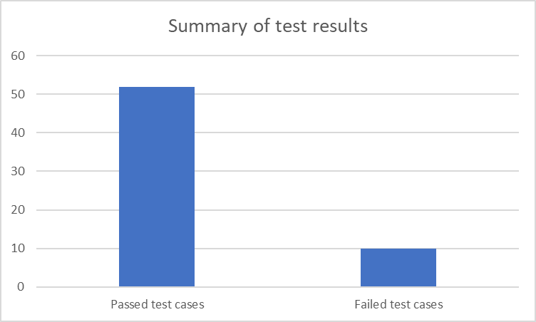
Total test cases | Passed test cases | Failed test cases
62 | 52 | 10

Below is the detailed table of test case report.

Test Case ID | Result | Defect Report ID
TF001 | PASS
TF002 | PASS
TF003 | PASS
TF004 | PASS
TF005 | PASS
TF006 | PASS
TF007 | PASS
TF008 | PASS
TF009 | PASS
TF010 | PASS
TF011 | PASS
TF012 | PASS
TF013 | PASS
TF014 | FAIL | DE001
TF015 | FAIL | DE002
TF016 | PASS
TF017 | PASS
TF018 | FAIL | DE003
TF019 | PASS
TF020 | PASS
TF021 | PASS
TF022 | PASS
TF023 | PASS
TF024 | PASS
TF025 | PASS
TF026 | PASS
TF027 | PASS
TF028 | PASS
TF029 | PASS
TF030 | PASS
TF031 | PASS
TF032 | FAIL | DE004
TF033 | PASS
TF034 | FAIL | DE005
TF035 | PASS
TF036 | PASS
TF037 | FAIL | DE006
TF038 | PASS
TF039 | PASS
TF040 | FAIL | DE007
TF041 | PASS
TF042 | PASS
TF043 | PASS
TF044 | PASS
TF045 | PASS
TF046 | PASS
TF047 | PASS
TF048 | PASS
TF049 | PASS
TF050 | PASS
TF051 | PASS
TF052 | PASS
TF053 | PASS
TF054 | PASS
TF055 | PASS
TC001 | PASS
TC002 | PASS
TC003 | PASS
TC004 | PASS
TU001 | FAIL | DE008
TU002 | FAIL | DE009
TU003 | FAIL | DE010

- Conclusion

In this project, we gained knowledge on various testing methodologies, analyzed test results for each test case, and ensured that the system met all the desired specifications and requirements which were mentioned. During system testing, we designed and executed test cases, and identified a few defects. One significant defect was found in the Sign-Up process of the marketplace, as it was accepting email IDs with wrong syntax or invalid email IDs, impacting the functionality of the website. We also found a few minor defects related to the graphical user interface (usability). Further testing, such as unit testing, is necessary, and the identified defects must be resolved to enhance the overall user experience.

- Appendix

Defect Report:

DEFECT ID | DE001
TEST CASE ID | TF 014
FEATURE | Functionality of “Feature Request” option
DESCRIPTION | - Click on “Feature Request” option present under the contribute heading.  - The button will take the user to a new web page.  - Click the “Submit Feature” button
DEFECT TYPE | Functional defect
EXPECTED RESULT | Submit feature form pop up should be displayed
ACTUAL RESULT | Not responding
Screenshot | 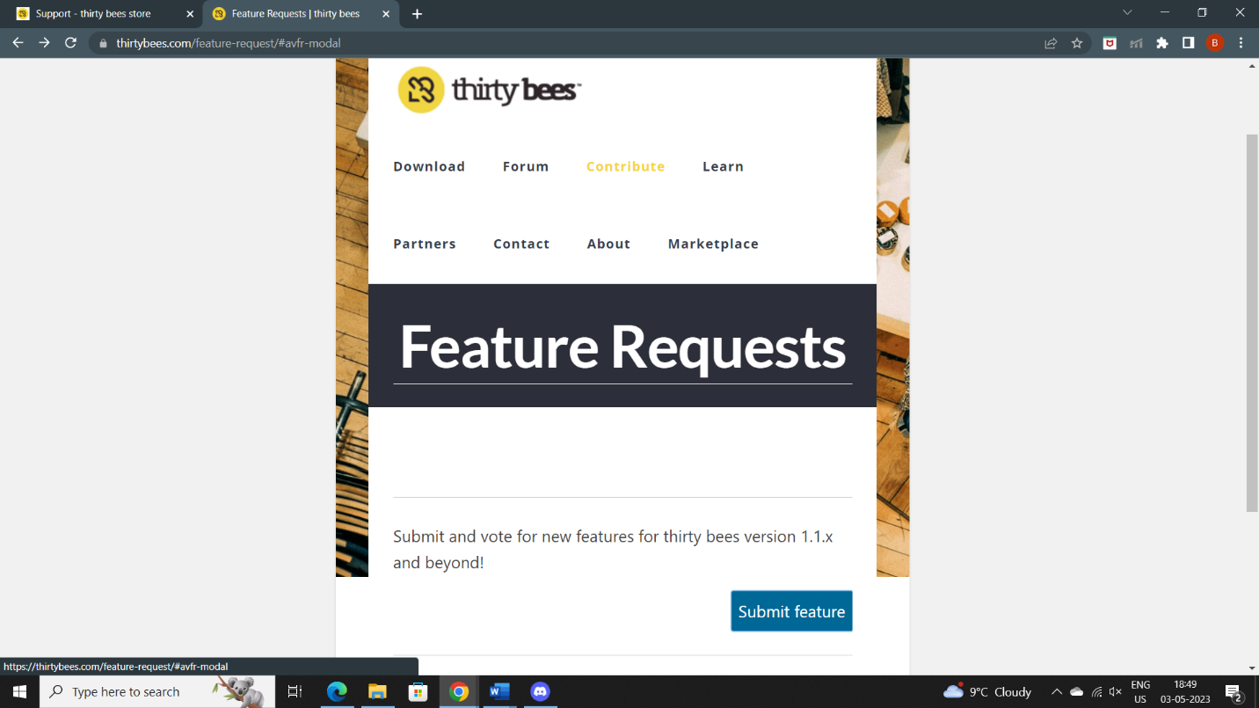

DEFECT ID | DE002
TEST CASE ID | TF 015
FEATURE | Functionality of “Report Bugs” option present right below feature request
DESCRIPTION | - Hover the arrow key on the “Report Bugs” option.  - Click on “REPORT A BUG” button.  - Describe the Bug “Not able to submit Feature Requests” in the give space.  - Click Submit
DEFECT TYPE | Functional defect
EXPECTED RESULT | Textbox should be displayed
ACTUAL RESULT | Sorry!  The page you requested does not exist is displayed
SCREENSHOT | 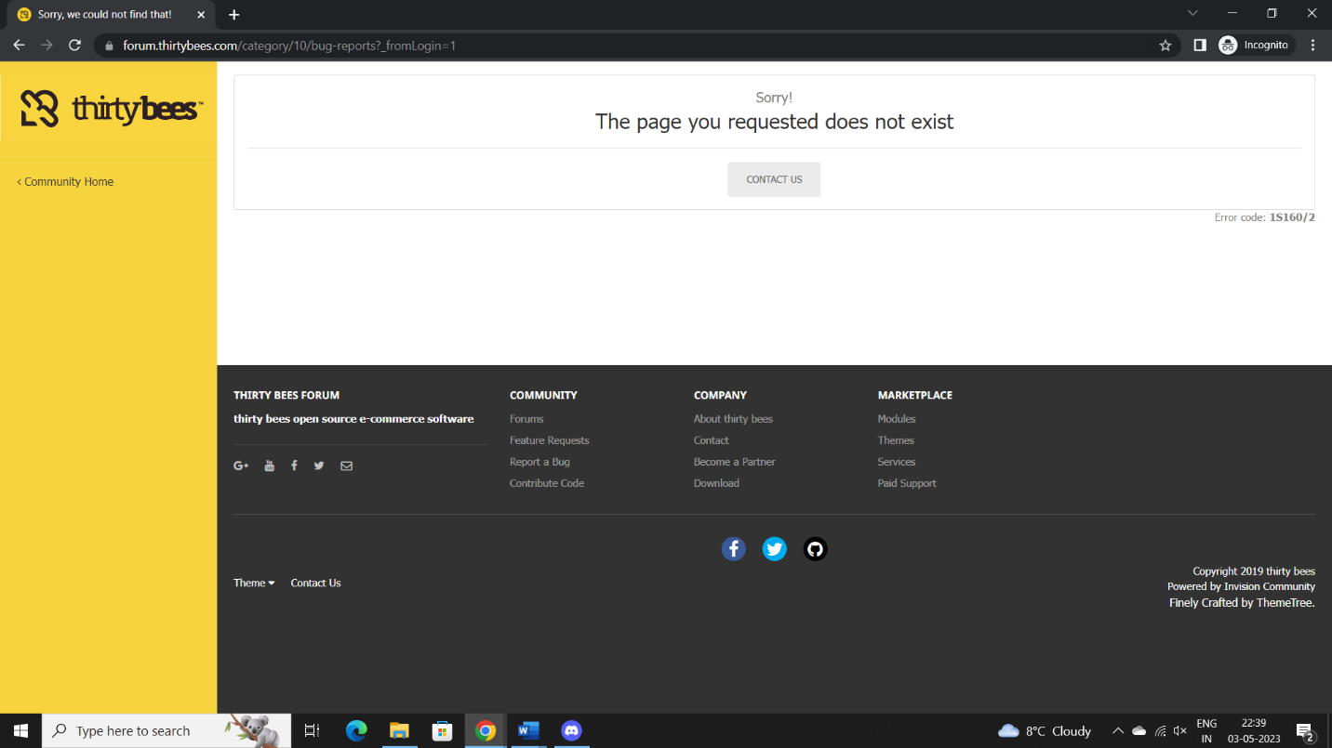

DEFECT ID | DE003
TEST CASE ID | TF 018
FEATURE | Functionality of “Learn” button
DESCRIPTION | - Click on “Learn” button
DEFECT TYPE | Functional defect
EXPECTED RESULT | Learn page should be displayed
ACTUAL RESULT | Not responding

DEFECT ID | DE004
TEST CASE ID | TF 032
FEATURE | Functionality of “Shop now” Button in Front office demo
DESCRIPTION | - Click on “Shop now! Button for Shop tea
DEFECT TYPE | Functional defect
EXPECTED RESULT | All the products related to Tea should be listed in the front office demo page
ACTUAL RESULT | Redirecting to thirtybees homepage
SCREENSHOT | 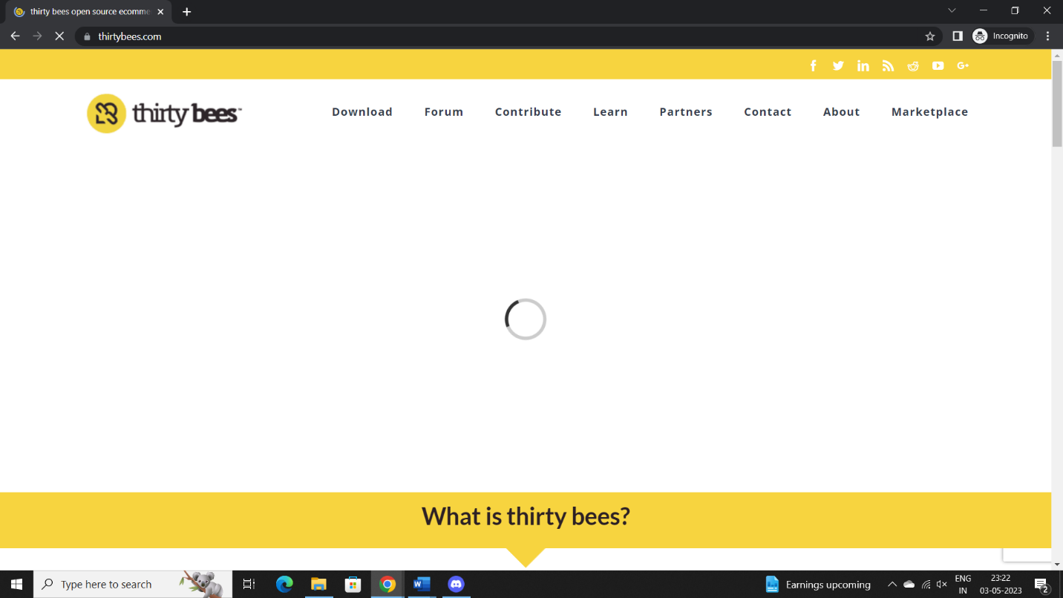

DEFECT ID | DE005
TEST CASE ID | TF 034
FEATURE | User Sign Up functionality
DESCRIPTION | 1.Click on the link “Marketplace” in Thirty bee’s homepage. The “Marketplace is present in top right corner of the main menu bar.  - Click on the “Sign in” button present on topmost menu bar of the “Market Place beta” webpage.  - Enter an invalid email ID “1234567@takemehomeWV.c” in the empty space, present right below “Create an account” dialog box.  - Select as “Mrs.” in title present right below the heading Your personal information.  - Enter a valid First name “Alice” in the empty space present right below First name.  - Enter a valid Last name “Homer” in the empty space present right below Last name.  - Enter the same Email address used in the step 3 in the empty space present right below email.  - Enter a valid Password “123456” in the empty space provided right below the Password.  - Provide date of birth by selectin“12” as the date from the 1st drop down menu. “April” as the month from the 2nd drop down menu.“1990” as the year from the 3rd drop down menu.  - Select the box “Sign up for our newsletter!”  - Click on “Register” button.
DEFECT TYPE | Functional defect
EXPECTED RESULT | The users account shouldn’t be created, and an error message should be displayed saying “invalid Email address”
ACTUAL RESULT | Account is created with invalid email address
SCREENSHOT | 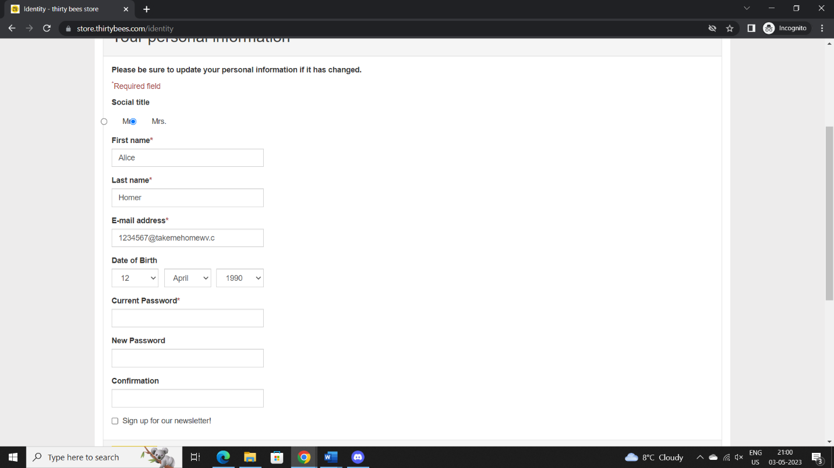

DEFECT ID | DE006
TEST CASE ID | TF 037
FEATURE | User Sign Up functionality
DESCRIPTION | - Click on the link “Marketplace” in Thirty bee’s homepage. The “Marketplace is present in top right corner of the main menu bar.  - Click on the “Sign in” button present on topmost menu bar of the “Market Place beta” webpage.  - Enter a valid email ID “12345678@gmail.com” in the empty space, present right below “Create an account” dialog box.  - Select as “Mrs.” in title present right below the heading Your personal information.  - Enter an invalid First name “10000” in the empty space present right below First name.  - Enter a valid Last name “Homer” in the empty space present right below Last name.  - Enter a different Email address “1268@gmail.com” other than the one used in the step 3 in the empty space present right below email.  - Enter a valid Password “1234567” in the empty space provided right below the Password.  - Provide date of birth by selecting  - “12” as the date from the 1st drop down menu.  - “April” as the month from the 2nd drop down menu.  - “1990” as the year from the 3rd drop down menu.  - Select the box “Sign up for our newsletter!”  - Click on “Register” button.
DEFECT TYPE | Functional defect
EXPECTED RESULT | The users account shouldn’t be created, and an error message should be displayed saying “Email entered doesn’t match”
ACTUAL RESULT | Account getting created with invalid firstname

DEFECT ID | DE007
TEST CASE ID | TF 040
FEATURE | User Sign in functionality
DESCRIPTION | - Click on the link “Marketplace” in Thirty bee’s homepage. The “Marketplace is present in top right corner of the main menu bar.  - Click on the “Sign in” button present on topmost menu bar of the “Market Place beta” webpage.  - Enter an invalid email ID “1234567@takemehomeWV.c” in the empty space provided right below Email address heading present in the “Already Registered” dialog box.  - Enter a valid Password “123456” in the empty space provided right below Password heading present in the “Already Registered” dialog box.  - Click the button Sign in.
DEFECT TYPE | Functional defect
EXPECTED RESULT | The user shouldn’t be Signed into their account and an error message should be displayed saying “Authentication failed” as the Syntax of the email ID is not right
ACTUAL RESULT | User is able to sign in

DEFECT ID | DE008
TEST CASE ID | TU 001
FEATURE | Front office demo “blog” page
DESCRIPTION | - Scroll down the page  - Click on recent post “ ORGANIC ROASTED”
DEFECT TYPE | Usability defect
EXPECTED RESULT | Product details and options should be aligned properly
ACTUAL RESULT | Product details are overlapped
SCREENSHOT | 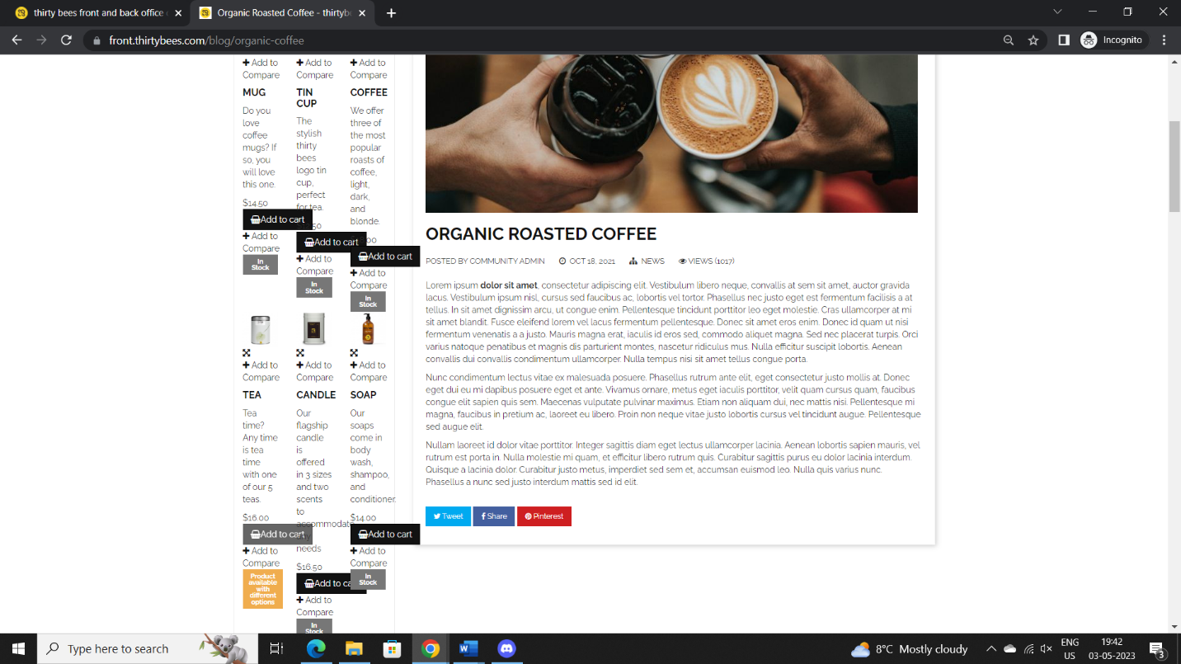

DEFECT ID | DE009
TEST CASE ID | TU 002
FEATURE | My account personal information page
DESCRIPTION | - Click on user account “Alice Homer”  - Click on my personal information
DEFECT TYPE | Usability defect
EXPECTED RESULT | Social title radio buttons should be properly aligned
ACTUAL RESULT | Radio buttons are not aligned
SCREENSHOT | 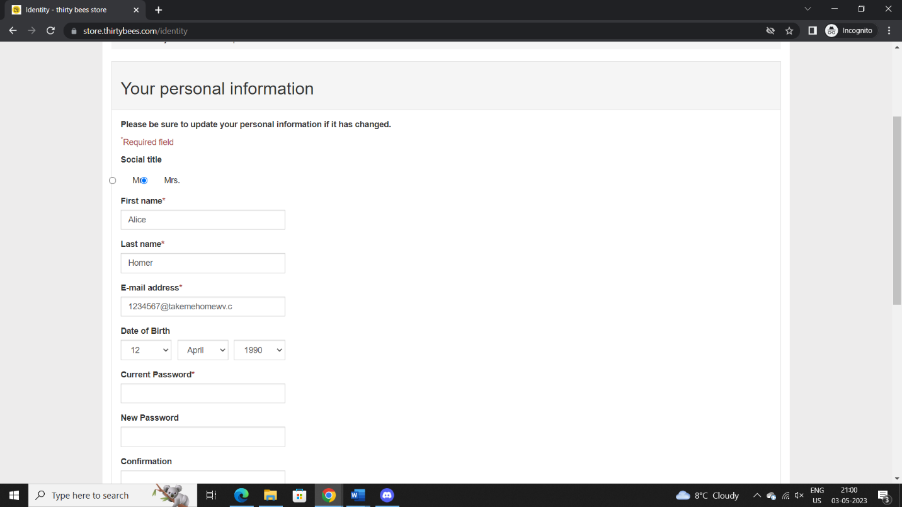

DEFECT ID | DE010
TEST CASE ID | TU 003
FEATURE | Shopping cart summary page Subtitles format
DESCRIPTION | - Click on the link “Marketplace” in Thirty bee’s homepage. The “Marketplace is present in top right corner of the main menu bar.  - Select a product and add to cart  - Click on proceed to checkout
DEFECT TYPE | Usability defect
EXPECTED RESULT | Subtitles format should be correctly displayed  Like “1. Account”  “2.Please choose your payment method”
ACTUAL RESULT | Subtitles are displayed like”1 Account”
SCREENSHOT | 