PROGRAM NO.17
#write a program for tic tac toe
a=['1','2','3','4','5','6','7','8','9']
def printBoard():
print('\n--------')
print('|',a[0],'|',a[1],'|',a[2],'|')
print('-----------')
print('|',a[3],'|',a[4],'|',a[5],'|')
print('-----------')
print('|',a[6],'|',a[7],'|',a[8],'|')
print('---------\n')
p1=True
while(True):
printBoard()
if p1:
p=input("player1,choose your place:")
if p in a:
a[int(p)-1]='x'
p1=not p1
else:
p=input("player2,choose your place:")
if p in a:
a[int(p)-1]='o'
p1=not p1
#checking for rows
for i in (0,3,6):
if(a[i]==a[i+1] and a[i]==a[i+2]):
print("game over!!!")
printBoard()
exit()
#checking for columns
for i in (0,1,2):
if(a[i]==a[i+3] and a[i]==a[i+6]):
print("game over!!!")
if (a[i]=='x'):
print("player1 won the game!!")
else:
print("player2won the game!!")
printBoard()
exit()
#checking for diagonal(l to r)
if(a[0]==a[4] and a[0]==a[8]):
print("game over!!!")
if (a[4]=='x'):
print("player1 won the game!!")
else:
print("player2won the game!!")
printBoard()
exit()
#checking for diagonal(r to i)
if(a[2]==a[4] and a[2]==a[6]):
print("game over!!!")
if (a[4]=='x'):
print("player1 won the game!!")
else:
print("player2won the game!!")
printBoard()
exit()
OUTPUT:python3 ttt.py
--------
| 1 | 2 | 3 |
-----------
| 4 | 5 | 6 |
-----------
| 7 | 8 | 9 |
---------
player1,choose your place:1
--------
| x | 2 | 3 |
-----------
| 4 | 5 | 6 |
-----------
| 7 | 8 | 9 |
---------
player2,choose your place:4
--------
| x | 2 | 3 |
-----------
| o | 5 | 6 |
-----------
| 7 | 8 | 9 |
---------
player1,choose your place:2
--------
| x | x | 3 |
-----------
| o | 5 | 6 |
-----------
| 7 | 8 | 9 |
---------
player2,choose your place:5
--------
| x | x | 3 |
-----------
| o | o | 6 |
-----------
| 7 | 8 | 9 |
---------
player1,choose your place:3
game over!!!
--------
| x | x | x |
-----------
| o | o | 6 |
-----------
| 7 | 8 | 9 |

PROGRAM NO.18
import matplotlib.pyplot as plt
x=[2,4,6,8]
y=[3,6,9,1]
plt.plot(x,y)
plt.xlabel("x axis")
plt.ylab("y axis")
plt.tittle("my first graph")
plt.show()
OUTPUT:

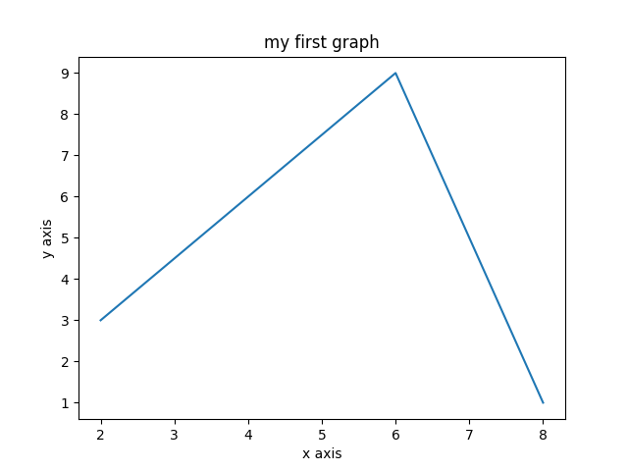

PROGRAM NO.19
import matplotlib.pyplot as plt
left=[1,2,3,4,5,6]
height=[5,10,25,30,35,40]
tick_label=['2001','2002','2003','2004','2005','2006']
plt.bar(left,height,tick_label=tick_label,width=0.5, color=['pink','black'])
plt.xlabel("x axis")
plt.ylabel("y axis")
plt.title("my bar chart")
plt.show()
OUTPUT:
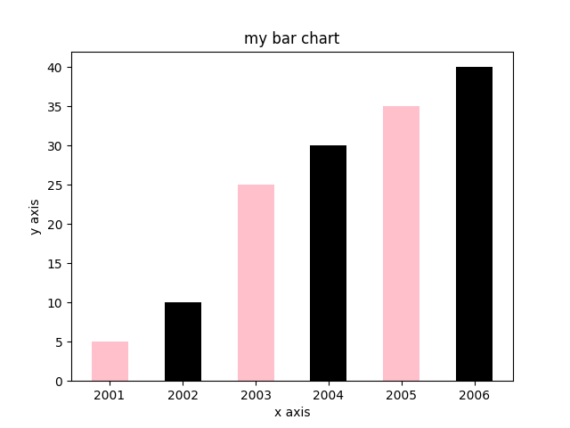

PROGRAM NO.20
import matplotlib.pyplot as plt

x = [1,2,3,4,5,6,7,8]
y = [5,2,4,2,1,4,5,2]

plt.scatter(x,y, label='skitscat', color='k', s=25, marker="o")

plt.xlabel('x')
plt.ylabel('y')
plt.title('Interesting Graph\nCheck it out')
plt.legend()
plt.show()
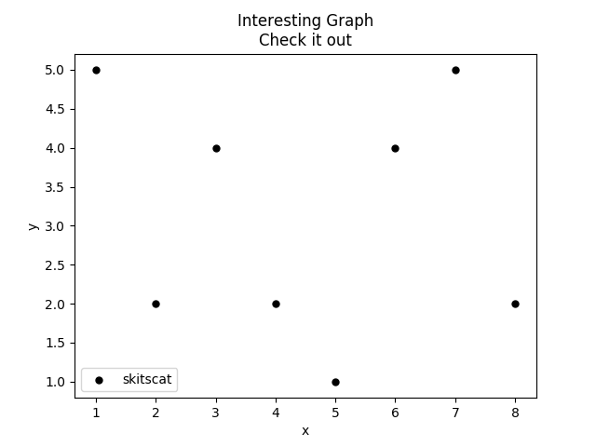
OUTPUT:

PROGRAM NO: 21
import matplotlib.pyplot as plt
import numpy as np

x, y ,z= np.loadtxt('new.csv', delimiter=',', unpack=True)
plt.plot(x,y,z)

plt.show()
OUTPUT:
