

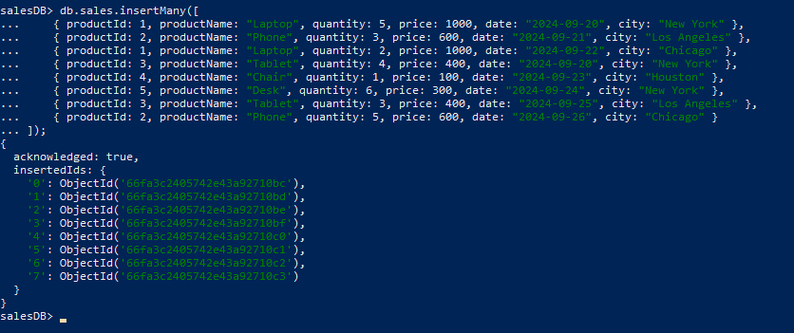
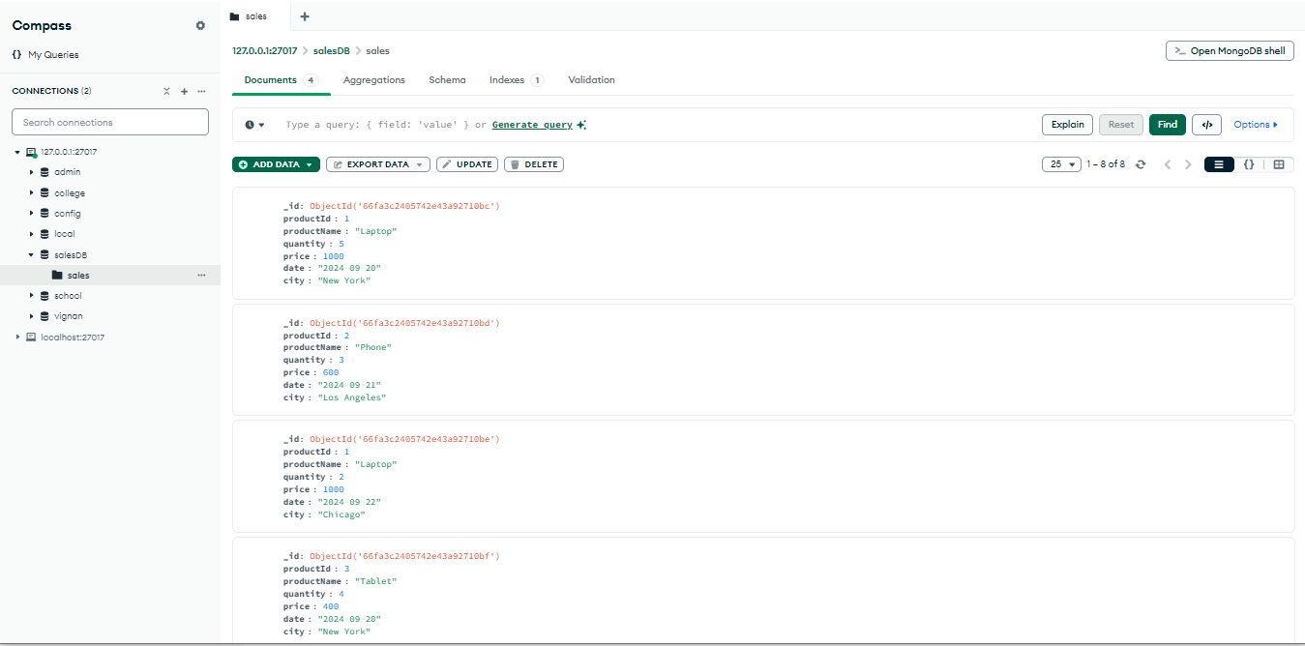
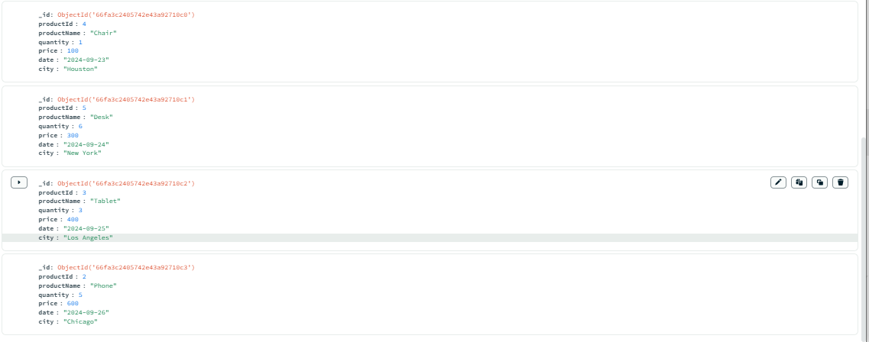
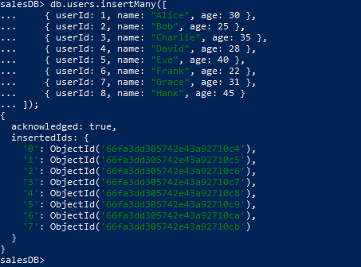
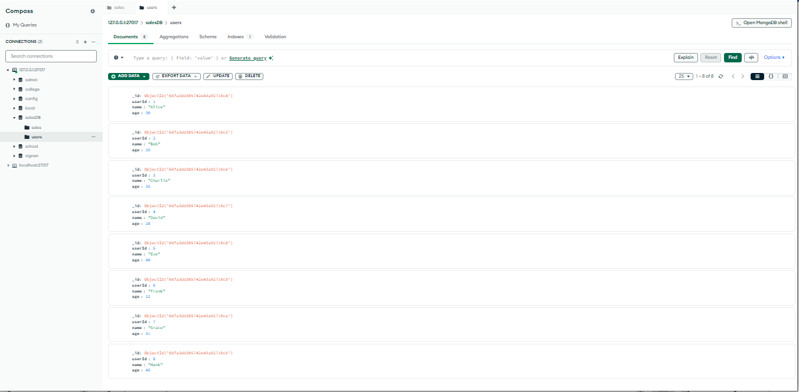
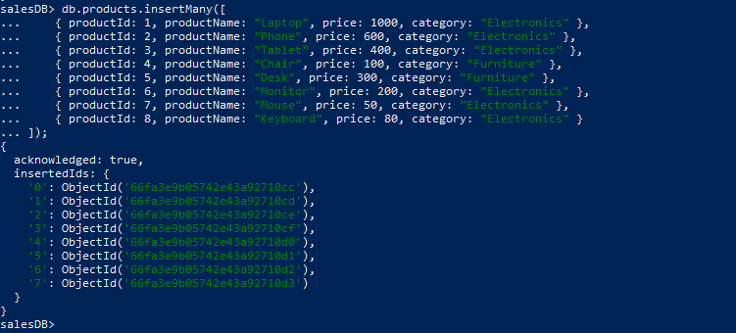

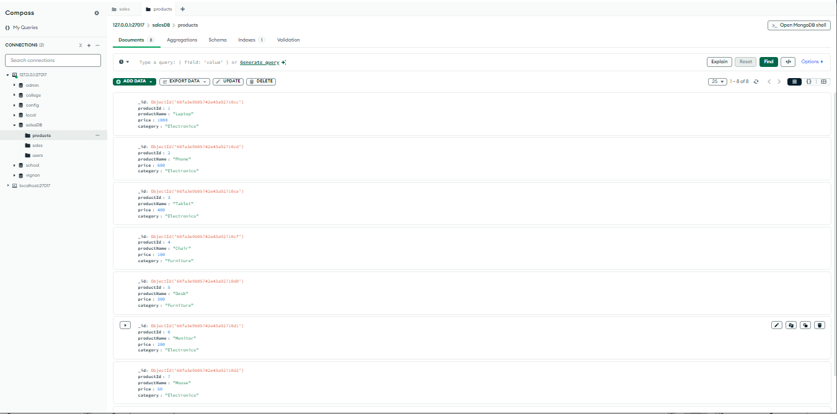
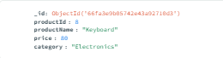
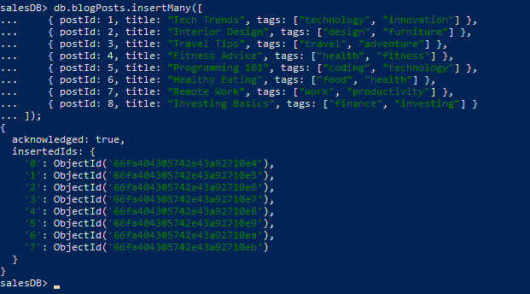
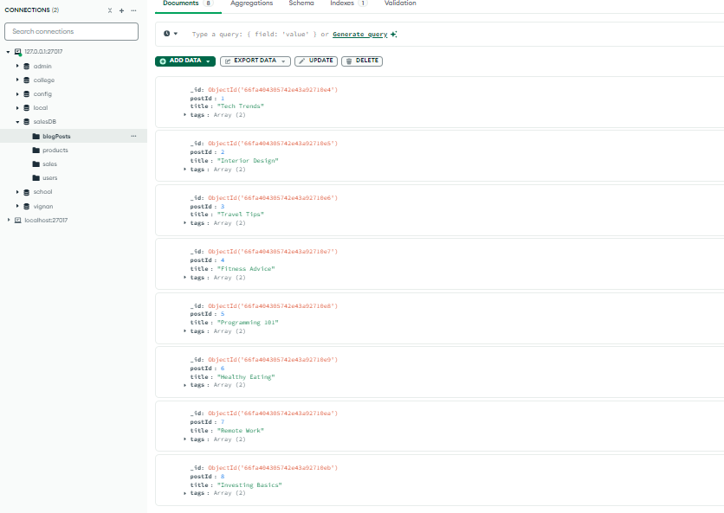
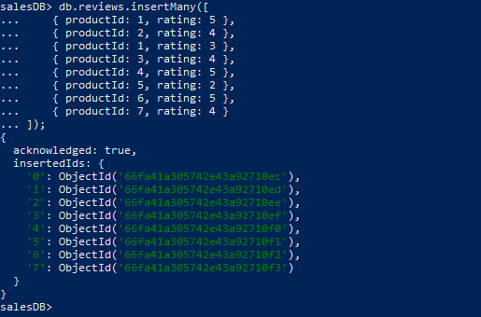
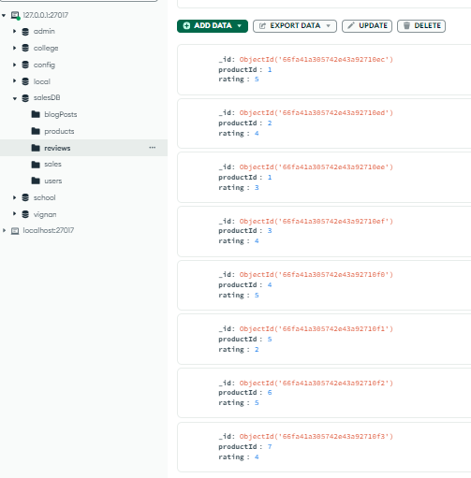
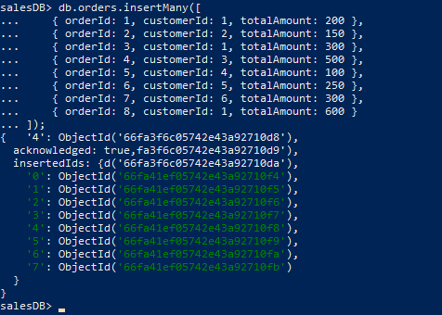
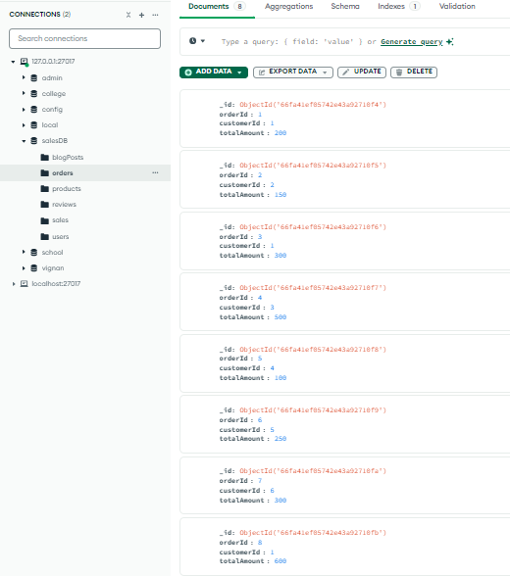
Question 1: Write an aggregation query to find the total sales amount for each product in the sales collection.
Answer:
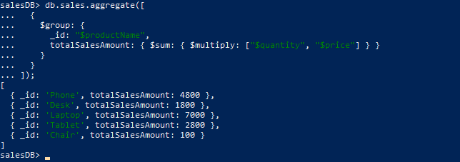

Question 2: Write an aggregation query to calculate the average age of users in the users collection.
Answer:
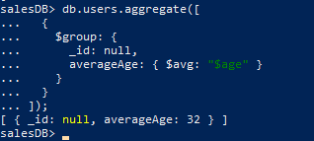
Question 3: Write an aggregation query to find the maximum and minimum price of products in the products collection.
Answer:
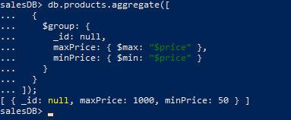
Question 4: Write an aggregation query to count the number of products in each
category in the products collection.
Answer:
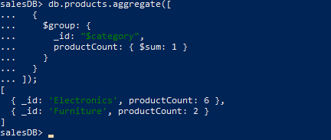
Question 5: Write an aggregation query to list all unique tags used in the blogPosts collection.
Answer:
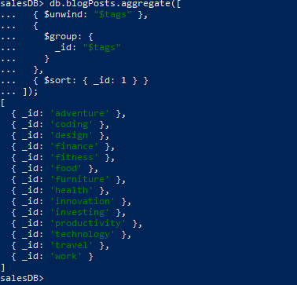
Question 6: Write an aggregation query to find the total quantity sold per day from the sales collection.
Answer:
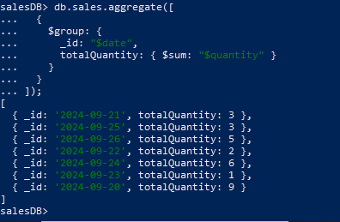
Question 7: Write an aggregation query to calculate the total revenue generated from each city in the sales collection.
Answer:
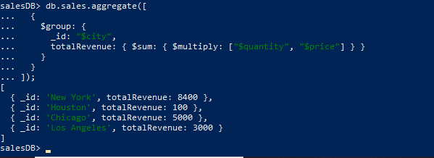
Question 8: Write an aggregation query to find the total number of orders placed by each customer in the orders collection.
Answer:
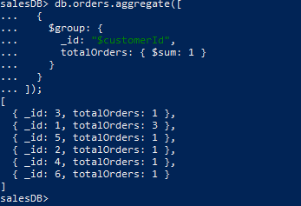
Question 9: Write an aggregation query to find the average rating for each product in the reviews collection.
Answer:
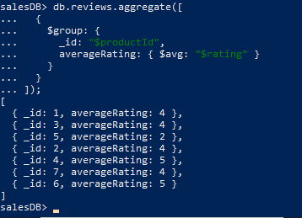
Question 10: Write an aggregation query to find the most popular category based on the total number of products sold in the sales collection.
Answer:
