AZURE PROJECT

WEB & APP DEPLOYMENT WITH LOAD BALANCERS

Submitted by:

Rachamalla Bindu

Objective :
- Create Azure resources (RG, VNet, subnets)
- Deploy two Linux VMs named web and app
- Configure NSGs to allow ports 22, 80 (both VMs) and 8080 (app VM)
- Install Nginx on web, Tomcat on app
- Deploy Public Load Balancer for Web (HTTP) and Private Load Balancer for App (8080)
- Verify end-to-end connectivity
Abstract :
- Deploy an Azure Resource Group containing a VNet with two subnets, two VMs (Web and App), Security Rules allowing SSH(22), HTTP(80), and App(8080).
- Install Nginx on Web VM and Tomcat on App VM.
- Create a public load balancer for the Web tier (port 80) and an internal/private load balancer for the App tier (port 8080).
- Verify connectivity by accessing public LB IP and confirming Nginx can reach the App through the private LB.

- 1. Create a Resource group :
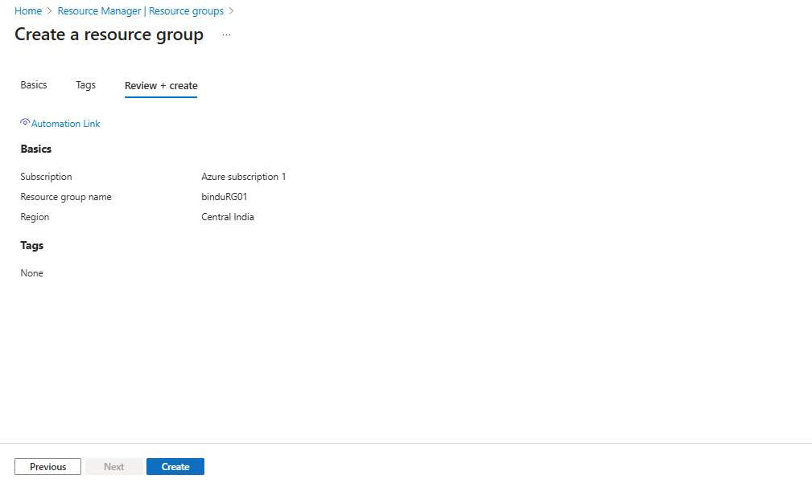

- 2. Create a Virtual Network with Two Subnets :
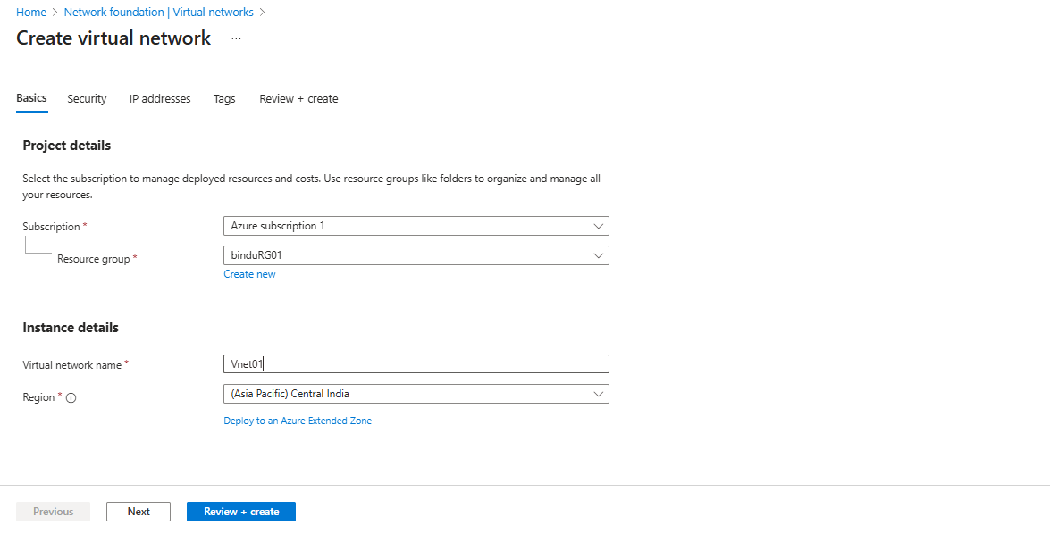
- Subnet 1 : WEBsubnet
- Subnet2 : Appsubnet

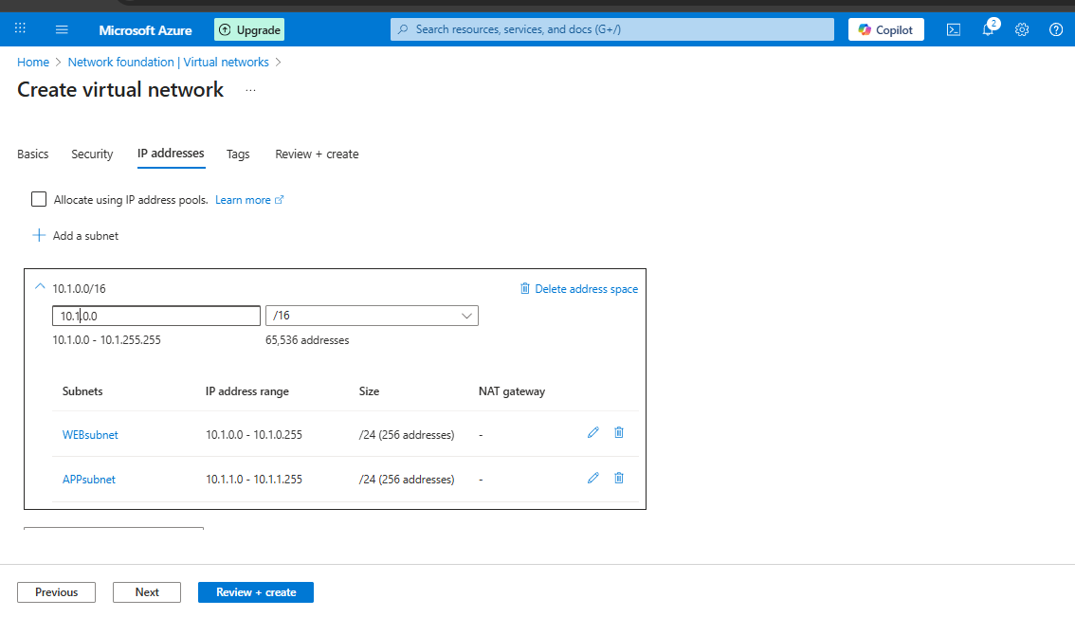

- 3.Create WEB Virtual Machine :
- OS: Linux (Ubuntu)
- Subnet: Web Subnet
- Public IP: Yes (for SSH access)
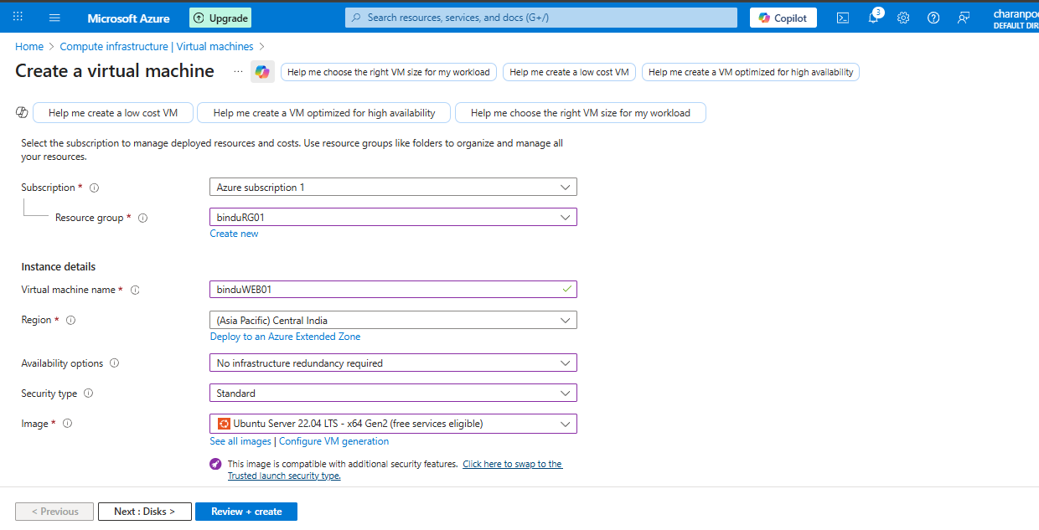
- Allow public inbound rules HTTP (80), SSH (22)
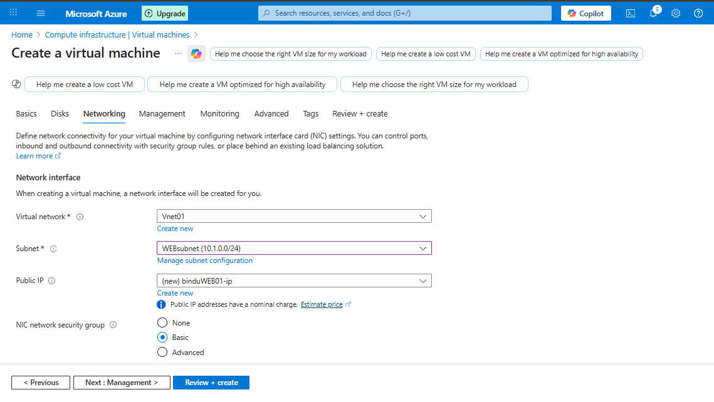
- Here the WEBvm is created in virtual network in web subnet.
- 4. Install NGINX on Web VM :
- By using below commands install nginx in mobaxtrem
- Sudo su (to switch to root user)
- sudo apt update
- sudo apt install nginx –y
- sudo systemctl start nginx
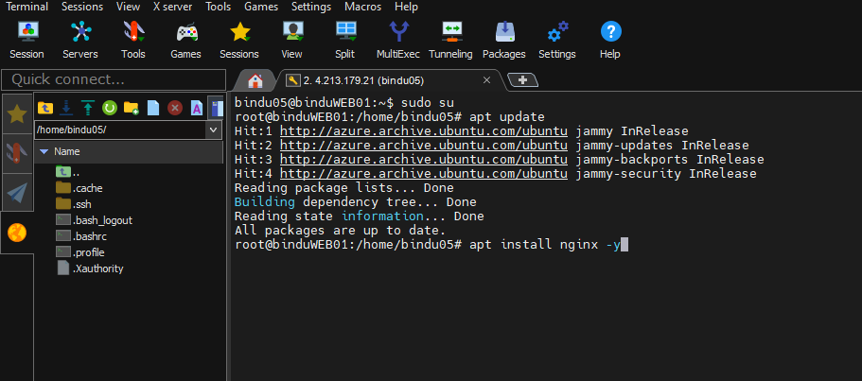

- The successful installation of NGINX was verified by checking the service status using the systemctl command, which showed the service as active and running in the above image.
- 5. Verify NGINX :
- Browse Web VM public IP
- NGINX default page should be displayed
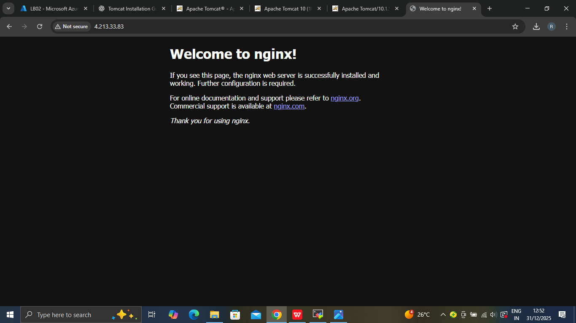
- 6. Create Application Virtual Machine (App VM) :

- OS: Linux (Ubuntu)
- Subnet: App Subnet
- Public IP: Optional (recommended only for admin access)
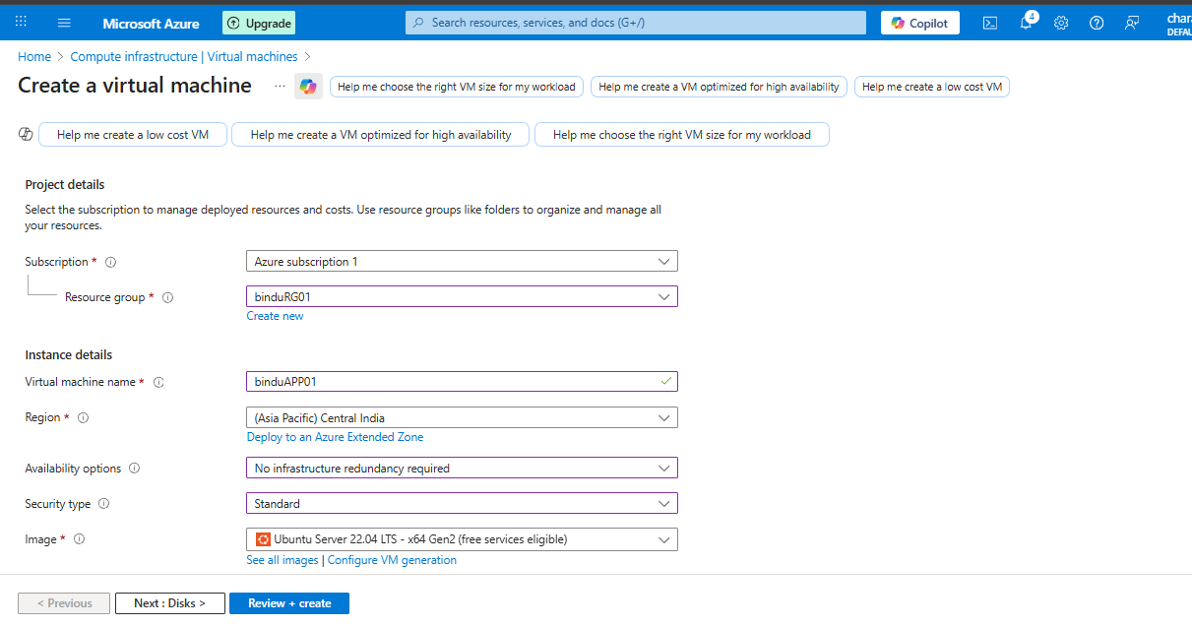
- Allow inbound rules SSH (22)
- 7. Install Tomcat on App VM :

By using below commands install Tomcat in mobaxterm :
- Sudo su (to switch to root user)
- sudo apt update
- sudo apt install openjdk-11-jdk –y
- wget https://dlcdn.apache.org/tomcat/tomcat-10/v10.1.50/bin/apache-tomcat-10.1.50.tar.gz
- tar -xvzf apache-tomcat-10.1.50.tar.gz
- mv apache-tomcat-10.1.50 tomcat
- ls
- cd /opt/tomcat/bin
- ./startup.sh
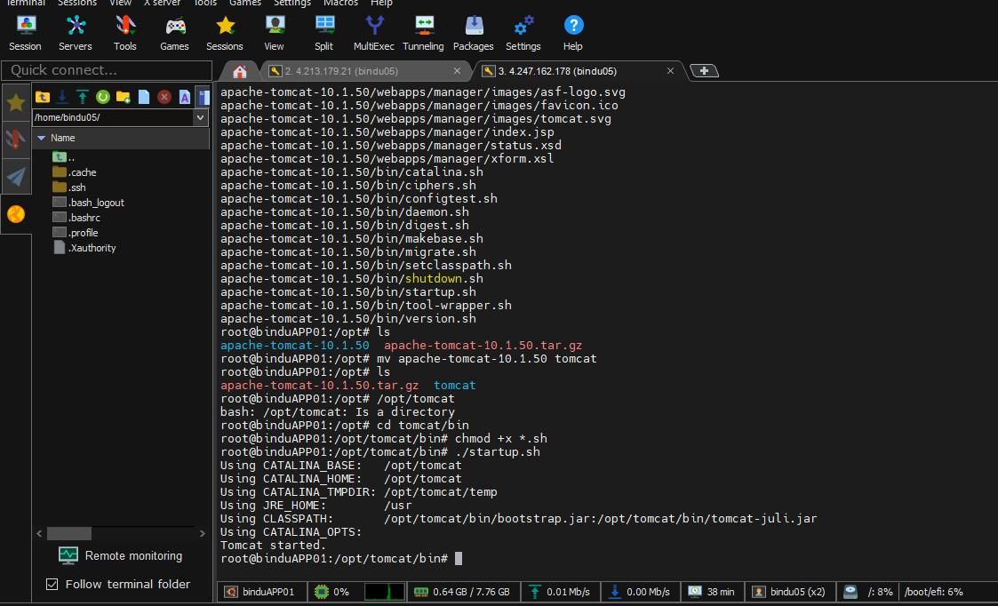
- Apache Tomcat was successfully installed and started, and the default Tomcat welcome page was verified by accessing it via the VM public IP on port 8080.
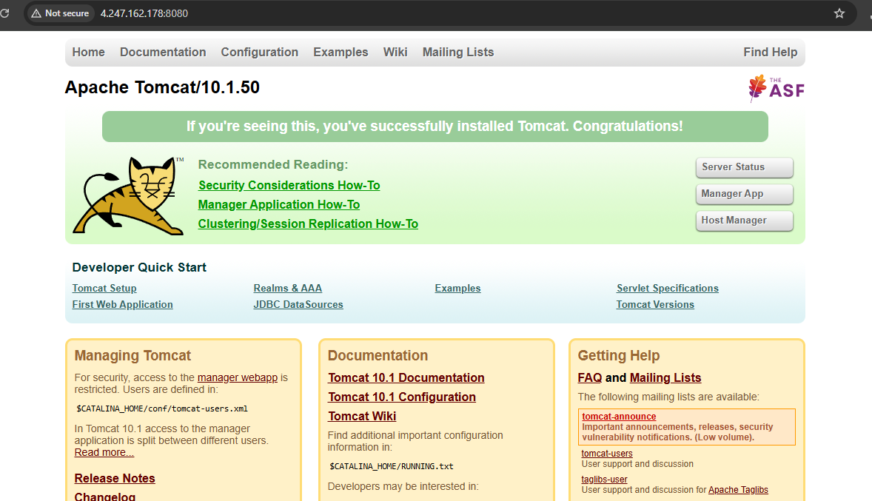
- 8. Create Azure Public Load Balancer :
- Select standard load balancer and Create .
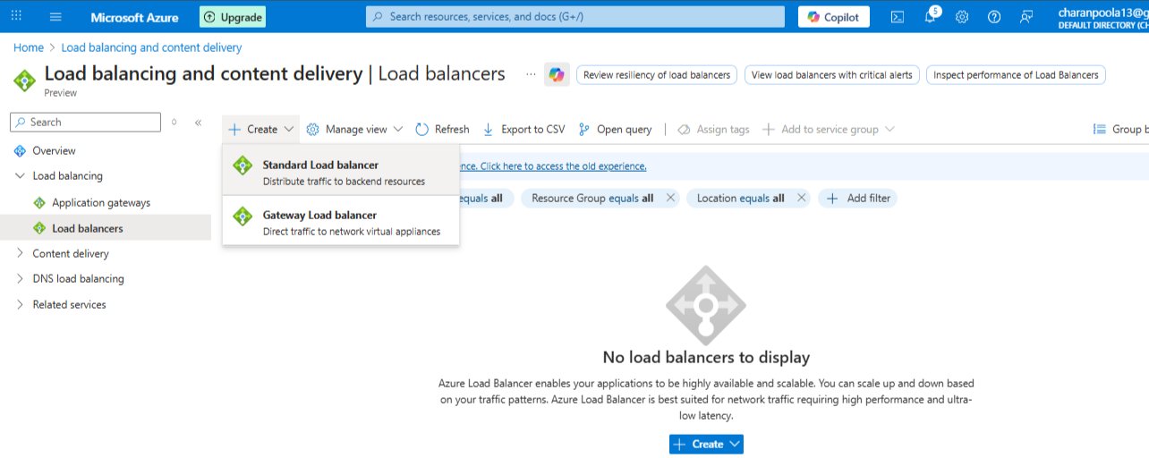
- Now in type select Public because it is public load balancer.

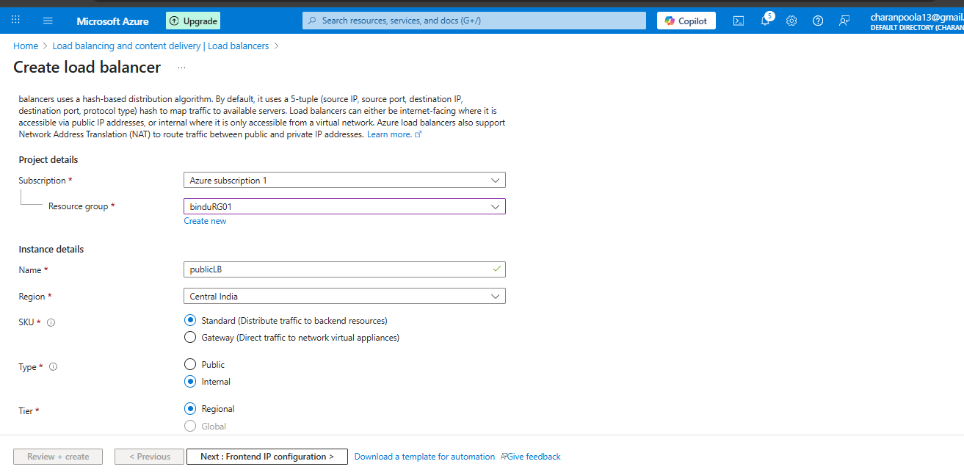

- Frontend IP Configuration .
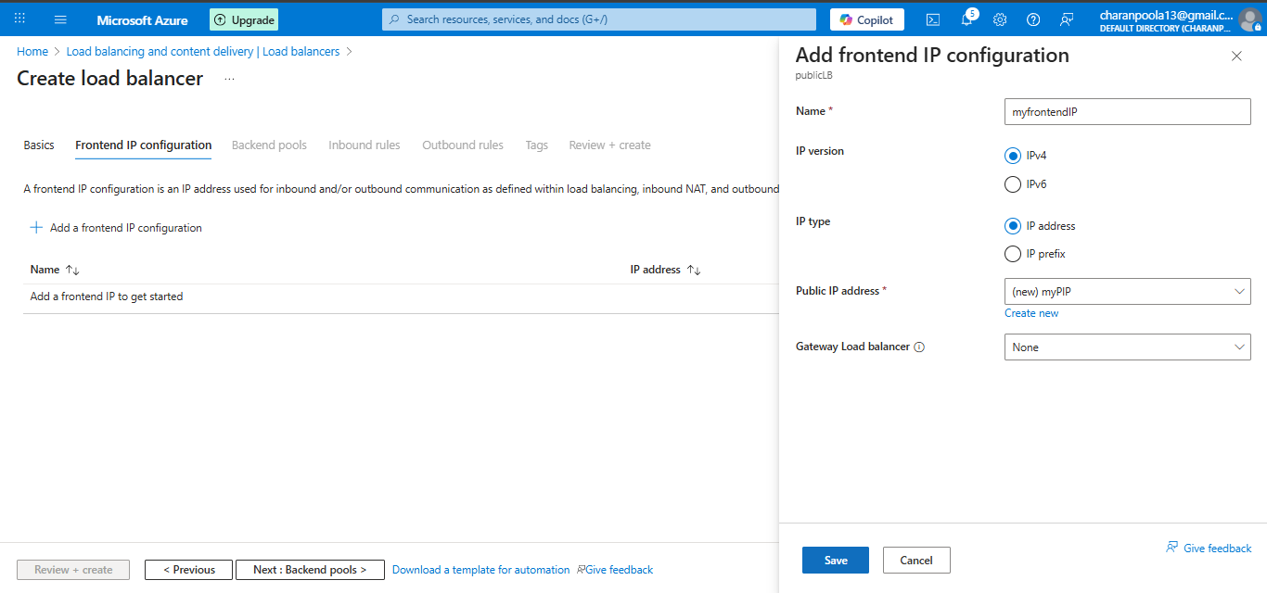

- Backend Pool: Add Web VM .

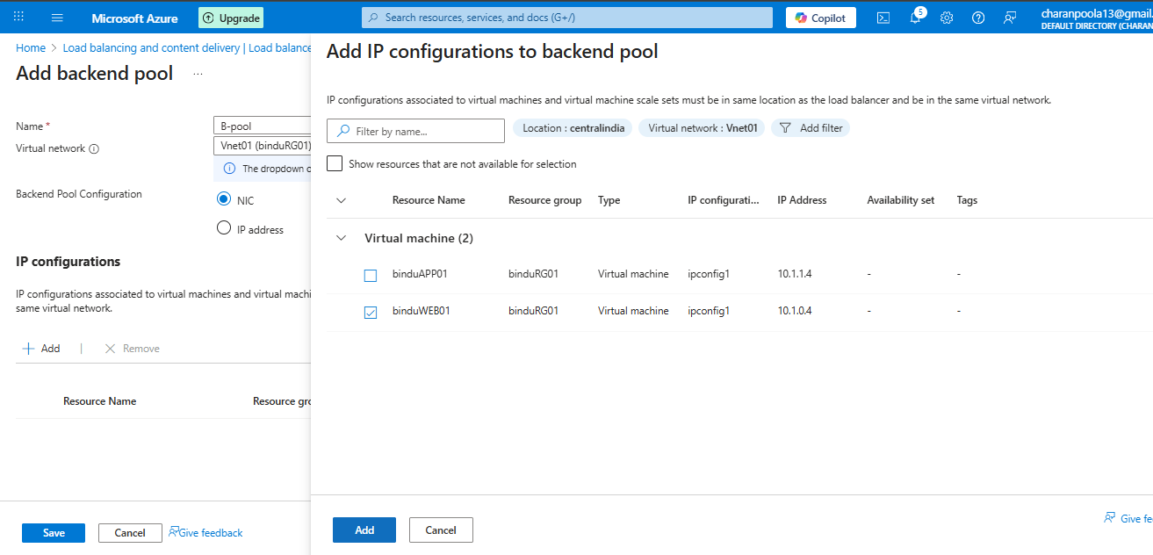

- Health Probe :
  - Protocol: TCP
  - Port: 80
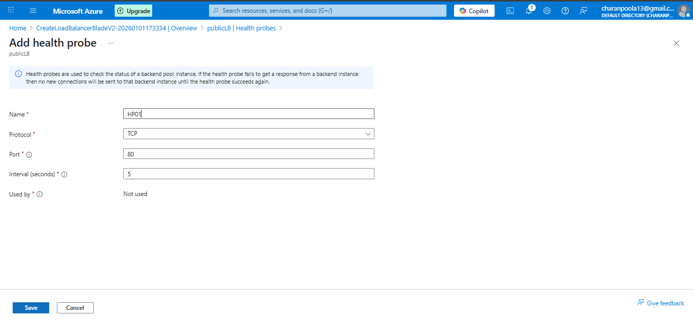
- Load Balancing Rule:
- Frontend Port: 80
- Backend Port: 80
- Backend Pool: Web VM
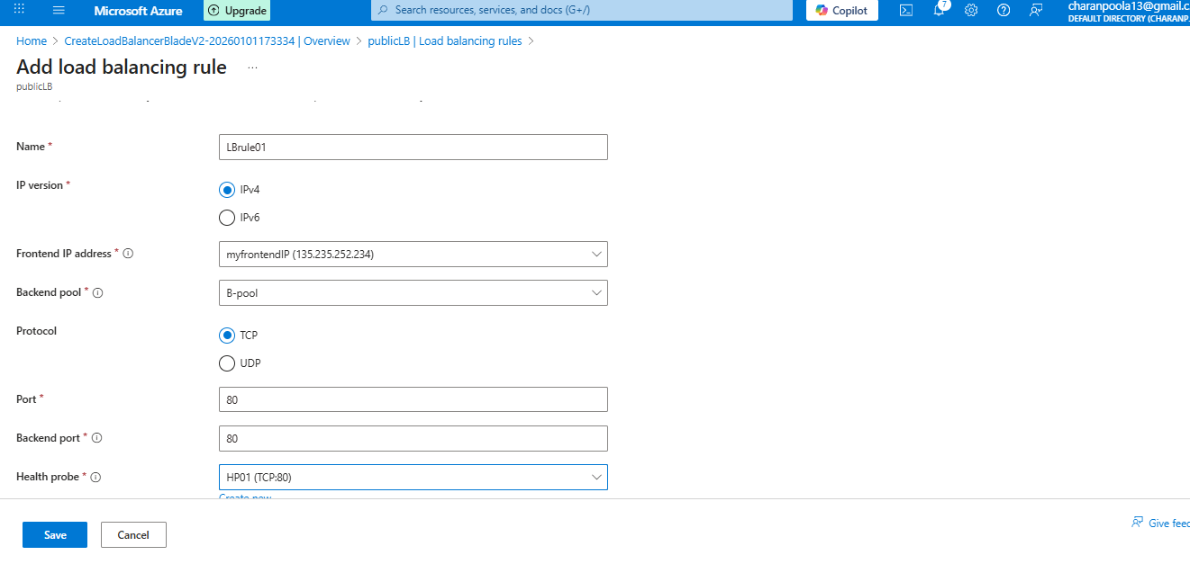
- 9. Create Azure Private Load Balancer :
- Create Private Load Balancer
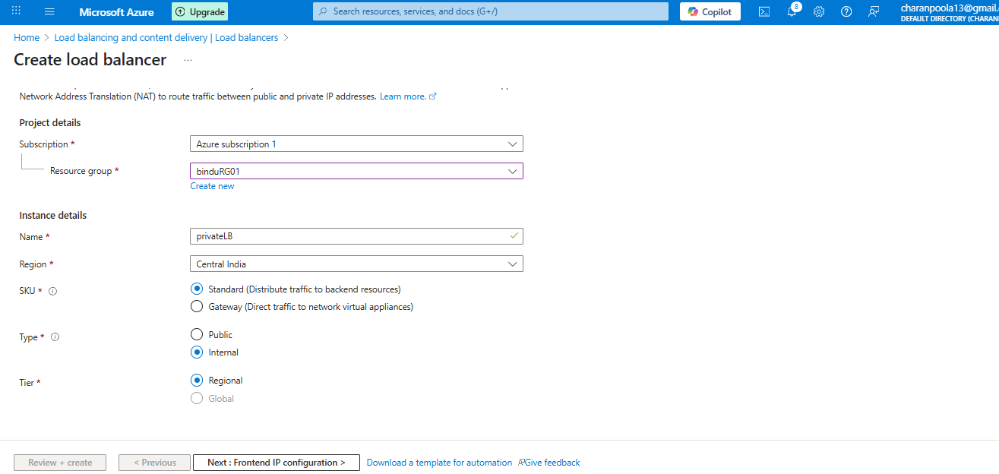
Here in type select internal because it is private load balancer .
- Frontend IP Configuration:
- Private IP from AppSubnet
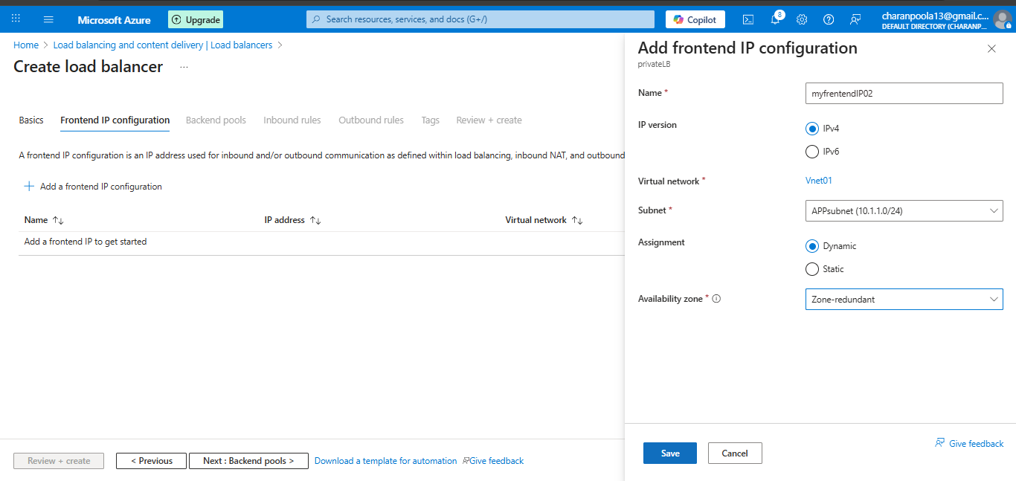
- Backend Pool : Add App VM
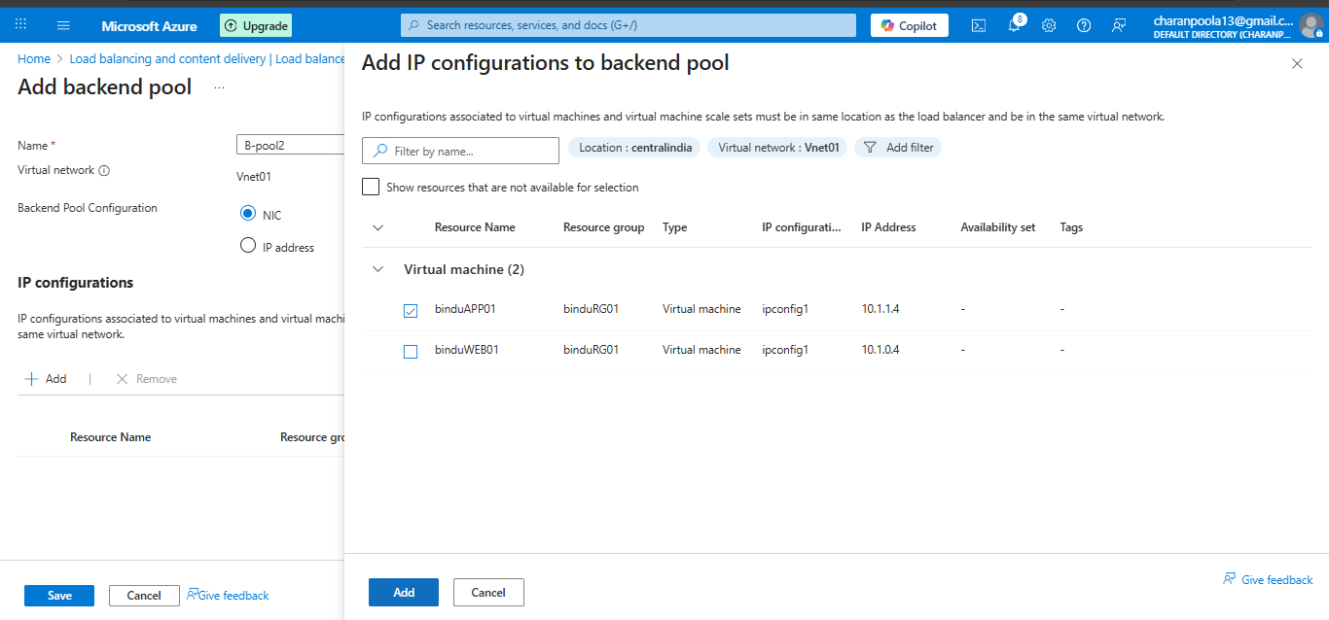
- Health Probe:
- Protocol: TCP
- Port: 8080
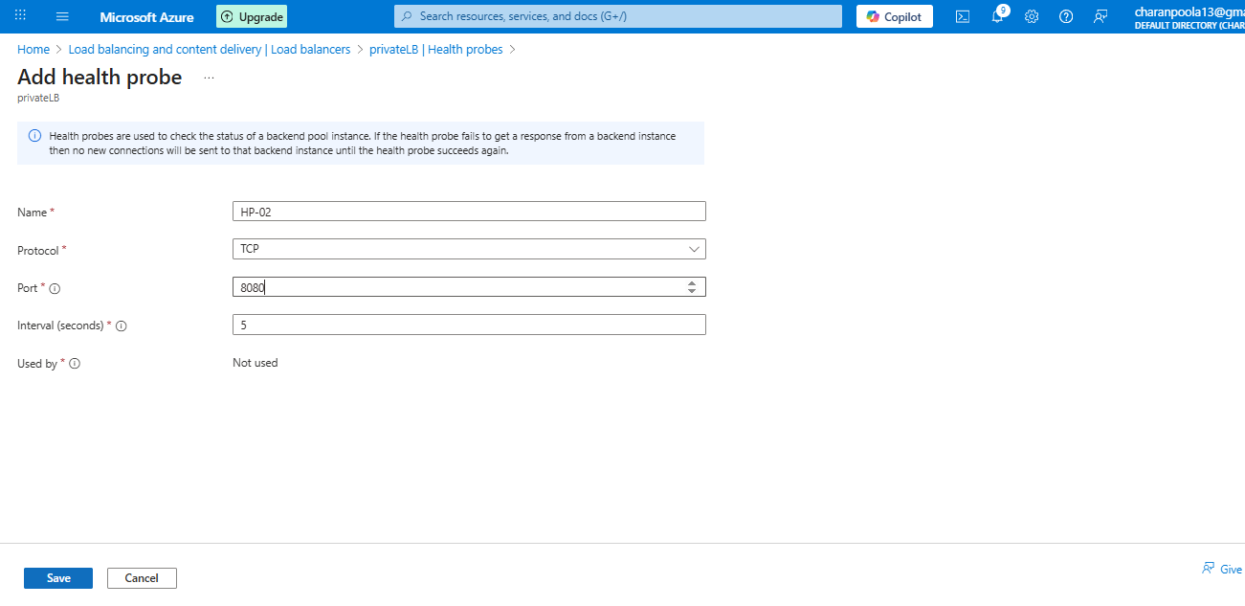
- Load Balancing Rule:
- Frontend Port: 8080
- Backend Port: 8080
- Backend Pool: App VM
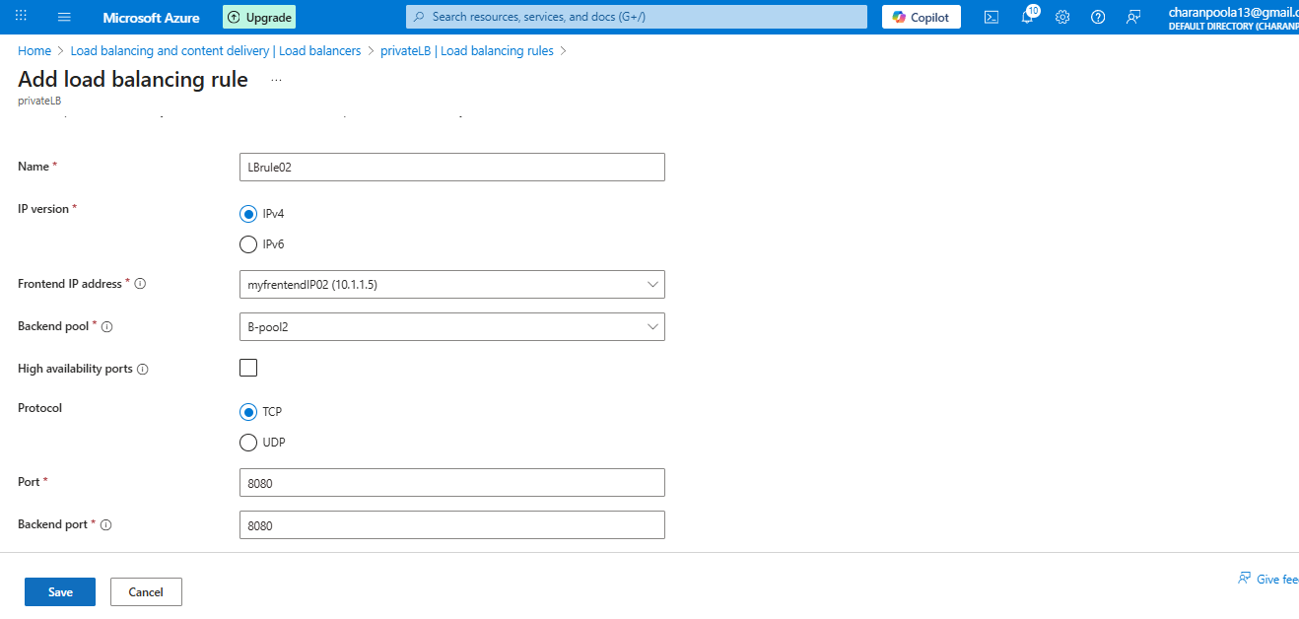
- 10. Connectivity Testing (Main Validation Step) :
- Test connection from Web VM to Private Load Balancer
- Connect to Web VM using SSH
- With WEB virtual machine public Ip and username.
- Run telnet command.

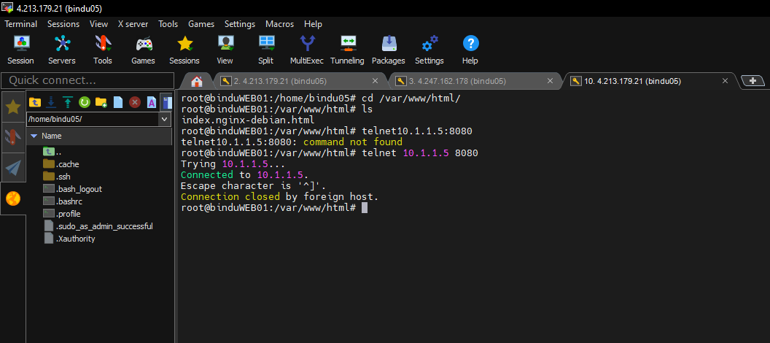
This confirms:
- Traffic flows from the public load balancer to the web VM and that Nginx can reach Tomcat via the private load balancer.

- Security Validation :

- Tomcat is not exposed publicly.
- Only Private Load Balancer IP is accessible from Web VM.
- Application layer is protected inside the VNet.
- End users cannot directly access Tomcat from the internet.
- This prevents unauthorized external access to the application layer.
- External traffic cannot reach the Private Load Balancer.
- Only the Web VM (NGINX) is exposed through the Public Load Balancer.
- Backend Application services remain isolated from the internet .

- Conclusion:

- In this project, we successfully implemented Azure Public and Private Load Balancers to design a secure two-tier architecture. The Public Load Balancer exposes the Web layer (NGINX) to the internet, while the Private Load Balancer ensures secure internal communication with the Application layer (Tomcat).
- Connectivity was validated using telnet, confirming proper backend pool configuration and network security. This architecture follows real-time industry best practices for scalability, security, and high availability.

