**Functions**

**1.** Write a function that will loop through a list of integers and print the index of each element after a 3 second delay.

var arr = [1,2,3,4,5];

function doScaledTimeout(i){

        setTimeout(function(){alert(i);},3000);

// The setTimeout() method calls a function or evaluates an expression after a //specified number of milliseconds.

}

for(var i = 0; i < arr.length - 1; i++){

doScaledTimeout(i);

}

**2**. Write a JavaScript function that generates all combinations of a string.

function combString() {

//String length

var lenStr = str.length;

//Initially empty, used to store results

var result = [];

//current letter

var indexCurrent = 0;

//looping from 0 to length of the string

//var char is selecting the character at this //index Ex: “a”,”b”, then “c”

While(indexCurrent < lenStr){

//get the character at the index position

var char = str.charAt(indexCurrent);

var x;

var arrTemp = [char];

// for the previous result

for(x in result){

//Add the current character to the index

arrTemp.push(“”+result[x] + char);

/*

*Ex:”abc”

*First round : result is empty

*Second round: result contain “a”. adds “ab” to the result array

*then result array will contain “a”,”b”, and “ab”

*Third round: Adds “c” to the array

Ex: “ac”,”bc”,”abc”

Then adds c

*/

}

result = result.concat(arrTemp);

// increment the index to go to next character

indexCurrent++;

}

return result;

}

Console.log(combString(“abc”));

**3.** Write a JavaScript function to find the first not repeated character.­­

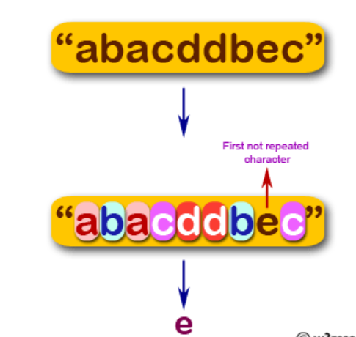

function repeater(string){

//no string is given

if(string.length==0)

return false;

var char = string.charAt(0);

// only one char is given

if(string.lastIndexOf(char)==0)

return char;

//more than one char

for(var i = 0; i < string.length; i++){

char = string.charAt(i);

if(string.lastIndexOf(char)==i && string.indexOf(char)==i)

return char;

}

char = string.charAt(string.length-1);

if(string.indexOf(char)==string.length-1)

return char;

return false;

}

**4.** Write a JavaScript function that accepts two arguments, a string and a letter and the function will count the number of occurrences of the specified letter within the string.

function char_count(str, letter)

{

var letter_Count = 0;

//iterate through the string

for(var position = 0; position < str.length; position++)

{

                //checks if the given letter matches

if(str.charAt(position) == letter)

                // if match is found count will be increased

{

letter_Count += 1;

}

}

return letter_Count;

}

console.log(char_count('newyorknew', 'n'));

**Output:** 2

**5.** Write a JavaScript function to get the function name

var function1 = function() {}

var object = {

function2: function() {}

}

console.log(function1.name);

// output: "function1"

console.log(object.function2.name);

// output: "function2"

**6.** Write a JavaScript program to pass a 'JavaScript function' as parameter.

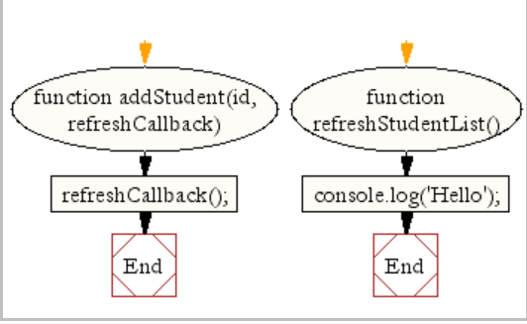

function addStudent(id, refreshCallback)

{

refreshCallback();

}

function refreshStudentList() {

console.log('Hello');

}

addStudent(1, refreshStudentList);

**Output:** Hello