BINDU SREEJA CHILAKALA

11550860

ICE-1

* USE THE DATASETS GIVEN IN THE CANVAS

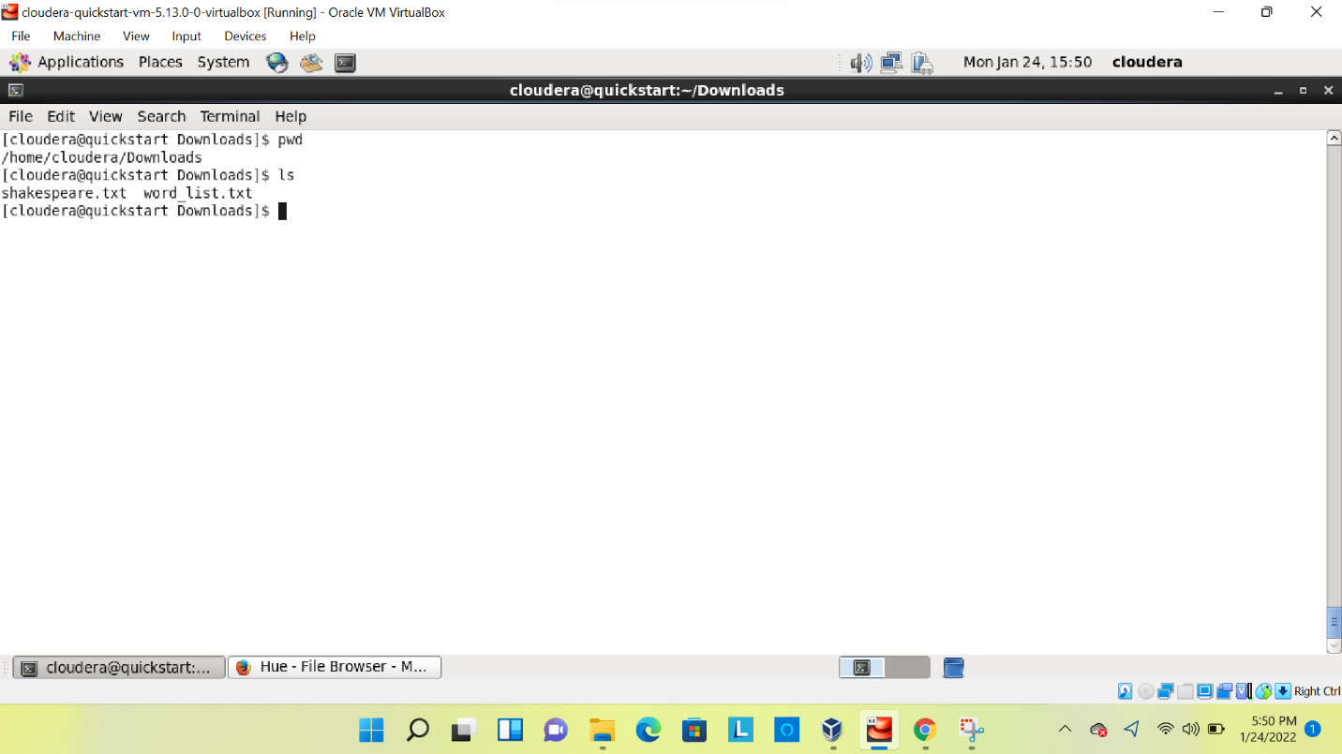

THE GIVEN DATASETS IN CANVAS IS DOWNLOADED INTO THE CLOUDERA

* LOAD IT INTO HDFS

TO LOAD THE DATASETS **-put** COMMAND IS USED

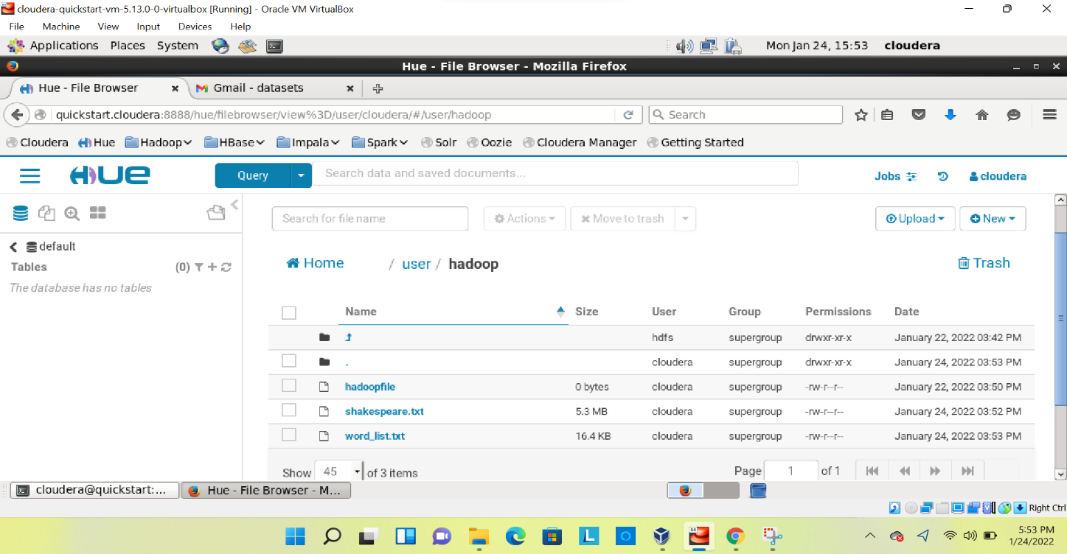

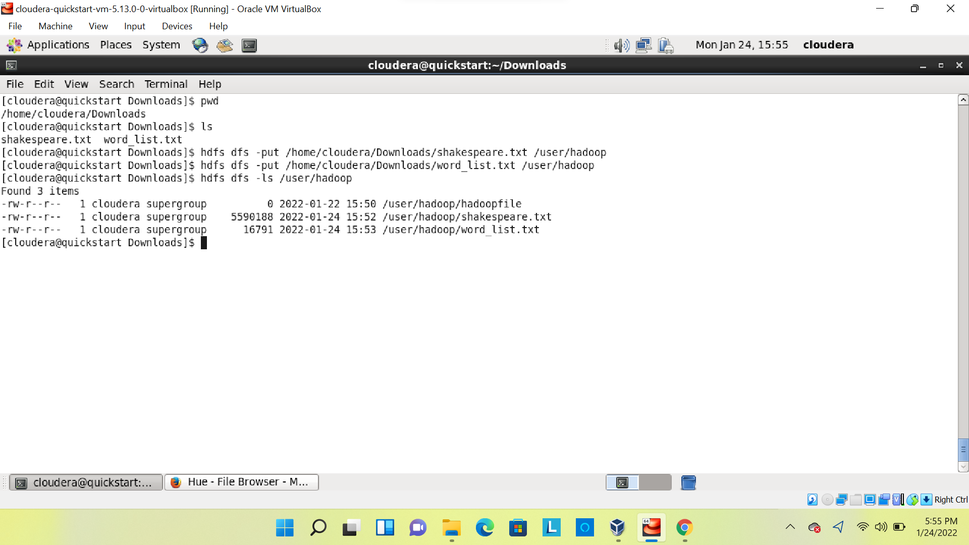

* USE THE SECOND FILE
* APPEND IT TO FIRST FILE
* VISUALIZE FILE WITH HUE

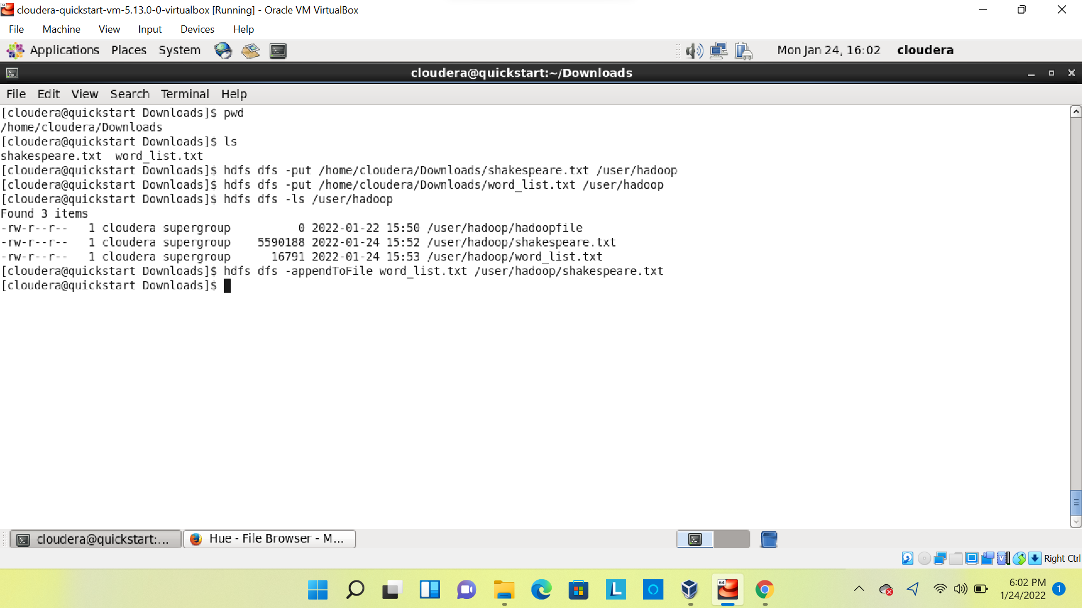

THE SECOND FILE IS APPENDED TO THE FIRST FILE BY USING **-appendToFile** WE CAN OBSERVE THIS IN BELOW IMAGE.

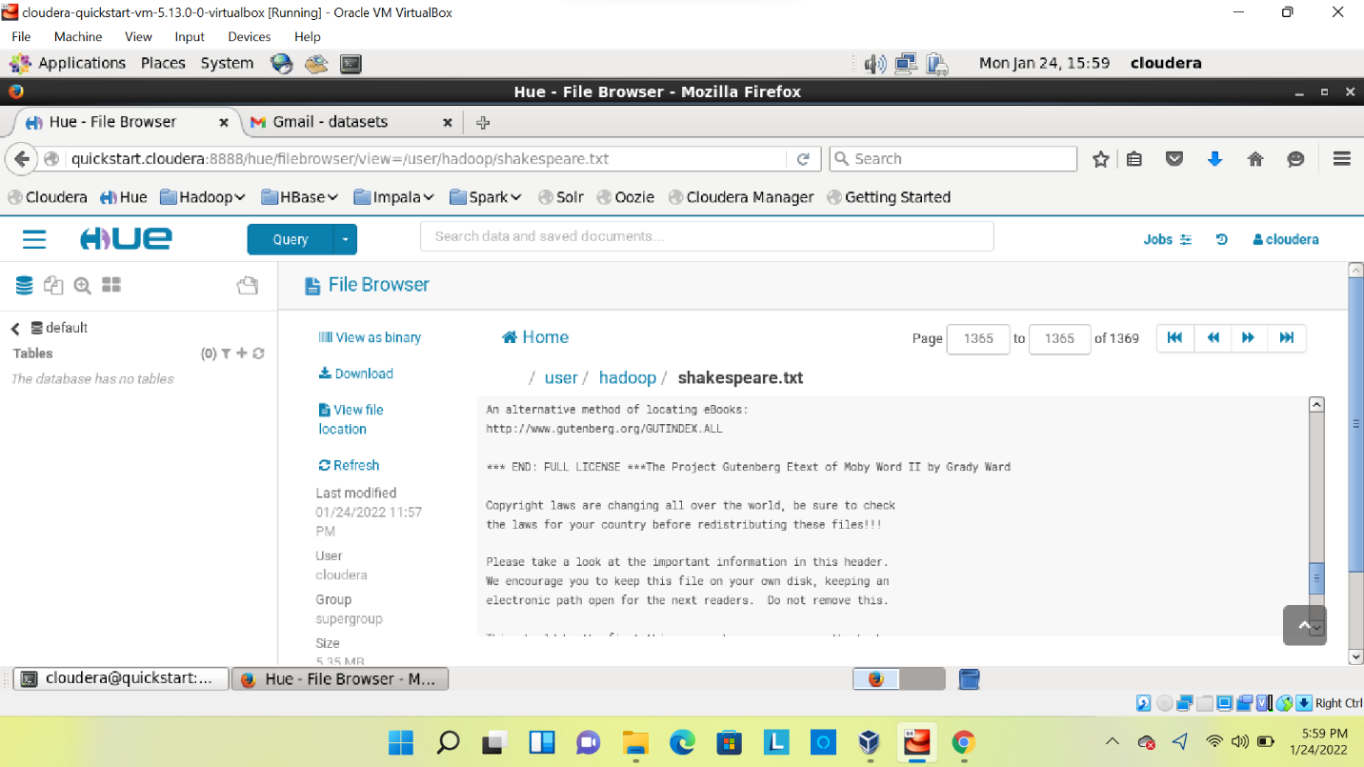

* VIEW THE FIRST AND LAST 5 LINES OF MERGED DATASET USING APPROPRIATE HDFS

COMMANDS

TO DISPLAY FIRST 5 LINES **head** COMMAND IS USED

TO DISPLAY LAST 5 LINES **tail** COMMAND IS USED

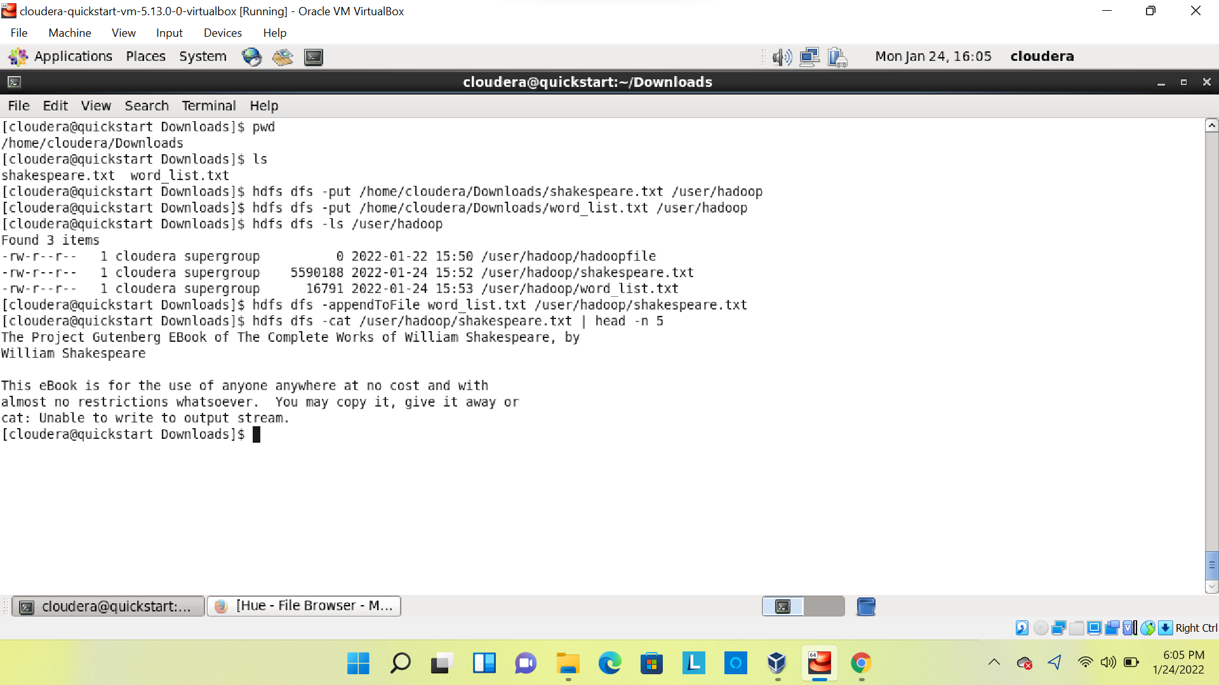

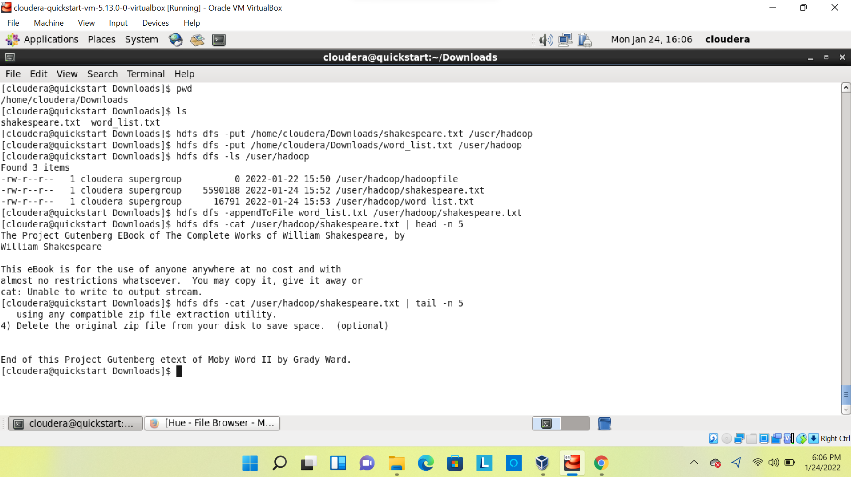

* CREATE A NEW TEXT FILE AND LOAD IT INTO HDFS AND TRY TO APPEND ALL THREE

DATASETS.

