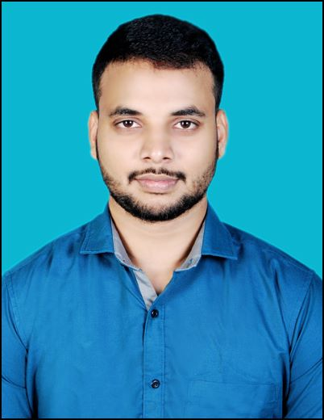BINESH MAHARANA

Mobile No.: +91- 8456982334

Email Id: bineshmaharana.official@gmail.com

Address: Jagannath Panda Buildings, Narayani Colony, Purusottampur, 761018, Ganjam, Odisha, India.

Languages: English, Hindi, Odia

Portfolio: <https://bineshm1610.github.io/portfolio/index.html>

LinkedIn: https://[www.linkedin.com/in/binesh-maharana-06815b253/](http://www.linkedin.com/in/binesh-maharana-06815b253/)

# CAREER OBJECTIVE

To secure an integral position in a reputable organization to expand my learnings, knowledge, and skills while making a significant contribution to the company's success.

# ACADEMIC QUALIFICATIONS

|  |  |  |  |  |
| --- | --- | --- | --- | --- |
| **S.N.** | **DEGREE / DIPLOMA** | **BOARD / UNIVERSITY / INSTITUTE** | **PERCENTAGE**  **/CGPA**  **DIVISION** | **YEAR OF PASSING.** |
| **1** | MCA(Master in Computer Application) | BPUT/ NIST Institute of Science & Technology (Autonomous) | 7.90 | 2024 |
| **2** | BCA(Bachelor of Computer Application) | Berhampur/ Science College (AUTONOMOUS), Hinjilicut, Odisha | 8.69 | 2022 |
| **3** | Intermediate | CHSE/Tara Tarini College Purusottampur, Ganjam, Odisha | 51% | 2019 |
| **4** | Matriculation | BSE/Sri Jhadeswar High School, Danapur, Ganjam, Odisha | 69% | 2017 |

**TECHNICAL SKILLS**

* **Programming Languages:** C programming, SQL, Core JAVA, Web Development, Python.
* **Web Skills:** HTML, CSS, JavaScript, Bootstrap
* **Hackerrank Profile :** https://www.hackerrank.com/binesh_maharana1
* **Software &Tools**: Git, GitHub, GCP(Google Cloud), MySQL.
* **OS**: Windows, Linux
* **Microsoft Office**: Excel, Word, PowerPoint, Access.

# SOFT SKILLS

* Team Player, Punctual, and Adaptable.

## **PROJECTS**

|  |  |  |
| --- | --- | --- |
| **TITLE** | **TECHNOLOGY** | **YEAR** |
| **e-Hospital Management** | HTML, CSS, JavaScript, DBMS | Jul 2022 |
| **Landing page** | HTML, CSS, JavaScript | Sep 2023 |
| **Temperature Converter** | HTML, CSS, JavaScript | Sep 2023 |
| **Homepage of Netflix** | HTML, CSS, JavaScript | sep 2023 |

**INTERNSHIP**

* Completed a one-month internship at “**Codsoft”** as a “**Web Developer”.**
* Completed a one-month internship at “**Bharat-intern”** as a “**Web Developer”.**

**TRAINING**

* **NPTEL** Internship on “**Software Testing** “at SWAYAM conducted by IITKGP.

# CERTIFICATIONS

* Core Java (Specialization) – Coursera
* Crash course on Python from Google- Coursera
* SQL for Data Science course from UCDAVIS – Coursera
* HTML, CSS, and Javascript for Web Developers – Coursera
* C for Everyone: Programming Fundamentals – Coursera
* Google Cloud career readiness Associate Cloud Engineer track- Google

## **AWARDS AND ACHIEVEMENTS**

## Google Cloud career readiness Associate Cloud Engineer track by GCP(Google Cloud).

## Achieved “PREMIUM PLUS” position in the “THE ARCADE” event organized by GCP(Google Cloud).

## **EXTRA-CURRICULAR ACTIVITIES**

* Participated in the “THE ARCADE Google Cloud” organized by Google Cloud(GCP).
* Participated in the “THE ARCADE Facilitators Google Cloud” organized by Google Cloud(GCP).
* Git & GitHub Workshop from Club Excel organized by NIST Institute of Science and Technology (AUTONOMOUS).
* Participated in the “Google Cloud Study Jams” organized by Google Cloud(GCP).

**DECLARATION**

I at this moment state that all the information noted above is accurate to the best of my beliefs and I take full responsibility for the correctness of the information.



Signature