Data Analytics Capstone
Predicting Service Level Agreement Breach in IT Incident Management: An Analysis of Ticket-Level Drivers in an Enterprise ServiceNow Event Log
Interim Report

Binesh Balakrishnan
Walsh College
QM640: Data Analytics Capstone
Ms Keya Choudhury Ganguli
Term 3
October 20, 2026
GitHub Repository (Data and Code)
All data files and code used in this report are available in the public GitHub repository:
https://github.com/binesh29/QM640_data_analytics_capstone
The repository contains the unchanged source data (data/raw), the incident-level analysis file (data/processed), four Jupyter notebooks that reproduce every table and figure in this report (notebooks/01 to 04), the numeric outputs in JSON format (results), the figures (figures), and the sample size script (src/sample_size.py). The README gives the installation and run instructions; Appendix B lists which notebook produces each table and figure.
Table of Contents
Introduction 4
Background and Context 4
Problem Statement 4
Purpose of the Study 5
Interim Project Status (Progress Snapshot) 5
Scope and Objectives 6
Research Questions and Hypotheses 7
Literature Survey 8
Literature Review Approach 8
Summary of Key Literature 8
Data Description 11
Data Source(s) and Access 11
Dataset Overview 11
Data Dictionary 12
GitHub Data Availability Statement 15
Screenshots / Evidence 15
Analysis 16
Data Cleaning 17
EDA Results 18
Sample Size Computation 25
Modelling 26
Choice of Models with Justification 26
Features Included and Feature Engineering 27
Evaluation Metrics 29
Preliminary Results 30
Preliminary Findings by Research Question 31
Preliminary Model Performance 32
Interim Limitations and Risks 36
Next Steps (for Final Report) 37
Bibliography 38
Appendix A 42
Appendix B 43

Introduction

Background and Context
Incident management is the IT service management (ITSM) process that restores normal service as quickly as possible after an unplanned interruption. In enterprise environments it runs on a ticketing platform such as ServiceNow, where each incident is logged, prioritised from its impact and urgency, routed to a support group, worked, resolved, and closed. Frameworks such as the IT Infrastructure Library (ITIL) formalise this lifecycle, and organisations that adopt them report gains in service quality alongside continuing difficulty in measuring and improving process performance (Marrone & Kolbe, 2011).
In managed services, the performance of this process is governed by a service level agreement (SLA): a contractual commitment to resolve incidents within target times that depend on priority. An SLA breach is therefore a commercial event as well as an operational one. Breaches erode customer confidence, can trigger service credits in outsourcing contracts, and consume the time of the service delivery managers who must explain them in monthly reviews. The stakeholders are the end users who experience the outage, the service desk and resolver groups who work the tickets, the service delivery manager accountable for SLA attainment, and the client who pays for the service.
Two operational behaviours are widely seen as drivers of delay: reassignment, where a ticket is passed between support groups before it reaches one that can resolve it (Shao et al., 2008), and the use or non-use of recorded knowledge. At the same time, artificial intelligence for IT operations (AIOps) has created interest in using historical operational data to predict and prevent service problems rather than react to them (Dang et al., 2019). The research basis for such prediction is predictive process monitoring, which uses event logs to forecast the outcome or remaining time of running cases (van der Aalst, 2016; Teinemaa et al., 2019).

Problem Statement
In enterprise incident management, SLA attainment is monitored after the fact: breaches are counted at month end, and the ticket attributes and process behaviours that preceded them are rarely tested statistically. Service delivery managers therefore make routing and knowledge-management decisions on intuition, and at-risk tickets are escalated only once the SLA clock is nearly exhausted. The problem this study addresses is the absence of evidence on which ticket-level factors are significantly associated with SLA breach, and whether breach risk can be predicted at the moment a ticket is logged more accurately than by priority alone. The study has one dependent variable, SLA breach (binary: 1 = breached, 0 = met).

Purpose of the Study
The study aims to identify the ticket-level drivers of SLA breach in an enterprise incident-management process and to test whether a model built only on attributes available at logging can predict breach risk, so that operations can escalate risky tickets earlier and route them better. It is both explanatory, through hypothesis tests on drivers (RQ1 to RQ3), and predictive, through binary classification (RQ4). This interim report documents the data, the cleaning and exploratory analysis, the sample size, the modelling approach, and the preliminary results for all four research questions.

Interim Project Status (Progress Snapshot)
- Completed: data download and validation (141,712 events, 36 columns); collapse to 24,918 incidents; cleaning log; exploratory data analysis with six figures; sample size confirmation; first run of the χ² tests and logistic regressions for RQ1 to RQ3; first run of the baseline and three machine-learning models for RQ4 with the DeLong test; all code published in the GitHub repository.
- In progress: sensitivity analyses for a structural break found in March 2016 (see EDA Results); time-aware cross-validation for RQ4; probability calibration and choice of an operating threshold.
- Pending: final model selection and tuning, interpretation of feature effects, translation of results into an escalation rule, final report and presentation.

Scope and Objectives
The study uses one publicly available event log extracted from the ServiceNow audit system of a real IT company (Amaral et al., 2018b). The unit of analysis is the incident: the 141,712 events are collapsed to 24,918 incidents so that each incident contributes one observation. The objectives are measurable and each maps to one analysis: (a) quantify how the SLA breach rate differs across the four priority levels (χ² test, Cramér's V); (b) estimate the odds ratio of breach per additional reassignment after controlling for priority and category (logistic regression); (c) estimate the odds ratio of breach for incidents where a knowledge-base article was used, with the same controls (logistic regression and Mantel–Haenszel odds ratio); and (d) build a breach-prediction model from at-logging attributes and test whether its area under the ROC curve (AUC) is significantly higher than that of a priority-only model (DeLong test).
Boundaries. In scope are the four research questions, descriptive profiling, and a validated prototype model, all on this dataset. Out of scope are the design of SLA targets (which are not recorded), staffing optimisation, causal claims about interventions, real-time deployment, and text analytics (the log has no free-text fields). Resolution time is used only to describe the data. Feasibility. The data is free and already downloaded, every incident has a recorded outcome, the full analysis runs on a laptop with open-source Python libraries in under ten minutes, and the 10-week schedule leaves five weeks after this report for refinement. Table 1 lists the variables used.
Table 1
Study Variables: Role, Type, and Measurement
Variable | Role | Type | Measurement and units | Used in
sla_breach | Dependent variable | Binary | 1 = breached, 0 = met (NOT made_sla, final record) | RQ1–RQ4
priority | Independent variable; control | Ordinal, 4 levels | 1 Critical, 2 High, 3 Moderate, 4 Low | RQ1; control in RQ2–RQ3
reassignment_count / reassigned | Independent variable | Count / binary | Number of reassignments, 0–27; reassigned = 1 if at least one | RQ2
knowledge | Independent variable | Binary | 1 = knowledge-base article used | RQ3
category | Control variable | Nominal | Service category; levels with fewer than 30 incidents grouped as Other | RQ2, RQ3
At-logging attributes (log_ prefix) | Predictors | Mixed | First event record of each incident (see Table 8) | RQ4
Note. Final-record values are used for RQ1 to RQ3; first-record (at-logging) values are used for RQ4.

Research Questions and Hypotheses
Each research question is tested at α = 0.05 and shares the same dependent variable, SLA breach. In the notation below, H0 and H1 denote the null and alternative hypotheses and the subscript gives the research question.

Research Question 1 (RQ1)
Does the SLA breach rate differ significantly across the four priority levels?
H0₁: SLA breach is independent of priority. H1₁: SLA breach is associated with priority.

Research Question 2 (RQ2)
Is the number of reassignments associated with the likelihood of SLA breach, after controlling for priority and service category?
H0₂: odds ratio for reassignment count = 1 (β₁ = 0). H1₂: odds ratio ≠ 1 (β₁ ≠ 0).

Research Question 3 (RQ3)
Is knowledge-base use associated with the likelihood of SLA breach, after controlling for priority and service category?
H0₃: odds ratio for knowledge use = 1 (β₁ = 0). H1₃: odds ratio ≠ 1 (β₁ ≠ 0).

Research Question 4 (RQ4)
Can a machine-learning classifier using only attributes available at ticket logging predict SLA breach with a significantly higher AUC than a priority-only baseline model?
H0₄: AUC of the best model = AUC of the priority-only baseline. H1₄: AUC of the best model > AUC of the baseline.

Literature Survey

Literature Review Approach
Sources were identified through keyword searches of Google Scholar, Crossref, and the ACM, IEEE, and Springer digital libraries, using the keywords "incident management", "ticket routing", "SLA violation prediction", "predictive process monitoring", "outcome prediction event log", and "data leakage". Peer-reviewed journal articles, conference papers, and standard methodological texts were included when they addressed IT service operations, prediction from event logs, or the statistical and machine-learning methods used here. All bibliographic details were checked against Crossref. Table 2 summarises the most relevant sources and links each to the research questions.

Summary of Key Literature
Table 2
Literature Relevance Matrix
Author (Year) | Domain / context | Dataset / setting | Method(s) | Key findings | How it supports the RQs
Marrone & Kolbe (2011) | ITSM frameworks | Survey of organisations adopting ITIL | Empirical survey analysis | Benefits grow with adoption, but measuring process performance remains hard | Motivates measuring SLA drivers (all RQs)
Shao et al. (2008) | Ticket routing | Historical problem-ticket transfer sequences | Resolution-sequence mining (Markov model) | Mined routing reduces the transfers needed to reach a resolver group | Reassignment as a cost driver (RQ2)
Botezatu et al. (2015) | Ticket dispatching | Enterprise incident tickets | Multi-view clustering | Clustering ticket views supports dispatching to the right group | First-time-right routing (RQ2, RQ4)
Kikuchi (2015) | Incident management | Incident ticket update histories | Prediction from update history | Ticket update history can be used to predict incident workload | Uses ticket logs for prediction (RQ4)
Leitner et al. (2010) | Service-oriented computing | Composite web services | Runtime monitoring and machine-learning prediction | SLA violations can be predicted during execution and prevented | SLA breach as a prediction target (RQ4)
Amaral et al. (2018a, 2019) | Process mining | This incident log (UCI) | Filter and wrapper attribute selection; completion-time prediction | Selected attributes improve completion-time prediction | Same data; a gap for breach classification (RQ4)
Teinemaa et al. (2019) | Predictive process monitoring | 24 tasks from 9 real event logs | Benchmark of 11 outcome-prediction methods | Taxonomy and benchmark of outcome-oriented methods | Outcome (breach) prediction design (RQ4)
Verenich et al. (2019); Tax et al. (2017) | Predictive process monitoring | Public event logs | Remaining-time benchmarks; LSTM networks | Remaining time and next events can be predicted from running cases | Contrast: in-flight vs at-logging prediction (RQ4)
Kaufman et al. (2012) | Data mining practice | Competitions and real projects | Formal definition of leakage | Leakage inflates performance; avoid with learn–predict separation | Feature exclusion rules (RQ4)
Grinsztajn et al. (2022) | Machine learning on tabular data | Benchmark of tabular datasets | Tree ensembles vs deep learning | Tree-based models remain strong on typical tabular data | Choice of RF and XGBoost (RQ4)
Saito & Rehmsmeier (2015) | Classifier evaluation | Simulated and real imbalanced data | ROC vs precision–recall analysis | Precision–recall plots are more informative under imbalance | Report PR-AUC with AUC (RQ4)
Mantel & Haenszel (1959); Hosmer et al. (2013) | Statistical methods | Stratified and observational data | Pooled odds ratio; logistic regression | Adjusted odds ratios separate a factor from confounders | Adjusted tests (RQ2, RQ3)
Note. Key findings are paraphrased from the sources' abstracts and stated aims.
Process performance and routing in ITSM. Studies of ITSM adoption show that organisations gain service quality from structured processes yet struggle to measure what drives performance (Marrone & Kolbe, 2011). Research on ticket routing treats reassignment as waste: Shao et al. (2008) mine historical transfer sequences to recommend the next resolver group, and Botezatu et al. (2015) cluster tickets on several views of their content to dispatch them correctly the first time. Both works optimise routing but measure success by transfers or dispatch accuracy, not by contractual SLA outcomes, and both rely on text or sequence data that are often unavailable. Kikuchi (2015) shows that ticket update histories carry predictive signal for workload. Together these studies support RQ2, but none estimates how much each reassignment changes the odds of breaching an SLA after accounting for priority.
Predicting outcomes from event logs. Predictive process monitoring forecasts the outcome or remaining time of running cases from event logs (van der Aalst, 2016). Benchmarks show that no single technique dominates: Teinemaa et al. (2019) compare 11 outcome-oriented methods on 24 tasks, and Verenich et al. (2019) compare remaining-time methods, including the long short-term memory (LSTM) networks of Tax et al. (2017) and the approach of Polato et al. (2018), which predicts both the remaining time and the sequence of future activities. These methods predict while a case is running, using the events observed so far. Leitner et al. (2010) predict SLA violations in composite web services from runtime monitoring data. The incident log used here has been studied only for completion-time prediction with attribute selection (Amaral et al., 2018a, 2019). The strength of this literature is its rigorous benchmarking; its limitation for service desks is that in-flight predictions arrive after reassignments and updates have already happened, which is too late for an escalation decision at logging.
Model choice and validity for tabular operational data. Incident attributes are mostly categorical with many levels, such as assignment group, location, and symptom. Tree ensembles, namely random forests (Breiman, 2001) and gradient boosting (Chen & Guestrin, 2016), remain among the strongest models for such tabular data (Grinsztajn et al., 2022), while regularised logistic regression offers interpretability (Hosmer et al., 2013). High-cardinality fields need encoding choices such as grouping rare levels or target encoding (Micci-Barreca, 2001). The most important validity threat is leakage, using information that would not be available at prediction time (Kaufman et al., 2012), which in this log includes reassignment and update counts. AIOps practitioners also stress data quality and shifting operating conditions (Dang et al., 2019), which supports a time-ordered train–test split rather than a random one.
Evaluation and inference. For imbalanced outcomes, AUC summarises ranking quality across thresholds (Fawcett, 2006), but precision–recall measures are more informative about the minority class (Saito & Rehmsmeier, 2015), and the Brier score assesses probability accuracy (Brier, 1950). Two AUCs computed on the same test set are compared with the DeLong et al. (1988) test. For the explanatory questions, Mantel–Haenszel pooling (Mantel & Haenszel, 1959) and multivariable logistic regression estimate associations adjusted for confounders, and the Holm (1979) procedure controls the family-wise error of pairwise tests.
Gap and justification of the approach. The literature optimises routing, predicts process outcomes during execution, and predicts SLA violations in web services, but no study found tests the managerial hypotheses that service delivery managers act on, namely priority, reassignment, and knowledge use, against SLA breach in an ITSM log, or frames breach as a classification problem at the moment of logging against the priority rule practitioners already use. This study fills that gap by combining adjusted hypothesis tests (RQ1 to RQ3) with a leakage-free, time-ordered comparison of a priority baseline, regularised logistic regression, random forest, and XGBoost (RQ4).

Data Description
The data is a real operational event log from an IT company's ServiceNow instance, enriched with fields from the platform's database and anonymised by its donors. It is not synthetic and is not sourced from Kaggle.

Data Source(s) and Access
Amaral et al. (2018b) donated the Incident Management Process Enriched Event Log to the University of California, Irvine (UCI) Machine Learning Repository, at https://archive.ics.uci.edu/dataset/498/incident+management+process+enriched+event+log (https://doi.org/10.24432/C57S4H). It is released under a Creative Commons Attribution 4.0 International (CC BY 4.0) licence, which permits redistribution with attribution, so the unchanged file is also stored in the project's GitHub repository.

Dataset Overview
- Number of records: 141,712 events (rows), which collapse to 24,918 incidents.
- Number of variables: 36 source columns, plus derived variables listed in Table 3.
- Time period: incidents opened from 29 February 2016 to 16 February 2017; 98.1% were opened between March and May 2016.
- Unit of analysis: the incident (one row per incident after collapsing the event log).
- Target variable: sla_breach = 1 if the incident did not meet its SLA (made_sla = false on the final record), else 0. Prevalence is 36.6% (9,115 incidents).
Each event row is a snapshot of an incident after an update, so one incident appears on 5.7 rows on average (Figure 1, in Screenshots / Evidence below). Analysing rows directly would count incidents many times and overstate significance, so each incident is represented by its first record, which holds the attributes known at logging and is used for RQ4, and its final record, which holds the outcome and accumulated counts and is used for RQ1 to RQ3. The UCI description of made_sla is ambiguous; the data confirms that true means the SLA was met, because median resolution time (excluding 39 zero-duration incidents) is 1.1 hours when true and 201.7 hours when false.
Completeness and limitations. The outcome is recorded for every incident. Five columns are 98% to 100% empty (caused_by, vendor, cmdb_ci, rfc, problem_id) and are not used, and symptom is missing for 23.0% of incidents at logging. The data comes from one anonymised organisation, category and group names are coded (for example, Category 26), SLA targets are not recorded, and almost all incidents fall in a three-month window. These limit generalisation and are discussed with the results. Analyst identifiers are not used, so the work rates tickets rather than people.

Data Dictionary
Table 3 defines every source column and each derived variable, with its data type, range, and the treatment of missing values.
Table 3
Data Dictionary
Variable name | Definition | Data type | Allowed values / range | Missing values handling | Notes
number | Incident identifier | String (ID) | INC codes; 24,918 unique | None missing | Unit-of-analysis key
incident_state | State of the incident at that event | Categorical | 8 states + "-100" | None missing; 5 "-100" rows kept | Final record ends in Closed
active | Whether the record is active | Boolean | true / false | None missing | Data check only
reassignment_count | Times the group or analyst changed | Integer | 0–27 | None missing | RQ2 IV; excluded from RQ4
reopen_count | Times the caller rejected the resolution | Integer | 0–8 | None missing | Descriptive; excluded from RQ4
sys_mod_count | Number of updates to that event | Integer | 0–129 | None missing | Event ordering; excluded from RQ4
made_sla | Whether the SLA target was met | Boolean | true = met | None missing | Source of the DV
caller_id | Affected user | String (ID) | 5,244 labels | 0%; "Missing" level | RQ4 as training-period frequency
opened_by | User who reported the incident | String (ID) | Labels | 3.4%; not used | Not used
opened_at | Incident opening time | Datetime | 29 Feb 2016 – 16 Feb 2017 | None missing | Hour/day features; split order
sys_created_by | User who registered the incident | String (ID) | Labels | 37.5%; not used | Not used
sys_created_at | System creation time | Datetime | Timestamps | 37.5%; not used | Not used
sys_updated_by | User who made the update | String (ID) | Labels | None missing; not used | Not used
sys_updated_at | Time of the update | Datetime | Timestamps | None missing | Tie-break for event order
contact_type | Reporting channel | Categorical | 5 levels (99.1% phone) | None missing | RQ4 predictor
location | Affected location | Categorical | 224 labels | 0.1%; "Missing" level | RQ4 predictor
category | First-level affected service | Categorical | 52 levels (incident level) | 0.1%; "Missing" level | Control (RQ2–RQ3); RQ4
subcategory | Second-level affected service | Categorical | 254 labels | 0.1%; "Missing" level | RQ4 predictor
u_symptom | User-reported symptom | Categorical | 525 labels | 23.3%; "Missing" level | RQ4 predictor
cmdb_ci | Affected configuration item | String (ID) | Labels | 99.7%; missing flag only | RQ4 (flag)
impact | Impact of the incident | Ordinal | 1 High, 2 Medium, 3 Low | None missing | RQ4 predictor
urgency | Urgency stated by the user | Ordinal | 1 High, 2 Medium, 3 Low | None missing | RQ4 predictor
priority | Calculated from impact and urgency | Ordinal | 1 Critical – 4 Low | None missing | RQ1 IV; control; RQ4 baseline
assignment_group | Support group in charge | Categorical | 78 labels | 10%; "Missing" level | RQ4 predictor (at logging)
assigned_to | Analyst in charge | String (ID) | Labels | 19.4%; not used | Not used (privacy)
knowledge | Whether a knowledge-base article was used | Boolean | true / false | None missing | RQ3 IV; RQ4 sensitivity
u_priority_confirmation | Whether priority was double-checked | Boolean | true / false | None missing | RQ4 predictor
notify | Whether notifications were generated | Categorical | 2 levels | None missing | RQ4 predictor
problem_id | Associated problem record | String (ID) | Labels | 98.4%; not used | Too sparse
rfc | Associated change request | String (ID) | Labels | 99.3%; not used | Too sparse
vendor | Vendor in charge | String (ID) | Labels | 99.8%; not used | Too sparse
caused_by | Change that caused the incident | String (ID) | Labels | 100%; not used | Empty
closed_code | Resolution code | Categorical | 17 levels | 0.5%; not used | Known only at closure
resolved_by | User who resolved the incident | String (ID) | Labels | 0.2%; not used | Not used (privacy)
resolved_at | Time of resolution | Datetime | Timestamps | 2.2% of events; 1,556 incidents left missing | Descriptive only
closed_at | Time of closure | Datetime | Timestamps | None missing | Descriptive only
sla_breach (derived) | 1 if made_sla is false on the final record | Binary | 0 / 1 | None missing | DV, RQ1–RQ4
reassigned (derived) | 1 if reassignment_count ≥ 1 | Binary | 0 / 1 | None missing | RQ2 χ² test
resolution_hours (derived) | resolved_at − opened_at | Continuous | 0 – 8,070 hours | 1,556 missing; left missing | Descriptive only
log_hour, log_dayofweek (derived) | Hour and weekday of opened_at | Integer | 0–23; 0 (Mon) – 6 (Sun) | None missing | RQ4 (cyclical hour, weekend flag)
caller_freq (derived) | Training-period incident count of the caller, log(1 + n) | Continuous | ≥ 0 | Unseen callers = 0 | RQ4 predictor
Note. Missing percentages are at event level unless stated. IV = independent variable; DV = dependent variable. Adapted from Amaral et al. (2018b).

GitHub Data Availability Statement
The raw and processed datasets and all code are available in the GitHub repository https://github.com/binesh29/QM640_data_analytics_capstone, organised as shown in Figure 2: raw data in data/raw/incident_event_log.csv, the processed incident-level file in data/processed/incidents.csv, and code in notebooks/ (01 to 04) and src/.

Screenshots / Evidence
Figure 1 shows a preview of the raw event log, and Figure 2 shows the folder structure of the repository.
Figure 1
Extract of the Raw Event Log (First Six Events, Eight of 36 Columns)
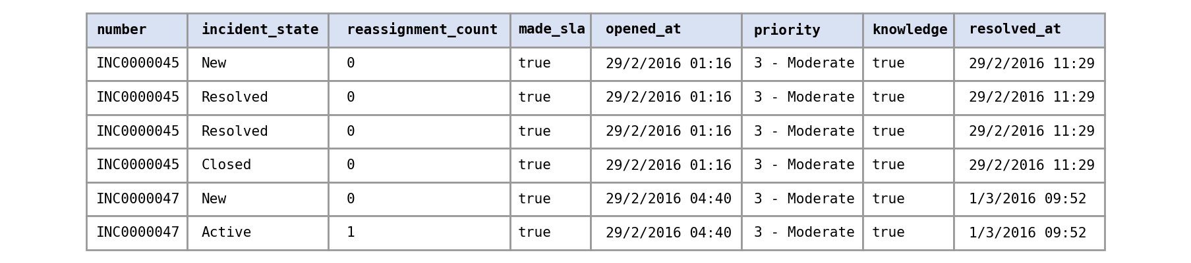
Note. Each incident (number) appears on several rows as it moves through states. From Incident Management Process Enriched Event Log [Data set], by C. Amaral, M. Fantinato, and S. Peres, 2018, UCI Machine Learning Repository (https://doi.org/10.24432/C57S4H). CC BY 4.0.
Figure 2
Structure of the GitHub Repository
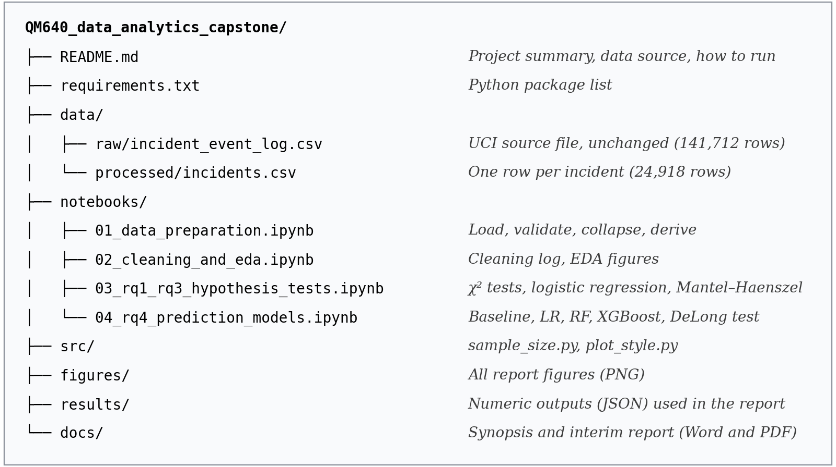

Analysis
The analysis has three parts: data cleaning, exploratory data analysis (EDA) linked to each research question, and confirmation of the sample size. Notebook 02 produces every number and figure in this section.

Data Cleaning
Cleaning was applied conservatively: every source row is kept, and treatments are recorded in Table 4 with counts. The missing-value code "?" was converted to missing, and timestamps were parsed as day-first dates. No exact duplicate rows exist, but 5 pairs of events share the same incident number and update counter; these ties are broken by update time so that the first and final records are well defined, and the collapsed file has no duplicate incidents. Five rows carry an undocumented state code of -100; they belong to two incidents whose final record is Closed, so they do not affect the outcome.
Missing categorical values at logging were kept as an explicit "Missing" level rather than imputed, because missingness itself may carry information; for example, an incident logged without an assignment group (3.6%) has not yet been routed. Outliers were detected with the interquartile range (IQR) rule. They are genuine operational values rather than errors, so they were retained: 2,848 incidents have more than two reassignments (maximum 27), and 812 took more than 1,000 hours to resolve. Removing them would delete exactly the difficult incidents the study is about. Instead, reassignment is also analysed in bands (0, 1, 2, 3+) to check linearity, and resolution time is shown on a log scale and used only descriptively.
Table 4
Data Cleaning Log
Issue | Variables affected | Detection method | Treatment applied | Rationale
Missing values (sparse) | caused_by, vendor, cmdb_ci, rfc, problem_id | Share of "?" per column: 98.4%–100% | Not used; cmdb_ci kept only as a missing flag | Too sparse to analyse
Missing values (categorical) | u_symptom (23.0%), assignment_group (3.6%), location, category, subcategory (< 0.3%) at logging | isna() on the incident file | Explicit "Missing" category | Keeps all incidents; missingness may be informative
Missing values (time) | resolved_at: 1,556 incidents (6.2%) | isna() | Left missing; resolution time descriptive only | Does not affect the outcome, which is complete
Duplicates | All columns; number + sys_mod_count | duplicated() | 0 exact duplicates; 5 key ties broken by sys_updated_at; 0 duplicate incidents | Defines first and final records uniquely
Anomalous code | incident_state = -100 (5 rows) | value_counts() | Retained; final state is Closed | No effect on the outcome
Outliers | reassignment_count, sys_mod_count, resolution_hours | IQR rule (Q3 + 1.5 × IQR) | Retained; banding and log scale | Valid extreme cases, central to the problem
Rare levels | category (22 of 52 levels below 30 incidents); high-cardinality RQ4 fields | Frequency counts | Grouped as Other (regression); one-hot with minimum frequency 30 in training data (RQ4) | Stable estimates; avoids empty cells
Note. Counts are from notebook 02_cleaning_and_eda.ipynb.

EDA Results
Table 5 summarises the numeric variables. All are strongly right-skewed: the median incident is never reassigned, is updated four times, and is resolved in 22.1 hours, but the mean resolution time is 178.2 hours because a minority of incidents stay open for weeks. Medians and percentiles are therefore more representative than means, and the counts are not suitable for methods that assume normality.
Table 5
Summary Statistics of Numeric Variables (Incident Level)
Variable | N | Mean | SD | Median | IQR (Q1 – Q3) | 95th pct. | Max | Above IQR fence
Reassignment count | 24,918 | 0.94 | 1.57 | 0 | 0 – 1 | 4 | 27 | 2,848
Reopen count | 24,918 | 0.01 | 0.15 | 0 | 0 – 0 | 0 | 8 | 275
Update count | 24,918 | 6.68 | 8.55 | 4 | 2 – 8 | 19 | 129 | 1,470
Resolution hours | 23,362 | 178.17 | 532.79 | 22.1 | 0.42 – 148.48 | 710.52 | 8,070.17 | 2,383
Note. SD = standard deviation; IQR = interquartile range. SLA breach (binary) has a mean of 0.366. Resolution hours exclude 1,556 incidents with no resolution timestamp.
Priority (RQ1). Figure 3 shows a steep breach gradient by priority. Critical and High incidents breach almost always (98.1% and 99.5%), Moderate incidents breach 35.5% of the time, and Low incidents 15.9%. Because Moderate incidents are 94.2% of volume, they account for 8,321 of the 9,115 breaches (91.3%). The near-certain breach of urgent tickets suggests that their targets are very tight relative to how these incidents are worked, while the size of the Moderate group means that most of the business impact, and most of the room for improvement, sits there. This pattern motivates the formal test in RQ1 and shows why a priority-only rule cannot separate risky from safe Moderate tickets, which is the gap RQ4 addresses.
Figure 3
SLA Breach Rate by Priority
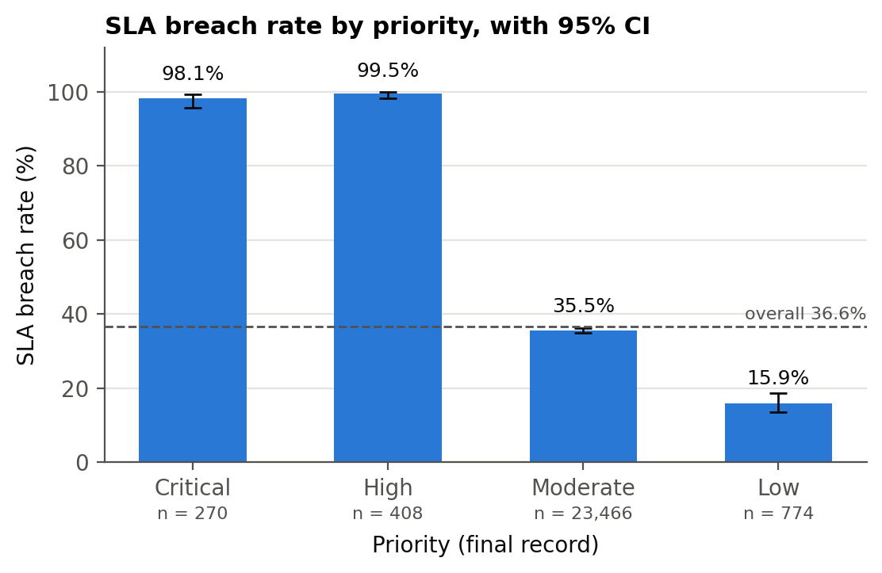
Note. Error bars are Wilson 95% confidence intervals. The dashed line is the overall breach rate.
Reassignment (RQ2). Figure 4 shows that the breach rate rises with every reassignment: 21.6% for incidents never reassigned, 42.9% after one reassignment, 60.1% after two, 67.1% after three, and 81.0% after four or more. Incidents reassigned at least once are 45.6% of all incidents but account for 67.9% of breaches. A monotonic dose–response pattern of this kind is consistent with each hand-off consuming SLA time, but it could also reflect harder incidents being passed around more, which is why RQ2 adjusts for priority and category.
Figure 4
SLA Breach Rate by Number of Reassignments
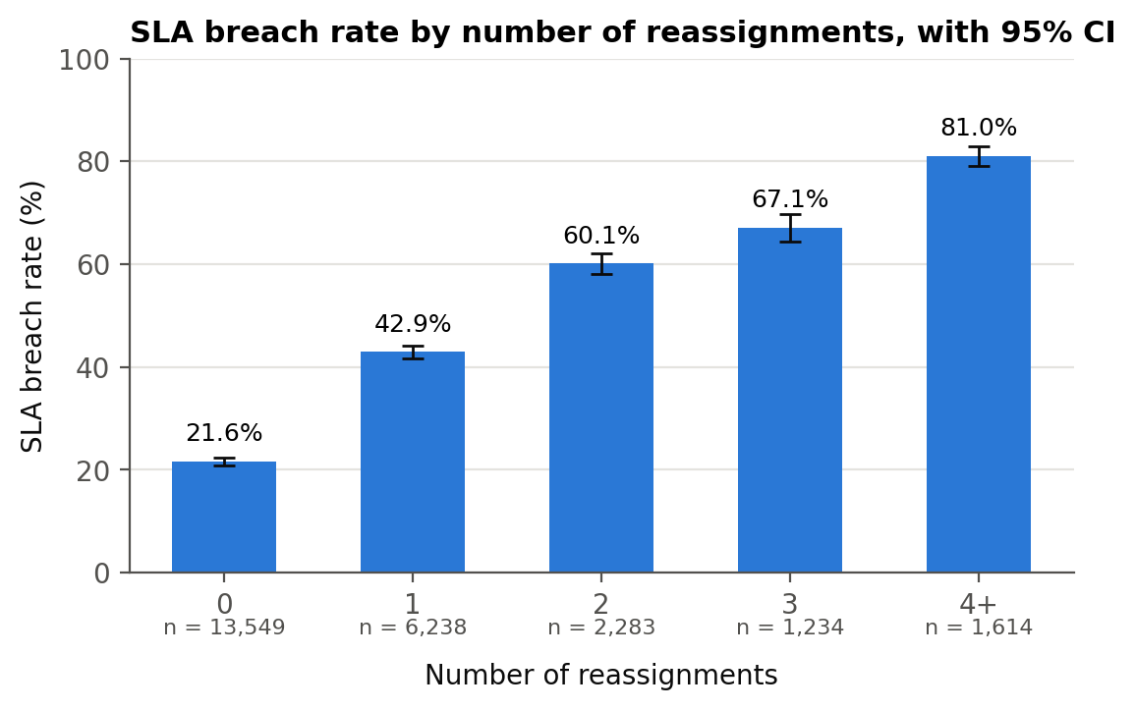
Note. Error bars are Wilson 95% confidence intervals.
Knowledge-base use (RQ3). Figure 5 compares breach rates for incidents with and without knowledge-base use within each priority. For Moderate and Low incidents, those that used a knowledge article breached far more often (75% against 29%, and 40% against 6%), while for Critical and High incidents breach is near-certain either way. A raw comparison would suggest that knowledge articles cause breaches, which is implausible, so the timing of knowledge use was examined next.
Figure 5
SLA Breach Rate by Knowledge-Base Use Within Each Priority
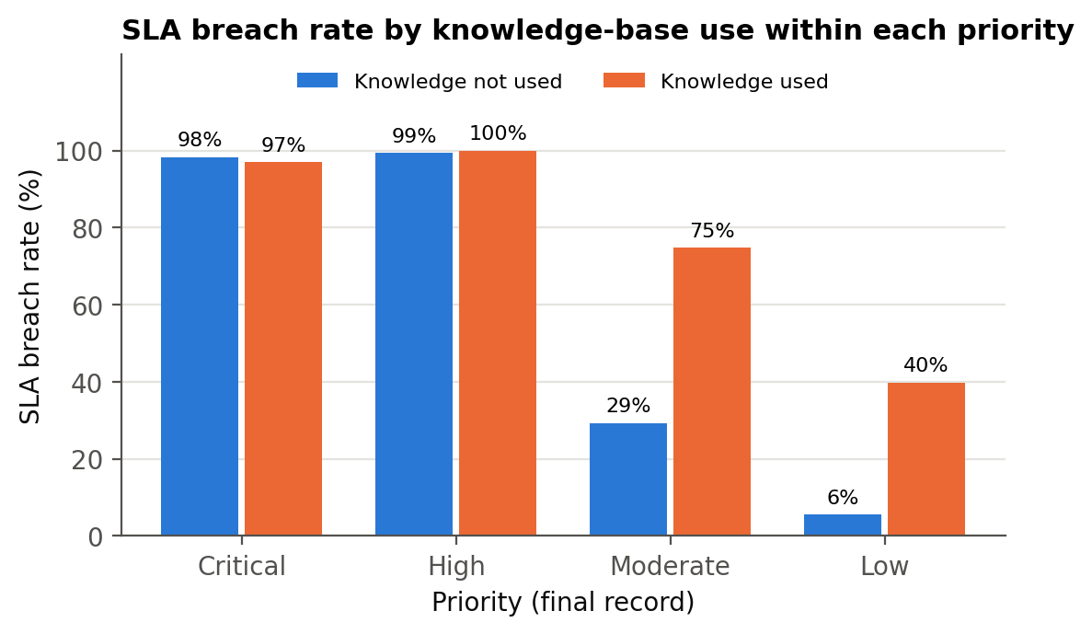
Change over time: a structural break (RQ3 and RQ4). Figure 6 shows weekly volume, breach rate, and knowledge use. Weekly volume is broadly stable, mostly between about 1,700 and 2,260 incidents in full weeks, but the breach rate is 68.3% in the week ending 7 March 2016 and 96.1% in the week ending 14 March, then falls to between 18% and 30% from April onwards. Over the same weeks the knowledge flag drops from 97% of incidents to under 1%. Of the 5,906 incidents opened before 21 March, 58.6% have the knowledge flag set and 73.1% breached; after that date only 0.5% have the flag and 25.2% breached. The most likely explanation is a change in process or recording in mid-March 2016, such as a change in how the knowledge field was filled in, together with an early backlog. The knowledge flag is therefore largely a marker of the period, which confounds the RQ3 comparison, and the breach rate differs between the RQ4 training period (42.3%) and test period (23.3%). Both points are handled in the preliminary results.
Figure 6
Weekly Incident Volume, SLA Breach Rate, and Knowledge-Base Use
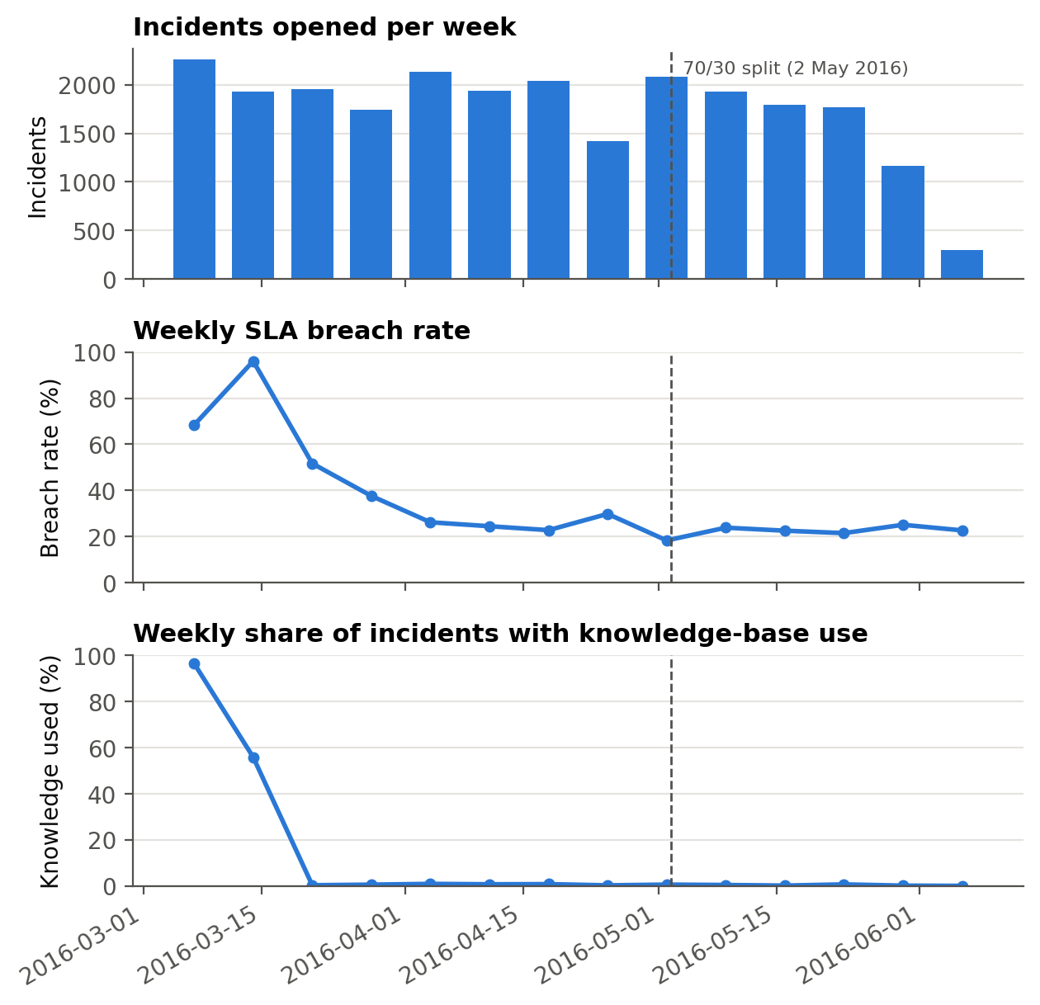
Note. Weeks end on the date shown. Weeks with fewer than 300 incidents (the week ending 29 February 2016 and all weeks after 6 June 2016) are omitted. The dashed line marks the 70/30 temporal split used for RQ4.
Resolution time (outcome check). Figure 7 shows that resolution time is bimodal for incidents that met their SLA, with peaks at minutes and at about one day, while breached incidents cluster around one to four weeks. The separation confirms that made_sla = true means the SLA was met, and the long right tail (812 incidents over 1,000 hours) explains the skew in Table 5. Resolution time is a consequence of the outcome rather than a predictor available at logging, so it is not used in any model.
Figure 7
Resolution Time by SLA Outcome
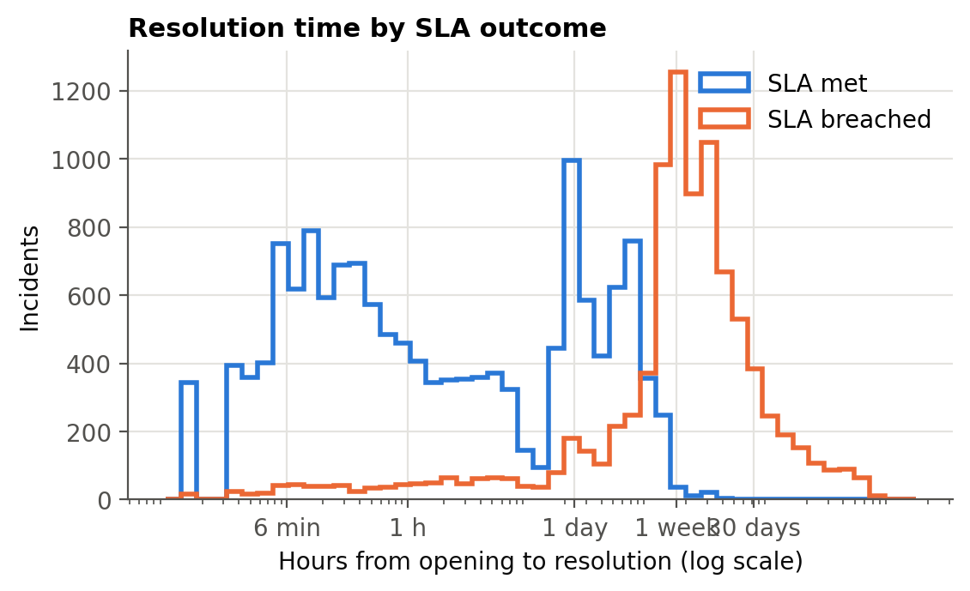
Time of logging (RQ4 features). Figure 8 shows that incidents logged during business hours breach more often (about 38% for 08:00 to 17:59) than those logged in the evening or overnight (about 28%). Separately, weekend incidents breach less often than weekday incidents (24.2% against 37.2%). A plausible reason is queue load: daytime tickets join longer queues. Because the hour and day of logging are known when a ticket is created, they are legitimate predictors for RQ4. Finally, the 52 categories are concentrated (the top 10 hold 75.9% of incidents) and their breach rates range from 19.4% to 51.6% among the eight largest, which supports controlling for category in RQ2 and RQ3.
Figure 8
SLA Breach Rate by Hour of Logging
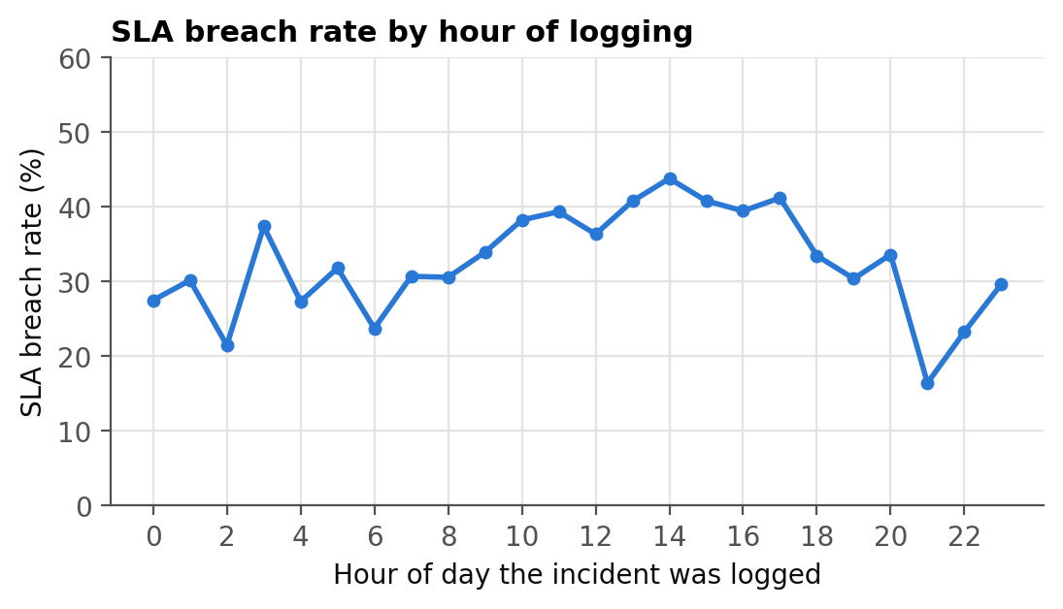
Table 6 summarises the insight from each figure and table and the decision it leads to.
Table 6
EDA Insight Summary
Figure / table | What it shows | Key insight | Why it matters (RQ link) | Decision / next step
Table 5 | Numeric distributions | Strong right skew; long tails are genuine | Model choice (all RQs) | Use medians, banding, non-parametric views
Figure 3 | Breach rate by priority | Critical/High breach ~99%; Moderate holds 91% of breaches | RQ1; limits of a priority rule (RQ4) | Test with χ²; focus the model on Moderate risk
Figure 4 | Breach by reassignments | Monotonic rise from 21.6% to 81.0% | RQ2 | Adjusted logistic regression; linearity check
Figure 5 | Breach by knowledge use | Knowledge users breach more within priority | RQ3 | Investigate confounding
Figure 6 | Weekly trends | Mid-March 2016 break in breach rate and knowledge flag | RQ3 confounding; RQ4 prevalence shift | Week-adjusted RQ3; stable-period RQ4 check
Figure 7 | Resolution time by outcome | Clear separation; confirms made_sla polarity | DV validity (all RQs) | Exclude resolution time from models
Figure 8 | Breach by hour of logging | Daytime logging breaches more; weekends breach less (24.2% vs 37.2%) | RQ4 features | Include hour and weekend features

Sample Size Computation
Minimum sample sizes were computed a priori for each research question, matching the method to the planned analysis, with α = 0.05, power = 0.80, and Cohen's (1988/2013) small effect size w = 0.10 throughout. For the χ² tests the required N is λ / w², where λ is the noncentrality parameter of the χ² distribution that gives 80% power (Faul et al., 2007). RQ2 and RQ3 inflate this by 1 / (1 − R²), where R² is the share of the variance in the independent variable explained by the control variables. RQ4 uses the confidence-interval method of Hanley and McNeil (1982) to size the test set so that an AUC of 0.75 is estimated within ±0.03. Table 7 shows the computation; Appendix A gives the code.
Table 7
Sample Size Computation by Research Question
RQ | Method | Parameters | Computation | Minimum N
RQ1 | Power: χ² test, 4 × 2 | α = 0.05; power = 0.80; w = 0.10; df = 3 | λ = 10.903; N = 10.903 / 0.10² = 1,090.3 | 1,091
RQ2 | Power: χ² test, 2 × 2, covariate-adjusted | α = 0.05; power = 0.80; w = 0.10; df = 1; R² = 0.047 | λ = 7.849; 785 / (1 − 0.047) = 823.7 | 824
RQ3 | Power: χ² test, 2 × 2, covariate-adjusted | α = 0.05; power = 0.80; w = 0.10; df = 1; R² = 0.154 | 785 / (1 − 0.154) = 927.9 | 928
RQ4 | Confidence interval: AUC precision | AUC = 0.75; e = 0.03; z = 1.96; prevalence 0.366; 30% test set | Test set n = 1,191 (436 / 755); 1,191 / 0.30 | 3,970
Final | N = max(RQ1–RQ4) | Available: 24,918 incidents | max(1,091; 824; 928; 3,970) | 3,970
Note. λ = noncentrality parameter; R² values are observed in the data; e = half-width of the 95% confidence interval for AUC. Results are rounded up.
The final sample size is N = max(1,091; 824; 928; 3,970) = 3,970 incidents, driven by RQ4. The dataset holds 24,918 incidents, 6.3 times this minimum, so all incidents are used. Two checks confirm logical consistency with the data as analysed. First, the smallest expected cell count in the RQ1 table is 98.8, well above the minimum of 5 for a χ² test. Second, the RQ4 test set has 7,476 incidents but a lower breach prevalence (23.3%) than assumed; recomputing with that prevalence requires a test set of 1,681, which the actual test set still exceeds by 4.4 times, and the achieved 95% confidence half-width for the best model's AUC is about ±0.012.

Modelling
The modelling follows the pipeline in Figure 9. Explanatory models answer RQ1 to RQ3, and a set of classifiers answers RQ4. Every step is scripted in the notebooks listed in Appendix B, with a fixed random seed (42), so all results can be reproduced from the repository.
Figure 9
Analysis Pipeline and Interim Status
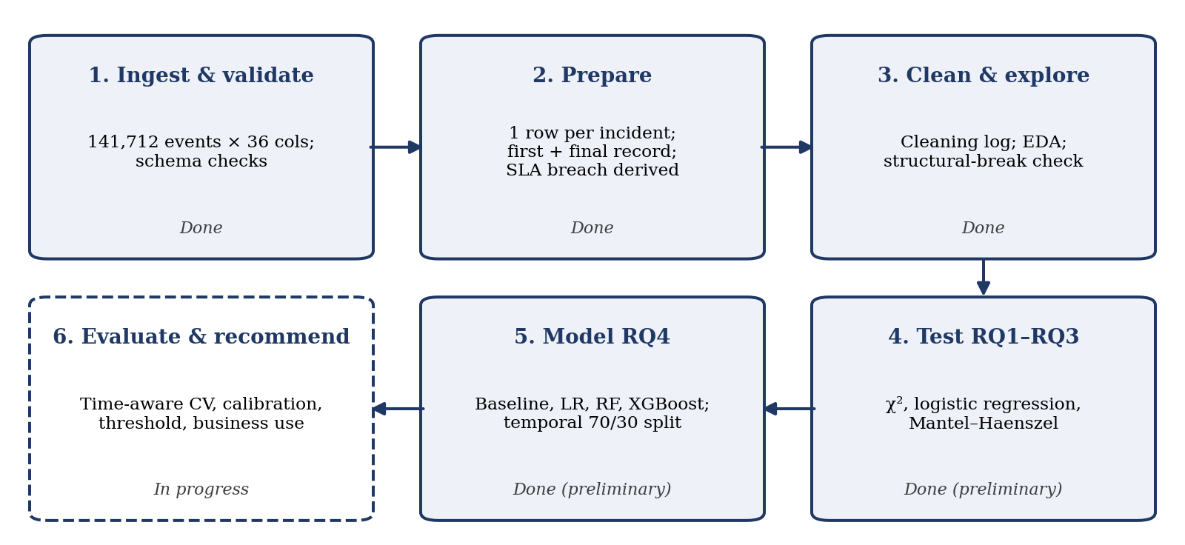

Choice of Models with Justification
Explanatory models (RQ1 to RQ3). The outcome is binary and the predictors are categorical or counts, so the χ² test of independence is the natural first test, reported with Cramér's V or φ as effect size because with 24,918 incidents almost any difference is significant. Pairwise χ² tests with Holm (1979) correction identify which priorities differ. Because reassignment and knowledge use are not randomly assigned and vary with priority and category, multivariable logistic regression estimates their adjusted odds ratios, with a Wald test on the coefficient (Hosmer et al., 2013). The Mantel–Haenszel odds ratio (Mantel & Haenszel, 1959) pools the knowledge effect across priority strata as a robustness check, and the Breslow–Day test checks whether that effect is the same in every stratum.
Model 1: priority-only logistic regression (baseline). This reproduces the rule service desks already use, which is to escalate by priority, so beating it is the meaningful benchmark for RQ4. Model 2: regularised logistic regression. It is interpretable through odds ratios, is a strong benchmark for categorical data, and its L1 or L2 penalty, chosen by cross-validation, controls overfitting across 255 encoded columns. Model 3: random forest. An ensemble of decision trees (Breiman, 2001) that captures interactions, such as an assignment group that is risky only for certain categories, without manual specification, and is robust to skewed inputs. Model 4: XGBoost. Gradient-boosted trees (Chen & Guestrin, 2016), which are often the most accurate models on tabular data (Grinsztajn et al., 2022) and were among the strongest methods in outcome-oriented process benchmarks (Teinemaa et al., 2019).
Assumptions and alternatives. All models assume that incidents are independent, which the collapse to one row per incident supports. The logistic models assume linearity in the logit for counts, which is checked by banding reassignments, and no perfect separation, which holds because even Critical and High incidents contain some non-breaches. The tree ensembles make no linearity or distributional assumptions, but, like all the classifiers, they assume that the training period represents the test period and that coded categories keep the same meaning over time, and boosted trees rely on depth and learning-rate limits to avoid overfitting; the structural break in Figure 6 shows that this assumption is only partly met, which is tested below. Sequence models such as LSTM networks (Tax et al., 2017) were not chosen because at logging there is no event sequence yet, and target encoding of high-cardinality fields (Micci-Barreca, 2001) is kept as a refinement for the final report.

Features Included and Feature Engineering
RQ4 uses 17 features, all taken from the first event record of each incident so that they are known when the ticket is logged (Table 8). Categorical features are one-hot encoded; levels seen fewer than 30 times in the training data are pooled into an "infrequent" level, and missing values form their own level, which gives 255 encoded columns. The caller is represented by how many incidents the same caller logged in the training period, computed on training data only. Hour of day is encoded with sine and cosine terms so that 23:00 and 00:00 are close, and numeric features are standardised for logistic regression. To avoid leakage (Kaufman et al., 2012), the model excludes everything that accumulates after logging: reassignment, reopen, and update counts, resolution and closure times, the closure code, and final-record priority. Knowledge use is excluded from the main model because Figure 6 shows it acts as a marker of the period, and is tested only in a sensitivity model. Class imbalance is handled with balanced class weights.
Table 8
Feature Set and Usage (RQ4)
Feature | Original / engineered | Type | Reason for inclusion | Used in model(s)
log_priority | Original | Ordinal (one-hot) | Current escalation rule; Figure 3 | All (only feature of Model 1)
log_impact, log_urgency | Original | Ordinal (one-hot) | Inputs to priority; finer detail | Models 2–4
log_category, log_subcategory | Original | Nominal (one-hot, pooled) | Service area; breach varies by category | Models 2–4
log_u_symptom | Original | Nominal (one-hot, pooled; Missing level) | User-reported symptom at logging | Models 2–4
log_assignment_group | Original | Nominal (one-hot, pooled; Missing level) | First resolver group; routing quality | Models 2–4
log_location, log_contact_type, log_notify | Original | Nominal (one-hot) | Context of the request | Models 2–4
log_u_priority_confirmation | Original | Binary | Whether priority was checked | Models 2–4
cmdb_ci_missing | Engineered | Binary flag | Configuration item recorded or not | Models 2–4
caller_freq | Engineered | Numeric, log(1 + n) | Frequent callers may differ; avoids 5,244 dummies | Models 2–4
hour_sin, hour_cos, weekend, day of week | Engineered | Numeric / binary / one-hot | Daytime and weekday effects (Figure 8) | Models 2–4
log_knowledge | Original | Binary | Period marker; tested separately | Sensitivity model only
Note. Excluded to prevent leakage: reassignment_count, reopen_count, sys_mod_count, resolved_at, closed_at, closed_code, and final-record priority.

Evaluation Metrics
Table 9 defines the metrics. AUC is the primary metric because it does not depend on a threshold and is the quantity tested in H1₄; precision–recall AUC, recall, and F1 describe performance on the breach class, and the Brier score measures probability accuracy. Validation uses a temporal split: incidents are ordered by opening time, the earliest 70% (17,442 incidents, opened before 11:30 on 2 May 2016) train the models, and the latest 30% (7,476) test them, which mimics deployment on future tickets. Hyperparameters are tuned by five-fold stratified cross-validation within the training set. The worked calculations use the random forest's confusion matrix on the test set at a threshold of 0.5: TP = 1,149, FP = 1,431, FN = 592, TN = 4,304.
Table 9
Evaluation Metrics, Formulae, and Worked Calculations
Metric | Formula | Interpretation | Worked calculation
Accuracy | (TP + TN) / N | Share of all incidents classified correctly; misleading under imbalance | (1,149 + 4,304) / 7,476 = 0.729
Precision | TP / (TP + FP) | Share of flagged incidents that breach | 1,149 / 2,580 = 0.445
Recall | TP / (TP + FN) | Share of actual breaches that are flagged | 1,149 / 1,741 = 0.660
F1-score | 2 × P × R / (P + R) | Balance of precision and recall | 2 × 0.445 × 0.660 / 1.105 = 0.532
ROC AUC | P(score of a breach > score of a non-breach) | Ranking quality; 0.5 = chance, 1 = perfect | 0.785 (95% CI 0.773–0.796)
PR-AUC | Σ (Rₙ − Rₙ₋₁) Pₙ (average precision) | Precision across recall levels; chance = prevalence | 0.536 against a chance level of 0.233
Brier score | (1 / N) Σ (pᵢ − yᵢ)² | Accuracy of predicted probabilities; lower is better | 0.181
χ², Cramér's V | Σ (O − E)² / E; √(χ² / (N(k − 1))) | Association test and its strength (RQ1–RQ3) | RQ1: √(1293.1 / 24,918) = 0.228
Odds ratio | e^{β}; 95% CI e^{β ± 1.96 SE} | Change in breach odds (RQ2–RQ3) | RQ2: e^{0.667} = 1.948
Note. TP, FP, FN, and TN are true positives, false positives, false negatives, and true negatives, with breach as the positive class; P = precision; R = recall; pᵢ = predicted probability; yᵢ = observed outcome.

Preliminary Results
This section reports the preliminary results for each research question (notebooks 03 and 04). Table 10 summarises the hypothesis tests for RQ1 to RQ3. P-values below .001 are reported as p < .001.
Table 10
Hypothesis Test Results for RQ1 to RQ3
RQ | Test | Result | Effect size | Decision
RQ1 | χ² test of independence, priority × breach (4 × 2) | χ²(3, N = 24,918) = 1,293.1, p < .001 | V = 0.228 | Reject H0₁
RQ2 | χ² test, reassigned × breach (2 × 2) | χ²(1) = 2,868.4, p < .001; OR = 4.33 [4.1, 4.58] | φ = 0.339
 | Logistic regression, reassignment count + priority + category (Wald) | OR = 1.948 [1.896, 2.002] per reassignment, z = 48.46, p < .001 | McFadden R² = 0.217 | Reject H0₂
RQ3 | χ² test, knowledge × breach (2 × 2) | χ²(1) = 2,399.9, p < .001; OR = 6.24 [5.76, 6.76] | φ = 0.31
 | Logistic regression, knowledge + priority + category (Wald) | OR = 6.62 [6.05, 7.25], z = 41.01, p < .001 | McFadden R² = 0.171
 | Mantel–Haenszel across priority strata | OR = 7.26 [6.68, 7.89]; Breslow–Day p = .006
 | Logistic regression adding opening week | OR = 0.61 [0.44, 0.86], p = .004 |  | Reject H0₃ (direction to confirm)
Note. OR = odds ratio with 95% confidence interval in brackets. Category controls use 31 groups (categories with fewer than 30 incidents pooled).

Preliminary Findings by Research Question
RQ1: priority. The breach rate differs strongly by priority, χ²(3, N = 24,918) = 1,293.1, p < .001, with Cramér's V = 0.228, a small-to-medium effect by Cohen's (1988/2013) benchmarks. Adjusted standardised residuals show more breaches than expected for Critical (+21.1) and High (+26.6) incidents and fewer for Moderate (-14.8) and Low (-12.1). Table 11 shows that five of the six pairwise comparisons remain significant after Holm correction; only Critical and High do not differ (98.1% against 99.5%), because both breach almost always. H0₁ is rejected. The finding answers RQ1: priority is clearly associated with breach, but in the opposite direction to its purpose, since the most urgent incidents are the least likely to meet their targets.
Table 11
Pairwise Comparisons of Breach Rates Between Priorities (RQ1)
Comparison | Breach rates | χ²(1) | Holm-adjusted p | Significant
Critical vs High | 98.1% vs 99.5% | 2.9 | .086 | No
Critical vs Moderate | 98.1% vs 35.5% | 454.3 | < .001 | Yes
Critical vs Low | 98.1% vs 15.9% | 580.0 | < .001 | Yes
High vs Moderate | 99.5% vs 35.5% | 709.4 | < .001 | Yes
High vs Low | 99.5% vs 15.9% | 755.5 | < .001 | Yes
Moderate vs Low | 35.5% vs 15.9% | 126.4 | < .001 | Yes
RQ2: reassignment. Reassigned incidents are more likely to breach, χ²(1) = 2,868.4, p < .001, φ = 0.339. After controlling for priority and category, each additional reassignment multiplies the odds of breach by 1.948 (95% CI 1.896–2.002), Wald z = 48.46, p < .001, and the variance inflation factor of 1.049 shows almost no overlap with the controls. The banded model gives odds ratios of 2.88, 5.89, and 12.78 for one, two, and three or more reassignments compared with none. The first hand-off therefore carries the largest single step, which a single per-reassignment coefficient understates, so the banded form will be reported in the final analysis. Adding the opening week leaves the effect almost unchanged (OR 1.93), so it is robust to the March 2016 break. H0₂ is rejected: reassignment is strongly and independently associated with SLA breach.
RQ3: knowledge-base use. The unadjusted association is large, χ²(1) = 2,399.9, p < .001, with an odds ratio of 6.24, and it survives adjustment for priority and category (OR 6.62) and Mantel–Haenszel pooling (OR 7.26). The Breslow–Day test (p = .006) shows that the effect differs by stratum: it is large for Moderate and Low incidents and absent for Critical and High, where nearly all incidents breach. However, Figure 6 showed that the knowledge flag marks the period before mid-March 2016 rather than individual engineer behaviour. When the opening week is added to the model, the direction reverses: within the same week, knowledge use is associated with lower odds of breach (OR 0.61, 95% CI 0.44–0.86, p = .004). H0₃ is rejected in every specification, but the preliminary conclusion is that the raw positive association is driven by the period, and that the true direction may be protective. Because fewer than 100 incidents after 21 March used a knowledge article, this estimate is imprecise and will be examined further.

Preliminary Model Performance
Table 12 compares the four RQ4 models on the temporal test set, and Figure 10 shows their ROC curves. The priority-only baseline reaches an AUC of only 0.552, barely above chance, because 95.0% of incidents have the same priority (Moderate) at logging. All three machine-learning models do far better: regularised logistic regression 0.779, random forest 0.785, and XGBoost 0.738. The DeLong test shows that the random forest's AUC is significantly higher than the baseline's (difference 0.233, z = 38.45, one-sided p < .001), so H0₄ is rejected; the logistic regression and XGBoost models are also significantly better than the baseline.
Table 12
Preliminary Model Performance Comparison (Temporal Test Set)
Model | Feature set | Validation approach | CV AUC | Test AUC [95% CI] | PR-AUC | Precision / recall / F1 | Brier | Key takeaway
Model 1: Baseline LR | Priority only | Temporal 70/30 | 0.533 | 0.552 [0.545, 0.558] | 0.289 | 0.884 / 0.070 / 0.130 | 0.240 | Priority rule barely beats chance
Model 2: Regularised LR | 17 at-logging | Temporal 70/30; 5-fold CV | 0.768 | 0.779 [0.768, 0.791] | 0.532 | 0.436 / 0.655 / 0.523 | 0.185 | Close second; most interpretable
Model 3: Random forest | 17 at-logging | Temporal 70/30; 5-fold CV | 0.790 | 0.785 [0.773, 0.796] | 0.536 | 0.445 / 0.660 / 0.532 | 0.181 | Preliminary best; stable from CV to test
Model 4: XGBoost | 17 at-logging | Temporal 70/30; 5-fold CV | 0.787 | 0.738 [0.725, 0.751] | 0.481 | 0.400 / 0.605 / 0.481 | 0.195 | Largest CV-to-test drop
Note. Test set: 7,476 incidents (1,741 breaches, prevalence 0.233). CV AUC = mean five-fold cross-validated AUC in the training set. Precision, recall, and F1 use a 0.5 threshold. Best settings: logistic regression C = 1 (l1); random forest min_samples_leaf = 2, max_features = sqrt; XGBoost max_depth = 7, learning rate = 0.1.
Figure 10
ROC Curves of the Four Models on the Temporal Test Set
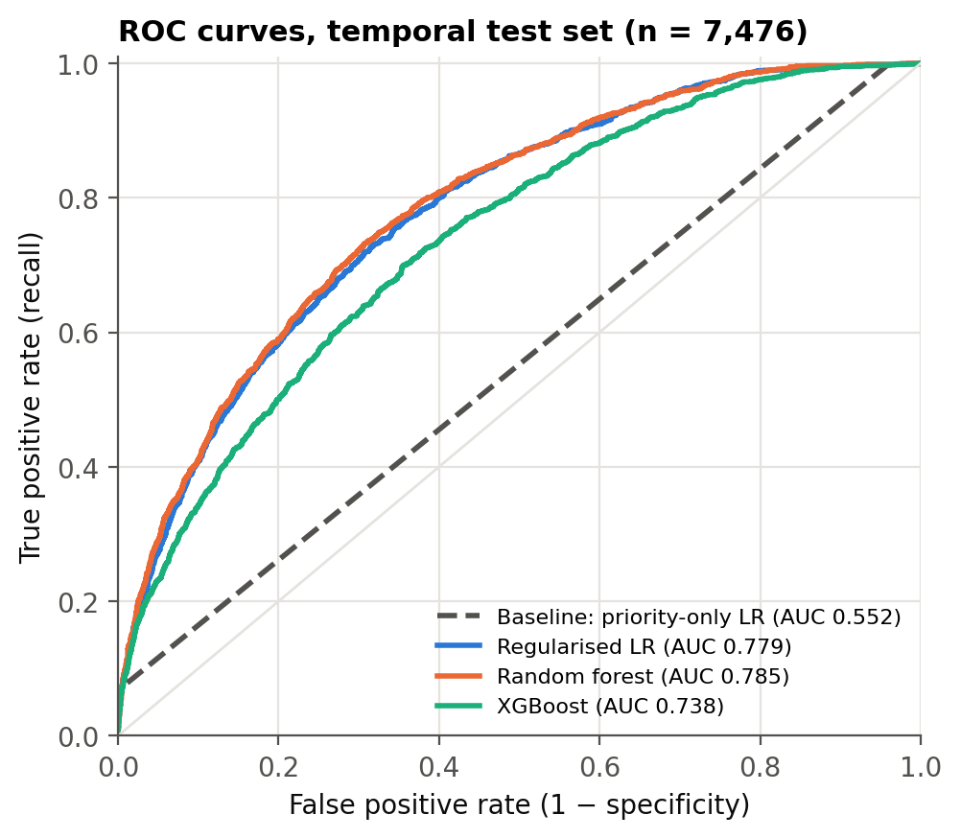
Three further points matter for interpretation. First, accuracy is misleading here: the baseline has the highest accuracy (0.781) only because it flags almost nothing, catching 7.0% of breaches, whereas the random forest catches 66.0% of breaches with a precision of 0.445, nearly double the 0.233 chance level. Its PR-AUC (0.536) is also almost double the baseline's (0.289), and its Brier score is lower (0.181 against 0.240). Second, XGBoost had almost the same cross-validated AUC as the random forest (0.787 against 0.790) but dropped to 0.738 on the test set. Random cross-validation mixes the pre-break and post-break periods, so it rewards patterns that do not carry forward in time; deeper boosted trees appear to have learned more of them. Third, the random forest is the most stable model across validation and test and is the preliminary best model.
Figure 11 shows the permutation importance of the random forest's features. The first assignment group dominates: shuffling it lowers the test AUC by 0.103, against 0.026 for symptom and 0.014 for location, while priority adds only 0.008. This complements RQ2: where a ticket first lands matters more for its SLA than how urgent it is. Two sensitivity checks support the result. Adding the knowledge flag changes the AUC only from 0.785 to 0.788, so excluding it costs nothing. Refitting on the stable period only (incidents opened from 21 March 2016, again split 70/30 in time) gives an AUC of 0.803 for the random forest against 0.551 for the baseline, so the advantage does not depend on the March break.
Figure 11
Top 10 Features of the Random Forest by Permutation Importance
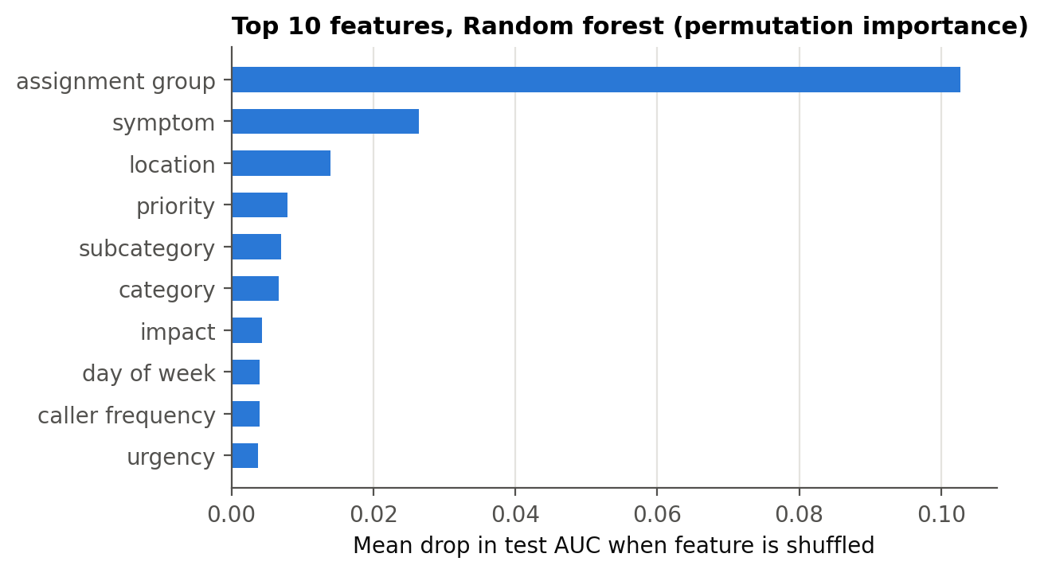
Note. Importance is the mean drop in test-set AUC over five random shuffles of each feature.
Table 13 maps each research question to its objective and preliminary answer.
Table 13
Preliminary Answers to the Research Questions
RQ | Objective | Preliminary answer | Decision | Remaining work
RQ1 | (a) Breach rate by priority | Strong association (V = 0.228); Critical and High breach ~99%, Low 15.9% | Reject H0₁ | Final wording; business translation
RQ2 | (b) Breach odds per reassignment | OR 1.948 per reassignment; first hand-off has the largest step; robust to period | Reject H0₂ | Report banded model; interaction with priority
RQ3 | (c) Breach odds with knowledge use | Positive raw OR (6.24) is driven by the March 2016 period; within-week OR 0.61 | Reject H0₃; direction tentative | Period-stratified analysis
RQ4 | (d) At-logging model vs priority rule | Random forest AUC 0.785 vs 0.552; DeLong p < .001 | Reject H0₄ | Time-aware CV, calibration, threshold

Interim Limitations and Risks
- Data. All incidents come from one anonymised organisation and mostly from three months in 2016, so results describe this service desk rather than service desks in general. SLA targets are not recorded, so the near-certain breach of Critical and High incidents cannot be checked against their targets. Coded category and group names limit business interpretation. Mitigation: findings are framed as evidence from one enterprise, and the method, not the coefficients, is presented as transferable.
- Structural break. The change in mid-March 2016 shifts the breach rate from 42.3% in the training period to 23.3% in the test period and turns the knowledge flag into a period marker. Mitigation: week-adjusted models for RQ2 and RQ3, a stable-period check for RQ4, and time-aware cross-validation in the final report.
- Model. Random-fold cross-validation overestimated XGBoost's out-of-time performance (CV AUC 0.787 against test AUC 0.738); the 0.5 threshold with balanced class weights is not a business-optimised operating point; and permutation importance can understate correlated features such as category and subcategory. XGBoost results are also sensitive to library versions: because depths 5 and 7 score almost the same in cross-validation, a rerun in Google Colab selected depth 5 and gave a test AUC of 0.751 rather than 0.738, while every other model changed by 0.001 or less and no conclusion changed. Mitigation: forward-chaining cross-validation, probability calibration, a threshold chosen for triage capacity, and exact library versions pinned in requirements.txt.
- Assumptions, reliability, and validity. RQ1 to RQ3 are observational, so the odds ratios are associations, not causal effects; unmeasured factors such as analyst skill may confound them. Reliability is supported by a fixed seed, a scripted pipeline, and the unchanged source file, so every number in this report can be regenerated. Internal validity is supported by leakage controls and a temporal test set; external validity is limited by the single-organisation data.

Next Steps (for Final Report)
- Replace random-fold tuning with forward-chaining time-series cross-validation and retune all RQ4 models.
- Calibrate the best model's probabilities and choose an alert threshold that matches a realistic triage capacity, for example the top 20% of daily tickets, and report breaches caught per 100 tickets flagged.
- Report the banded reassignment model and test a reassignment × priority interaction for RQ2; complete a period-stratified analysis for RQ3.
- Test target encoding for high-cardinality fields and compare it with the current pooling.
- Translate the results into recommendations for service delivery managers and prepare the final report and presentation.

Bibliography
Amaral, C. A. L., Fantinato, M., & Peres, S. M. (2018a). Attribute selection with filter and wrapper: An application on incident management process. In Proceedings of the 2018 Federated Conference on Computer Science and Information Systems (Annals of Computer Science and Information Systems, Vol. 15, pp. 679–682). https://doi.org/10.15439/2018F126
Amaral, C., Fantinato, M., & Peres, S. (2018b). Incident management process enriched event log [Data set]. UCI Machine Learning Repository. https://doi.org/10.24432/C57S4H
Amaral, C. A. L., Fantinato, M., Reijers, H. A., & Peres, S. M. (2019). Enhancing completion time prediction through attribute selection. In Information technology for management: Emerging research and applications (Lecture Notes in Business Information Processing, pp. 3–23). Springer. https://doi.org/10.1007/978-3-030-15154-6_1
Botezatu, M. M., Bogojeska, J., Giurgiu, I., Voelzer, H., & Wiesmann, D. (2015). Multi-view incident ticket clustering for optimal ticket dispatching. In Proceedings of the 21st ACM SIGKDD International Conference on Knowledge Discovery and Data Mining (pp. 1711–1720). ACM. https://doi.org/10.1145/2783258.2788607
Breiman, L. (2001). Random forests. Machine Learning, 45(1), 5–32. https://doi.org/10.1023/A:1010933404324
Brier, G. W. (1950). Verification of forecasts expressed in terms of probability. Monthly Weather Review, 78(1), 1–3. https://doi.org/10.1175/1520-0493(1950)078<0001:VOFEIT>2.0.CO;2
Chen, T., & Guestrin, C. (2016). XGBoost: A scalable tree boosting system. In Proceedings of the 22nd ACM SIGKDD International Conference on Knowledge Discovery and Data Mining (pp. 785–794). ACM. https://doi.org/10.1145/2939672.2939785
Cohen, J. (2013). Statistical power analysis for the behavioral sciences (2nd ed.). Routledge. https://doi.org/10.4324/9780203771587 (Original work published 1988)
Dang, Y., Lin, Q., & Huang, P. (2019). AIOps: Real-world challenges and research innovations. In 2019 IEEE/ACM 41st International Conference on Software Engineering: Companion Proceedings (ICSE-Companion) (pp. 4–5). IEEE. https://doi.org/10.1109/ICSE-Companion.2019.00023
DeLong, E. R., DeLong, D. M., & Clarke-Pearson, D. L. (1988). Comparing the areas under two or more correlated receiver operating characteristic curves: A nonparametric approach. Biometrics, 44(3), 837–845. https://doi.org/10.2307/2531595
Faul, F., Erdfelder, E., Lang, A.-G., & Buchner, A. (2007). G*Power 3: A flexible statistical power analysis program for the social, behavioral, and biomedical sciences. Behavior Research Methods, 39(2), 175–191. https://doi.org/10.3758/BF03193146
Fawcett, T. (2006). An introduction to ROC analysis. Pattern Recognition Letters, 27(8), 861–874. https://doi.org/10.1016/j.patrec.2005.10.010
Grinsztajn, L., Oyallon, E., & Varoquaux, G. (2022). Why do tree-based models still outperform deep learning on typical tabular data? In Advances in Neural Information Processing Systems 35 (pp. 507–520). https://doi.org/10.52202/068431-0037
Hanley, J. A., & McNeil, B. J. (1982). The meaning and use of the area under a receiver operating characteristic (ROC) curve. Radiology, 143(1), 29–36. https://doi.org/10.1148/radiology.143.1.7063747
Holm, S. (1979). A simple sequentially rejective multiple test procedure. Scandinavian Journal of Statistics, 6(2), 65–70. https://www.jstor.org/stable/4615733
Hosmer, D. W., Jr., Lemeshow, S., & Sturdivant, R. X. (2013). Applied logistic regression (3rd ed.). Wiley. https://doi.org/10.1002/9781118548387
Kaufman, S., Rosset, S., Perlich, C., & Stitelman, O. (2012). Leakage in data mining: Formulation, detection, and avoidance. ACM Transactions on Knowledge Discovery from Data, 6(4), 1–21. https://doi.org/10.1145/2382577.2382579
Kikuchi, S. (2015). Prediction of workloads in incident management based on incident ticket updating history. In 2015 IEEE/ACM 8th International Conference on Utility and Cloud Computing (UCC) (pp. 333–340). IEEE. https://doi.org/10.1109/UCC.2015.53
Leitner, P., Michlmayr, A., Rosenberg, F., & Dustdar, S. (2010). Monitoring, prediction and prevention of SLA violations in composite services. In 2010 IEEE International Conference on Web Services (pp. 369–376). IEEE. https://doi.org/10.1109/ICWS.2010.21
Mantel, N., & Haenszel, W. (1959). Statistical aspects of the analysis of data from retrospective studies of disease. Journal of the National Cancer Institute, 22(4), 719–748. https://doi.org/10.1093/jnci/22.4.719
Marrone, M., & Kolbe, L. M. (2011). Impact of IT service management frameworks on the IT organization: An empirical study on benefits, challenges, and processes. Business & Information Systems Engineering, 3(1), 5–18. https://doi.org/10.1007/s12599-010-0141-5
Micci-Barreca, D. (2001). A preprocessing scheme for high-cardinality categorical attributes in classification and prediction problems. ACM SIGKDD Explorations Newsletter, 3(1), 27–32. https://doi.org/10.1145/507533.507538
Polato, M., Sperduti, A., Burattin, A., & de Leoni, M. (2018). Time and activity sequence prediction of business process instances. Computing, 100(9), 1005–1031. https://doi.org/10.1007/s00607-018-0593-x
Saito, T., & Rehmsmeier, M. (2015). The precision-recall plot is more informative than the ROC plot when evaluating binary classifiers on imbalanced datasets. PLOS ONE, 10(3), Article e0118432. https://doi.org/10.1371/journal.pone.0118432
Shao, Q., Chen, Y., Tao, S., Yan, X., & Anerousis, N. (2008). Efficient ticket routing by resolution sequence mining. In Proceedings of the 14th ACM SIGKDD International Conference on Knowledge Discovery and Data Mining (pp. 605–613). ACM. https://doi.org/10.1145/1401890.1401964
Tax, N., Verenich, I., La Rosa, M., & Dumas, M. (2017). Predictive business process monitoring with LSTM neural networks. In E. Dubois & K. Pohl (Eds.), Advanced information systems engineering (Lecture Notes in Computer Science, Vol. 10253, pp. 477–492). Springer. https://doi.org/10.1007/978-3-319-59536-8_30
Teinemaa, I., Dumas, M., La Rosa, M., & Maggi, F. M. (2019). Outcome-oriented predictive process monitoring: Review and benchmark. ACM Transactions on Knowledge Discovery from Data, 13(2), 1–57. https://doi.org/10.1145/3301300
van der Aalst, W. (2016). Process mining: Data science in action (2nd ed.). Springer. https://doi.org/10.1007/978-3-662-49851-4
Verenich, I., Dumas, M., La Rosa, M., Maggi, F. M., & Teinemaa, I. (2019). Survey and cross-benchmark comparison of remaining time prediction methods in business process monitoring. ACM Transactions on Intelligent Systems and Technology, 10(4), 1–34. https://doi.org/10.1145/3331449

Appendix A
Sample Size Calculation Code
The code below, saved as src/sample_size.py in the GitHub repository, reproduces Table 7.
# QM640 capstone - minimum sample sizes (alpha = 0.05, power = 0.80)
# Dependent variable for all RQs: SLA breach (binary)
import numpy as np
from scipy.stats import chi2, ncx2

def chi2_n(w, df, a=0.05, p=0.80): # chi-square test of independence
n, c = 10, chi2.ppf(1 - a, df)
while ncx2.sf(c, df, n * w**2) < p:
n += 1
return n

def auc_test_n(auc, e, prev): # RQ4 (Hanley & McNeil, 1982)
q1, q2 = auc / (2 - auc), 2 * auc**2 / (1 + auc)
n = 50
while True:
pos = round(n * prev); neg = n - pos
var = (auc*(1-auc) + (pos-1)*(q1-auc**2) + (neg-1)*(q2-auc**2)) / (pos*neg)
if 1.96 * np.sqrt(var) <= e:
return n
n += 1

rq1 = chi2_n(0.10, 3) # priority (4) x breach (2): 1091
rq2 = int(np.ceil(chi2_n(0.10, 1) / (1 - 0.047))) # 785 / 0.953 -> 824
rq3 = int(np.ceil(chi2_n(0.10, 1) / (1 - 0.154))) # 785 / 0.846 -> 928
test = auc_test_n(0.75, 0.03, 9115 / 24918) # observed prevalence 0.366: 1191
rq4 = int(np.ceil(test / 0.30)) # 3970
print(rq1, rq2, rq3, test, rq4, "final N =", max(rq1, rq2, rq3, rq4))

Appendix B
Notebook Map and Run Order
Run the notebooks in order from the notebooks folder after installing requirements.txt. Each notebook writes its figures to figures/ and its numbers to results/.
Notebook | Purpose | Produces
01_data_preparation.ipynb | Load, validate, collapse events to incidents, derive variables | data/processed/incidents.csv
02_cleaning_and_eda.ipynb | Cleaning checks and exploratory analysis | Tables 4–6; Figures 3–8
03_rq1_rq3_hypothesis_tests.ipynb | χ² tests, logistic regressions, Mantel–Haenszel, week adjustment | Tables 10–11
04_rq4_prediction_models.ipynb | Baseline and three classifiers, DeLong test, importance, sensitivity checks | Tables 9 and 12; Figures 10–11
src/sample_size.py | Minimum sample sizes | Table 7

