Question 1: Find out the mail servers of the following domain :

* Ibm.com
* Wipro.com

WWW.IBM.COM

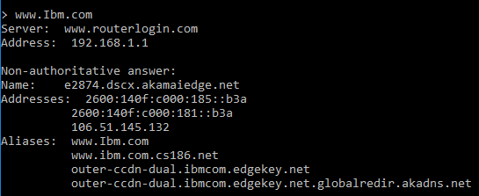

WWW.WIPRO.COM

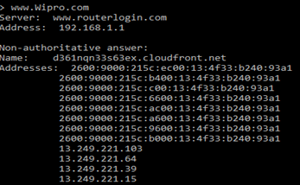

Question 2: Find the locations, where these email servers are hosted.

* using mx command

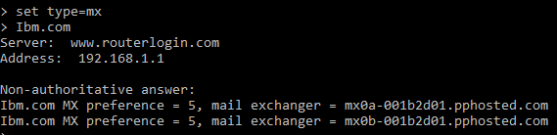

Question 3: Scan and find out port numbers open 203.163.246.23

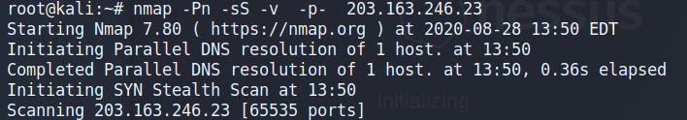

Question 4: Install nessus in a VM and scan your laptop/desktop for CVE.

