**Name**

Real Estate Market Assessment – by the-very-best-team

**Overview**

The-very-best-team elected to focus on what is driving the residential real estate market. We sourced real estate and mortgage rate data through Quandl and unemployment and population data through the US Bureau of Labor Statistics. Followed by running correlations between key prospective drivers to include unemployment rates, mortgage rates and population.

**Approach & Methodology**

WHY was this topic selected? … We shared a general curiosity about what factors drive real estate prices up or down. We chose to focus on Zillow real estate and Freddie Mac mortgage rate data because our research found this information to be readily and abundantly available through Quandl. We added additional unemployment and population data through the US Bureau of Labor Statistics.

The Zillow data set led us to focus on QUESTIONS about home value, sales price, inventory and days-to-sell. The key Indicator ID’s that will be in the scripts are summarized as follows:

ZALL - Zillow Home Volume Index for all homes

ISAM - For Sale Inventory (number of listings on the market)

NSAM - Median days to pending (median number of days a listing is on the market)

SSAM - Median sale price (median value for listings that sold)

We added additional datasets to evaluate or HYPOTHESES about prospective drivers in the residential real estate market:

UNEMPLOYMENT RATE was incorporated because we hypothesized that with fewer people getting paychecks there would be less money being invested into real estate.

MORTGAGE RATES were incorporated because we hypothesized that the cost of borrowing has a significant impact on what people can afford to purchase

POPULATION was incorporated because we hypothesized that Colorado population growth would increase demand for housing and subsequently impact home values and sales indicators

**Key Takeaways**

We were able to arrive at satisfactory, but sometimes surprising answers to our question set and hypotheses. Our initial analysis lends itself to additional questions and items to explore. Our key takeaways from this initial project were as follows:

1. POPULATION is highly correlated to sales pricing and home values
2. UNEMPLOYMENT RATE is mildly correlated to sales pricing
3. Surprisingly MORTGAGE RATES are uncorrelated to sales pricing, home values, time-to-sell and for-sale inventory

**Project Initiation**

We utilized a live API with Quandl to secure and narrow our initial Colorado real estate data set. Additional information regarding unemployment, mortgage rates and population were merged without main real estate data set to build a master file to drive our assessment.

**Notebook Summary & Locator**

* Branch = ba/coding = Home Value assessments
* Branch = cc/coding = Sales Price assessments
* Branch = pw/coding = Sales Inventory assessments
* Branch = KMR/Coding = Days-to-Pending assessments
* The main Quandl API is represented in the cc/coding file notebook

**Support**

Our TA Talon provide key in ensuring our branch updates were handled successfully.

Please reference the Denver University GitLab repository for class materials and instructions.

**Roadmap**

Not applicable

**Contributing**

Contributions were made in a collaborative, team-oriented style. The team included Binet Alagic, Cole Comstock, Kent Rodgers and Pete Witwer.

**License**

We were able to secure our data without cost to the team.

**Project status**

Complete.

Rodgers Pandas Homework – Working File

Background. The data dive continues! Now, it's time to take what you've learned about Python Pandas and apply it to new situations. For this assignment, you'll need to complete **one of two** (not both) Data Challenges. Once again, which challenge you take on is your choice. Just be sure to give it your all -- as the skills you hone will become powerful tools in your data analytics tool belt.

Before You Begin

1. Create a new repository for this project called `pandas-challenge`.
   1. **Do not add this homework to an existing repository**.
2. Clone the new repository to your computer.
3. Inside your local git repository, create a directory for the Pandas Challenge you choose. Use folder names corresponding to the challenges: **HeroesOfPymoli** or **PyCitySchools**.
4. Add your Jupyter notebook to this folder. This will be the main script to run for analysis.
5. Push the above changes to GitHub or GitLab.

Option 1: Heroes of Pymoli

Congratulations! After a lot of hard work in the data munging mines, you've landed a job as Lead Analyst for an independent gaming company. You've been assigned the task of analyzing the data for their most recent fantasy game Heroes of Pymoli.

Like many others in its genre, the game is free-to-play, but players are encouraged to purchase optional items that enhance their playing experience. As a first task, the company would like you to generate a report that breaks down the game's purchasing data into meaningful insights.

Your final report should include each of the following:

Player Count

* Total Number of Players

Purchasing Analysis (Total)

* Number of Unique Items

* Average Purchase Price

* Total Number of Purchases

* Total Revenue

### Gender Demographics

* Percentage and Count of Male Players

* Percentage and Count of Female Players

* Percentage and Count of Other / Non-Disclosed

### Purchasing Analysis (Gender)

* The below each broken by gender

* Purchase Count

* Average Purchase Price

* Total Purchase Value

* Average Purchase Total per Person by Gender

### Age Demographics

* The below each broken into bins of 4 years (i.e. &lt;10, 10-14, 15-19, etc.)

* Purchase Count

* Average Purchase Price

* Total Purchase Value

* Average Purchase Total per Person by Age Group

### Top Spenders

* Identify the the top 5 spenders in the game by total purchase value, then list (in a table):

* SN

* Purchase Count

* Average Purchase Price

* Total Purchase Value

### Most Popular Items

* Identify the 5 most popular items by purchase count, then list (in a table):

* Item ID

* Item Name

* Purchase Count

* Item Price

* Total Purchase Value

### Most Profitable Items

* Identify the 5 most profitable items by total purchase value, then list (in a table):

* Item ID

* Item Name

* Purchase Count

* Item Price

* Total Purchase Value

As final considerations:

* You must use the Pandas Library and the Jupyter Notebook.

* You must submit a link to your Jupyter Notebook with the viewable Data Frames.

* You must include a written description of three observable trends based on the data.

* See [Example Solution](HeroesOfPymoli/HeroesOfPymoli_starter.ipynb) for a reference on expected format.

## Hints and Considerations

* These are challenging activities for a number of reasons. For one, these activities will require you to analyze thousands of records. Hacking through the data to look for obvious trends in Excel is just not a feasible option. The size of the data may seem daunting, but pandas will allow you to efficiently parse through it.

* Second, these activities will also challenge you by requiring you to learn on your feet. Don't fool yourself into thinking: "I need to study pandas more closely before diving in." Get the basic gist of the library and then _immediately_ get to work. When facing a daunting task, it's easy to think: "I'm just not ready to tackle it yet." But that's the surest way to never succeed. Learning to program requires one to constantly tinker, experiment, and learn on the fly. You are doing exactly the _right_ thing, if you find yourself constantly practicing Google-Fu and diving into documentation. There is just no way (or reason) to try and memorize it all. Online references are available for you to use when you need them. So use them!

* Take each of these tasks one at a time. Begin your work, answering the basic questions: "How do I import the data?" "How do I convert the data into a DataFrame?" "How do I build the first table?" Don't get intimidated by the number of asks. Many of them are repetitive in nature with just a few tweaks. Be persistent and creative!

* Expect these exercises to take time! Don't get discouraged if you find yourself spending hours initially with little progress. Force yourself to deal with the discomfort of not knowing and forge ahead. Consider these hours an investment in your future!

* As always, feel encouraged to work in groups and get help from your TAs and Instructor. Just remember, true success comes from mastery and _not_ a completed homework assignment. So challenge yourself to truly succeed!

* Ensure your repository has regular commits (i.e. 20+ commits) and a thorough README.md file

### Copyright

Trilogy Education Services © 2019. All Rights Reserved.

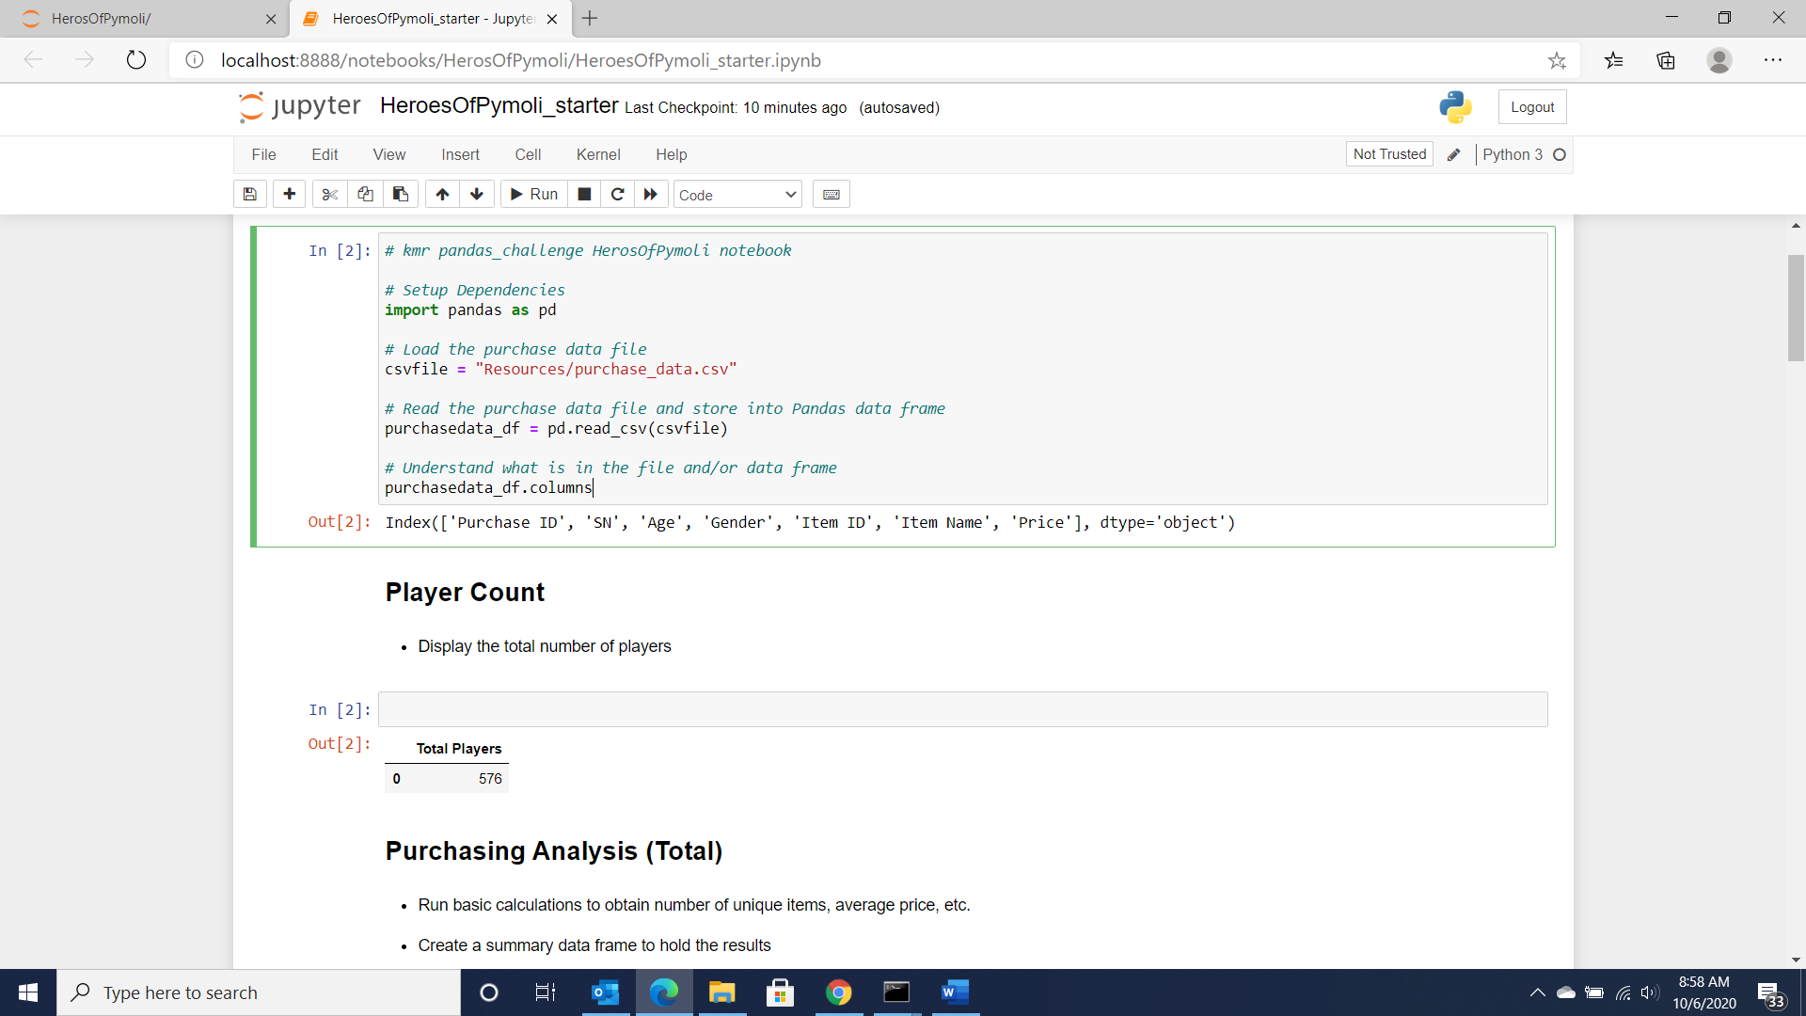

x