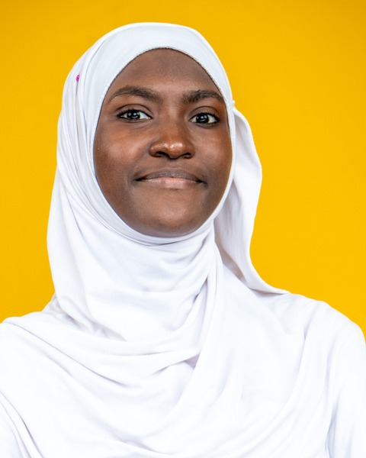
Binetou GUEYE
Front-End Developer – Angular & React | UI/UX
Dakar, Senegal | +221 77 678 77 11 | binetouguey3s@gmail.com
LinkedIn | GitHub | Portfolio
PROFILE
Front-End Developer certified by Simplon Senegal (Web, Mobile and AI Developer), specialized in Angular and React. I turn Figma mockups into responsive, accessible web and mobile interfaces connected to REST APIs. Trained in UI/UX design, I bridge user experience and code, and I integrate AI features into interfaces.
SKILLS
- Front-End Development: build responsive interfaces with Angular, React, TypeScript, JavaScript, HTML5, CSS3 and TailwindCSS
- Integration: turn Figma mockups into pixel-perfect pages, build PWAs and create animations (GSAP)
- Data Visualization: display dashboards and dynamic charts with Chart.js
- API Consumption: connect interfaces to REST APIs and manage asynchronous calls and application state
- UI/UX Design: create mockups, prototypes, logos and design systems in Figma
- Artificial Intelligence: integrate an AI chatbot, speech-to-text and text-to-speech into an interface
- Tools & Deployment: build with Vite and deploy continuously on Vercel and Netlify
- Methods: work with Scrum and Kanban (Scrum Master role) and version code with Git and GitHub
- Soft skills: rigor, adaptability, team spirit, autonomy, perseverance, curiosity
PROJECTS
Portfolio – Personal animated website November 2026
Front-End Developer
- Development of an animated portfolio with React 19, TypeScript, Vite and TailwindCSS.
- Animations built with GSAP and deployment on Vercel.
Sen Suivi – Mental well-being monitoring platform September – November 2026
Full-Stack Developer
- Certification project: Figma mockups and development of the Angular user interface.
- Interfaces for the three-level chatbot, the anonymous forum and matching with professionals.
- Mood journal, stress self-assessment tests and tracking dashboards, with voice input.
- Consumption of the Django REST APIs and continuous deployment of the front end on Vercel.
YEES NAA CONNECT – Marketplace for the local rice sector June – July 2026
Full-Stack Developer
- Integration of the Figma design system with TailwindCSS for the admin and processor pages.
- Workflow planning and task allocation for a 4-person team.
- Containerization with Docker and production deployment on LWS.
AgriMétéo Sénégal – Climate monitoring application June 2026
Front-End Developer
- Development of an Angular 17 SPA with TypeScript and TailwindCSS to monitor the climate in Senegal's 14 regions.
- Creation of Angular services and components, and integration of dynamic charts with Chart.js.
- Pair work with a branch-based Git workflow and writing of the technical documentation.
Sunu Signalement – Civic-tech incident reporting application June 2026
Front-End Developer
- Development of an Angular 17 application with standalone components to report urban incidents in Dakar.
- Delivery with complete documentation and a task breakdown.
Sunu Idées – AI-powered idea management application May – June 2026
Full-Stack Developer
- Evolution of the application from vanilla JavaScript to Vite.js, then to Angular.
- Supabase integration and automatic AI categorization of ideas through the OpenRouter API.
- Deployment on Vercel with a server-side proxy to protect the API key.
EDUCATION
Professional Certification – Web, Mobile and AI Developer (DWWM + AI) October 2026
Simplon Senegal, Dakar
Higher National Diploma (BTS) in Industrial Computing and Networks October 2023 – July 2025
Senegal-Japan Vocational and Technical Training Center (CFPT), Dakar
2nd-year Bachelor's in Mathematics, Physics and Computer Science October 2021 – February 2023
Alioune Diop University, Bambey
Scientific Baccalaureate (S2 series) July 2018
Groupe Scolaire Educazur
CERTIFICATIONS
Artificial Intelligence Certificate | FORCE-N Program (UN-CHK & Mastercard Foundation) 2026
Front-End Development Certificate | FORCE-N Program 2024
Cybersecurity Certificate – Women in Cybersecurity Education (WiCE) | Cyber221 2024
Digital Marketing Certificate | FORCE-N Program 2023
Computer and Internet Skills Certificate | FORCE-N Program 2023
INTERESTS
Writing | Tech watch and artificial intelligence
LANGUAGES
French: fluent | Wolof: native | English: intermediate (B1)

