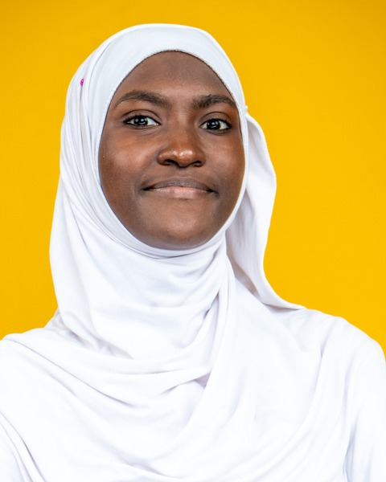
Binetou GUEYE
Full-Stack Web, Mobile & AI Developer
Dakar, Senegal | +221 77 678 77 11 | binetouguey3s@gmail.com
LinkedIn | GitHub | Portfolio
PROFILE
Full-Stack Web, Mobile and AI Developer certified by Simplon Senegal. I build complete web and mobile applications, from Figma mockups to continuous deployment in production, covering Angular or React front ends, Django and FastAPI back ends, and AI integration (LLMs, RAG). Used to working in Agile teams, I enjoy building useful solutions that meet real needs.
SKILLS
- Front-End Development: build responsive web and mobile interfaces with Angular, React, TypeScript and TailwindCSS, and create PWAs
- Back-End Development: design secure, documented REST APIs with Django, Django REST Framework and FastAPI, and test them with Pytest
- Databases: model data with Merise and UML, and manage PostgreSQL (Neon), MySQL, SQLite and Supabase
- Artificial Intelligence: integrate LLMs (Groq, Mistral), RAG (ChromaDB, embeddings), speech-to-text, text-to-speech and computer vision (Hugging Face)
- Automation: build n8n workflows (reminders, notifications, indexing) and scheduled jobs with GitHub Actions
- DevOps & Deployment: containerize with Docker and Docker Compose, and deploy continuously on Vercel, Render, Netlify and LWS
- Design & UI/UX: analyze needs, model in UML, and create mockups, prototypes and logos in Figma
- Agile Project Management: run projects with Scrum and Kanban, act as Scrum Master and write project scoping documents
- Collaboration: work in teams with Git, GitHub and Git Flow, following conventional commits
- Soft skills: rigor, adaptability, team spirit, autonomy, perseverance, curiosity
PROJECTS
Sen Suivi – Mental well-being monitoring platform September – November 2026
Full-Stack Developer
- Certification project: Angular, Django REST Framework and PostgreSQL (Neon) application with a FastAPI AI microservice.
- Three-level chatbot with distress detection, built on RAG (ChromaDB, Mistral) and LLMs served through Groq.
- AI-moderated anonymous forum, matching with professionals, speech-to-text and text-to-speech.
- Automation with n8n and continuous deployment of three services (GitHub Actions, Vercel, Render).
Andë Sétal – Civic-tech platform for urban sanitation August 2026
Back-End Lead
- Design of the REST API (Django 5, DRF, MySQL) for citizen incident reporting for the Dakar Plateau city hall.
- Contribution to a full architecture: Angular PWA, TailwindCSS, AI module (FastAPI, Hugging Face, RAG) and Docker.
- Git Flow team organization and delivery of the project in 8 days with a cross-functional team.
AI Quality Control – Computer vision image inspection July 2026
AI Developer
- FastAPI microservice that analyzes product images and returns a compliant or defective diagnosis.
- Comparison of two Hugging Face models (ViT and ResNet-50) and selection of ResNet-50, lighter on CPU.
- File validation (JPEG, PNG, WebP, 5 MB maximum) and a confidence threshold set at 0.70.
YEES NAA CONNECT – Marketplace for the local rice sector June – July 2026
Full-Stack Developer
- Django architecture with 5 apps and end-to-end product traceability using QR codes.
- Integration of the Figma design system with TailwindCSS and task allocation for a 4-person team.
- Containerization with Docker and production deployment on LWS.
AgriMétéo Sénégal – Climate monitoring application June 2026
Front-End Developer
- Development of an Angular 17 SPA with TypeScript and TailwindCSS to monitor the climate in Senegal's 14 regions.
- Creation of Angular services and components, and integration of dynamic charts with Chart.js.
- Pair work with a branch-based Git workflow and writing of the technical documentation.
Sunu Idées – AI-powered idea management application May – June 2026
Full-Stack Developer
- Evolution of the application from vanilla JavaScript to Vite.js, then to Angular.
- Supabase integration and automatic AI categorization of ideas through the OpenRouter API.
- Deployment on Vercel with a server-side proxy to protect the API key.
EDUCATION
Professional Certification – Web, Mobile and AI Developer (DWWM + AI) October 2026
Simplon Senegal, Dakar
Higher National Diploma (BTS) in Industrial Computing and Networks October 2023 – July 2025
Senegal-Japan Vocational and Technical Training Center (CFPT), Dakar
2nd-year Bachelor's in Mathematics, Physics and Computer Science October 2021 – February 2023
Alioune Diop University, Bambey
Scientific Baccalaureate (S2 series) July 2018
Groupe Scolaire Educazur
CERTIFICATIONS
Artificial Intelligence Certificate | FORCE-N Program (UN-CHK & Mastercard Foundation) 2026
Front-End Development Certificate | FORCE-N Program 2024
Cybersecurity Certificate – Women in Cybersecurity Education (WiCE) | Cyber221 2024
Digital Marketing Certificate | FORCE-N Program 2023
Computer and Internet Skills Certificate | FORCE-N Program 2023
INTERESTS
Writing | Tech watch and artificial intelligence
LANGUAGES
French: fluent | Wolof: native | English: intermediate (B1)

