**Original:**

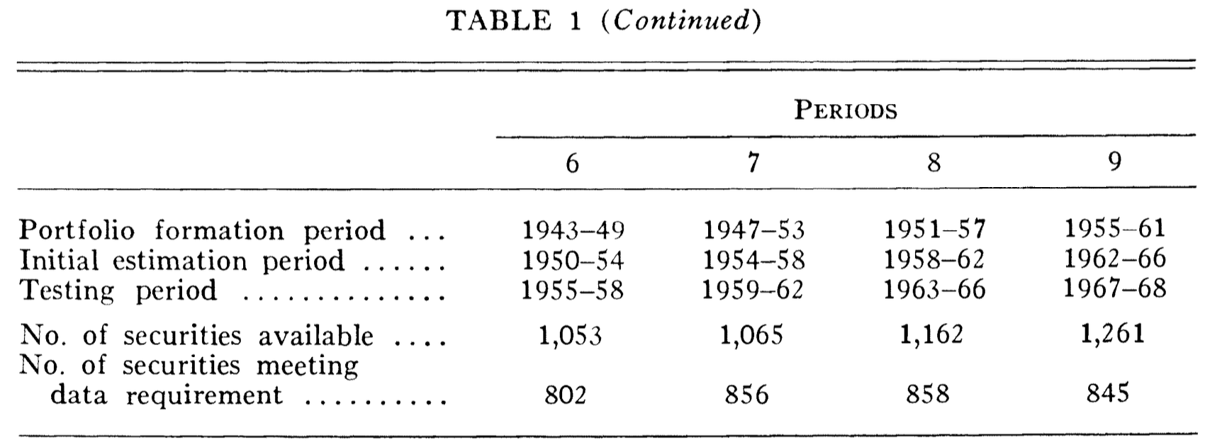

**Replicated:**

The numbers in the replicated table in general match the ones in the original table. However, they are consistently lower in the number of securities available and number of securities meeting data requirement than the original ones. There are two main reasons causing the discrepancy.

* Ongoing historical corrections.

CRSP continually audits and retroactively corrects historical records. Each release can change past security information and even index histories. So stock counts at specific month-ends can be slightly different to what was available in 1970s. CRSP also completed a major project in 2005 to compile and merge daily data back to 1925 for NYSE securities. The post-FM enhancement can affect derived monthly status thus impacting the availability of certain securities in a given window.

* Delisting data handling method.

The treatment and storage of delisting returns have changed over time. Modern best practice also corrects missing delisting returns to mitigate delisting bias—an issue documented well after 1973—so contemporary replications often differ from tables built before these corrections existed. The different methods used to treat delisted securities can also be a source of the discrepancy.

Despite of the reasons that might have caused the small differences in the numbers, our replication is very close to the original work in data preparation/exclusions and the final numbers. This will have minimal impact to the next steps we have replicated.

**Original:**

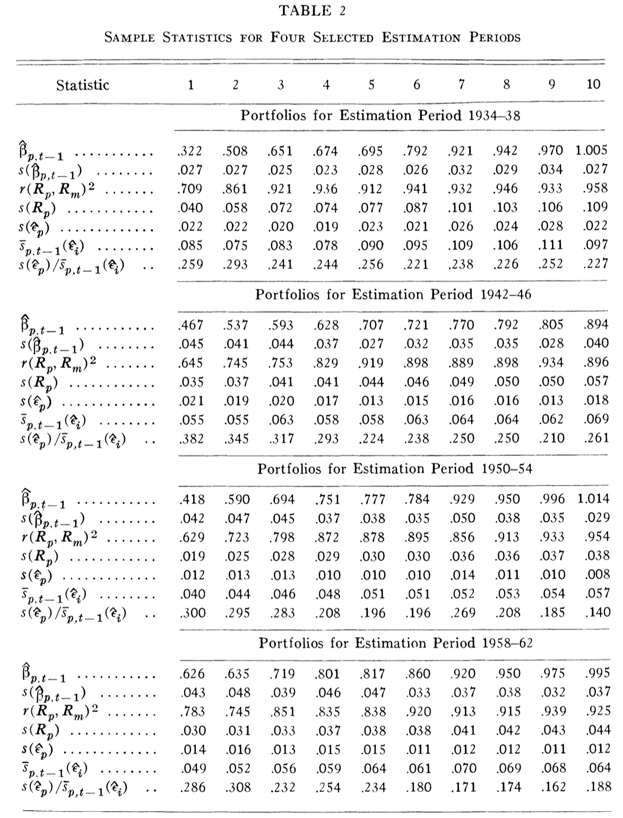

**Original:**

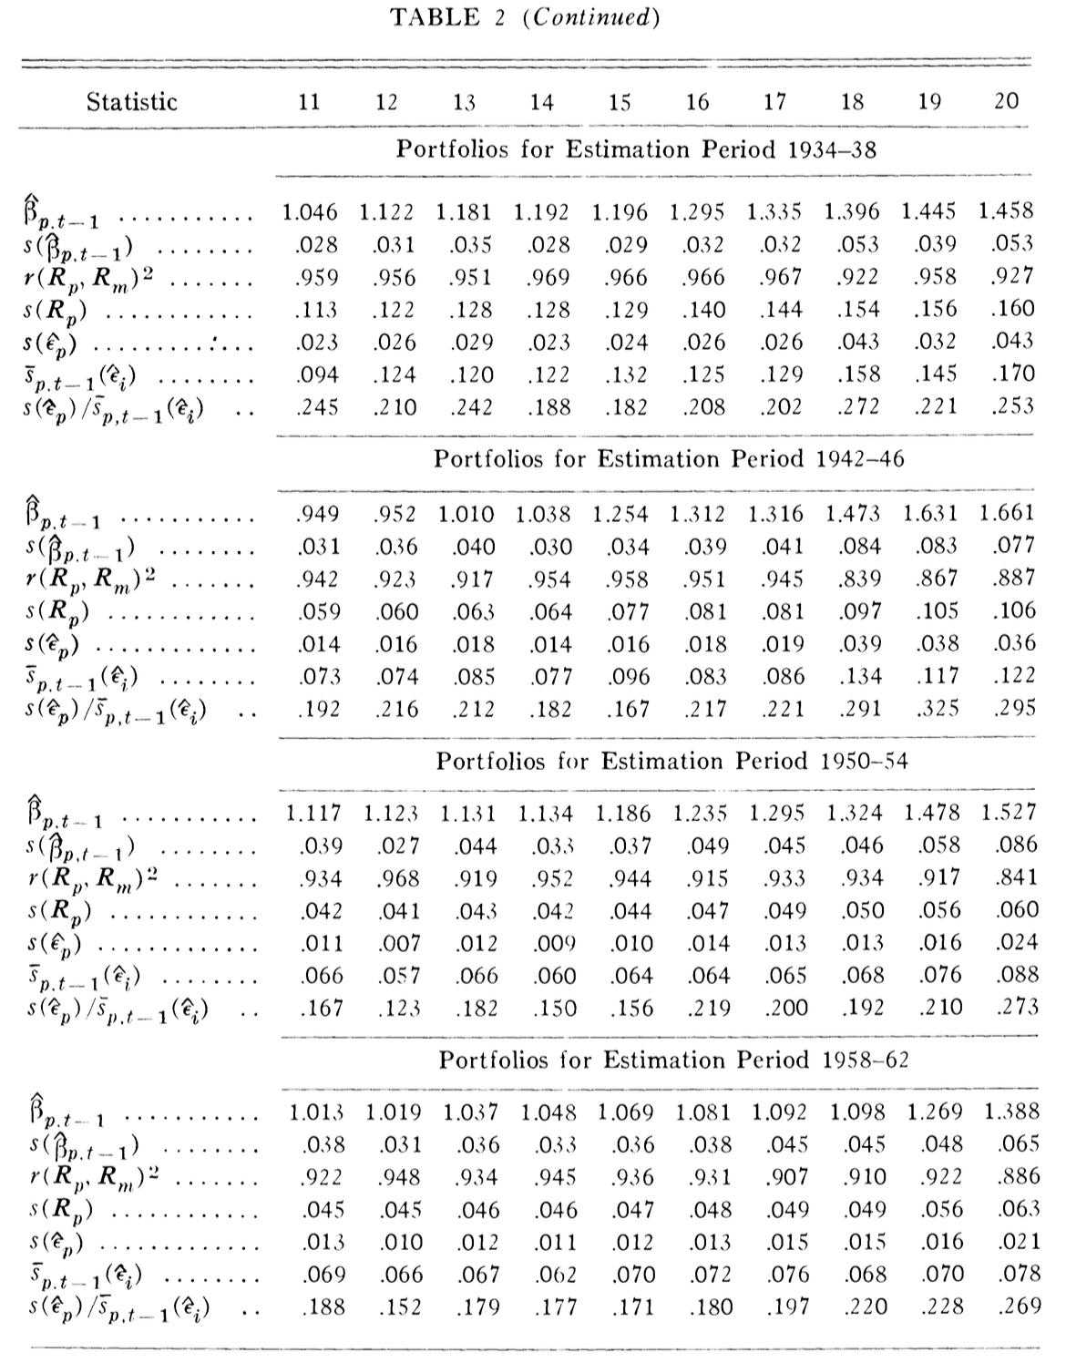

**Replicated:**

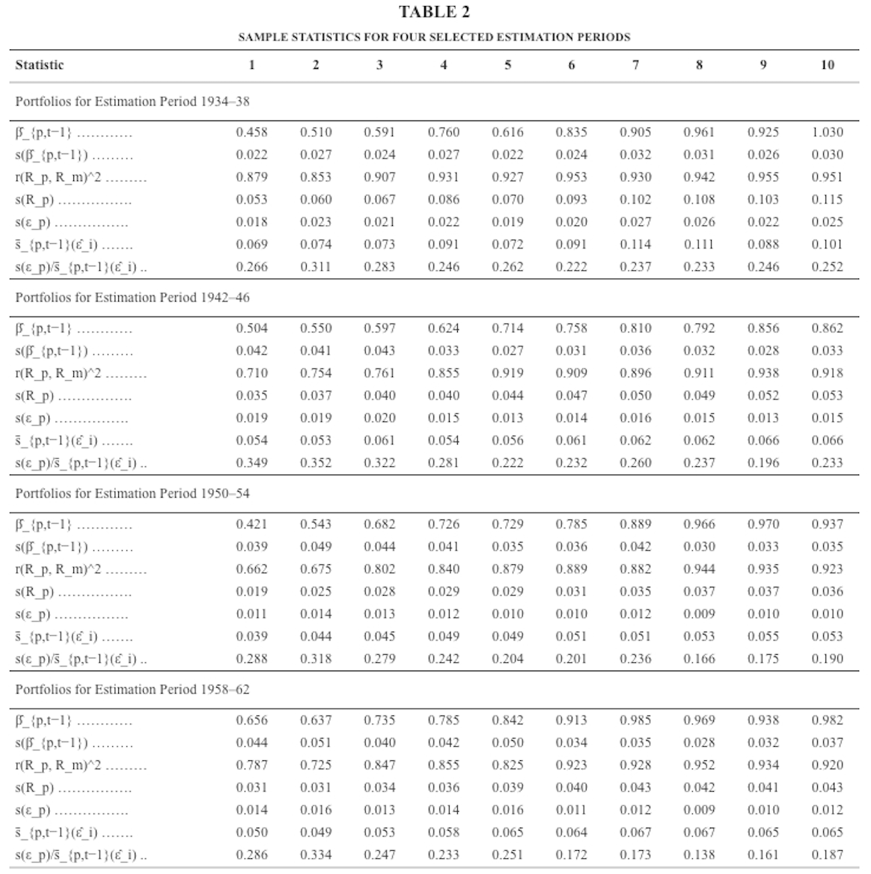

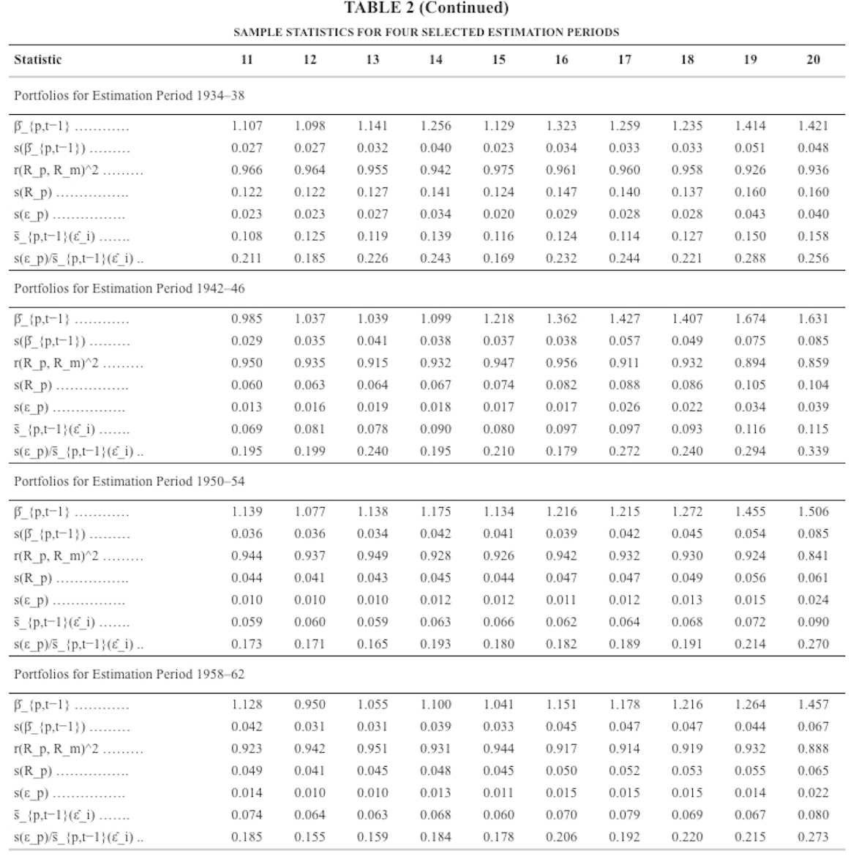

Our replicated results are quite close to the original ones for all metrics. There are three additional checks we have done:

1. Monotonicity of betas across 20 portfolios

The original table does perfectly in this aspect while ours see some reversal in a few portfolios for almost every estimation period. We interpret this as noise as the pattern and trend is there and consistent with those from the original tables. The inconsistency does not change any conclusions drawn from the numbers compared to those from the original table.

1. High R squared observed for all portfolios

FM report very large R squared when regression equal-weighted portfolio returns on the market. Not only our replicated R squared match almost perfectly to the original ones, but also the standard deviations are almost identical, which confirms the conclusions drawn by FM and also the consistency of the methods we used compared to the original ones.

1. Diversification gain

The ratio calculated in the last row indicates that diversification removes idiosyncratic noises and our replicated numbers are all within the same range shared by the original table.

**Original:**

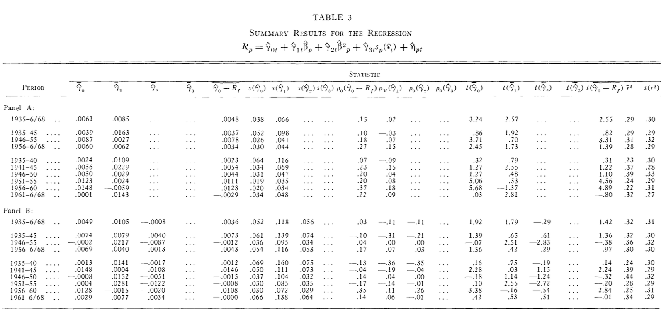

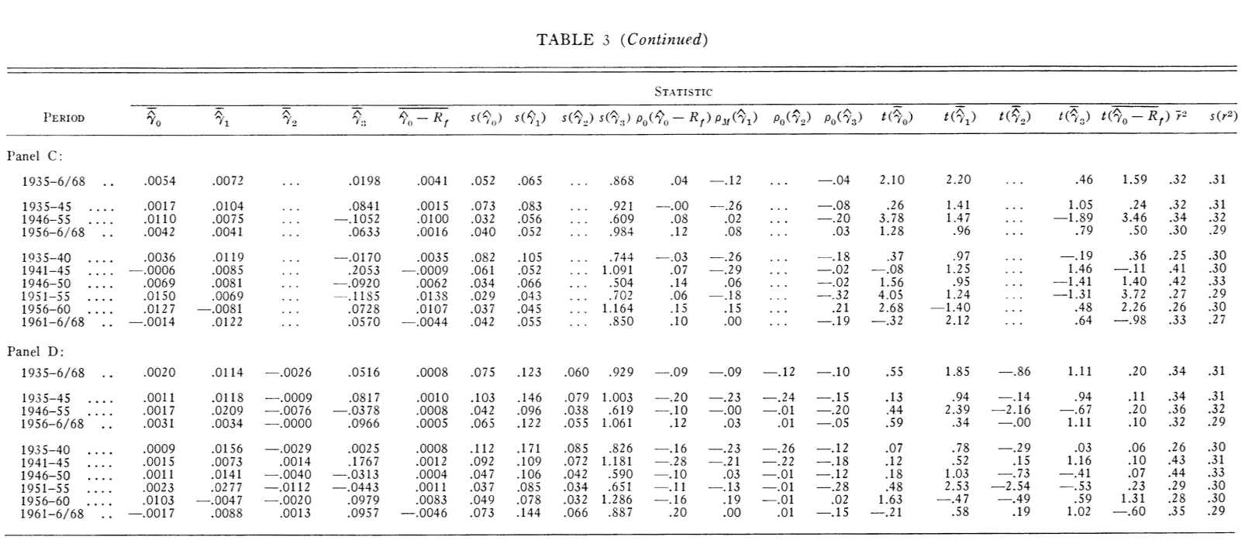

**Replicated:**

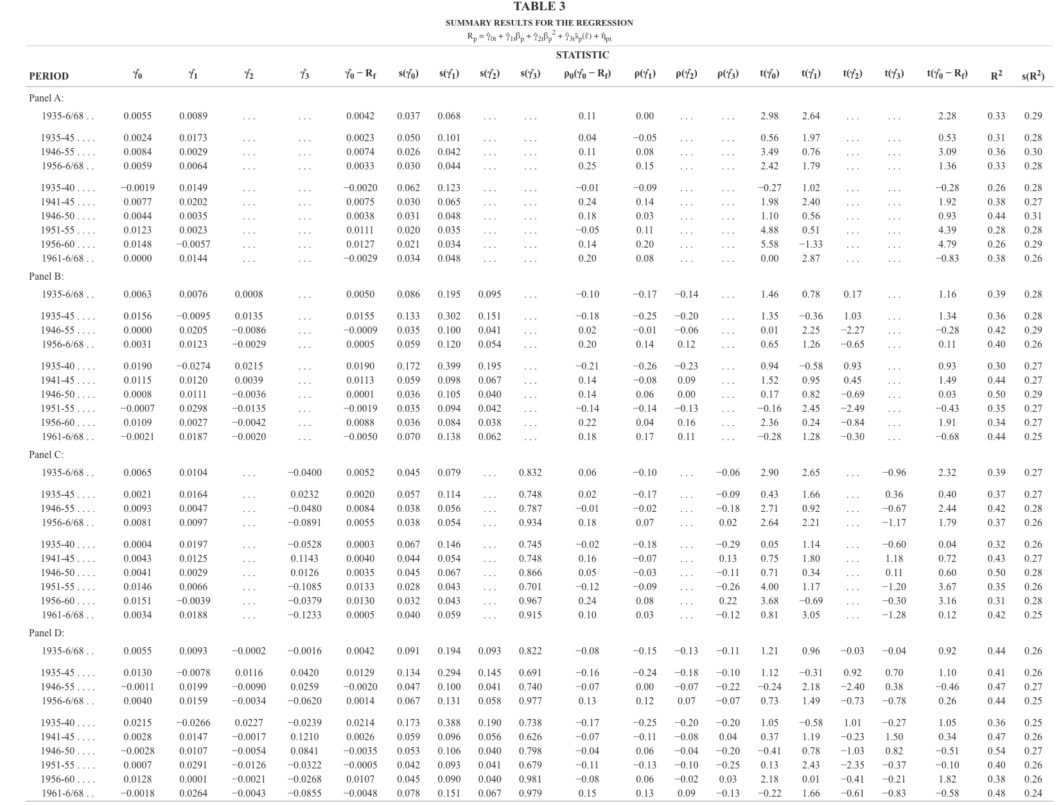

In general, our results are in line with the ones from the original table. Our models (A-D) match FM’s one, two and three variable cross-sectional regressions on the 20 beta-sorted portfolios. The regressors and model structure line up with FM’s for the monthly cross-sections. Also, in FM, gamma 1 (the price of beta risk) is generally positive. The quadratic term and idiosyncratic risk aren’t reliably priced and the one-variable model from Panel A yields intercept tests that most strongly reject Sharpe-Lintner, while adding beta squared and standard deviation (Panel B and D) makes the SL stats closer to zero. Our results are consistent with the original ones broadly.

Admittedly, there exist some discrepancy among our results and FM’s results. The source of the difference might come from the different market proxies being used, different risk-free rate used, and as mentioned above the delistings and portfolio constructions due to different availability of the securities today and in 1970s.

But overall, the Panel A results from us show positive and significant Sharpe-Lintner stats which are weakened in the Panel B and D, which are consistent with FM’s core findings. The small difference is unlikely from the conceptual mismatch.