**Bingbing Feng**

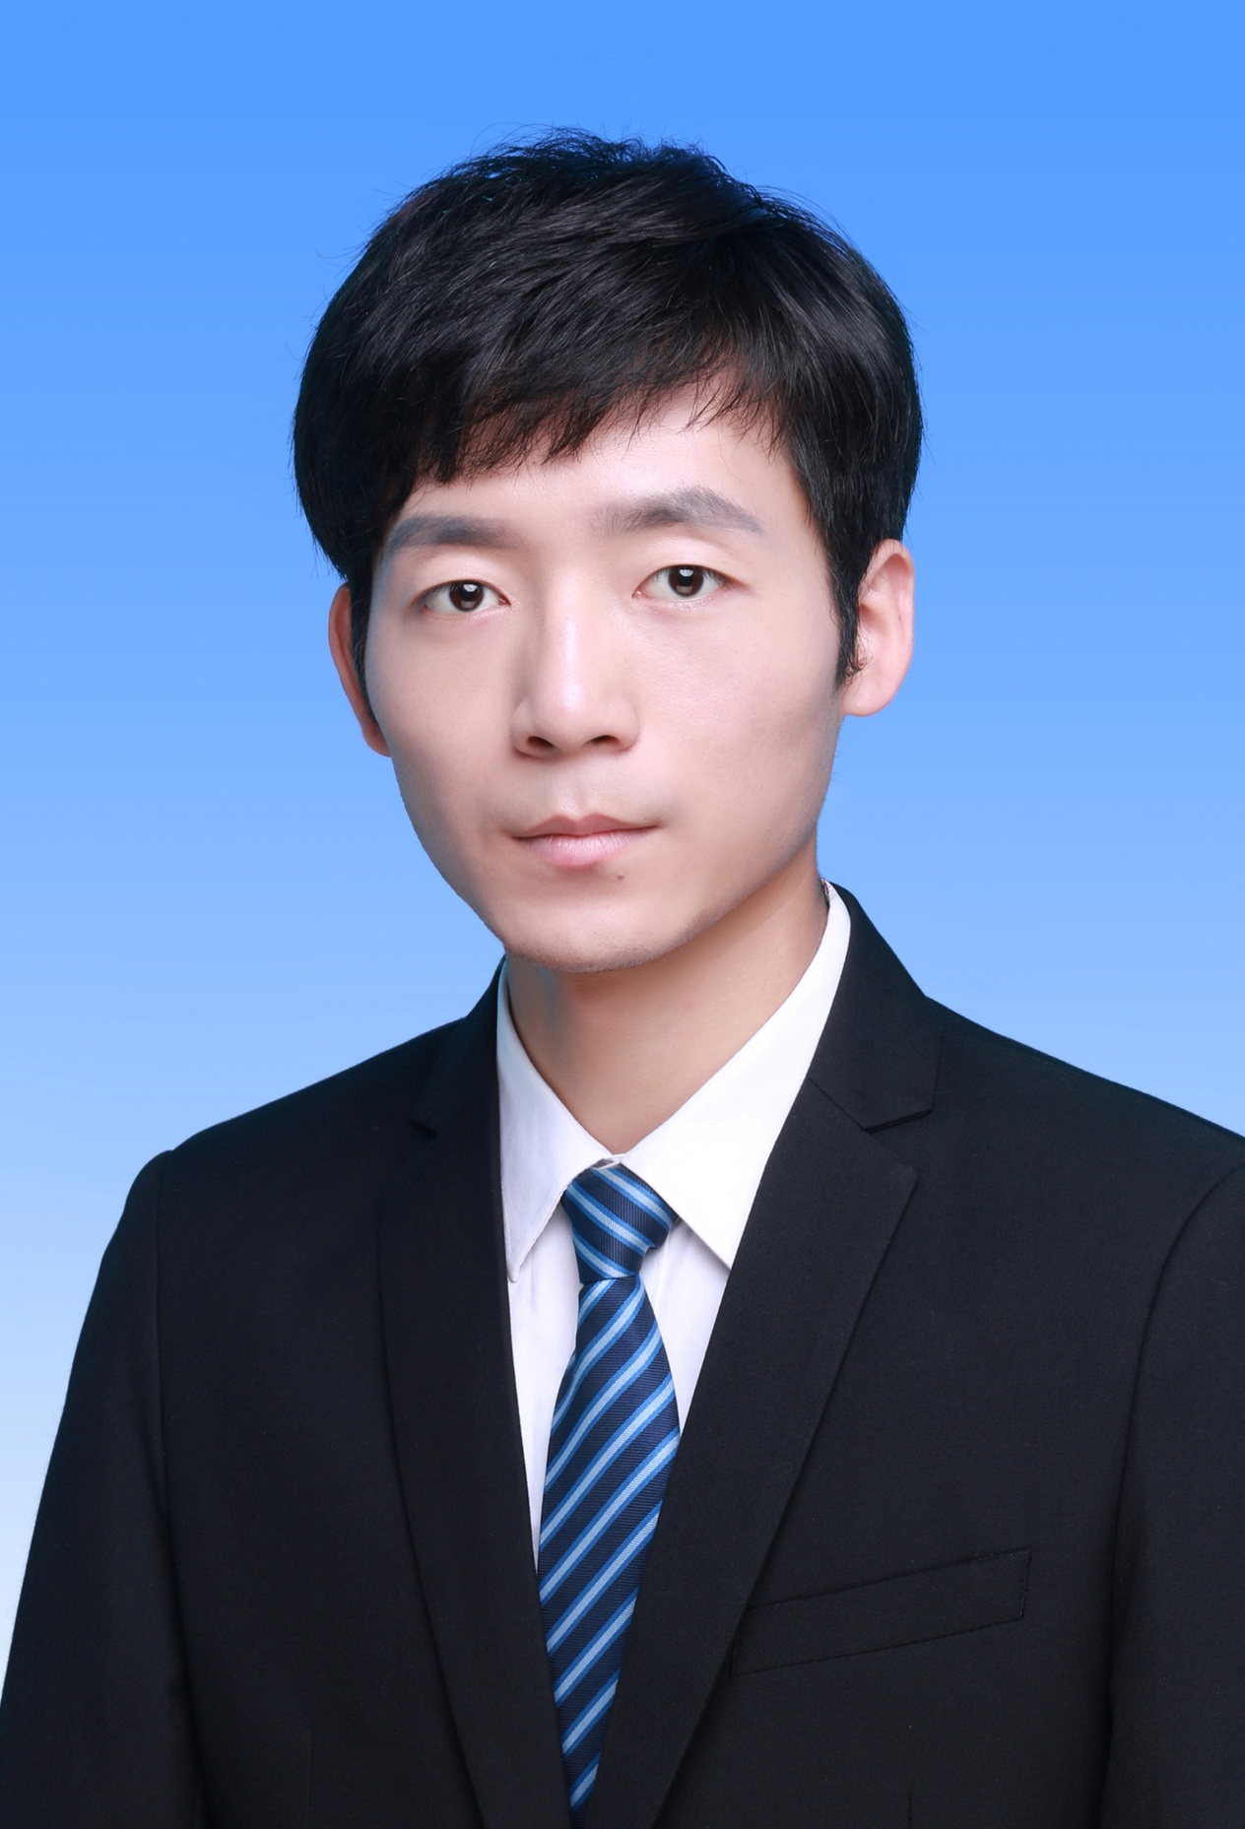

Email: [bbingfeng@yeah.net](mailto:bbingfeng@yeah.net)

dean.feng.cs@gmail.com

**Research Interests**

**Speech**: Speech Recognition, Speech Enhancement

**Chaos**: Nonlinear Dynamics, Complex Networks Analysis

**Publications**

1. [Chengqing Li (supervisor)](https://ieeexplore.ieee.org/author/37897392900), [**Bingbing Feng**](https://ieeexplore.ieee.org/author/37086555080), [Shujun Li](https://ieeexplore.ieee.org/author/37067151000), [Jürgen Kurths](https://ieeexplore.ieee.org/author/38527166800), [Guanrong Chen](https://ieeexplore.ieee.org/author/37085348099),

“**Dynamic Analysis of Digital Chaotic Maps via State-Mapping Networks**,”

[*IEEE Transactions on Circuits and Systems I: Regular Papers*](https://ieeexplore.ieee.org/document/8602460), vol. 66, no. 5, pp. 1–14, 2019

[doi](https://ieeexplore.ieee.org/document/8602460) [Latex Source Files](https://bingbingfeng1993.github.io/files/latex/2019-Dynamic_Analysis_of_Digital_Chaotic_Maps_via_State-Mapping_Networks.tar.gz) [Code](https://bingbingfeng1993.github.io/files/codes/2019-Dynamic_Analysis_of_Digital_Chaotic_Maps_via_State-Mapping_Networks-Code.tar.gz) [2022 IEEE Guillemin-Cauer Best Paper Award](https://ieee-cas.org/paper-award/outstanding-paper-awards/ieee-transactions-circuits-and-systems-guillemin-cauer-best)

1. [Chengqing Li (supervisor)](https://ieeexplore.ieee.org/author/37897392900), [Kai Tan](https://ieeexplore.ieee.org/author/37088984330), [**Bingbing Feng**](https://ieeexplore.ieee.org/author/37086555080), [Jinhu Lü](https://ieeexplore.ieee.org/author/37278641900),

“**The graph structure of the generalized discrete Arnold Cat map**,”

[*IEEE Transactions on Computers*](https://ieeexplore.ieee.org/document/9321487), vol. 71, no. 2, pp. 364-377, 2022

[doi](https://ieeexplore.ieee.org/document/9321487) [Latex Source Files](https://bingbingfeng1993.github.io/files/latex/2022-The_Graph_Structure_of_the_Generalized_Discrete_Arnolds_Cat_Map.tar.gz) **ESI Highly Cited Paper**

1. [Chengqing Li (supervisor)](https://ieeexplore.ieee.org/author/37897392900), [Dongdong Lin](https://ieeexplore.ieee.org/author/37086106583), [**Bingbing Feng**](https://ieeexplore.ieee.org/author/37086555080), [Jinhu Lü,](https://ieeexplore.ieee.org/author/37278641900)[Feng Hao](https://ieeexplore.ieee.org/author/37085889634),

“**Cryptanalysis of a Chaotic Image Encryption Algorithm Based on Information Entropy**,”

[*IEEE Access*](https://ieeexplore.ieee.org/document/8548554), vol. 6, pp. 75834–75842, 2018

[doi](https://ieeexplore.ieee.org/document/8548554) [Latex Source Files](https://bingbingfeng1993.github.io/files/latex/2018-Cryptanalysis_of_a_Chaotic_Image_Encryption_Algorithm_Based_on_Information_Entropy.tar.gz) [Code](https://bingbingfeng1993.github.io/files/codes/2018-Cryptanalysis_of_a_Chaotic_Image_Encryption_Algorithm_Based_on_Information_Entropy-Code.tar.gz) **ESI Highly Cited Paper**

**Patents**

1. Lirong Ye (CEO), **Bingbing Feng**, Danping Luo,

“**Door Area Identification Method, Door Area Identification System and Cleaning Robot for Home Environment**,”

*CN Patent 110,141,164 (2021)* [PDF](https://bingbingfeng1993.github.io/files/patents/CN201910511838.X.pdf)

1. Danping Luo, **Bingbing Feng**,

“**Door Position Identification Method and Mobile Robot**,”

*CN Patent 110,269,550 (2021)* [PDF](https://bingbingfeng1993.github.io/files/patents/CN201910511122.X.pdf)

**Refereed Journals**

[IEEE Transactions on Circuits and Systems I: Regular Papers](https://mc.manuscriptcentral.com/tcas1)

[International Journal of Bifurcation and Chaos](https://www.worldscientific.com/worldscinet/ijbc), World Scientific

**Education**

**M.Sc.** in Computer Science and Technology 2015.09 – 2018.06

[Xiangtan University](https://www.xtu.edu.cn/), Hunan, China

Supervisor: [Prof. Chengqing Li](http://www.chengqingli.com/)

Master's Thesis: [Network Analysis of Dynamics of Chaotic Systems in Digital Domain](https://bingbingfeng1993.github.io/files/publications/2018-Bingbing_Feng-MSC-Network_Analysis_of_Dynamics_of_Chaotic_Systems_in_Digital_Domain.pdf)

**B.Sc.** in Computer Science and Technology 2011.09 – 2015.06

[Xiangtan University](https://www.xtu.edu.cn/), Hunan, China

Majors: Linear Algebra (100 out of 100)

Mathematical Analysis (90 out of 100)

Probability and Mathematical Statistics (100 out of 100)

Complex Function and Integral Transform (99 out of 100)

**Work Experience**

* **Algorithm Researcher**

[Silver Star](https://www.silverstar-robot.com/), Shenzhen, China 2018.07 – 2019.07

Worked on VSLAM (Visual Simultaneous Localization and Mapping) for floor mopping robot.

* **Speech Recognition Algorithm Researcher**

[eMeet](https://emeet.com/), Shenzhen, China 2019.11 – 2022.11

Worked on end-to-end ASR (Automatic Speech Recognition), improving AED (Attention-based Encoder-Decoder) model with chunk-wise self-attention and speech enhancement for robust streaming ASR, developing important production-oriented features ranging from ITN (Inverse Text Normalization), Punctuation Restoration, Contextual Biasing and Endpoint Detection.

**Awards**

* 2022 [IEEE Transactions on Circuits and Systems Guillemin-Cauer Best Paper](https://ieee-cas.org/paper-award/outstanding-paper-awards/ieee-transactions-circuits-and-systems-guillemin-cauer-best)

**Skills**

* Programming: MATLAB (advanced level), Python (advanced level), C/C++ (advanced level).
* Software: LaTeX, Bash, Git.
* Languages: English (basic level), Chinese (mother tongue), Japanese (basic level).
* Hobbies: Cycling, Reading.