Ve370 Introduction to Computer Organization
Homework 6 with problems

- Exercise 4.21.4 (b), refer to the following figure instead of Figure 4.60. (20 points)
- Exercise 4.21.5 (b), refer to the following figure instead of Figure 4.60. (10 points)
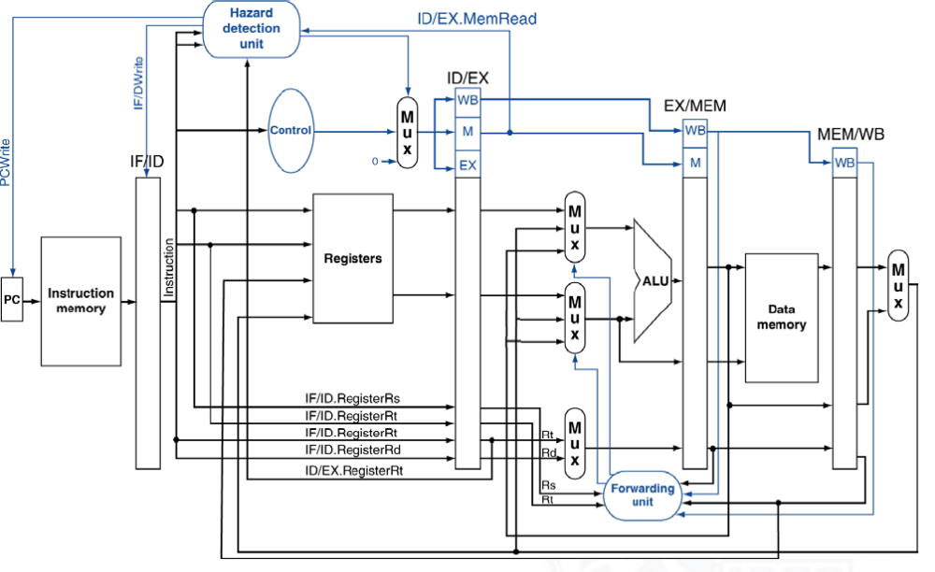
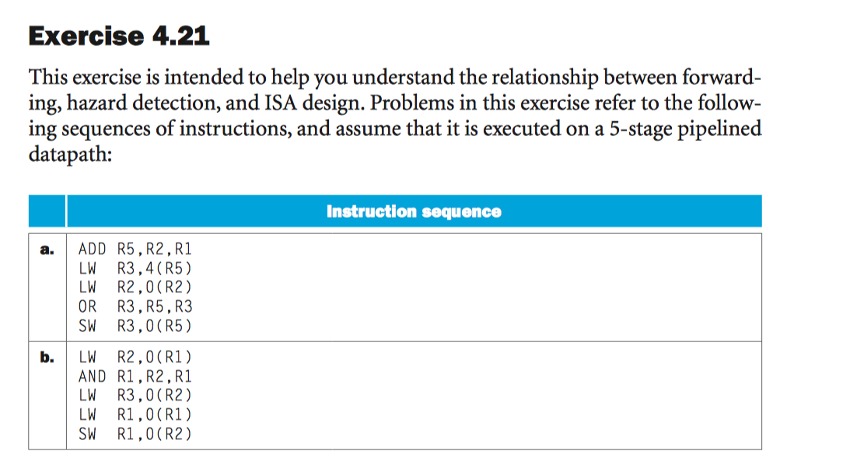

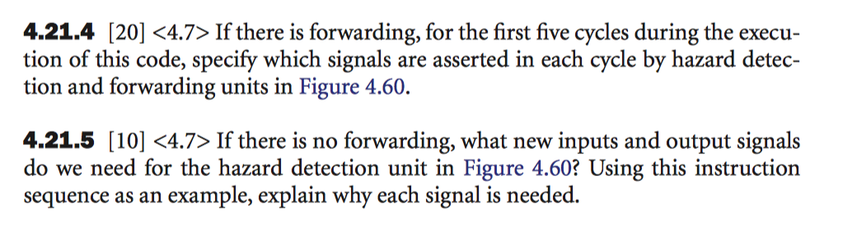

- Exercise 4.22.4 (b) (10 points)
- Exercise 4.22.5 (b) (10 points) 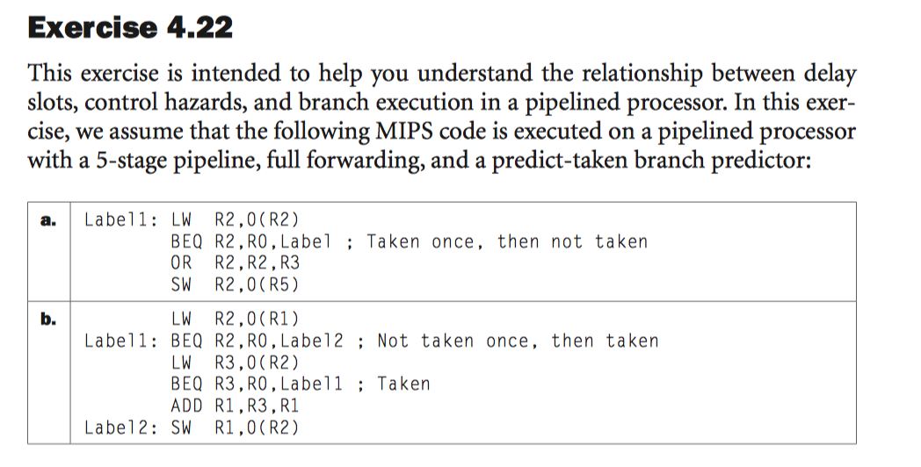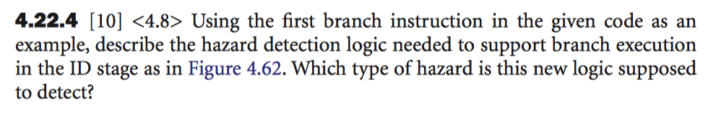
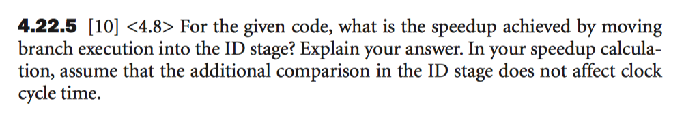
- Exercise 4.23.1 (a) (10 points)
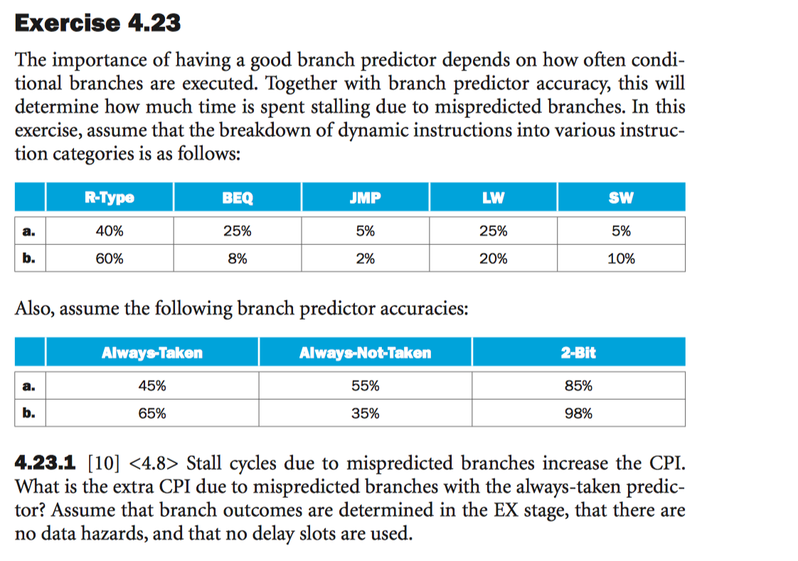
- Exercise 4.24.1 (b) (5 points)
- Exercise 4.24.2 (b) (5 points)
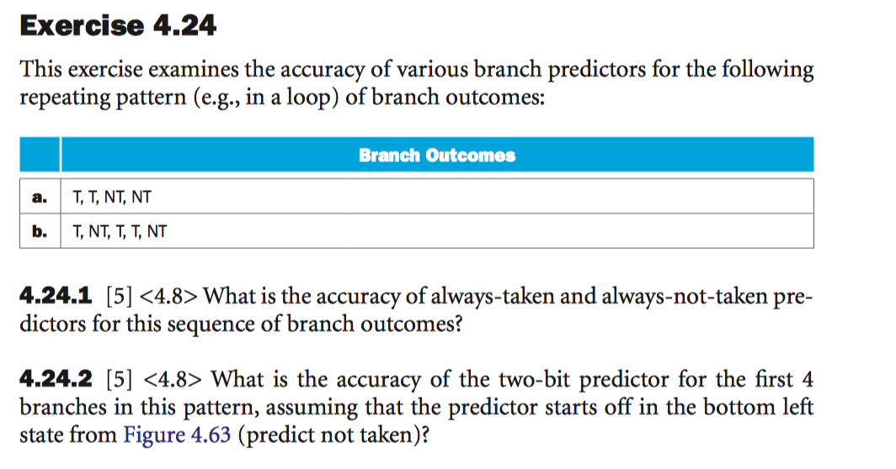
- Exercise 4.26.1 (b), refer to the following figure instead of Figure 4.66. (5 points)

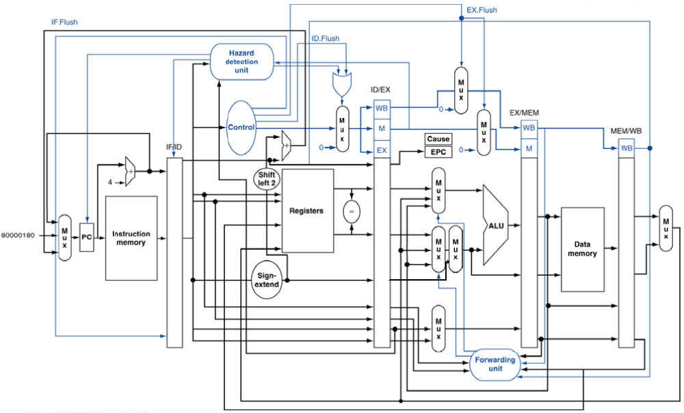
- Exercise 4.26.2 (a) (5 points)
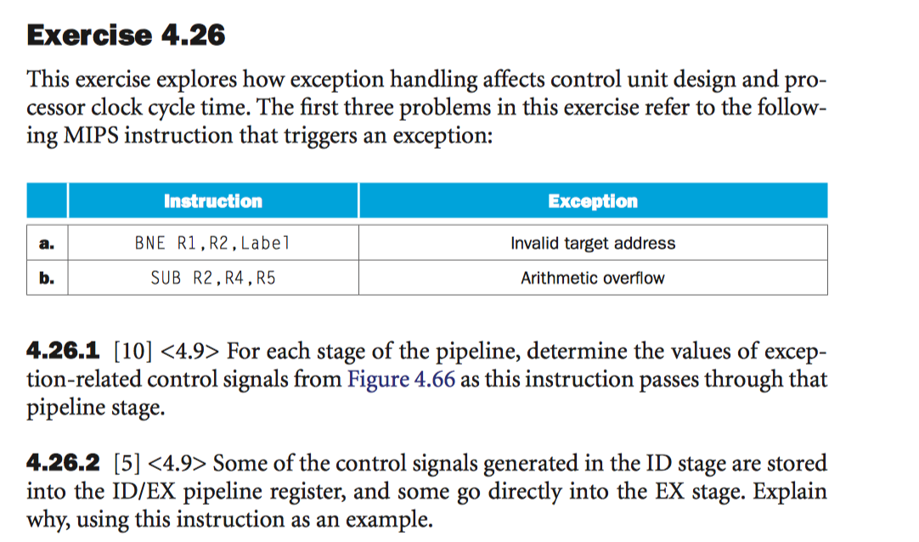

- Excercise 4.27.4 (b) (20 points)
