Ve370 Introduction to Computer Organization
Homework 1

- Exercise 1.3.1 ~ 1.3.3 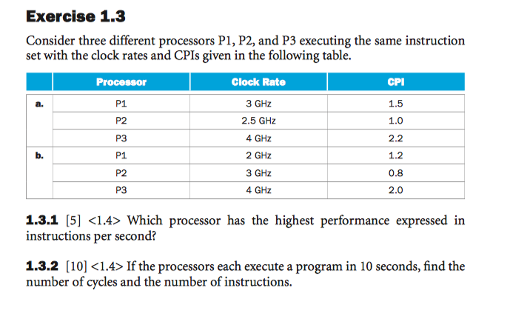
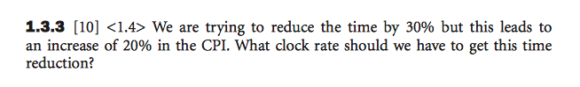
- Exercise 1.4.4 ~ 1.4.6
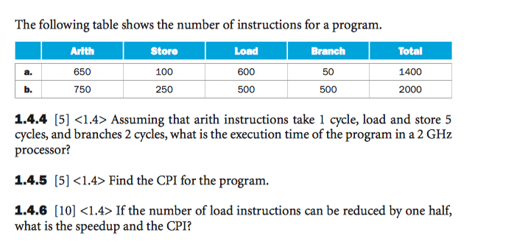
- Exercise 1.10.1 ~ 1.10.5
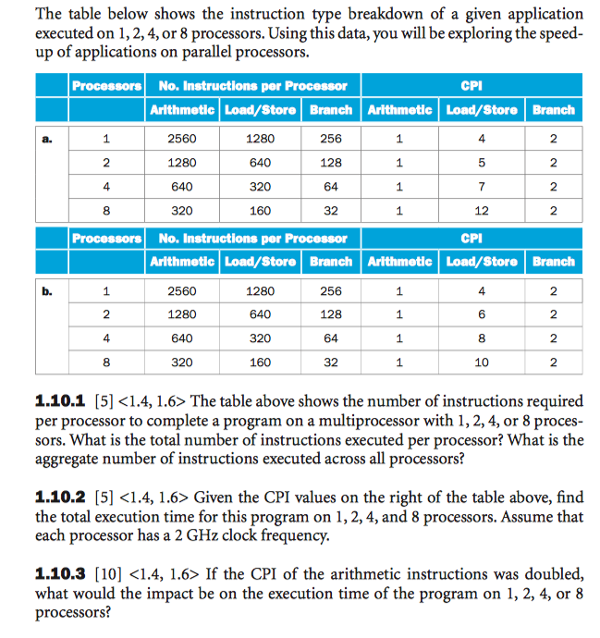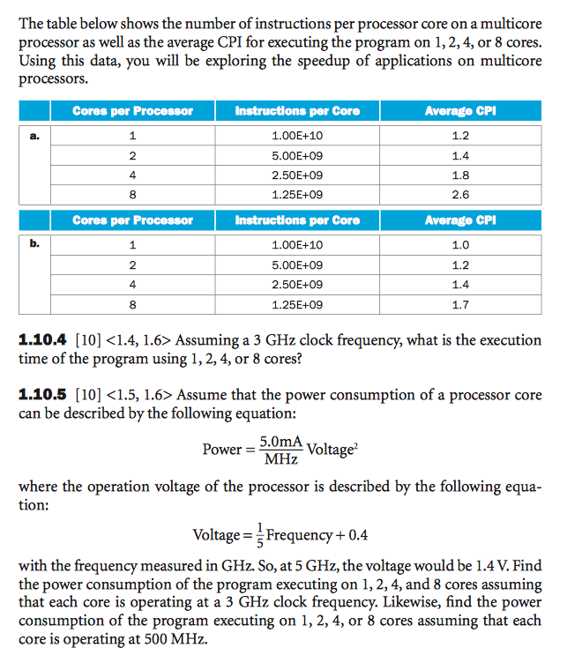
- Exercise 2.3.1
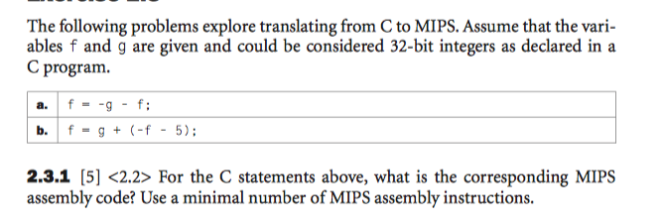
- Exercise 2.6.1
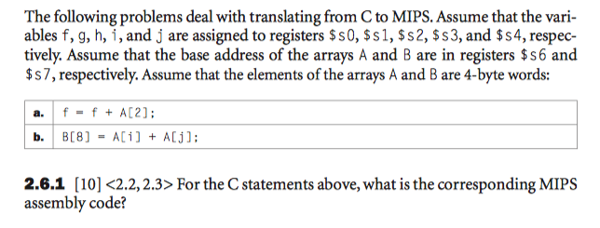
- Exercise 2.6.4
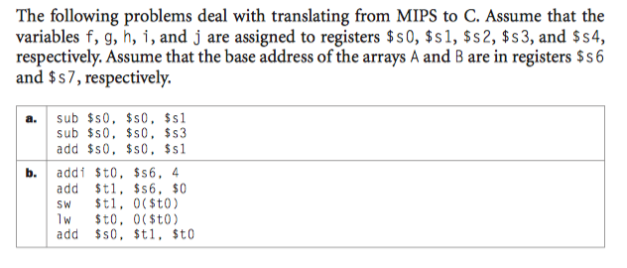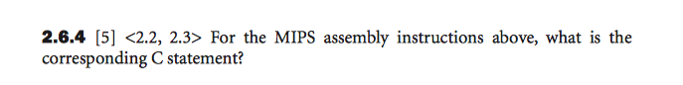
- Exercise 2.10.1, 2.10.2
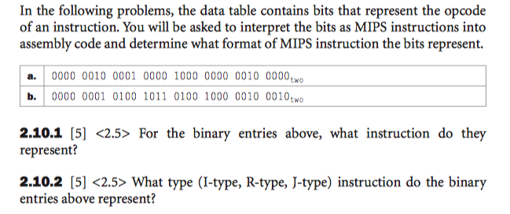
- Exercise 2.10.4, 2.10.5
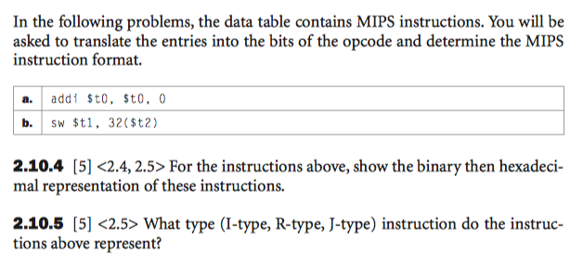
- Exercise 2.12.1, 2.12.2
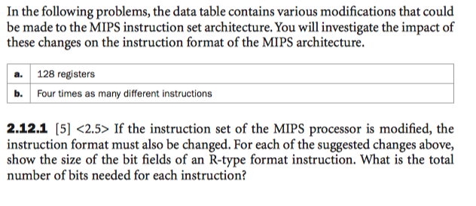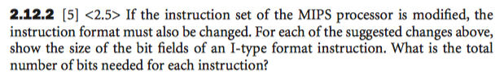
- Exercise 2.13.3
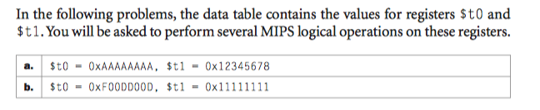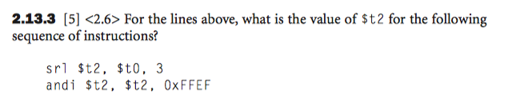
- Exercise 2.14.1
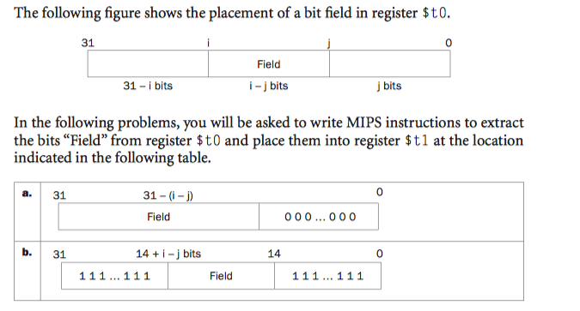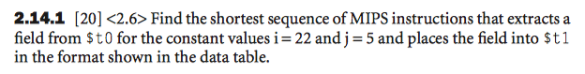
- Exercise 2.16.4
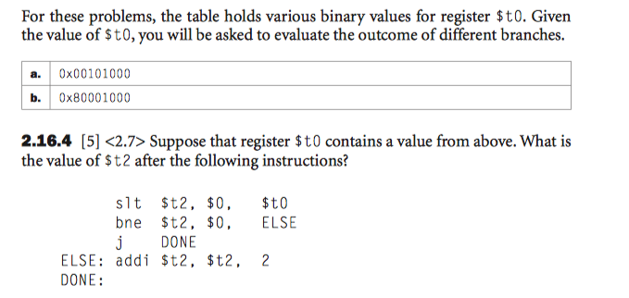
- Exercise 2.17.3
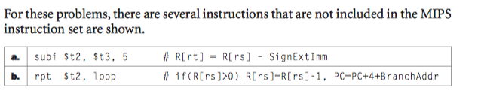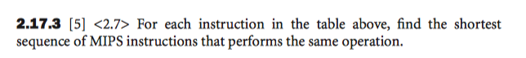
- Exercise 2.17.4
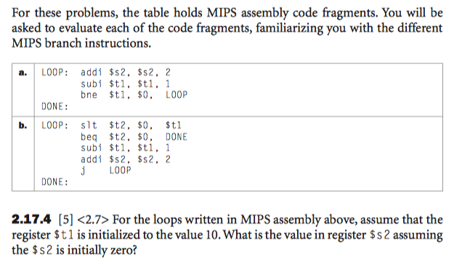
- Exercise 2.18.4, 2.18.5, 2.18.6
