# 实验七：组合模式

个人与组织：个人必定属于每一个组织，组织可以组合成更大的组织。

### (1) 安全组合模式

#### 1.1 UML图



#### 1.2 代码

|  |
| --- |
| **package** cn.edu.scau.cmi.lizhibin.componsite.safe;  **public** **abstract** **class** Member {  } |

|  |
| --- |
| **package** cn.edu.scau.cmi.lizhibin.componsite.safe;  **import** java.util.List;  **public** **class** Organization **extends** Member{  **private** List<Member> team;  **public** **void** add(Member member) {  team.add(member);  System.***out***.println("添加成功");    }  **public** **void** delete(Member member) {    team.remove(member);  System.***out***.println("删除成功");  }      } |

|  |
| --- |
| **package** cn.edu.scau.cmi.lizhibin.componsite.safe;  **public** **class** Person **extends** Member{    } |

|  |
| --- |
| **package** cn.edu.scau.cmi.lizhibin.client;  **import** cn.edu.scau.cmi.lizhibin.componsite.safe.*;  **public** **class** CompositeSafeClient {  **public** **static** **void** main(String[] args) {  Organization group1 = **new** Organization();    Organization group2 = **new** Organization();  Member people = **new** Person();  group1.add(group2);  group1.add(people);  }  } |

### (2) 一致性组合模式

#### 2.1 UML图



#### 2.2 代码

|  |
| --- |
| **package** cn.edu.scau.cmi.lizhibin.componsite.transparent;  **import** java.util.List;  **public** **class** Organization **implements** Member{  **private** List<Member> team;  **public** **void** add(Member member) {  team.add(member);  System.***out***.println("添加成功");    }  **public** **void** delete(Member member) {    team.remove(member);  System.***out***.println("删除成功");  }  } |

|  |
| --- |
| **package** cn.edu.scau.cmi.lizhibin.client;  **import** cn.edu.scau.cmi.lizhibin.componsite.transparent.*;  **public** **class** CompositeTransparentClient {  **public** **static** **void** main(String[] args) {  Member group1 = **new** Organization();    Member group2 = **new** Organization();  Member people = **new** Person();  group1.add(group2);  group1.add(people);    }  } |

|  |
| --- |
| **package** cn.edu.scau.cmi.lizhibin.componsite.transparent;  **public** **interface** Member {  **public** **void** add(Member member);  **public** **void** delete(Member member);  } |

|  |
| --- |
| **package** cn.edu.scau.cmi.lizhibin.componsite.transparent;  **public** **class** Person **implements** Member{    @Override  @Deprecated  **public** **void** ~~add~~(Member member) **throws** UnsupportedOperationException{  **throw** **new** UnsupportedOperationException();  }    @Override  @Deprecated  **public** **void** ~~delete~~(Member member) **throws** UnsupportedOperationException{  **throw** **new** UnsupportedOperationException();  }  } |

实验效果

safe:

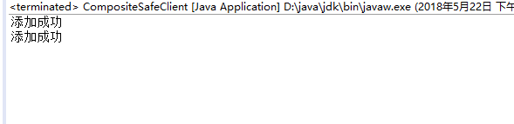

transparent:

