**SCI5590 Advanced Software Engineering**

# Agile-Mind

# Project Proposal & Plan

1. Project Proposal

**Members :**

Kendal Bingham

Vidya Sridhar

# Introduction

Memory games are a proven technique to stimulate the retention power as well as overall cognitive sense. Our focus is on designing a mobile application that helps people ranging from children to adults, to think fast and recognize shapes/symbols/features relating to anything from their past/present learning. Small tests in different tracks depending on the age/purpose can help for entertainment, learning and also healing purposes for some, as described below.

# Project Goal and Objectives

Overall goal

Our overall goal is to design a web based mobile interface, that provides a simple, easy to play game for both children and adults, for educational purposes. Retention can be achieved and will not only be stimulating but also therapeutic.

**Specific objectives**

Objectives:

Our main objective is to experiment with some features in web services, JavaScript, android services, etc. so as to get a mobile application for the above mentioned goal. A neat application with a simple interface and interesting game dimension with a user friendly GUI is aimed at.

# Features to Implement:

* Tracks available for different purposes (Learning or Retention Purposes)
* For Learning : tests for children based on mathematical operations (one minute tests that can promote quick problem solving skills)
* For Retention Purposes :
* Set of initial tests, with basic questions and the correct answers
* Other tests with questions from the initial ones, to verify if the user remembers the answers correctly.
* Shape & Symbol Recognition Tests
* Text and Color Recognition Quizzes Tracker, that checks percentage of correct answers over a series of repeated/different tests.

**Significance**

Brain diseases like Alzheimer’s have unfortunately increasingly become common among adults beginning at an age as low as 40. These games would help stimulate brain retentiveness. Simple pre answered questionnaires could serve as input, to be tested against several times (depending on the stage of memory degradation of the patient) and be incorporated via a simple game with a neat GUI.

In addition, children can also use this application to identify shapes/symbols/colors, etc. that would be useful in learning. Winning the game would prove incentive in learning their essential requirements like their home address, phone no., etc. asked as a part of the application.

In short, this application can be used as a powerful tool when it comes to stimulating

thinking power.

**Project Background and Related Work**

Some sites that we used for a reference

[http://www.doctoroz.com/exercise-your-brain](https://ch1prd0102.outlook.com/owa/redir.aspx?C=wuYrwIkwH0CTJvFB9fBOBirn6WpC4M8IohkwGUkwrJYcBomexsEmIypLFYr7665j4-KDQnajoDw.&URL=http%3a%2f%2fwww.doctoroz.com%2fexercise-your-brain)

[http://www.aarp.org/health/brain-health/info-02-2012/exercising-may-prevent-alzheimers-health-discovery.html](https://ch1prd0102.outlook.com/owa/redir.aspx?C=wuYrwIkwH0CTJvFB9fBOBirn6WpC4M8IohkwGUkwrJYcBomexsEmIypLFYr7665j4-KDQnajoDw.&URL=http%3a%2f%2fwww.aarp.org%2fhealth%2fbrain-health%2finfo-02-2012%2fexercising-may-prevent-alzheimers-health-discovery.html)

[http://online.wsj.com/article/SB10001424052748703416204575145921517534304.html#project%3](https://ch1prd0102.outlook.com/owa/redir.aspx?C=wuYrwIkwH0CTJvFB9fBOBirn6WpC4M8IohkwGUkwrJYcBomexsEmIypLFYr7665j4-KDQnajoDw.&URL=http%3a%2f%2fonline.wsj.com%2farticle%2fSB10001424052748703416204575145921517534304.html%23project%253DALZHEIMERSQUIZ100326%2526articleTabs%253Darticle)

[http://www.brightfocus.org/alzheimers/resources/memorygames.html](https://ch1prd0102.outlook.com/owa/redir.aspx?C=wuYrwIkwH0CTJvFB9fBOBirn6WpC4M8IohkwGUkwrJYcBomexsEmIypLFYr7665j4-KDQnajoDw.&URL=http%3a%2f%2fwww.brightfocus.org%2falzheimers%2fresources%2fmemorygames.html)  
[http://www.lumosity.com](https://ch1prd0102.outlook.com/owa/redir.aspx?C=wuYrwIkwH0CTJvFB9fBOBirn6WpC4M8IohkwGUkwrJYcBomexsEmIypLFYr7665j4-KDQnajoDw.&URL=http%3a%2f%2fwww.lumosity.com)  
[http://www.webmd.com/alzheimers/guide/preventing-dementia-brain-exercises](https://ch1prd0102.outlook.com/owa/redir.aspx?C=wuYrwIkwH0CTJvFB9fBOBirn6WpC4M8IohkwGUkwrJYcBomexsEmIypLFYr7665j4-KDQnajoDw.&URL=http%3a%2f%2fwww.webmd.com%2falzheimers%2fguide%2fpreventing-dementia-brain-exercises)  
[http://www.everydayhealth.com/longevity/mental-fitness/brain-exercises-for-memory.aspx](https://ch1prd0102.outlook.com/owa/redir.aspx?C=wuYrwIkwH0CTJvFB9fBOBirn6WpC4M8IohkwGUkwrJYcBomexsEmIypLFYr7665j4-KDQnajoDw.&URL=http%3a%2f%2fwww.everydayhealth.com%2flongevity%2fmental-fitness%2fbrain-exercises-for-memory.aspx)

Related work as shown above serve as our reference and may serve as a future reference to influence/inspire our ideas in the course of the project.

These are separate games built for different exercises. However our project aims at creating an application involving multiple games/exercises in one, accessible in a web based mobile interface.

### General Plan of Work

1. **Proposed system**

**Domain analysis/Functional Non Functional, Technical / business requirements**

**Business Model**: The application, Agile-Mind is designed for memory improving exercises reachable to the user as a neat and simple game application. Stakeholders are the users – ranging from children to the relatively older age group.

Functional Requirements: login page, game pages, report score, progress reports

Non Functional Requirements: authentication, good performance amongst multiple games, timely progress reports.

**Technological and Architectural requirements:**

* Knowledge of c# to work on Visual Studio 2010 DotNet 4.0
* SQL server 2008
* Jquery, JavaScript, JQueryMobile, KnockoutJS, HTML 5, android
* Access IBM smart cloud enterprise

1. **Framework Specification :**

Assumptions and Principles:

While the research is not conclusive about brain exercises and warding off Alzheimer’s, there is a lot of promising evidence that it may help. Users must have a phone or computer with connectivity. While HTML 5 may not be required for all activities JavaScript will have be enabled and running for the web clients both mobile and desktop browser. The android phone development will only require internet connectivity. This will not be a solitary program, but will always require connection to the cloud. Users will also need to be somewhat savvy with cell phones and computers. They will also need to be able to read.

Overall System Architecture Diagram :

Deployment Diagram

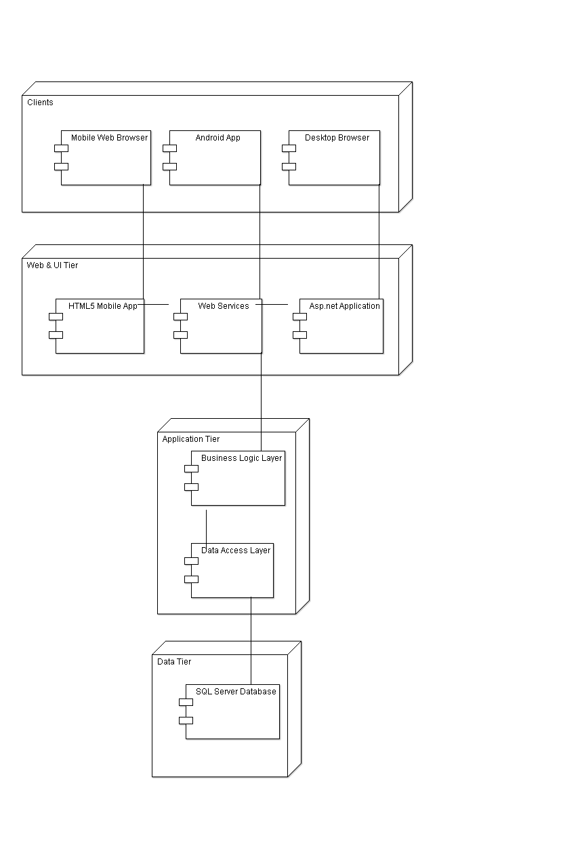

**Use Case Diagram :**

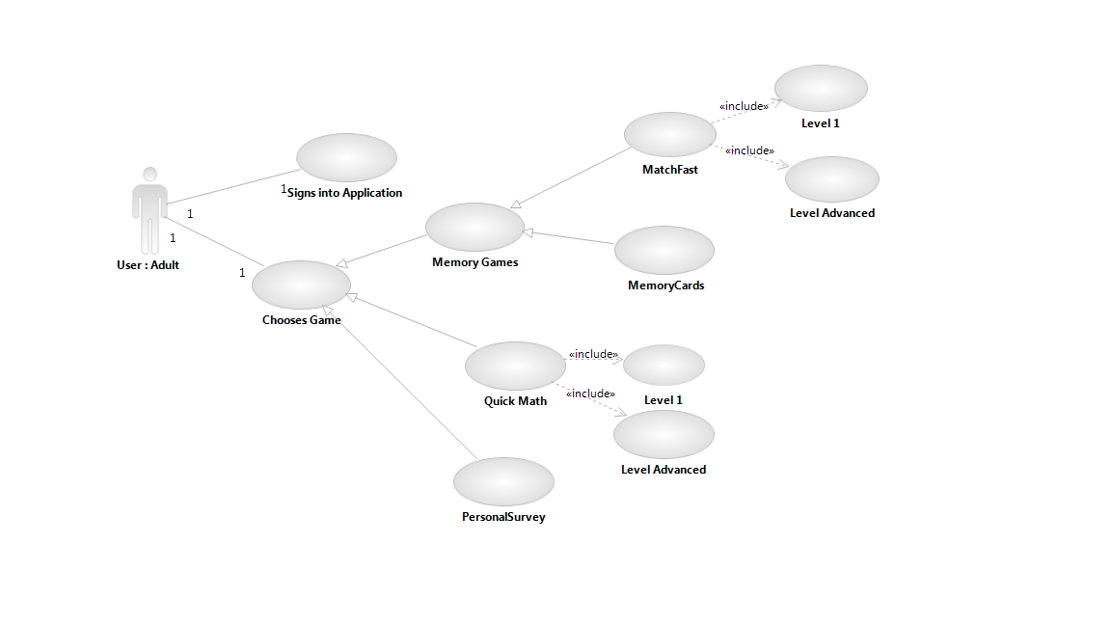

There is a sign on application, followed by the GUI representing various choices for the user, with respect to his choice of game. As of now, the games decided are those that pertain to math puzzles, a personal survey containing information that is first entered by the user and then repeatedly posed as questions for retentive purposes and color matching games.

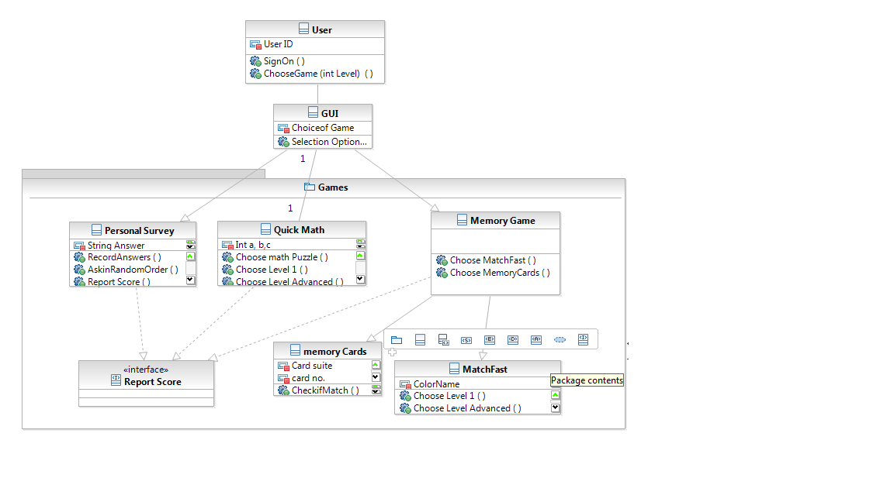

**Class Diagram** showing over all modules in the project. Each class has its separate functions.

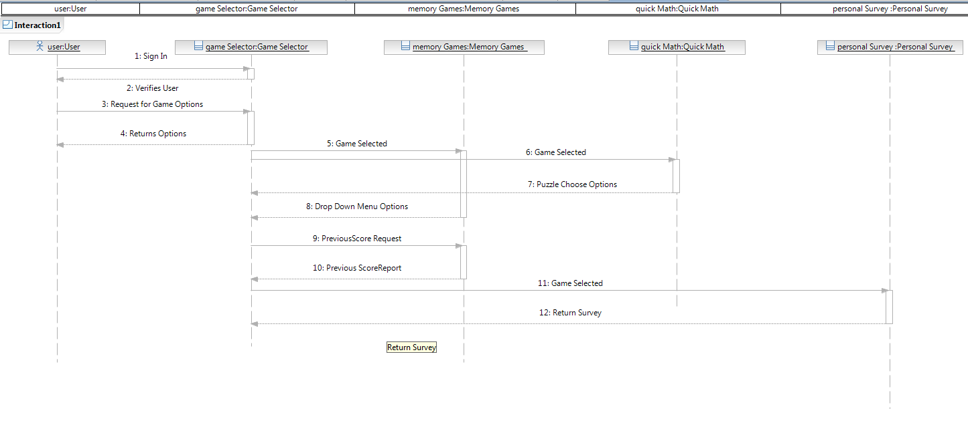

**Sequence Diagram 1**. :

This has the overall flow of the functions. Once the user decides on which game he would like to play, after the drop down menu appears, he can then play it and see the score report.

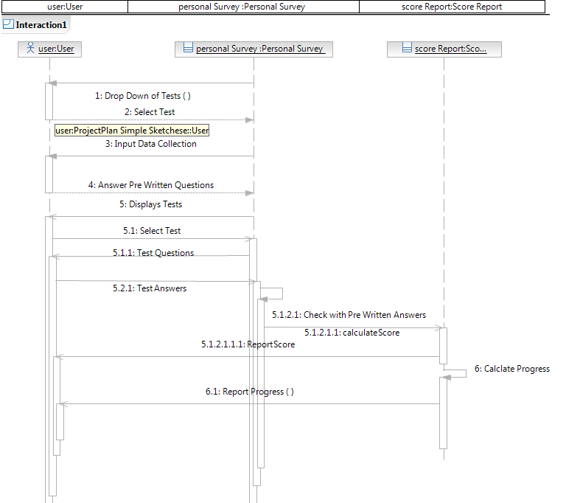

**Sequence Diagram 2** :

This further elaborates on the personal survey game. First, he is asked to input some answers to some questions. Then he will repeatedly get these questions in mixed order so that he can remember the answers for a longer period of time. A progress report can also be shown.

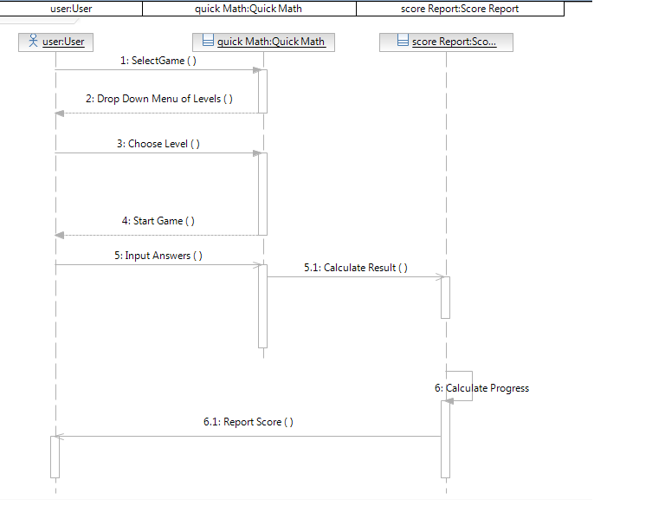

**Sequence Diagram 3** :

A math puzzle or quick mental math questions are incorporated in this game, after which the score is reported.

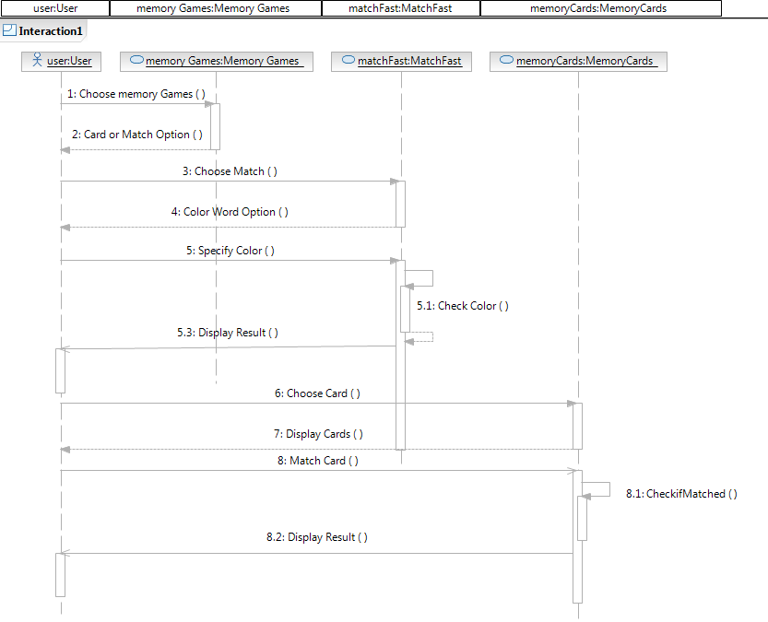

**Sequence Diagram 4 :**

Memory games like matching cards and the color are given as options, and are used for memory and cognition enhancement.

1. **Plan by Services**

**Project Timelines:**

Feb 21: Project Proposal & Plan

Mar 8 : Iteration 1

Mar 22 : Iteration 2

April 12 : Iteration 3

May 3 : Iteration 3

May 7 : Final Project Presentation

May 10 : Final Project Report

Mar 8: 1st iteration

* Design of GUI
* Implementation of login page, basic game layout
* Provision of some outside web services

Mar 22: 2nd iteration

* Implement Memory Games

Apr. 12: 3rd iteration

* Concentrate on Quick Math and Personal Survey Questions

May. 3: 4th iteration

* Testing and fixing the bugs
* Deploy the project
* Complete the project report
* Make a video of the working project

may. 7 (T) & 8 (Th): Final project presentations

#### Features to be implemented

Major functions to be focused are:

**Educational / Memory Retentative based Games:**

**Match Cards ( )**: This card game would be based on the memory card game, where out of a particular deck of cards, some would be over turned and the player must remember which positions were held by cards that matched.

**Match Color ( ):** Here, based on the color of the word, the adjacent color must spring up as the answer. The player must not be able to see the color of the word and spell it out correctly and verify if the adjacent word is indeed indicating the same color next to it or not. These can be timed if the user wishes.

**Think Fast ():** These sets of modules pertain to the fast mental mathematics games that children and adults would like and if practiced, would increase their thinking power.

**Personal Survey ( )** – Here, the surveys would be pre written and be filled out by the user. At a later date, he can go back to the tests and answer the same questions he previously answered, to make sure to keep in mind essential points.

**Other Features**  :

**Login page :**  Every user can log in with their username and password

**Show_progress ( ):** The progress of a user can be tracked with the help of this service. When a user repeatedly takes a test, he can track his scores.

#### Services to be implemented or (existing services) to be used

Webservices to be used can be used as a part of the features discussed above.

#### Mobile phone interfaces

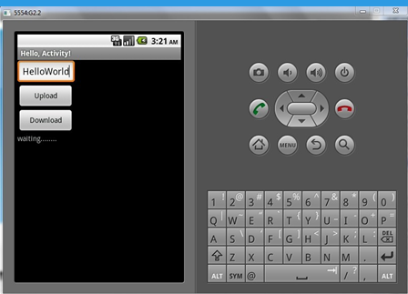

Images and text strings can be transferred and be asked to be recognized by the user, to also improve retention and recognition.

### Plan by Features

### Schedule for the four increments

### Design by feature (detailed service design, unit test design)

Unit test design

* Log in / Authorization
* Match Card ()

The game would be tested with its respective test cases with similar, dissimilar cards being flipped over to see if the result is given correctly.

* Match Color

This can be tested with multiple words in different colors.

* Mental Math ()

This web service also can be tested separately testing if the math games are apt for every level and if they are displaying accurate results within specified time duration..

* Show Progress ( )

This web service can be tested by playing all the games twice, at least and seeing if the progress is individually being tracked per game.

### Build by feature (implementation and testing)

Our target is to complete implementation of all features mentioned by 3rd increment. We will be targeting to implement at least 2 features per week, starting from week 3.

1stIncrement:

Week1:

* Begin construction and design of games
* Begin implementation of features mentioned in iteration

Week 2:

* Implement remaining features and test those features

Week 3:

* Target completion of implementation and testing of already deployed features

2ndIncrement:

Week4:

* Begin iteration 2
* Begin features that need integration of android emulator, cloud and jquery scripting.

. Week 5:

* Complete implementation of above mentioned features

3rdIncrement:

Week 6:

* Testing and fixing bugs for features implemented
* Begin iteration 3

Week 7 and 8:

* Target completion of remaining features

4thIncrement :

Week 9:

* Begin iteration 4
* Test and fix bugs from previous iterations
* Preparing for final presentation that includes making a video of our project

.

### Backup plan (risk management)

We have scheduled our iterations such that we will have time to accommodate any slip of deadline. Just in case we are not able to maintain a deadline, we plan to implement the unique features of our project with high priority.

Implementation of priority features only:

1. Setting up a login page/ authorization page
2. Building the Memory Games including :

* Match Card game
* Match color game

1. Working on a personal survey questionnaire
2. Recognition of words/images
3. Working on the Mental Math game
4. Showing a progress Report
5. Audio/image recognition

**Bibliography** :

For our reference, we have thus far used :

[http://www.doctoroz.com/exercise-your-brain](https://ch1prd0102.outlook.com/owa/redir.aspx?C=wuYrwIkwH0CTJvFB9fBOBirn6WpC4M8IohkwGUkwrJYcBomexsEmIypLFYr7665j4-KDQnajoDw.&URL=http%3a%2f%2fwww.doctoroz.com%2fexercise-your-brain)

[http://www.aarp.org/health/brain-health/info-02-2012/exercising-may-prevent-alzheimers-health-discovery.html](https://ch1prd0102.outlook.com/owa/redir.aspx?C=wuYrwIkwH0CTJvFB9fBOBirn6WpC4M8IohkwGUkwrJYcBomexsEmIypLFYr7665j4-KDQnajoDw.&URL=http%3a%2f%2fwww.aarp.org%2fhealth%2fbrain-health%2finfo-02-2012%2fexercising-may-prevent-alzheimers-health-discovery.html)

[http://online.wsj.com/article/SB10001424052748703416204575145921517534304.html#project%3](https://ch1prd0102.outlook.com/owa/redir.aspx?C=wuYrwIkwH0CTJvFB9fBOBirn6WpC4M8IohkwGUkwrJYcBomexsEmIypLFYr7665j4-KDQnajoDw.&URL=http%3a%2f%2fonline.wsj.com%2farticle%2fSB10001424052748703416204575145921517534304.html%23project%253DALZHEIMERSQUIZ100326%2526articleTabs%253Darticle)

[http://www.brightfocus.org/alzheimers/resources/memorygames.html](https://ch1prd0102.outlook.com/owa/redir.aspx?C=wuYrwIkwH0CTJvFB9fBOBirn6WpC4M8IohkwGUkwrJYcBomexsEmIypLFYr7665j4-KDQnajoDw.&URL=http%3a%2f%2fwww.brightfocus.org%2falzheimers%2fresources%2fmemorygames.html)  
[http://www.lumosity.com](https://ch1prd0102.outlook.com/owa/redir.aspx?C=wuYrwIkwH0CTJvFB9fBOBirn6WpC4M8IohkwGUkwrJYcBomexsEmIypLFYr7665j4-KDQnajoDw.&URL=http%3a%2f%2fwww.lumosity.com)  
[http://www.webmd.com/alzheimers/guide/preventing-dementia-brain-exercises](https://ch1prd0102.outlook.com/owa/redir.aspx?C=wuYrwIkwH0CTJvFB9fBOBirn6WpC4M8IohkwGUkwrJYcBomexsEmIypLFYr7665j4-KDQnajoDw.&URL=http%3a%2f%2fwww.webmd.com%2falzheimers%2fguide%2fpreventing-dementia-brain-exercises)

**Project Management Tools** : Agile Fant

We have used Agile Fant, an agile development tool used to capture project management sequences. Stories have been created, and their respective priorities and deadlines can be checked and mapped, aiding the project progress.

Wiggio : https://r3.res.outlook.com/owa/14.15.48.0/themes/resources/clear1x1.gifASE Spring Group ‎[asespringgroup-4inbo@wiggiomail.com]‎

Github ID : [https://github.com/kbinghamibs/UMKC5551_Project.git](https://ch1prd0102.outlook.com/owa/redir.aspx?C=R0Y1vC9VV0CeQ62cNnY1EeP27n4X4c8Inf0bStsElkmRhPl8UOzZ-b-XvvY93_RyQhSyEkVtg2M.&URL=https%3a%2f%2fgithub.com%2fkbinghamibs%2fUMKC5551_Project.git)

