PRACTICE TASKS
TASK 1 — CHECK YOUR IP ADDRESS
🎯 Objective
Find:
- IPv4 Address
- Default Gateway
- DNS Server
📌 Steps
Step 1
Press: Windows + R
Step 2 Type: cmd
Press Enter.
Step 3 Command Prompt opens.
Type: ipconfig
Press Enter.

📸 Screenshot
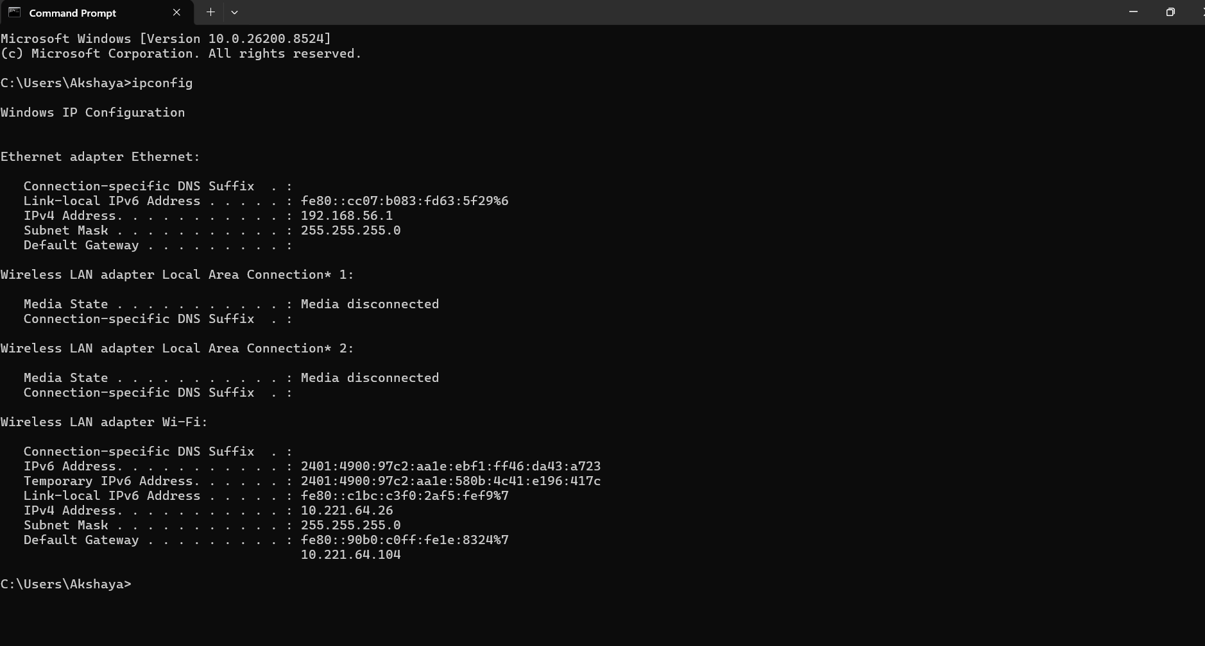

NOTES
- IPv4 Address Identifies your device in network.
- Default Gateway Router address used to access internet.
- DNS Server Converts domain names into IP addresses.

TASK 2 — TEST INTERNET CONNECTIVITY
🎯 Objective
Check whether internet is working.

📌 Steps
In Command Prompt type:
ping google.com
Press Enter.

📌 Learn
Reply Packets: Shows connection success.
Time: Measures response speed.
Packet Loss: Shows network problems.

📸 Screenshot
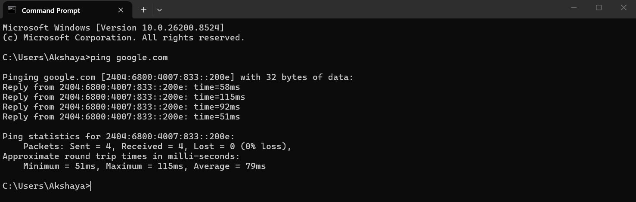

Ping command checks:
- Connectivity
- Network availability
- Response time

TASK 3 — DNS LOOKUP
🎯 Objective
Understand how DNS converts names into IPs.

📌 Steps
Type:
nslookup google.com
Press Enter.

📌 Learn
DNS converts: google.com into : 142.x.x.x

📸 Screenshot
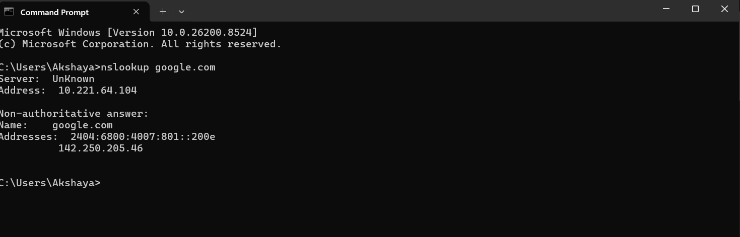

DNS helps users access websites using names instead of remembering IP addresses.

TASK 4 — IDENTIFY PRIVATE IP
🎯 Objective
Check whether your IP is private.

📌 Steps
Look at your IPv4 from:
ipconfig

📌 Compare With Private Ranges
192.168.x.x
10.x.x.x
172.16.x.x – 172.31.x.x

📌 Example
If your IP is:
192.168.1.5
Then it is a:
✅ Private IP

📸 Screenshot


Private IP addresses are used inside local networks and cannot directly access the internet.

TASK 5 — WRITE 5 VALID IPv4 ADDRESSES
🎯 Objective
Understand IPv4 structure.

📌 Steps
Write any 5 valid IPv4 addresses.
Example:
192.168.1.1
10.0.0.5
172.16.1.20
8.8.8.8
192.168.10.25
IMPORTANT NOTES
IPv4 contains:
- 4 octets
- Values from 0–255

TASK 6 — RESEARCH PUBLIC IP
🎯 Objective
Understand Public IP vs Private IP.
📌 Steps
Open browser.
Search:
What is my IP
Google shows your public IP.

📌 Learn
Public IP: Used on internet.
Private IP: Used inside local network.
📸 Screenshot
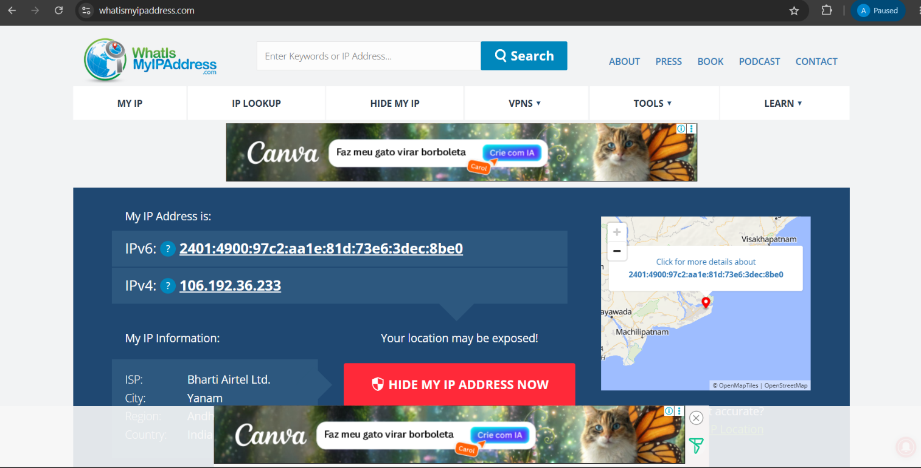
Public IP is assigned by ISP and visible on internet.

TASK 7 — COMMON TERMS
🎯 Objective
Learn basic networking terminology.

📌 Write Meanings
IP: Unique address for devices.
DNS: Converts names into IP addresses.
Gateway: Connects network to internet.
Router: Routes traffic between networks.
Network: Group of connected devices.

TASK 8 — IAM CONNECTION TASK
🎯 Objective
Understand networking importance in IAM.

📌 Write:
“How IP Addresses Help IAM Security”
Minimum 5 points.

📝 Example Points
- Track user login locations
- Detect suspicious logins
- Apply conditional access
- Restrict unauthorized access
- Monitor authentication activities

