Hands-on Assignment 7
Due Date: See Web
(HA12 depends on HA7)

Small Formal Language Model (SFLM)
In this assignment, you will need to complete the code for a small language model for a formal language, called Small Formal Language Model. This small language model is implemented as a transformer as illustrated in the following figure.
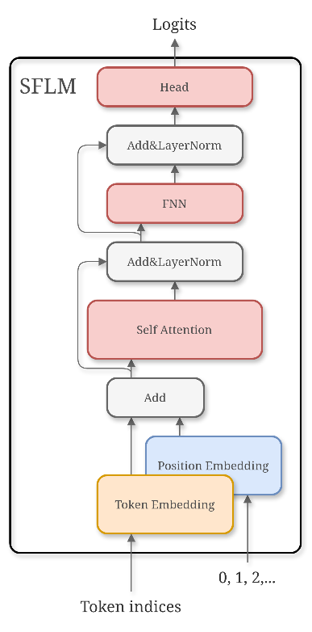
The structure of SFLM.
The formal language L to be modeled is defined as
L={strings over {a, b, c} such that
1). # of a’s + # of b’s = # of c’s,
2). the length does not exceed 20 }
For example,
- aabbcccc∈L
- cccab∉L.
The goal is to train a SFLM to fit L such that it can complete a prompt to generate strings in L.

Dependencies
To install dependencies for this Assignment, run
$ pip3 install -r requirements.txt

Tasks
The code skeleton is given. It consists of 4 files:
- src/model.py: It includes two pytorch modules:
  - SelfAttention: It defines the Self-Attention layer used in SFLM.
  - SFLM: It defines the transformer illustrated in the figure above.
- src/utils.py: It includes two helper classes:
  - LangABC: It’s a Dummy dataset to generate strings online.
  - TokenizerABC: It’s a simple predefined tokenizer which translates between human-readable strings and SFLM-readable token indices
- train.py: A script for training a SFLM to fit L.
- infer.py: A script for using a saved SFLM to conditionally generate strings in L interactively.
Your tasks in this assignment are:
- Complete the forward functions of the two modules in the src/model.py file. You can refer to their API documentations for their functionalities:
  - model.SelfAttention.forward(),
  - model.SFLM.forward().
- Train a SFLM to fit L with the train.py script.
API Reference: readme/autoapi

Usage
After you have finished the two forward functions in the model.py file, you can train your SFLM with the default options by running
$ python3 train.py
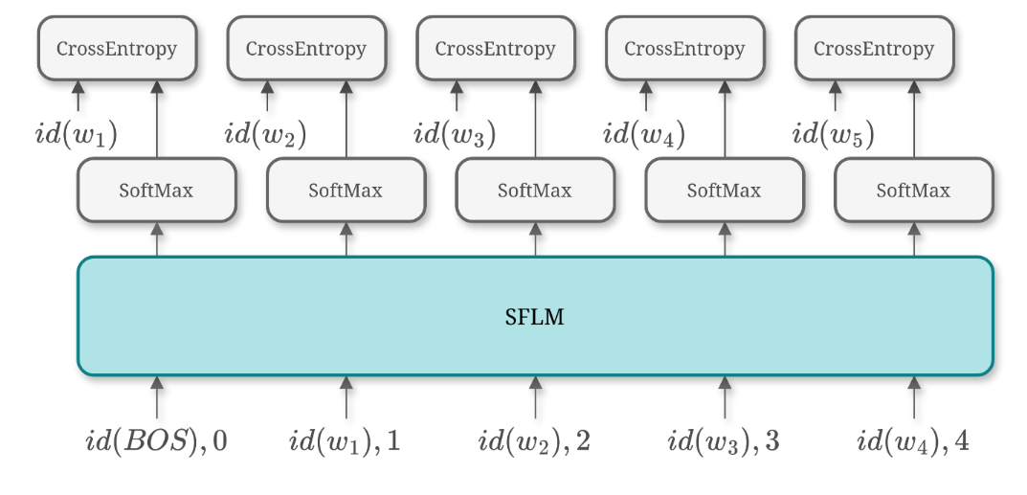
The train.py file applies teacher forcing to train the SFLM.
For more available configurations, check
$ python3 train.py -h
With the default setting, the training should finish within an hour even on CPU. Once the training is done, the model would be saved in model.sav file by default.
You can interact with your saved model, by run
$ python3 infer.py
This will load model from the default path. To specify the model file, run
$ python3 infer.py --save-path <path_to_your_model>

Grading Scheme:
- 2: correctness and clarity of your code
- 2: Performance of your model: Whether it generate correct completions and whether it generates diverse completions.

Notes:
- Submission format: A single zip file with your finished model.py file and saved model.sav. The zip file should be named Student_ID_Assign#.zip, i.e. 1234567_Assign_x.zip.
- Headers: Add the following headers at the beginning of your submission code:
"""
Student Name:
Student ID:
Student Email:
"""
- Similarity penalty will not be applied to this assignment. However, the Turnitin report will be used as clues for manual plagiarism detection.

Copyright Statement: The materials provided by the instructor in this course are for the use of the students enrolled in the course. Copyrighted course materials may not be further disseminated.

